***HOW TO PATH REVIEW A CBC OR A CBCWO***

***In the interface, post as normal***

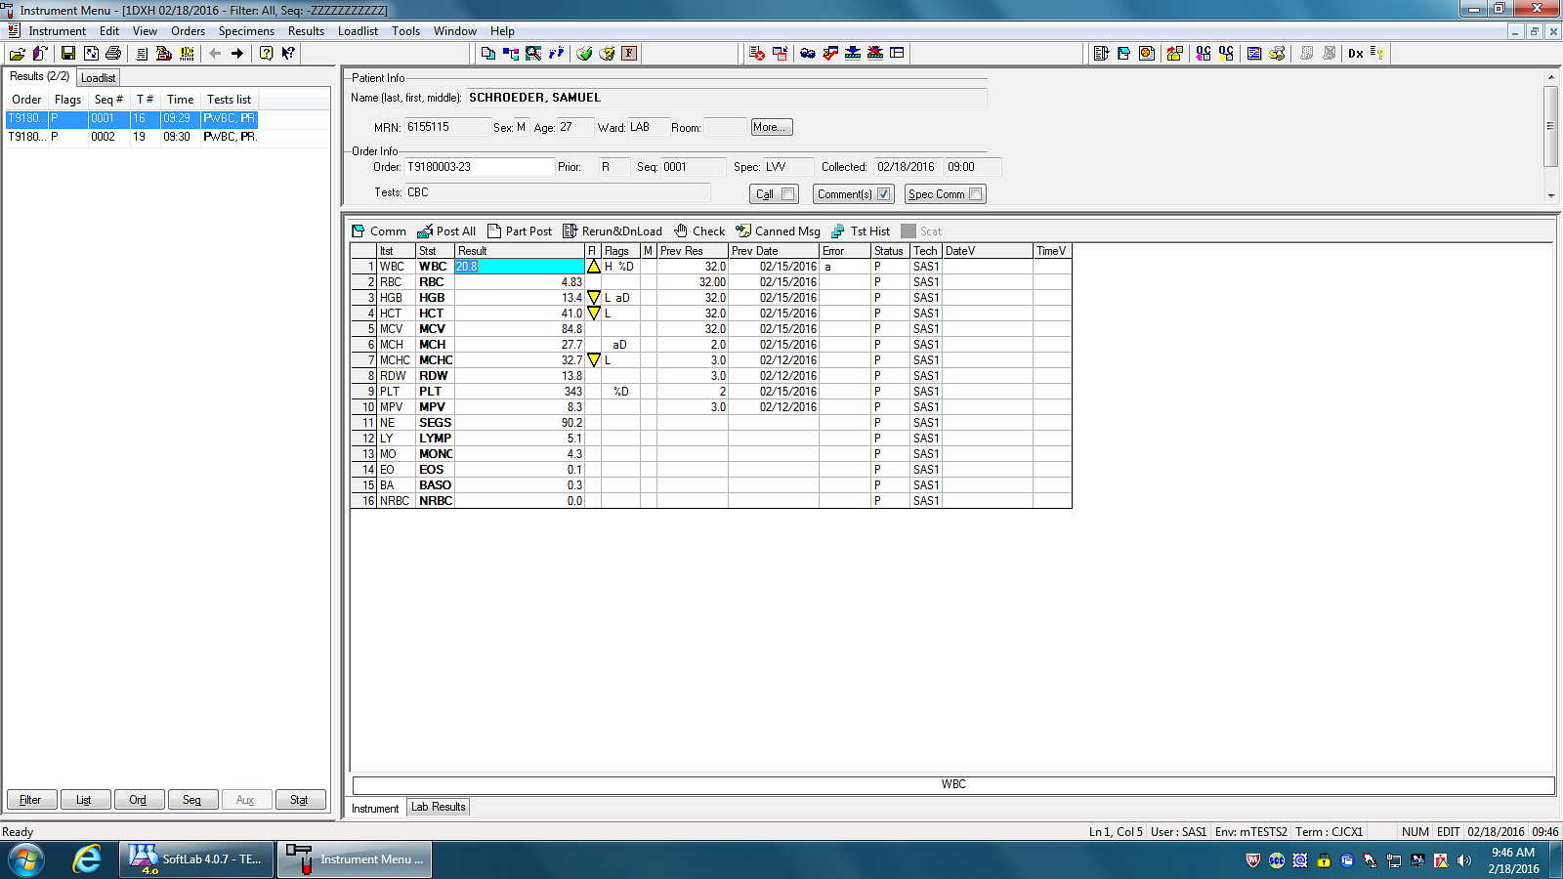

If required to have Pathologist Reviewed, ***take the period out.*** Once the pathologist reviewed the sample, they will add their initials to the PATH line. Do not verify this line.

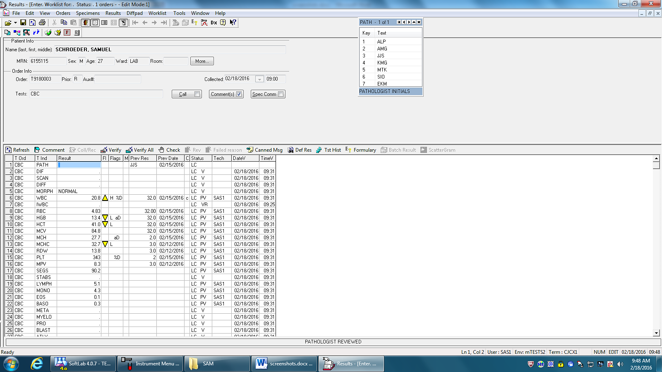

Notice the pathologist initials showing up that is was path reviewed 2/15/16

When doing incompletes, the removal of the period would indicate that it is in for pathologist review.

This is how it looks on a Laboratory Instant Report

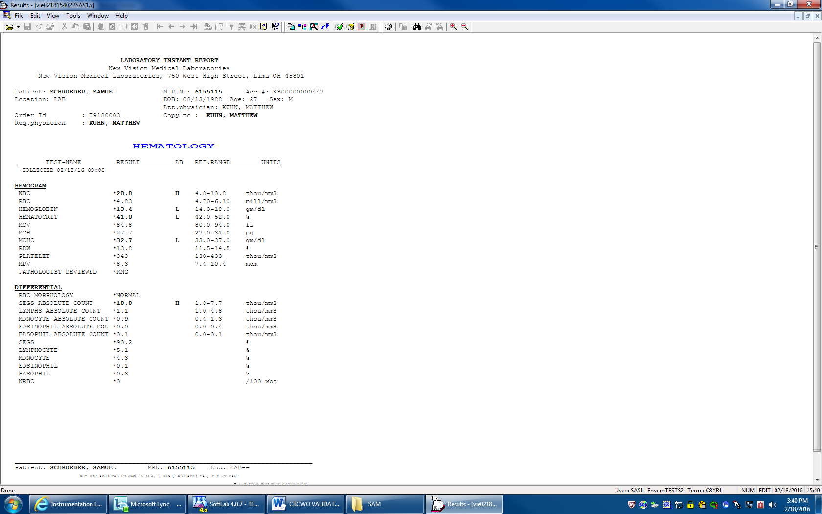

This works the same way on the CBCWO

