*This MTS is being assigned as a results of a laboratory mislabel that occurred June 21 2016.*

|  |  |
| --- | --- |
| **SUBJECT:** | **Labeling and Handling of Laboratory Specimens, Aliquots, Dilutions, In Case and Reaction Tubes** |
| **POLICY:**  **PROCEDURE:** | Medical Center and Ambulatory Care personnel shall follow the prescribed labeling procedure in order to ensure correct identification of all specimens, from collection through final disposition.   1. Specimens must be labeled at the point of collection using LIS labels, HIS/CIS labels, stamped paper labels, or tape, or by directly writing on the tube/container with permanent ink with the following required information. Micro collection tubes must be inserted into a micro collection tube holder prior to labeling with the required identification.    1. Patient name.    2. A Unique Identifying Number including any or all of the following:       1. Account Number.       2. Medical Record number.       3. Birth date.       4. Social Security number.    3. Initials of the person collecting the sample    4. Date and Time. 2. Specimens accepted with labeling other than the bar-coded LIS label must have the correct LIS label applied over the existing label by the lab staff prior to LIS receipt and testing.    1. Verify specimen patient information and generate bar-coded LIS labels or retrieve those already generated.    2. Verify the identification of the specimen and apply the LIS label over the existing label on the specimen. It is the sole responsibility of the accepting tech to verify that the identification on the existing label and the LIS barcode label are the same prior to placing label on specimen.    3. Anyone who misidentifies a specimen by over-labeling with the wrong labels on a specimen will receive an immediate Decision Day Leave for the first offense and may be terminated for any subsequent occurrence. 3. Improperly labeled or unlabeled specimens will not be accepted for testing.    1. Collecting person is responsible for labeling the specimen.    2. When an Outpatient presents with an unlabeled specimen or incorrect label information, accepting lab personnel must request patient write full name and DOB with date and time of collection on container.    3. No unlabeled specimens will be labeled by laboratory personnel and no corrections will be made to inaccurately labeled specimens by laboratory personnel.    4. Unlabeled or inaccurately labeled specimens will be discarded upon receipt. The sender will be notified immediately that an unacceptable specimen was received by the laboratory. Conflicts must be resolved by consulting a pathologist.    5. The following specimen types that are unlabeled or inaccurately labeled must not be discarded and a pathologist must be consulted   to resolve labeling issue.  a. Sterile body fluids (i.e. CSF, Pleural fluid, peritoneal fluid, synovial fluid)  b. Surgical specimens, biopsies  c. Specimens that can’t be recollected.   * 1. Any laboratory employee who labels an unlabeled specimen or makes corrections to an incorrect label will receive an immediate Decision Day Leave for the first offense and may be terminated for any subsequent occurrence.  1. All pertinent information such as "Call Results", "Patient in Surgery", "Results Needed by ________", Patient not fasting, , Date and Time of last dose of medication, antibiotic therapy, etc. must be written on the tube label. 2. Surgical specimens must have a label affixed when received in the laboratory. The label must include specimen type. Upon receipt in the laboratory, a surgical case number must be assigned to the specimen and must be placed on all samples, blocks, sections, and slides from that specimen. Any mislabeling of specimens for Histology and Cytology including original sample container, voucher, block or slide preparation, will receive an immediate Decision Day Leave for the first offense and may be terminated for any subsequent occurrence. 3. Specimens and slides for PAP smear must be labeled with the patient name and one of the unique identifiers listed in A.2. The slides must be placed in a slide folder and the folder placed in an envelope. The completed requisition containing the name, address, birth date, and physician must be placed inside the envelope. If a plastic slide box is used, the completed requisition must be securely attached to the box. Upon receipt in the laboratory, a case number shall be assigned and affixed to the slides. 4. Slides for blood smears, gram stains, semen analysis, etc. must be labeled using a pencil or permanent marker on the frosted end of the slide with the patient’s last name and the sample number or one of the unique identifying numbers. 5. Aliquot specimens must be labeled using the LIS generated aliquot label or with complete written labeling consistent with the initial specimen labeling. 6. Blood samples for crossmatch or type and screen must be labeled in accordance with Blood Bank procedure including date and time of procurement and the initials of the phlebotomist or the first initial and last name of a non-laboratory person collecting the specimen. A properly completed Typenex label must be attached to the blood tube or micro tube holder. 7. Reaction tubes and containers and dilution tubes must be labeled with the patient’s last name and sample number or other unique identifying number. Samples on an automated instrument must be labeled with identifying labels such as barcodes or identified by tray location which must be noted on the tube and may be noted on the tube and may be noted on the worksheet. Labels on dilutions must also show the dilution factor. |

***When relabeling for an add on, ensure the specimen shows the earlier name and the sample number as shown below.***

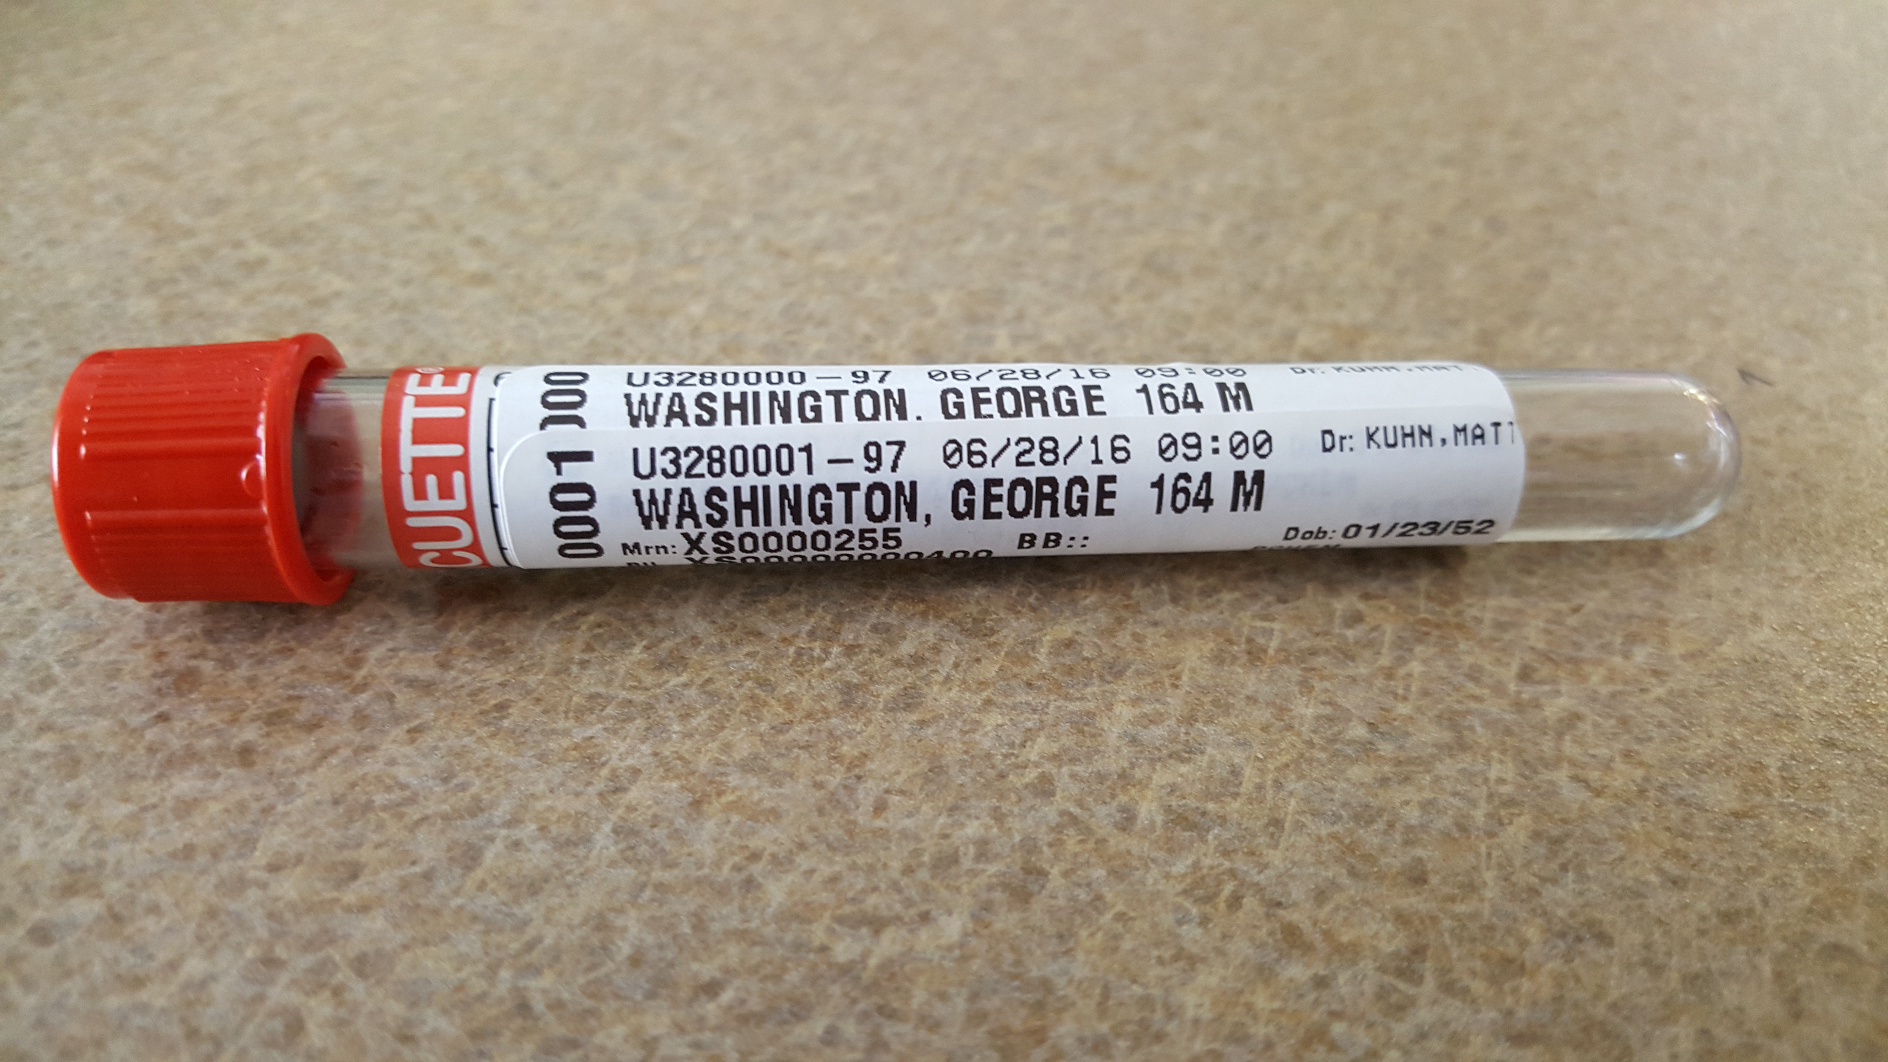

***Always check for two identifiers before relabeling a specimen.*** *Failure to do so is dangerous to the patient as a result of a mislabel. In our scenario, a pregnant women could have received a harmful radiological scan to the fetus.*

*Please read the following article from CAP. This more pertains to phlebotomy mislabels but it is a very good read.*

As every laboratorian knows, reporting a wrong result can have potentially devastating effects on the patient. This can be doubly true if there is a patient identification mix-up: one patient could receive the wrong medical or surgical treatment while another doesn’t get the treatment he or she needs. Either situation can result in severe, irreversible consequences.

Researchers say that most laboratory errors occur in the preanalytic phase, and many of those involve mislabeled specimens. These errors can be frustrating for the laboratory medical director, because many happen outside the lab. But with the appropriate policies, feedback, and education, most specimen labeling errors can be prevented.

The effort is well worth it. In a study by Steven Kahn at Loyola University Health System, the average cost of a misidentified specimen was $712, not including immeasurable costs such as patient anxiety and discomfort and the delays in diagnosis and treatment (Kahn et al.). Using the median identification error rate of 390 identification errors per million specimens (Valenstein, Raab), the cost of misidentified specimens adds up to approximately $280,000 per million specimens.

Getting Started

Ensuring correct patient and sample identification is goal #1 of the CAP’s Laboratory and Patient Safety Goals. This is consistent with goal #1 of the Joint Commission’s National Patient Safety Goals: to improve the accuracy of patient identification.

It is up to the laboratory medical director to provide leadership around this important patient safety issue.

* Review the guidelines for specimen rejection. Does everyone follow them? If needed, update and recommunicate the following information:
  + Rationale behind the guidelines.
  + Minimum requirements for specimen acceptance.
  + Deficiencies that will lead to rejection (eg, unlabelled specimens, mislabeled specimens, leaking or broken containers, inadequate volume).
* Define the circumstances under which a new specimen is requested. The greater the ease of obtaining a replacement specimen, the more prudent it may be to request a new, correctly labeled specimen.
* Review the definitions of the various labeling errors. Does everyone in your institution understand them? Here is one institution’s set of definitions:
  + **A requisition/specimen mismatch** is the mislabeling error most frequently identified, because the mistake is easy to spot. The name on the specimen doesn’t match that on the requisition.
  + **Unlabeled specimens** are also easy to recognize, because the label is missing altogether. Some labs take it further, defining any specimen with only one of the two required patient identifiers as “unlabeled.”
  + **Mislabeled specimens**, sometimes known as “wrong blood in tube,” occur when a specimen from one patient is labeled with another patient’s name. If the mismatch or abnormal result is not caught by the laboratory, the error can remain undiscovered until the clinician questions the atypical result. These errors have low detectability and potentially significant consequences.
  + **Incomplete labels** might be missing one of the following, depending on the institution’s guidelines: patient name, patient date of birth, unique patient identifier, date and time of specimen collection, specimen type, and the name (or initials) of the person collecting the specimen.
* Review the guidelines regarding labeling errors involving specimens that are irreplaceable (eg, kidney stones, cerebrospinal fluid) or that cannot be readily recollected (eg, cultures taken prior to antibiotic therapy, tissue biopsies, timed blood draws). Is the rationale for each circumstance clearly defined? Are clinical personnel required to attest to the identity of the patient? Are disclaimers entered into the written laboratory report?
* Define the circumstances under which relabeling may occur. For example, would a reasonable person move forward if:
  + The lab receives a lung biopsy, with the patient’s first name obscured on the label but the last name is clearly Doe;
  + Only one lung biopsy was performed in your hospital in the last three days, and that was for John Doe;
  + Mr. John Doe can show you his scar from his lung biopsy; and
  + Mr. John Doe’s physician confirms that that specimen was removed from that patient?
* Define the trace-back procedure when a mislabeling error comes to light. Make sure everyone in the lab knows that anyone can call a halt at any time. Specimen mislabeling errors can be like mice in the walls—if there’s one, there’s probably more. You may need to shut down an area—nothing in, nothing out—until you resolve the problem.
* Review and update the blood bank rejection policy. Does the lab have a quarantine refrigerator so that mislabeled specimens don’t get mixed up with the specimens you know are labeled appropriately?
* Make sure that all the policies relating to the reporting of results from improperly or incompletely labeled laboratory specimens are reviewed and approved by your institution’s risk manager, legal counsel, liability insurer, or all of the above.
* Define what a complete label should look like. As the laboratory medical director, you determine the policy.
* As the Joint Commission requires, use two patient identifiers, neither of which is the patient’s room number.
* Review the guidelines for specimen collection, labeling, transport, and storage.
* Provide tips to specimen labeling staff on how to avoid specimen mislabeling. For example:
  + Never put the label on the cap, which can become detached. Always put the label on the container instead.
  + Special handling by non-routine personnel is rarely a good idea. For example, the chief of medicine may want to draw blood on an important patient, label the container, and hand-carry it to the lab. Don’t let the chief do it. Have your regularly assigned phlebotomist do it instead. He or she is more likely to do it properly.

Despite the advances in medical hardware and electronic systems that help reduce identification errors, preanalytic errors will continue to happen. What should a lab do when a specimen mislabeling error comes to light?

* Best practice is to recollect the specimen. The CAP guidelines call for discarding the specimen. But as described above, sometimes recollection is impossible or impractical.
* Contact the clinician immediately. If the error has major patient care repercussions, the laboratory medical director or physician designee should do it directly—don’t assign the task to someone below you on the organizational chart. Some physicians would like nothing better than to eat a med tech for breakfast. Document your interaction; consider adding a comment to your report.
* The bigger the problem, the higher up on the organizational ladder both parties should be. If there’s a mix-up involving an anatomic specimen, go directly to the operating surgeon who collected the specimen.
* When discussing the situation with the operating surgeon, make full use of your diplomacy skills:
  + Avoid angry or anger-causing language; use tact in pointing out the labeling error.
  + Take responsibility for the error (even if it was not your fault).
  + Offer a solution, not just a problem. “There’s an identification problem with one of the four smears. Would you be willing to recollect it tomorrow? Or would you like us to move forward with the other three?”
* As part of your Quality Improvement document that is “not discoverable,” keep a resolution log for recording inadequate specimens and specimen labeling errors. Explain how and by whom the errors were resolved.

Dig Deeper

Errors cannot be corrected unless and until you determine where and when they are occurring. Once you understand the extent of the problem, you will be able to track your institution’s progress.

* First, create a laboratory culture in which honesty is valued more than perfection. If staff members are afraid to tell the truth about mistakes, the mistakes will remain hidden—and unfixable. Reward people for pointing out specimen labeling errors—in fact, any kind of error.
* Collect data on what kind of labeling errors are happening. Sort by location and phlebotomist or the person responsible for labeling the specimen.
* Think about how you can detect errors earlier and more effectively (eg, through the use of delta checks, judicious second review) or, even better, think about how to prevent errors from occurring (eg, through LEAN/Six Sigma process control, bar coding).
* Post aggregate data on the bulletin board through the patient care committee or quality committee.
* Create a plan of action—eg, if specimen labeling errors exceed X per month or Y per quarter in the Emergency Department, follow up with continuing education.
* Set a goal of reducing occurrences below a certain number per month.
* Add patient identification and specimen labeling questions to the yearly safety quiz for all employees.
* Push for a bedside barcode patient and specimen labeling system, if one is not already in place in your institution. Implement the system first in the units with the highest occurrences of specimen mislabeling.
* Consider an electronic event reporting system that automatically forwards reported labeling errors to nursing and clinical services. Awareness is a major component of patient safety.
* Consider creating the role of laboratory ambassador or laboratory envoy—someone from the lab who periodically visits the clinical locations to explain lab procedures, troubleshoot communication errors, offer instruction on proper specimen collection, and gather feedback on lab performance.

Share the Data

Any improvement in patient safety involves three steps: discovering what the problem is, figuring out the remedy, and teaching everyone else. Once you’ve discovered a specimen labeling problem in your institution, spread the word so that everyone can help remedy it. Provide an educational presentation to senior leadership on the mislabeling, including why it is important, steps that have been taken to eliminate it, additional opportunities for improvement, and how the institution is performing over time on this important patient safety issue.

Consider creating a positive, catchy hospital-wide marketing/educational campaign about proper specimen labeling. As with any quality improvement program in your laboratory, design the campaign to provide the data that easily proves its success. And make sure the focus of the campaign is quality improvement, not punishment