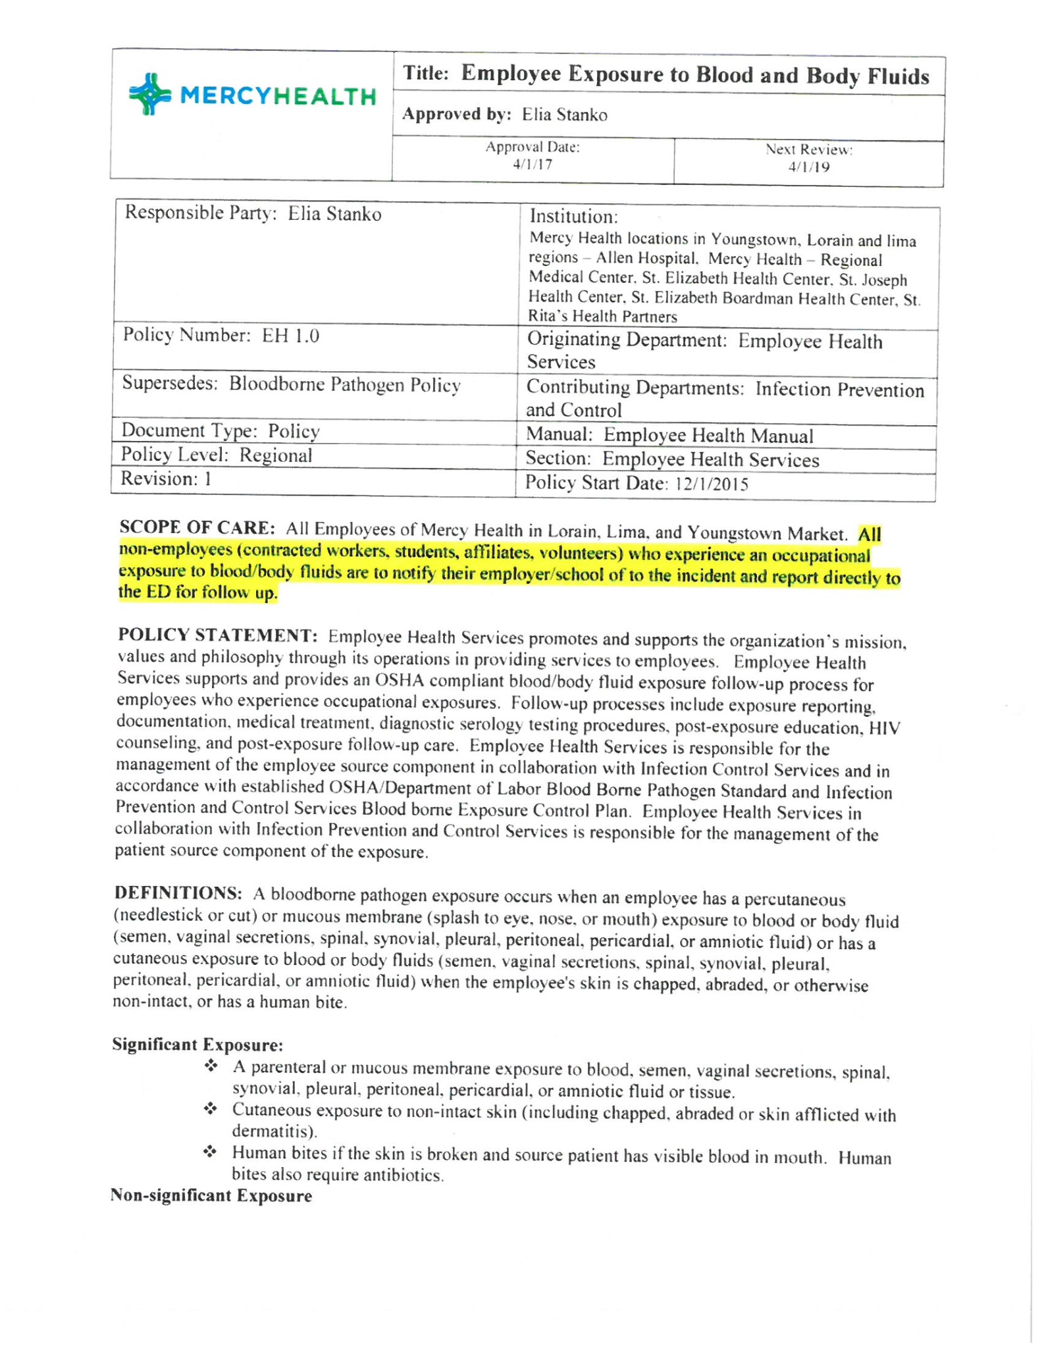

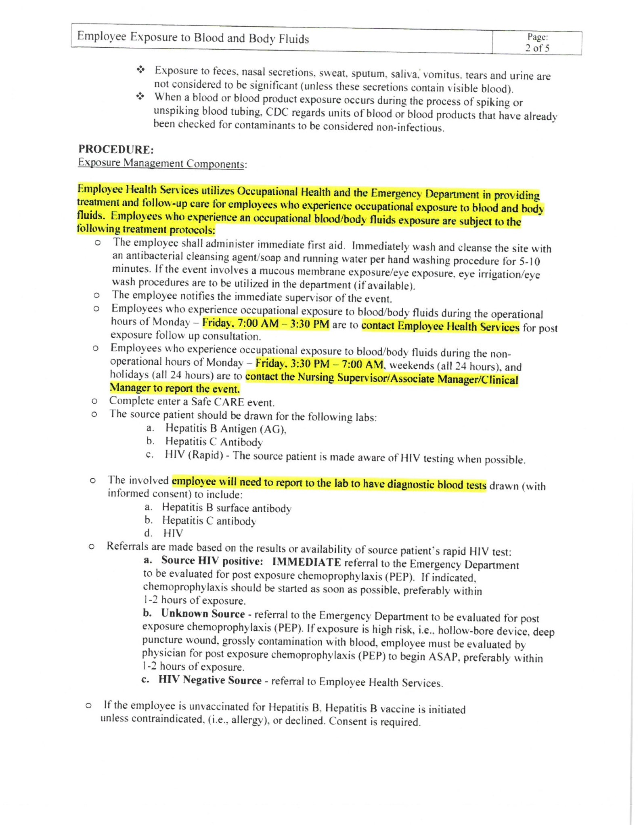

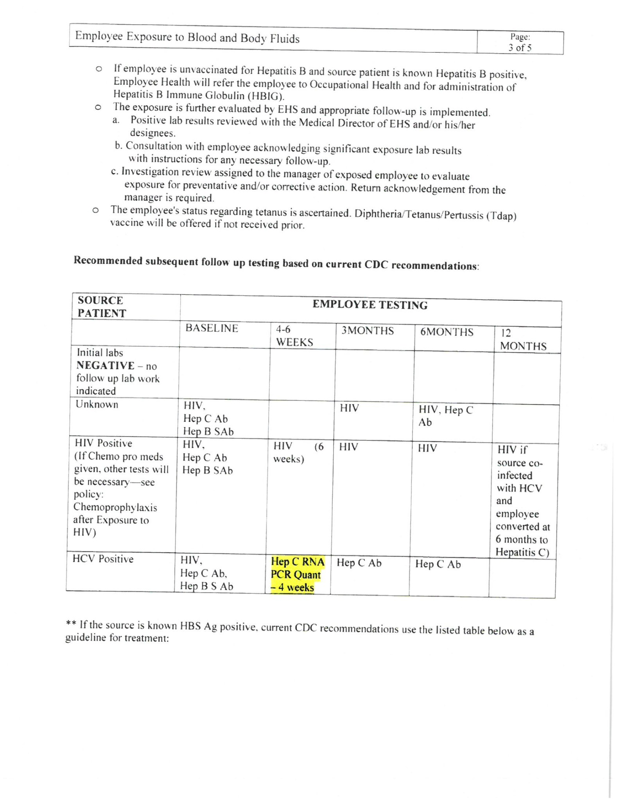

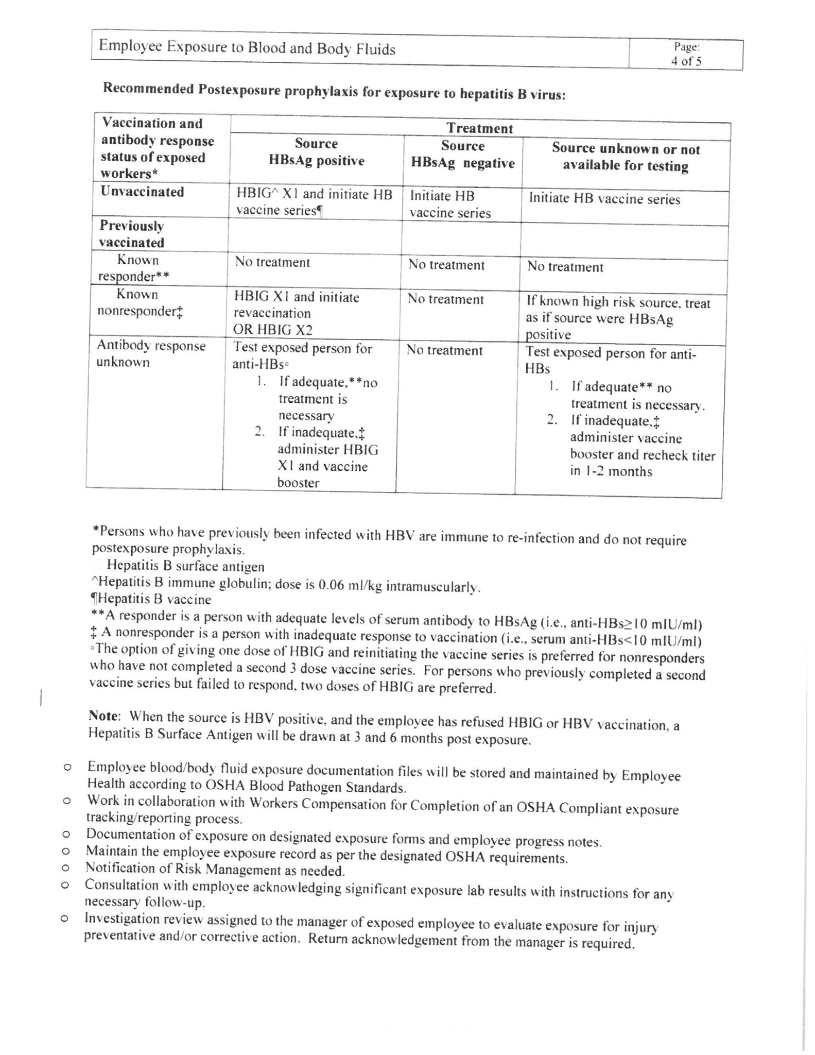

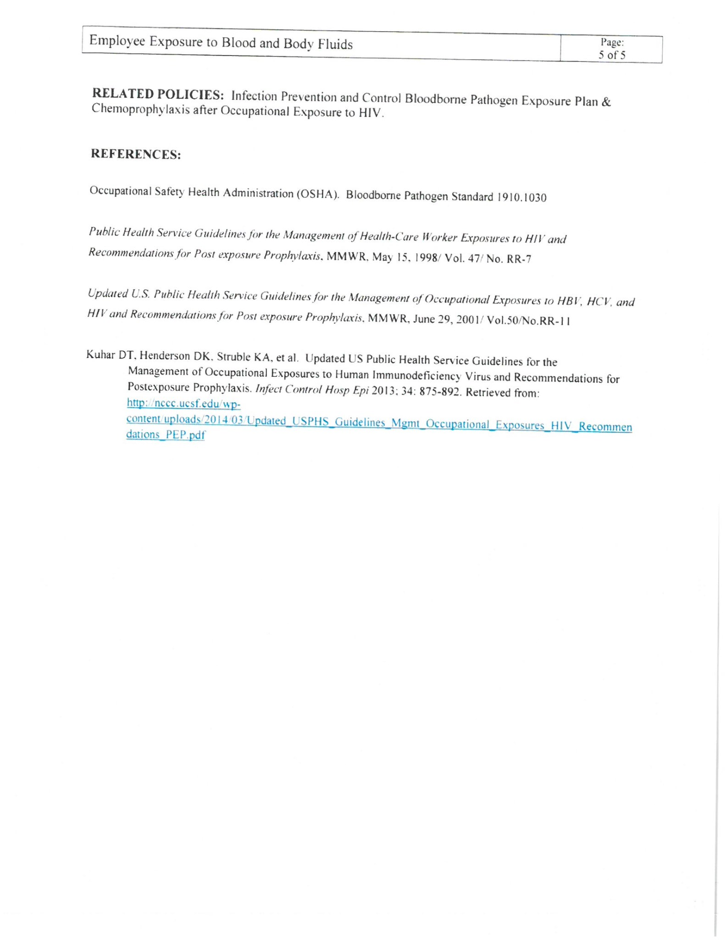

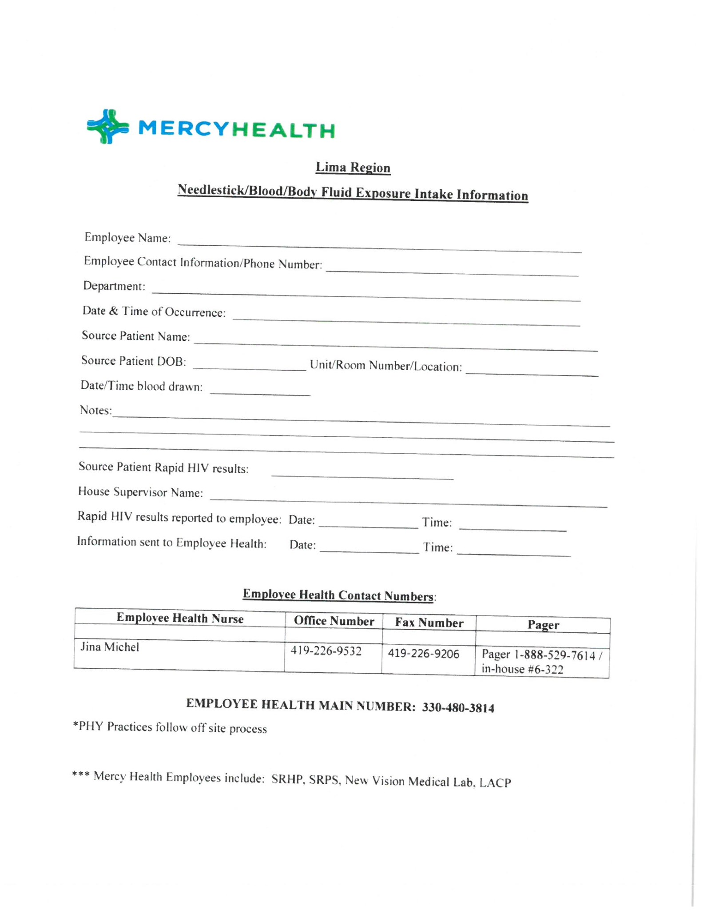

Exposure Protocol

1. **Employee Health or House Supervisor will initiate this Protocol by calling the lab and sending the order with the employee and patient information.**
2. **We will Order for a needlestick/Exposure events for Employees or Source Patients should be ordered as Employee Health** as per the NVML.srmc.ss.001 procedure.
   1. **DO NOT register the patient in the HIS.**
   2. **In the LIS enter the patient’s demographics, “EMP” ward for Employee Health and a valid MRN number or a dummy medical record number if no valid MRN exists.**
      1. **To create the dummy MRN and B# use the date and random number with the alpha suffix appended: MMDDnnnnaa (example: 0915123EH)**
      2. **For Employee Health, the suffix is “EH”**
      3. **Physician is 100(Employee Health Physician)**
   3. **Order the requested tests on Mercy Health requisition or outpatient requisition submitted. See the policy nvml.054, *Outpatient Testing: Patient Registration, Test Request, and Specimen Handling*, for detailed steps for test order entry. The patient will have an “EH” billing number and the EMP ward. Employee Health or House Supervisor will initiate the Exposure/Needlstick event and paperwork with a phone call to lab. They will fax the lab the information and we will need to order and notify Phlebotomy to draw.Carefully compare the patient identification on both the specimens and the labels and label the specimens.**
   4. **You must Contact Phlebotomy to draw if no blood in lab ASAP . Be sure to note location of the patient in comments and call phlebotomy as they will NOT see this on their scanner.**
   5. **Be sure to call the Rapid HIV results to the House Supervisor or Employee Health and document who you spoke to just like a critical call.**
3. **\*\*For Non- Employees such as a police officer or EMT or fireman/Nursing Student…have the person registered and order tests as requested and perform stat testing. Typicallly this is done in the Emergency Department.**

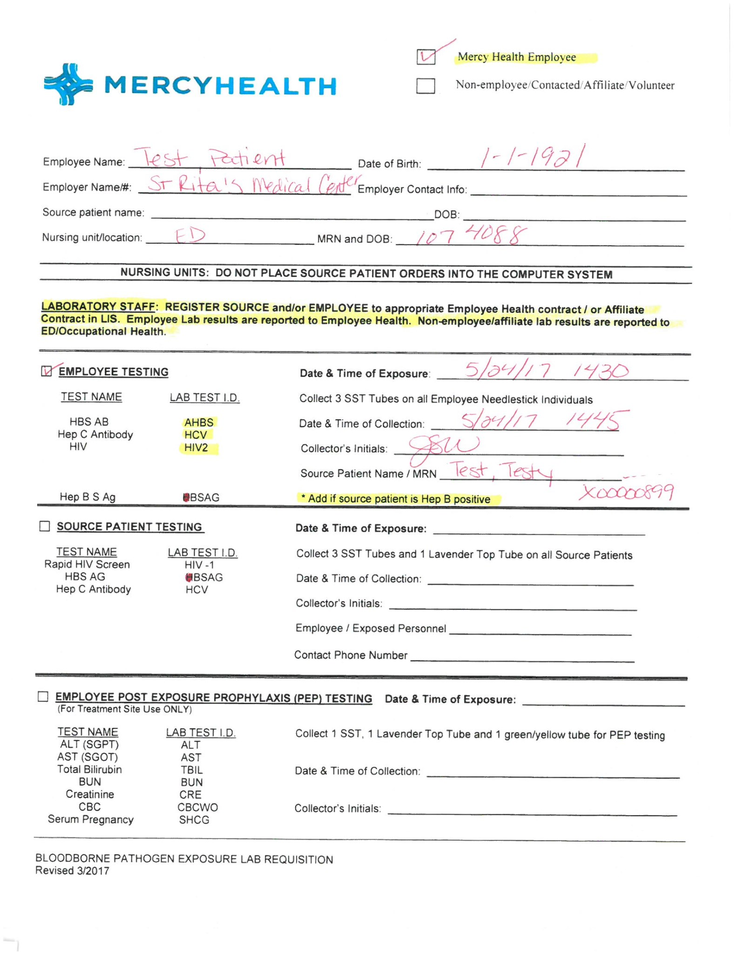

**Figure 1- Example of Employee with needlestick**

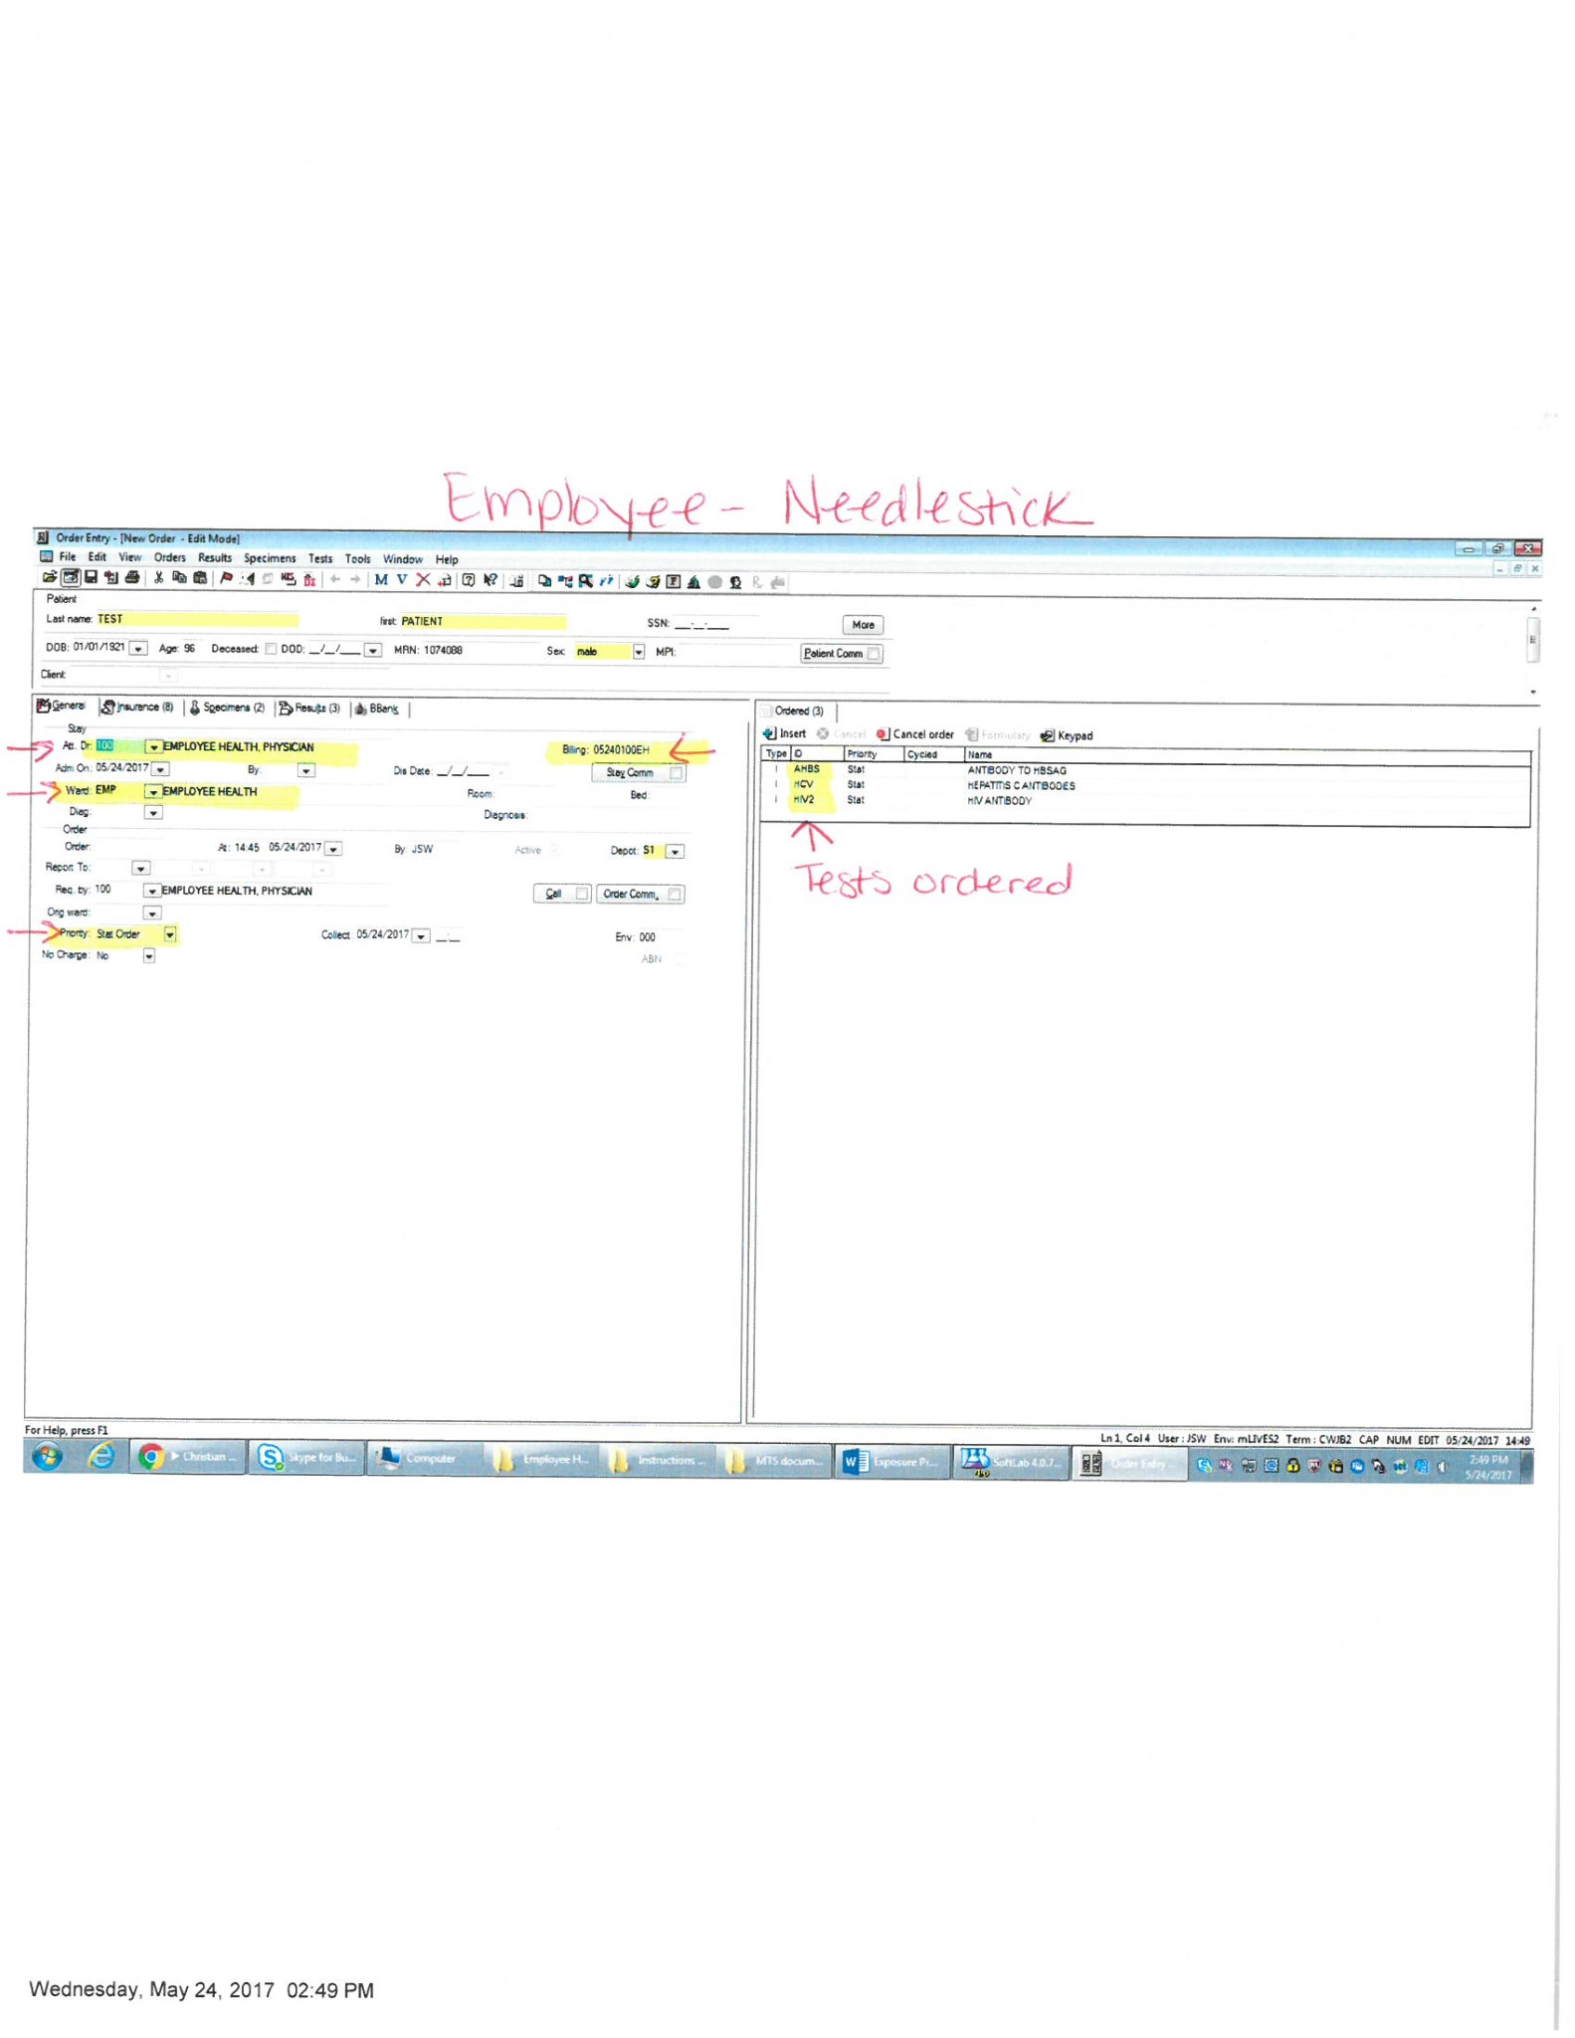

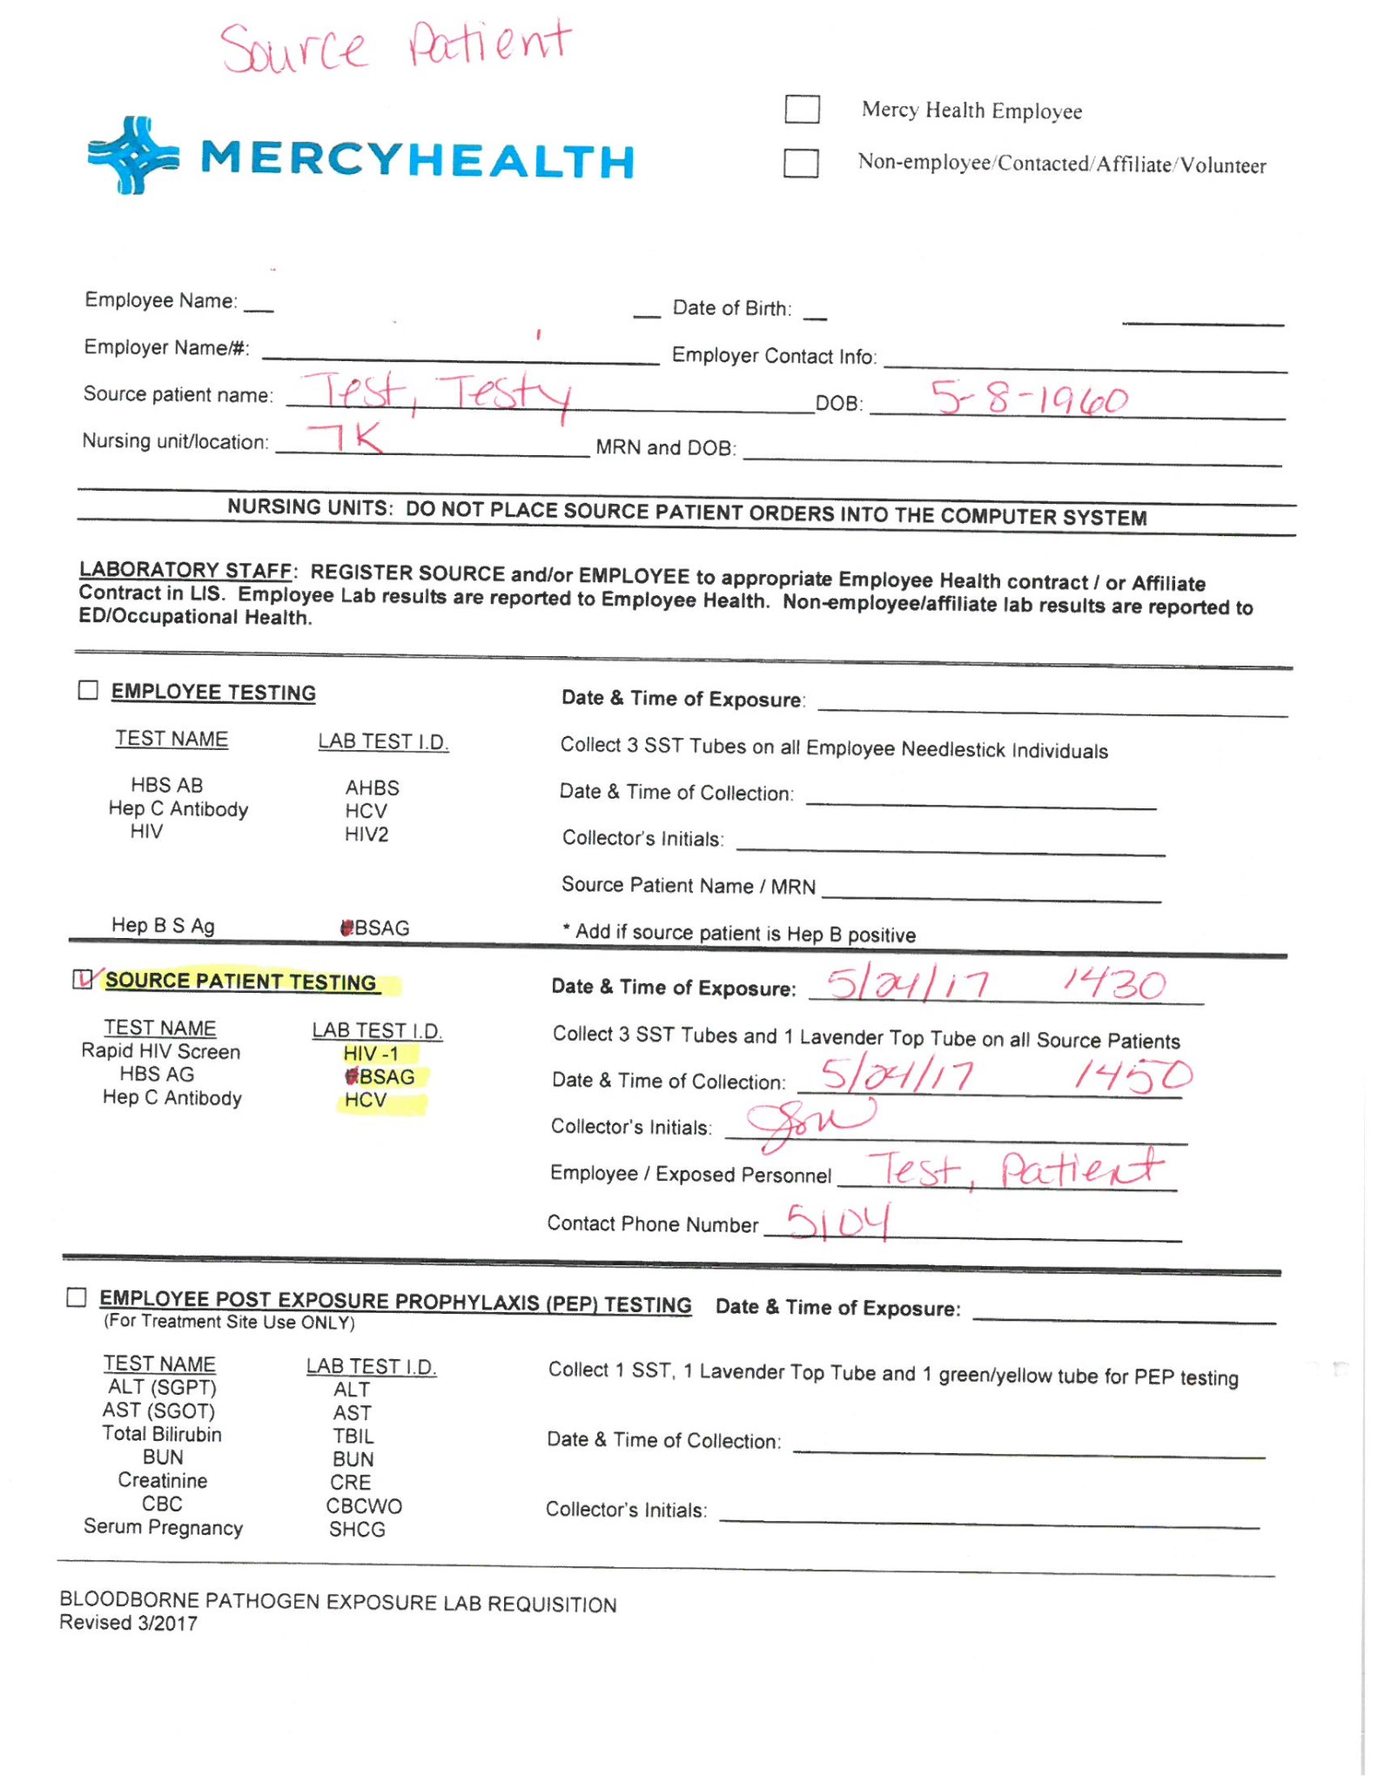

**Figure 2-Example of Source Patient Order**

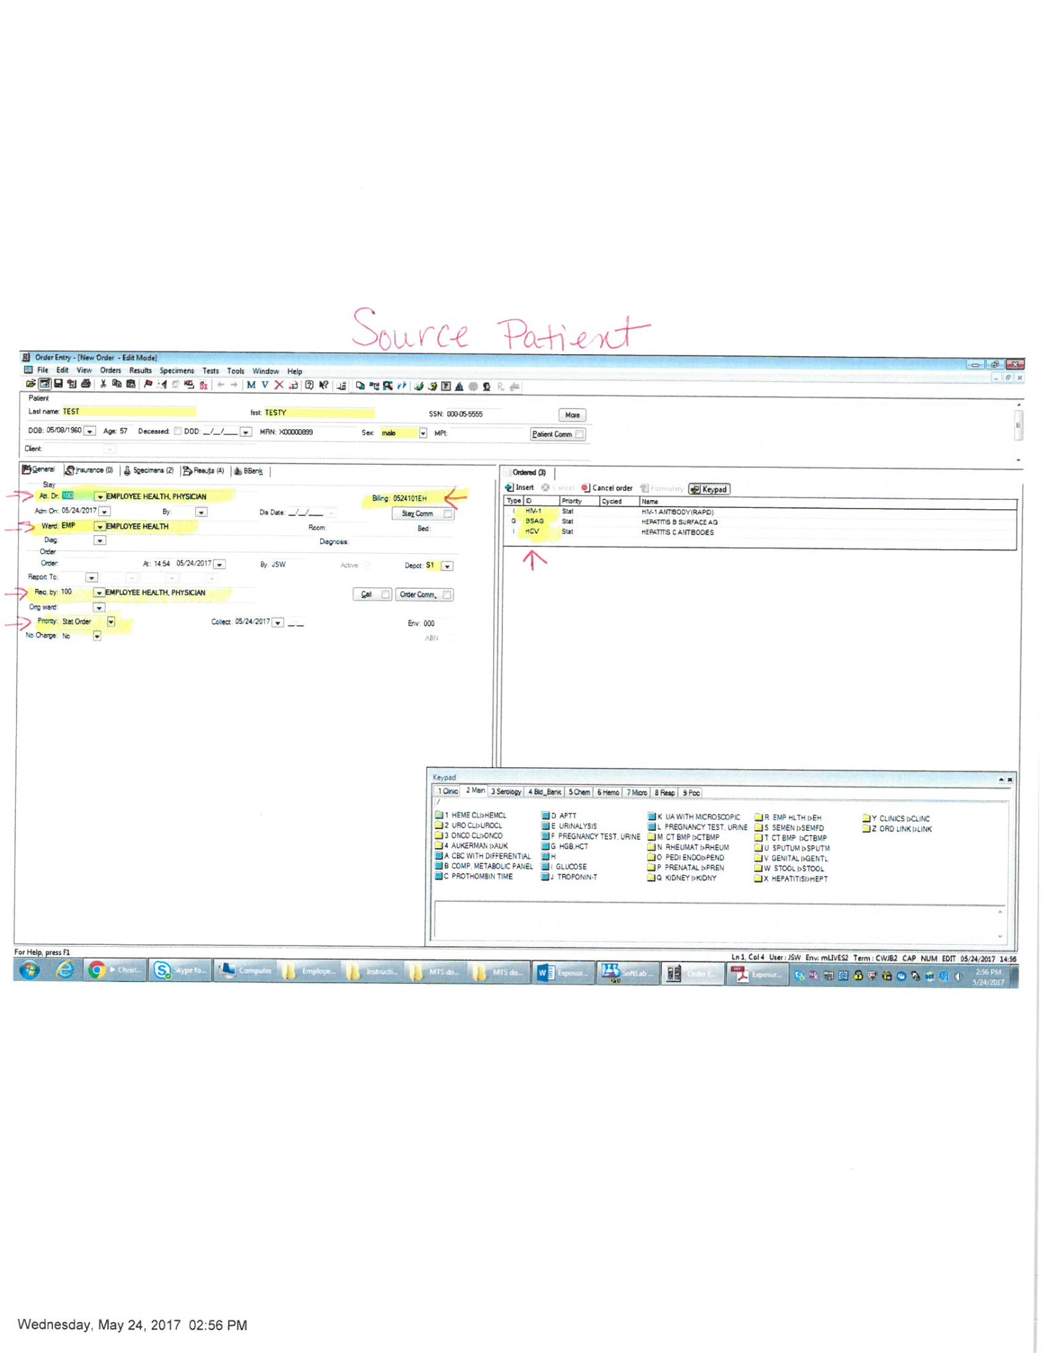

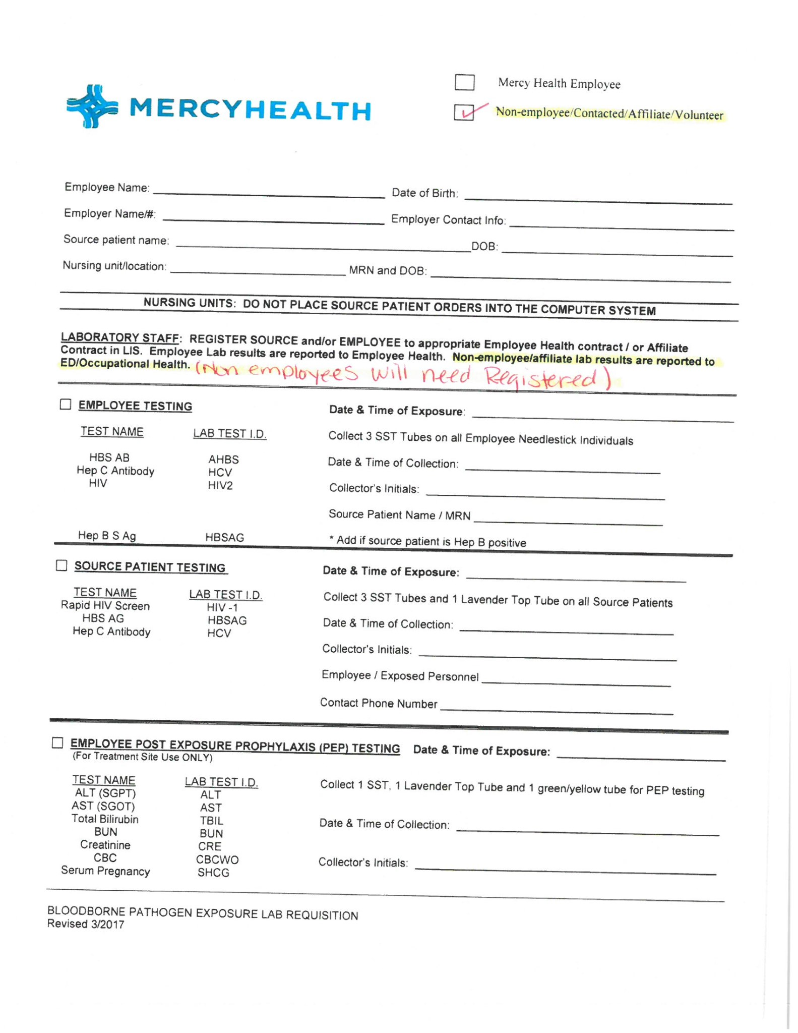

**Figure 3-Example order for Non-Employee Needlestick** Would need Registered**