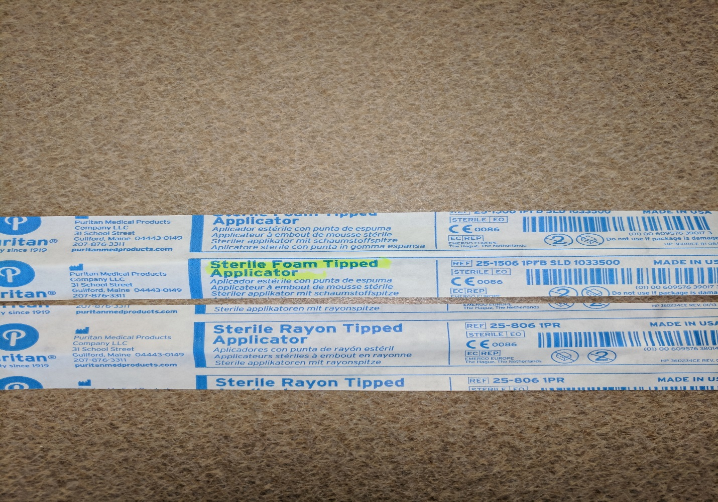

Please be very careful with these two swabs. Since the packaging is the same please double check that a **FOAM** swab is submitted for Flu testing. The rayon swabs are included in the Strep kits and are to be discarded upon opening the Strep kits.

Thank you!