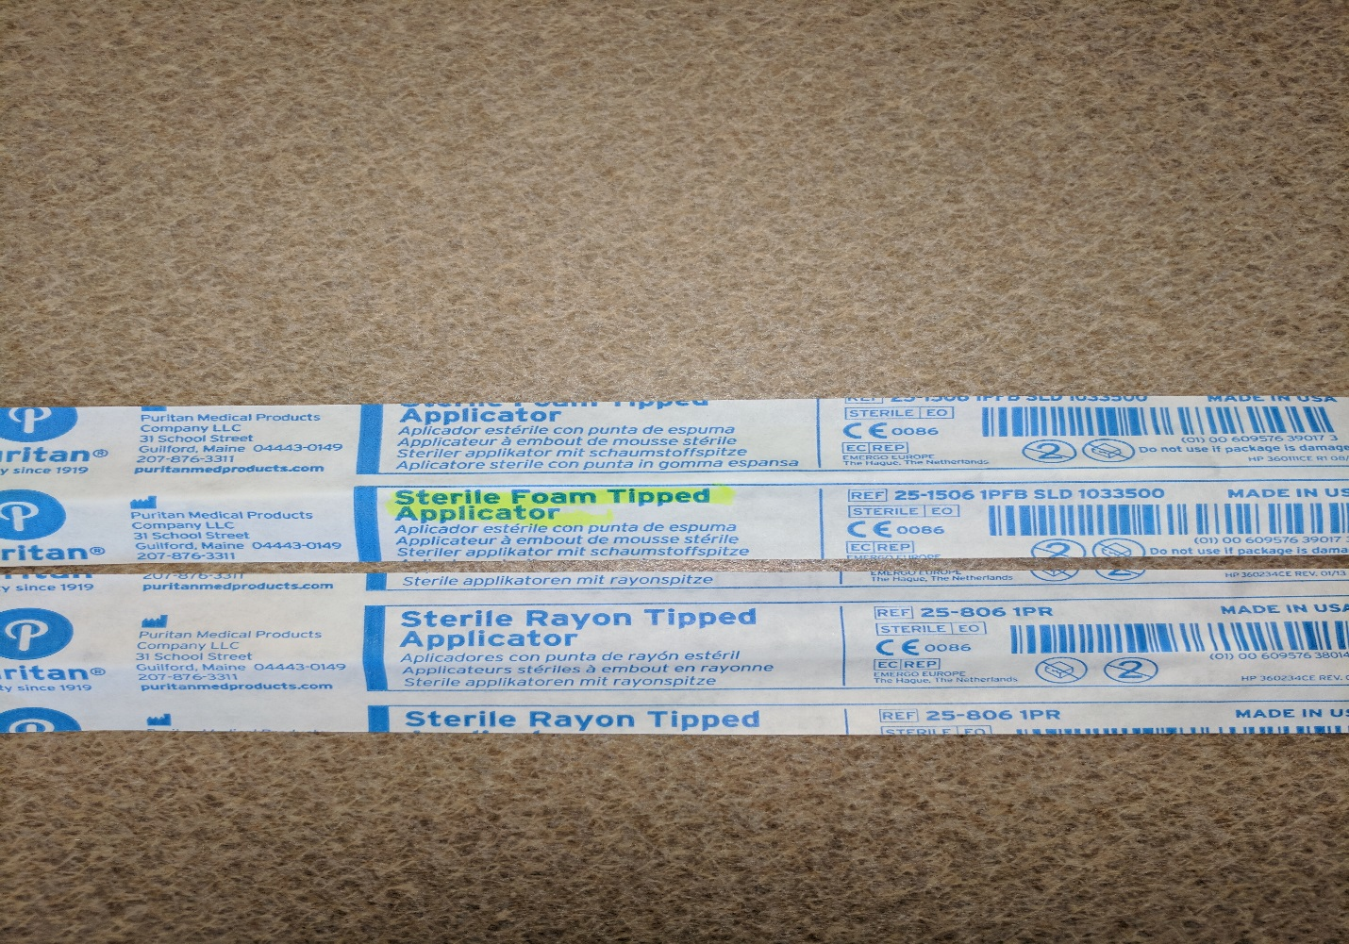

Please be very careful with these two swabs. Since the packaging is the same please double check that a **FOAM** swab is submitted for Flu testing. The rayon swabs are included in the Strep kits and are to be discarded upon opening the Strep kits. If a Rayon swab is submitted for FLU testing, please call the unit and ask for them to recollect the specimen with a **FOAM** swab. Rayon subs are not acceptable for FLU testing. **FOAM for FLU**.

Thank you!