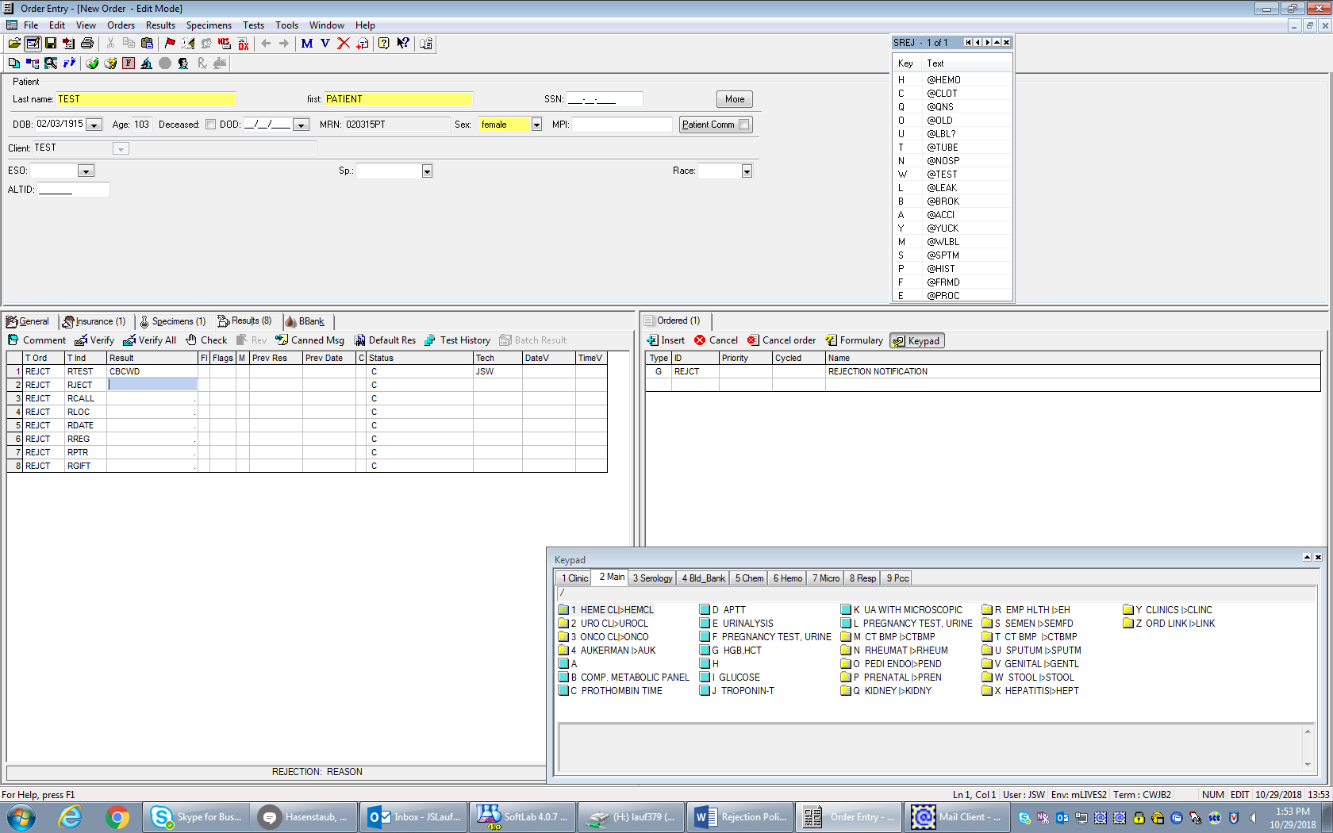

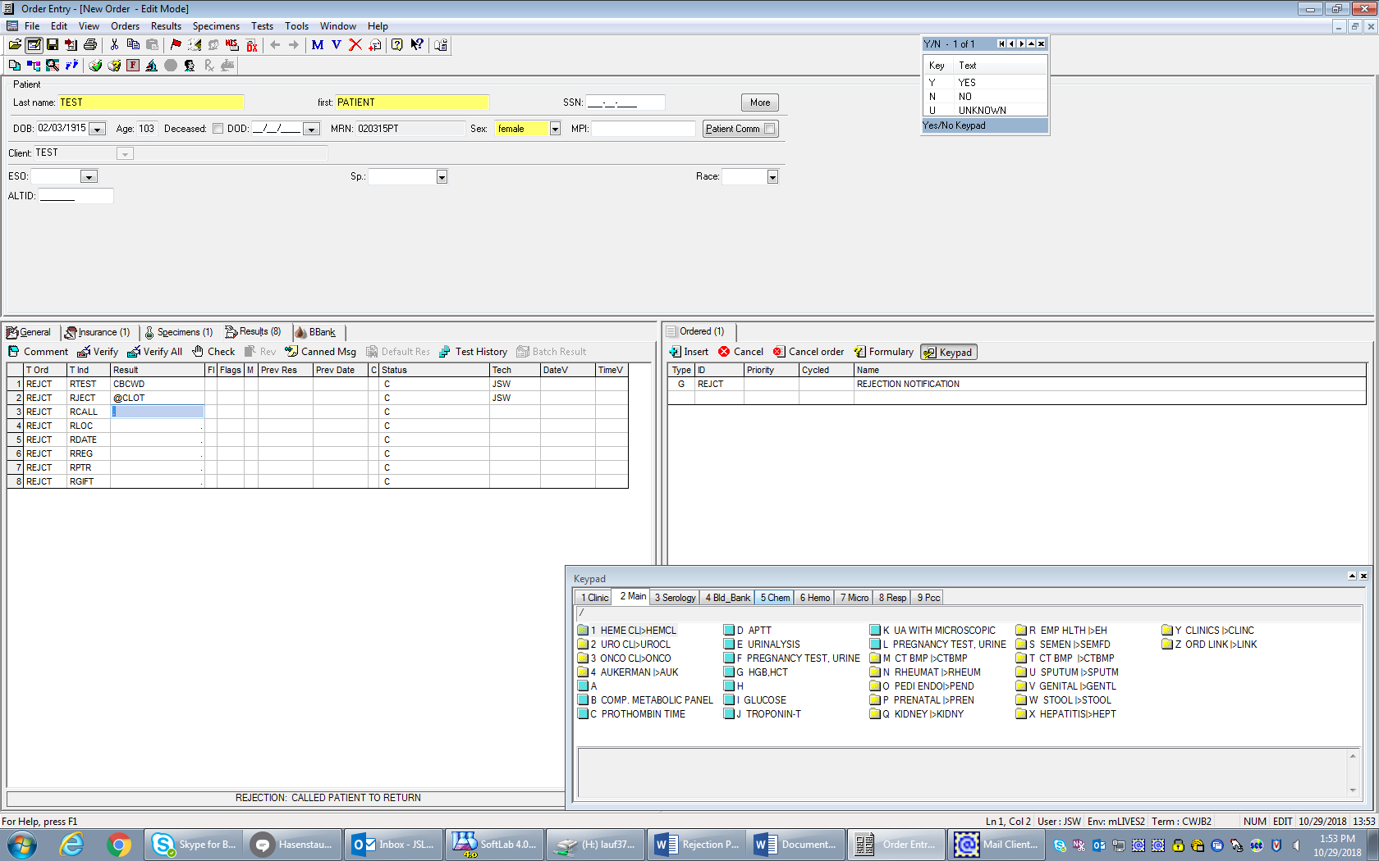

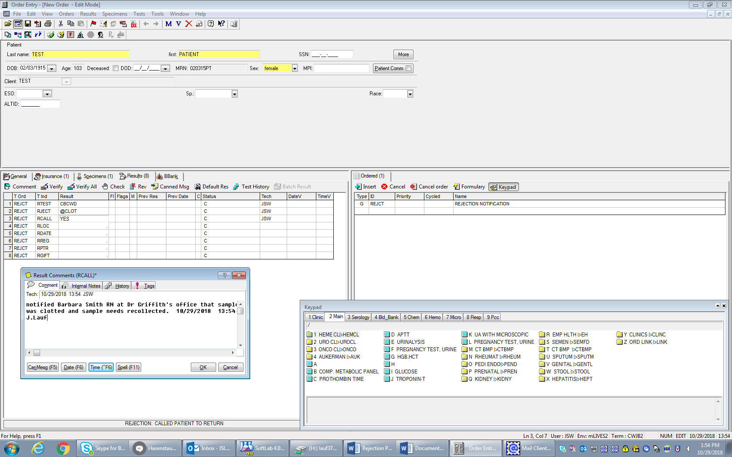

It is one reject test per tube rejected, no matter how many tests are ordered on that one tube.

If there needs to be a later reject on a sample # that already has one, then you must put the new reject test on a different sample #.

Place the original sample in the order comments for lookback purposes.