This procedure is electronically produced, revised, monitored, reviewed and/or retired. For a full document history of initiation, revisions, and reviews with electronic signatures and dates, please open document in the procedure publishing software.

SUBJECT: URINALYSIS (UA2, UAWM2, UR_CS) OPERATION OF ATLAS
AND AUWi

1. PRINCIPLE:

A routine urinalysis consists of a macroscopic analysis, chemical analysis, and, if indicated, a microscopic examination of urine. A freshly voided urine specimen is examined macroscopically for physical appearance, (color and clarity), as well as chemically. The chemical analysis is performed using a Clinitek Atlas reagent strip that is read optically by the Clinitek Atlas, a full automated reflectance spectrophotometer. The microscopic analysis is an assessment of the formed elements that may be present in the urine. An automated microscopic is performed on the UF-1000i and reported from this analyzer if no review criteria are present. If necessary, a manual microscopic is performed.
When combined with the Clinitek Atlas, the Clinitek AUWi (Automated Urinalysis Workcell) is a fully automated urine chemistry analyzer and a fully automated urine sediment analyzer. They system automatically routes samples from the Atlas to the UF 1000i via a sample transport assembly The AUWi coordinates the operation by using a dedicated computer with specialized rules-based software. The UF-1000i enumerates and identifies the cellular elements of the urine by use of fluorescent flow cytometer technology. The UF-1000i can classify 10 parameters (5 enumerated and 5 flagged). The enumerated are: RBC, WBC, epithelial cell, hyaline cast, and bacteria. The flagged are: Pathological casts, small round cells, yeast, crystals, and sperm.

2. CLINICAL SIGNIFICANCE:

The urinalysis is used as a screening tool to help detect several metabolic and kidney disorders. It is ordered to detect any abnormalities that require follow up. Often, protein or glucose will appear in the urine before patients are aware that they have a disorder. It is often used to detect urinary tract infections or other disorders of the urinary tract. In patients with acute or chronic conditions the UA may be ordered at intervals as a rapid method to monitor organ function, status and response to treatment.

3. SPECIMEN:

A. COLLECTION AND PROCESSING:

- First AM specimen is preferred.
- Optimal volume is 12 ml. 5 ml should be considered the absolute minimum for running the AUWI system.
If only running the Atlas – 2 ml is the absolute minimum. If running only the UF-1000i, 1 ml is the absolute minimum.
- If volume is <5 ml, attach the comment to the report: “Urine quantity less than recommended amount.”
- If volume is <1 ml and a microscopic is required, do not centrifuge. Attach the comment to the report: “Microscopic performed on uncentrifuged specimen.”
- For emergency room samples that do not initially require a culture and collected by catheterization, pour over into the urine culture vacuette. This will allow the sample to be good for a culture for 48 hours from collection.
- For Male Trichomonas Wet Prep(MTRIC) samples MUST be received within an hour. Testing is time sensitive as 20 % are lost after the first hour.

See supplemental patient information sheets for detailed collection instructions.

B. REJECTION:

The following samples should be avoided or rejected:
1. Visibly bloody samples
2. Mucoid samples. Mucous may clog the pipette and/or the flowcell
3. Bubbles or foam should be removed to avoid dispensing errors.
4. Specimens improperly labeled

NOTE: Manual microscopic examination should be performed on specimens that may block the aperture flow, clog the flowcell or any other type of problem specimen. Refer to the LIMITATIONS AND INTERFERING SUBSTANCES section for instructions on how to handle these abnormal specimens.

Rules are set up in the instrument to detect other abnormalities such as casts other than hyaline.

Refer to the AUW Track Instructions for Use for complete details.

C. STORAGE AND PRESERVATION:

Specimens should be tested within 2 hours if left at room temperature. If refrigerated, urines may be stored for up to 24 hours. Specimens which have been refrigerated should be warmed to room temperature prior to testing and testing must take place within 2 hours after being removed from refrigerator.

4. REAGENTS, STANDARDS, AND CONTROLS:

A. PREPARATION:

ATLAS 1. Reagents –
  - Clinitek Atlas Reagent Pak (Product Number 5017): Step-by-step instructions for loading and unloading the Clinitek Atlas Reagent Pak are given on the instrument’s screen display. The SG well must be cleaned each time a new reagent roll is loaded. If the lot number of the reagent roll is different from that previously entered, or if more than 24 hours have elapsed since the last calibration was performed, the instrument must also be calibrated. Testing of control specimens is required following calibration.
The reagent roll can be loaded by pressing “4” from the Main Menu. Follow the instructions on the instrument display to remove the old roll. Perform required cleaning procedures (stationary rod sleeve, readhead assembly and platform) and check the syringe to be sure it is tightly seated before loading the new reagent roll. Also remove, empty, rinse and replace the waste bottle and replace the old rinse solution with freshly prepared solution.
  - Clinitek Atlas Rinse Additive (Product Number 5007A): The Rinse Additive is added to distilled or deionized water to make the rinse solution used by the instrument to rinse the pipette tip and SG well. It is prepared by adding 2 mL of the Rinse Additive to 1000 mL distilled or deionized water. The instrument requires 1 liter per reagent roll. The solution is prepared fresh and replaced with every new reagent roll.
- Standards-
Clinitek Atlas Calibration Kit (Product Number 5018 A)
  - Contains four bottles (#1, #2, #3, and #4) of Calibrator Solution. Each bottle contains 230 mL.
  - Calibrator #4 (Clarity) is stored at room temperature.
  - Calibrators #1, #2, and #3 are refrigerated until use.
- Controls-
Refer to “Current Quality Control Materials-Urinalysis” for information on selection, preparation, and storage of QC material.

Reagents for the UF-1000i are as follows:
UFII SHEATH (20l) - part number 10378290
UFII PACK-SED(2.1L) – part number 10378291
UFII SEARCH-SED (25ML) – part number 10378292
UFII PACK-BAC (2.1L) – part number 10378293
UFII SEARCH-BAC (25ML) – part number 10378294
UFII Control (48 ml) Two Level (Lo/Hi) – part number 10378295 (must be stored 2-10C)
Lipless sample tubes – part number 088-0047-01
Reagent Grade Ethanol- Per Service Recommendation for daily UF cleaning.

B. CONTROL PROCEDURE:

- Controls must be run once per 24 hours.
- Control materials: Refer to “Current Quality Control Materials-Urinalysis” for information on selection, preparation, and storage of QC material.

5. EQUIPMENT:

A. INSTRUMENTS:

Clinitek Atlas, Clinitek Advantus, Sysmex UF-1000i

B. MICROSCOPIC EXAMINATIONS (AND REJECTIONS):

- All requests for a UAWM2 (urinalysis with microscopic) will have microscopic analysis routinely done.
- UA2 and UR_CS requests that meet certain criteria will have a UWMIC, URCS2, (urine microscopics) and/or CURR (urine culture) "reflexed" by the computer.
Criteria for Microscopic Analysis include:
  - Positive Protein
  - Positive Blood
  - Brown, Amber, Green, Red, Orange Urine
  - Positive Nitrite
  - Positive Leukocyte Esterase
  - Turbid or Cloudy Urine

6. PROCEDURE:

A. PERFORMANCE:

- Ensure that the reagents have not expired. If the reagent use life has been exceeded, the instrument will display a message saying “new reagent must be loaded”. The Analyze Mode will not begin until a new roll has been loaded.
- Allow the specimen to reach room temperature if it has been refrigerated. Mix the specimen thoroughly.
- Either a plastic urine tube or a yellow top BD tube may be used. You must have 5 ml to use the AUWi complete line system. Urine specimens that are visibly bloody or mucoid should not be analyzed on this instrument. Also, a large amount of foam on top of a specimen may cause inaccurate results or a dispensing error.
- Load the tubes of patient specimens into the racks. Be sure the barcode labels are placed vertically on the tube. A skew of greater than 5 degrees may result in reading problems. Each tube must be place in the rack so the bar code is facing the open side of the rack. Ensure that the tubes are properly seated.
NOTE: The analyzer will end the run if 10 consecutive empty positions are detected. Therefore, it is suggested that you always load tubes beginning with position 1 in each rack. This will ensure that no more than nine empty positions are detected consecutively.
- Place the racks onto the sample handler with the open side of the rack facing the back. Each side of the sample handler holds 11 racks; however, a rack jam will occur if you load more than 10 racks onto either side.
6. Push all racks to the right so they are aligned along the retaining rail.
7. If samples have not been analyzed within the previously ten minutes, the lamp will have a warm-up time of 45 seconds; the display will show the message “Optics Stabilizing” and a time bar will indicate the time remaining.
8. Press ANALYZE on the analyzer (ready for testing) screen. The screen shows a change in the softkey options.
From this next screen, you can analyze routine specimens, control specimens, or calibrate the analyzer. Press the appropriate softkey to select a function.
To analyze specimens, press the ROUTINE softkey and continue. Press run on the track, NOT on the Atlas to start.
Controls are barcoded and run as patients.
To calibrate, press CALIBRATE
9. The ROUTINE screen will show the strips remaining, the tray ID, the tube positions, specimen ID, results completed for the last specimen, first tube marked for review, and total number of tubes marked for review.
10. For each sample analysis:
a. The pipette moves to the appropriate tube and aspirates a small volume of sample.
b. The pipette moves into position above the first reagent pad and the rack moves to the next tube.
c. At a specific time in the timing cycle, the pipette dispenses urine onto each reagent pad and into the SC well.
d. The pipette dispenses the remaining sample into the rinse well followed by rinse solutions.
This rinses both the inside and the outside of the pipette.
e. The pipette returns to the SG well and dispenses rinse solution.
f. The pipette moves to the sample tray and the cycle begins again.
11. After testing is complete the instrument returns to the standby mode.

If running both the Atlas and the UF 1000:
- If running using the Atlas/AUWi track, you should have 5ml to allow for the proper mixing of the sample by the UF sample probe.
- Check to make sure that both the Atlas and the UF are ready. On the Atlas, the “Ready for Testing” screen should appear. There are 2 displays on the AUW track, one for the UF-1000 and Atlas sections respectively. They should say:

UF → READY | AT → READY
UFSU -→ READY | ATSU → READY

- Set the sample tubes in the sample racks.
- Place the rack in the sampler start rack pool of the of the Atlas sampler unit.
- Press the Start/Stop key on the track. Do not touch the rack once it is moving.
- If no flagging is present, the entire urinalysis and microscopic can be verified and reported. If the results need reviewed the following will be displayed: REVIEW If an error occurs that prevents accurate analysis a red ERROR box will be displayed. Clicking on the ERROR box will show what the error was.
The following indicators may appear after the data:
* Data is suspect and needs confirmation
+ Review – judgment limit exceeded
+ Negative limit exceeded
----- Data won’t appear due to analysis error or abnormal sample
----- Data won’t appear due to bacteria only order
++++ Data exceeds range
If flagging is present a manual microscopic must be performed. The flagged parameters are:
Crystals (X’tal)
Yeast (YLC)
Small round cells (SRC)
Path casts
Sperm
After specimen has completed cycling through the analyzers, further testing may be needed:
(Remember, the microscopic that is reflexed may be either the automated one or a manual one. The criteria indicating the need for a manual microscopy is listed above).
1. Positive results for bilirubin are confirmed using the Ictotest procedure.
2. Results of macroscopic analysis are posted.
  - UA2 and UR_CS requests: If any of the criteria for microscopic examination are present (outlined in Section B) the computer will reflex order a request for microscopic analysis (URCS2 or UWMIC). If no criteria for microscopic examination are present, the UA2 or UR_CS is complete and can be verified.
  - UAWM2 requests: microscopic analysis is automatically performed.
  - Criteria which reflexes a culture for UR_CS include:
    - Macroscopic: Positive Nitrite and/or Moderate or Large Leukocyte Esterase
    - Microscopic: Greater than 10 WBC/hpf, WBC’s in clumps, and/or moderate or many bacteria
3. Centrifuge specimens requiring manual microscopic analysis for 5 minutes at 1800rpm.
4. Decant the urine being sure to retain at least 1 ml of urine sediment.
- Add one drop Kova stain (Sternheimer-Malbin stain #87116) to the one ml of urine sediment. Mix stain with sediment.
- Place a small drop in the corner of a Kova Slide (disposable, standardized microscope slide) and examine microscopically:
  - Low Power (100x)
    - Scan approximately 10 fields for casts/field
    - Report number and type of casts seen using the computer keypad options. (Do not toggle off.)
      - First Keypad:
0 = none
1 = 0-4 4 = >15
2 = 4-8 5 = obscured
3 = 8-15

      - Second Keypad:
1 = Hyaline 4 = Fine Gran
2 = Waxy 5 = WBC
3 = C. gran
When answering Casts with "none" it is necessary to hit the Enter key after the zero to bypass the second keypad and advance to the next result entry area.

  - High Power (400x)
    - Count any formed elements that are present and report using the computer keypad options. (Do not toggle off.)

a) RBC
1 = 0-2 5 = 15-20 9 = >100
2 = 3-5 6 = 25-50 > = > 200
3 = 5-10 7 = 50-75 A = obscured

b) WBC
0 = none 4 = 10-15 8 = 75-100
1 = 0-2 5 = 15-20 9 = >100
2 = 2-4 6 = 25-50 > = >200
3 = 5-10 7 = 50-75 A = obscured

c) Epithelial Cells
0 = none 4 = 10-15 8 = >100
1 = 0-2 5 = 15-20 9 = >200
2 = 3-5 6 = 25-50 A = obscured
3 = 5-10 7 = 50-75

d) Bacteria
O = none
1 = Few (present, do not fill field, 10-25/hpf)
2 = Moderate (25-100/hpf)
3 = Many (field is full, >100/hpf)

e)Yeast - Indicate budding or pseudohyphae if present.
0 = none
1 = Few (1-10/hpf)
2 = Moderate (10-25/hpf)
3 = Many (>25/hpf)

- Miscellaneous elements are reported qualitatively. These elements include crystals, mucous, amorphous, fat bodies, Trichomonas and sperm. For Male Trichomonas Wet Prep(MTRIC) samples MUST be received within an hour. Testing is time sensitive as 20% are lost after the first hour. If not received within an hour, pour the urine into Aptima urine specimen transport tube. Order a “TRICV” and place in Reference/Sendout department.

- Refer to the microbiology procedure manual for directions on setting up urine cultures when indicated on UR_CS specimens.

B. INTERPRETATION OF RESULTS:

Macroscopic analysis should correlate to the microscopic results seen in the urine. Data correlation includes:
Macroscopic Microscopic
- Clarity - Turbid ⬆wbc's, rbc's, and/or amorphous
- Protein - Positive ⬆ rbc's, mucous and/or any casts
- Blood – Positive ⬆rbc’s, no rbc’s (lysis or myoglobin)
- Nitrite – Positive Bacteria, yeast
- Leukocytes – Positive WBC (neutrophils)

7. QC PERFORMANCE POLICY:

A. CALIBRATION AND CALIBRATION VERIFICATION

- Calibration
  - Calibration is required when a new reagent roll is loaded into the instrument (at least every 14 days). However, recalibration is NOT required if fewer than 24 hours have elapsed since the previous calibration AND it is the same lot number of reagent. Calibration may also be required following certain error conditions or repair/replacement procedures.
  - The instrument automatically prompts for calibration following replacement of reagents (if required); it can also be selected by the operator from the initial screen in the Analyze Mode, which is entered by pressing “ANALYZE” from the Standby Mode (“Ready for Testing” screen), then pressing the soft key option of “CALIBRATE”.
  - Follow the instrument instructions or refer to the operator’s manual
  - After all calibrators have been pipetted and while the instrument is analyzing the results, the display will show the message” Completing Calibration Process. Please wait.” Upon the successful completion of the Calibration Mode, the display changes to “Calibration Successful”.
- Calibration Verification:
A positive and negative control is run after the calibration.

B. FAILURE/REMEDIAL ACTION:

- If an error occurs during the Calibration Mode, an appropriate screen will be displayed. The problem, a brief description of the remedy, and in some cases an error number are displayed. Some errors require more than one screen to provide a complete description of the problem or the action needed. These screens will display a soft key of “MORE” that will move the display to the continuing information. The screens will also offer one or more soft keys in order to correct the error. Refer to Section 11, TROUBLESHOOTING/DIAGNOSTICS of the manufacturer’s operating manual for further information
- Failure to allow the calibrators to come to room temperature prior to use can cause calibration failure.
- Urinalysis quality control results are posted directly into the computer system. Pull results up through the interface menu. Once instrument and proper sequence are entered, press "shift +" to post results. There should be 10 results posted. Unacceptable QC results are posted along with corrective actions.
- If QC is out of range for one or more analytes and rerunning does not correct the problem, check the following possibilities in the order given:
  - The QC material was poured incorrectly. Repour and rerun.
  - The QC solution may have deteriorated. Open a new bottle and rerun the qc.
  - The existing calibration may be invalid because the room temperature has changed by more than 5°C since the last calibration. Recalibrate and rerun the qc.
  - The reagent roll has deteriorated. Load a new roll, calibrate, and rerun the qc.
  - The instrument is malfunctioning. Refer to the troubleshooting section of the manual or call Customer Service.

8. EXPECTED RESULTS:

A. REPORTABLE RANGE:

- Macroscopic Ranges:
  - Glucose: negative - >1000 mg/dl
  - Bilirubin: negative - large
  - Ketone: negative – large
  - Specific Gravity: <1.005 - >1.030
  - Hemoglobin (Bld): negative – large
  - pH: 5.0->9.0
  - Protein: negative - >300 mg/dl
  - Urobilinogen: 0.2-8.0 mg/dl
  - Nitrite: negative, positive
  - Leukocytes: negative – large
- Microscopic Ranges:
RBC : 1-5000/uL
WBC: 1-5000/uL
Epithelial Cells: 1-200/uL
Hyaline Cast: 0-30/uL
Bacteria: 1-10000/uL
.

B. REFERENCE RANGE:

- Macroscopic:
a) Color – Yellow/Straw g) Clarity - Clear
b) Glucose - Negative h) Bilirubin - Negative
c) Ketone - Negative i) Specific Gravity - 1.005-1.030
d) Blood - Negative j) pH - 5.0-9.0
e) Protein - Negative k) Urobilinogen - <1.0 mg/dl
f) Nitrite - Negative l) Leukocyte – Negative

- Microscopic:
a)RBC: 0-2/hpf
b)WBC: 0-4/hpf
c)Epithelial Cells: 3-5/hpf
d)Hyaline Casts: None Seen
e)Bacteria: Few or None Seen

C. CRITICALVALUES:

Strongly positive glucose values in conjunction with a positive ketone should be documented and called to the appropriate unit.

9. REPORTING RESULTS: Do not report patients if controls are not acceptable.

A. NORMAL VALUES:

- Patient results are posted to the worksheet through the computer interface, after which they are checked and verified.
- Patient microscopic results performed manually are entered using an option from the keypad that appears on the computer screen with each result entry field. Do not toggle off the keypad and manually enter results; this may result in tests not being reflexed properly. There is a "miscellaneous" result entry field available for results that are not commonly seen.

B. CRITICAL VALUES:

Strongly positive glucose values, (>=1000 mg/dL) in conjunction with a positive ketone are documented and called to the appropriate unit.

10. PROCEDURAL NOTES:

A. BACKUP FOR INOPERABLE SYSTEM

The Advantus may be used as backup. If all instruments are down, manual reading of the strips may be done. See separate procedures for detailed instructions. Any absurd results must be rerun by a backup method (ie. SG 1.000).

B. REFERAL OF SPECIMENS:

n/a

11. LIMITATIONS AND INTERFERING SUBSTANCES:

It is the responsibility of all urinalysis operators to recognize abnormal urine samples that do not meet criteria for automated urinalysis.

Turbid samples with too many red blood cells, white blood cells, bacteria or crystals cannot be reliably analyzed by automated instruments and require manual microscopic examination.

Loading unacceptable urine specimens on automated urinalysis systems can produce erroneous results, damage instrumentation, and leave subsequent specimens vulnerable to carryover.

Example images of common abnormal urine specimens can be found below the ‘REFERENCES’ section.

  - Common Abnormal Urine Specimens:
- Turbid Samples
- High Density Samples within pyuria
- Macroscopic hematuria samples
- Samples that consist of high concentration of small strands of mucus or debris
- Samples that include fluorescent matter due to inclusion of chemicals.
- Orange Specimens - See Orange Color Instructions Below

To process an abnormal urine specimen:

- Identify the abnormal urine specimen, and note its color and clarity.
- Centrifuge the unacceptable specimen in the urinalysis centrifuge for 5 minutes.
- After centrifugation, separate the supernatant liquid from the sediment by transferring the supernatant to a clean, appropriately labeled plastic tube. Clearly mark the tube as “SUPERNATANT.”
- Using only the supernatant, perform a dip stick chemical analysis. This can be done either by loading the single tube in to the “STAT position” on the Clinitek Atlas instrument; or by manually dipping a dip stick and using the Clinitek Advantus. Refer to the Advantus procedure for specific instructions.
- Post the results of the dip stick chemical analysis in the LIS, and make sure your noted color and clarity from step 1 are present and correct in the report.
- Perform a manual microscopic on the remaining sediment in the original tube and complete the urinalysis.

  - Optimal volume is 12 ml. 5ml should be considered the absolute minimum for running the AUWI system. If only running the Atlas – 2ml is the absolute minimum. If running only the UF-1000i, 1ml is the absolute minimum. If volume is <5ml, attach the comment to the report: “Urine quantity less than recommended amount.” If volume is <1ml and a microscopic is required, do not centrifuge. Attach the comment to the report: “Microscopic performed on uncentrifuged specimen.”

  - Do not toggle off when quantitating elements. Reflex tests may be missed if alternate values are entered.
  - Crystal identification may require polarization or the use of solvents.
  - Orange color
    - Report color and clarity.
    - Perform bilirubin by Ictotest. Report these results.
    - All other results are reported as "Unable to assay due to color” @UCO on keypad.

12. METHOD VALIDATION:
- New lot numbers of reagents and controls must have their results validated. They are to be compared with the current lot numbers that are in use.
- Results of the comparison must be recorded on the reagent lot verification sheet located in the urinalysis maintenance book.
- Unacceptable results should be taken to the technical specialist

Limitations of Bayer Urinalysis Reagent strips: Supplemental Information
Assay | False Positive/Increase | False Negative/Decrease
Glucose | - Vaginal Powders | - Ascorbic Acid (50 mg/dl)  - Levadopa  - Increased specific Gravity  - Increased bacterial growth
Bilirubin | - Metabolites of Iodine and Indican cause interference | - Ascorbic Acid (25 mg/dl)  - Metabolites of Iodine and Indican cause interference
Ketones | - Increased urine pigment  - Increased conc. of Levadopa metabolites  - Compounds with sulfhydral groups
Specific Gravity | - Increased protein conc.  - Increased glucose conc. | - Increased pH may cause a false decrease in comparison with the refractometer.
Blood | - Oxidizing contaminants (bleach)  - Microbial peroxidases associated with UTI | - Increased Specific gravity  - Capoten
pH |  | - “Run over” of the acid buffer of the protein reagent onto the pH pad
Protein | - Increased pH  - Quaternary ammonium compounds (detergents)  - Skin cleaners
Urobilinogen | - Increased reaction temperature  - Sulphonimides | - Formalin (formaldehyde)  - Chloramphenical
Nitrite |  | - Increased specific gravity  - Ascorbic acid (25mg/dl)
Leukocyte Esterase | - Contamination with vaginal discharge | - Increased glucose (3g/dl)  - Increased specific gravity  - Cephalothin  - Tetracycline  - WBCs are not segs.

13. REFERENCES:

- Graff, Sister Laurine; A Handbook of Routine Urinalysis; J.B. Lippencott Co.Phil 1983.
- Wallach MD, Jacques; Interpretation of Pediatric Tests 1st ed, pgs 635-639, Little,Brown and Co; Boston 1983
- HYCOR Biomedical Inc/Irvine Ca; Kova System for Standardized Urinalysis; Rev 6-93 P/N 91062RQ.
- Bayer Corporation/Elkhart, Ind; Bayer Multistix 10 SG Tests for Glucose, Bilirubin Ketone, Specific gravity, Blood, pH, Protein, Urobilinogen, Nitrite and Leukocytes in Urines, AN 30516C,Rev 4/99USA.
- Bayer Corporation/Tarrytown, NY; Clintek Atlas Automated Urine Chemistry Analyzer Operating Manual, Revised 9/01.
- Murray, Patrick R.; Manual of Clinical Microbiology; 7th ed, pg 75, American Society for Microbiology; Washington D.C. 1999.
- G. Clinitek Atlas Operating Manual, REF 074D0035-01
- H. UF-100i Quick Guide, Document Number MKT-70-1091, Rev. 1.0
  - UF-1000i Instruction for Use, Code Number 461-2535-0, May 2007
- J. AUWI Track Instructions for Use, Code Number AG308604, May 2008
- K. Schumann, GB, Friedman SK : Specimen collection, preservation and transportation. In Wet urinalysis, Chicago, 2003, ASCP Press
- L. Becton Dickinson VACUTAINER Systems: Understanding additives: urine preservatives. In Lab notes- a newsletter from Becton DIckinson VACUTAINER Systems, Vol 4 NO 2 Franklin Lakes, NJ, 1993, Becton DIckinson VACUTAINER Systems.
- Clinical and Laboratory Standards Institute (formerly NCCLS). Urinalysis; Approved Guideline – 3rd Edition; Approved Guideline. NCCLS document GP16-A3, Vol. 29, No. 4, 2009.
- Heilman MD, James. Hematuria, (Figure 2.0) Digital image. 1 Jan. 2016. Web. 6 Feb. 2019.
- Heilman MD, James. Pyuria. (Figure 1.0) Digital image. 1 Jan. 2011. Web. 6 Feb. 2019.

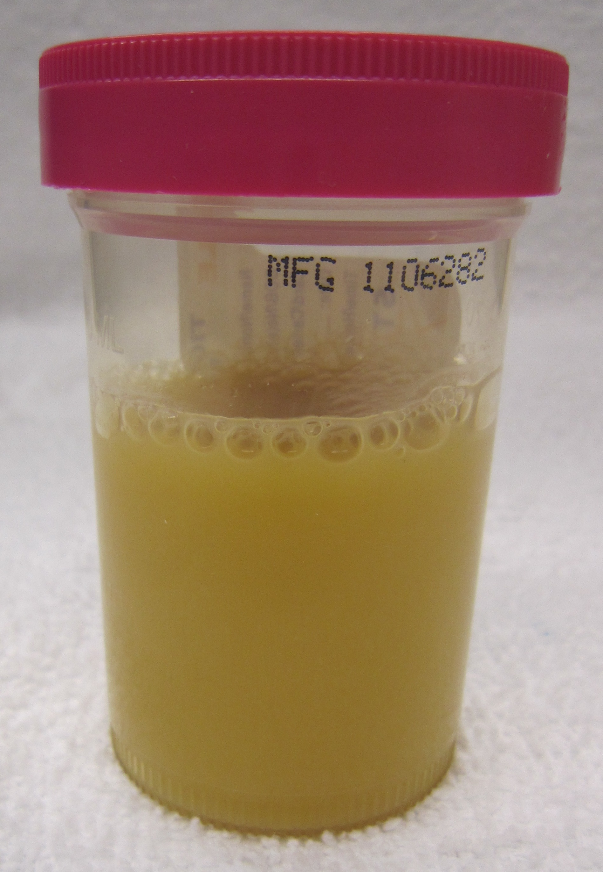
Figure 1.0 - Turbid urine specimen from a patient with pyuria.

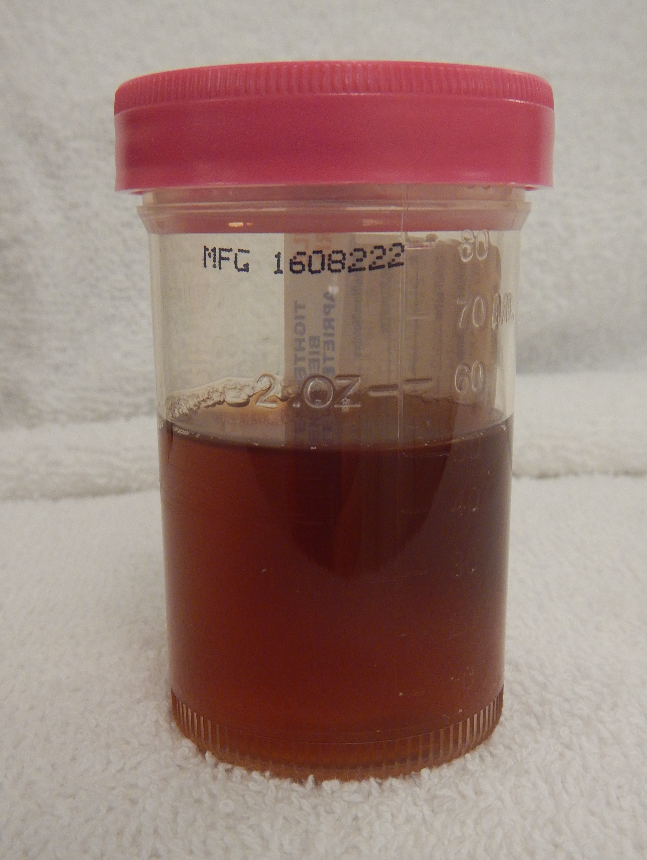
Figure 2.0 - Bloody urine specimen from a patient with hematuria.

Policy Approval

Elsa Malcolm, MD
Hematology Section Director
4/09/2019

Samuel Ware, MLS (ASCP)
Technical Specialist
4/09/2019

