**How to Handle Positive *Campylobacter* / *Cryptosporidium* Results**

Due to a product recall for non-specific DNA amplification in our gastrointestinal panels by PCR, all *Campylobacter* and *Cryptosporidium* positives require confirmation testing. **DO NOT REPORT CAMPY OR CRYPTO AS** ‘**Detected’** in the LIS.

If you perform a GI Panel by PCR that comes up **positive** for Campylobacter or Cryptosporidium, please follow these steps.

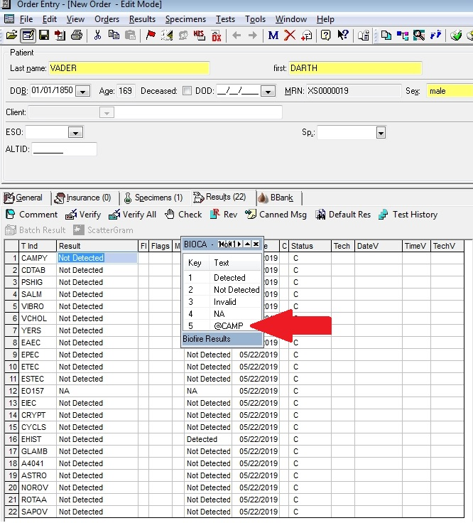1.Select “@CAMP” option for positive Campylobacter results, or “@CRYP “ option for positive Cryptosporidium. You may now verify the results.

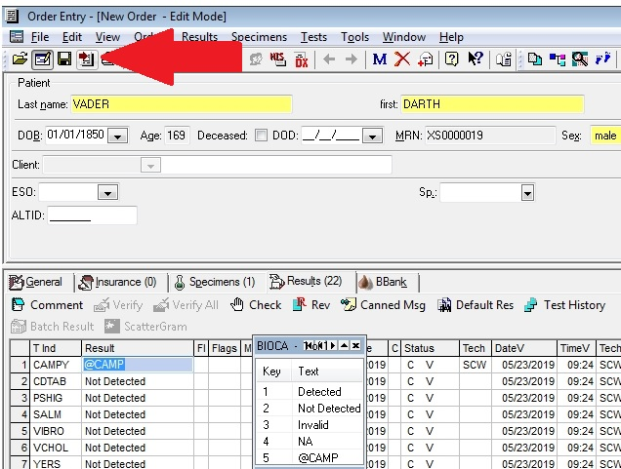

2. Create a new order.

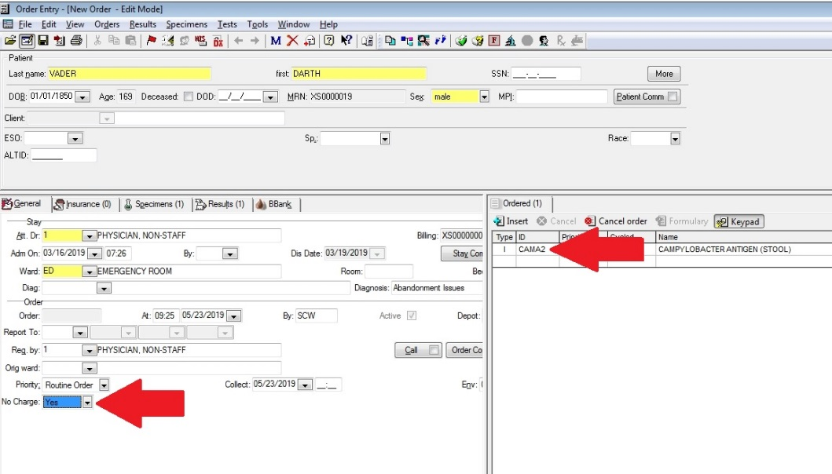 3. Order “ **CAMA2** “ for Campylobacter

Order “ **CRYP2** “ for Cryptosporidium

**Make it a No Charge**

***Campylobacter*** confirmatories may be sent to ARUP in Green Top Cary Blair Media. Stability is 4 days **refrigerated**.

ARUP 0058002

***Cryptosporidium*** confirmatories require raw stool to be sent unpreserved and **frozen**. Transfer raw stool to a White Top Para-Pak Clean Vial and **freeze** immediately. (Must have been kept refrigerated and frozen within 24 hours of collection).

ARUP 0060045

Please notify SCW if a GI panel has come up positive for Cryptosporidium or Campylobacter. Thank you.