**Attention Biofire Operators:**

Confirmatory testing for *Campylobacter* and *Cryptosporidium* is NO LONGER REQUIRED effective 6/26/2019.

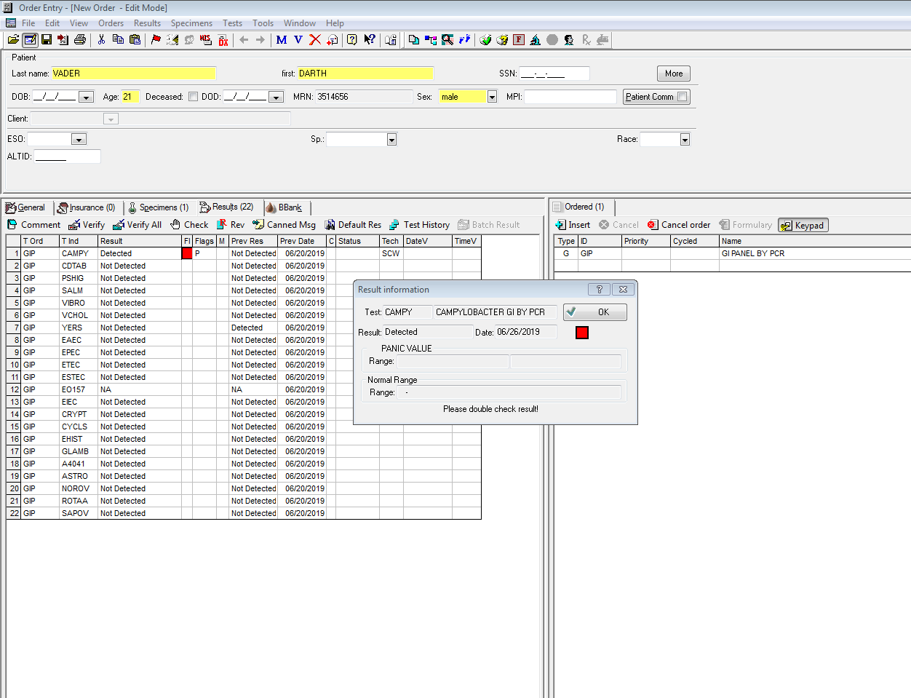You may simply report as “Detected” or “Not Detected” again.

**Note:**

**No** increased rate of false positive *Campylobacter* / *Cryptosporidium* results were found on our BioFire FilmArray 2.0 System. An increased incidence of non-specific chemistry interactions in BioFire GI Panels performed on the *BioFire Torch System* led to a recall affecting all GI Panel users.

Sam W 6.26.19 .Version 1.0