Clinicians may now request a Path. Review by ordering “**SMREV”** – “BLOOD SMEAR REVIEW” in the LIS. When you encounter an SMREV order, simply place the patient’s most recent order for path review.

* If there is a CBC ordered at the same time, the LIS should place it on the same sample number.
* If it is ordered as an ADD ON, it should print on data’s designated Add-On label printer and be brought to the hematology operator.
* The clinician will place comments as to what they want reviewed, and those comments will be viewable in the LIS’ “ORDER COMMENTS.”
* “SMREV” will now appear on the hematology pending list; so if you miss the order on the label, you will still catch it on the pending list.
* SMREV is not a *duplicate* of a path review. If a specimen is already being path reviewed, you do not need to cancel the SMREV request.

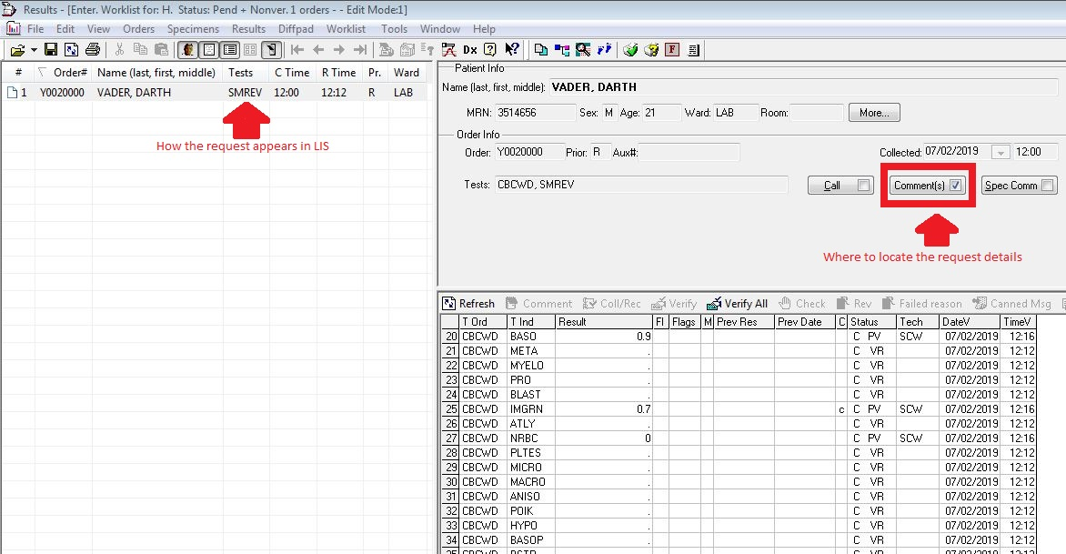Sam W 7.2.19 .Version 1.0