**Patient admission dates must be checked before performing a GIP on an inpatient**

1. **Use Order Entry to view GIP orders before performing**

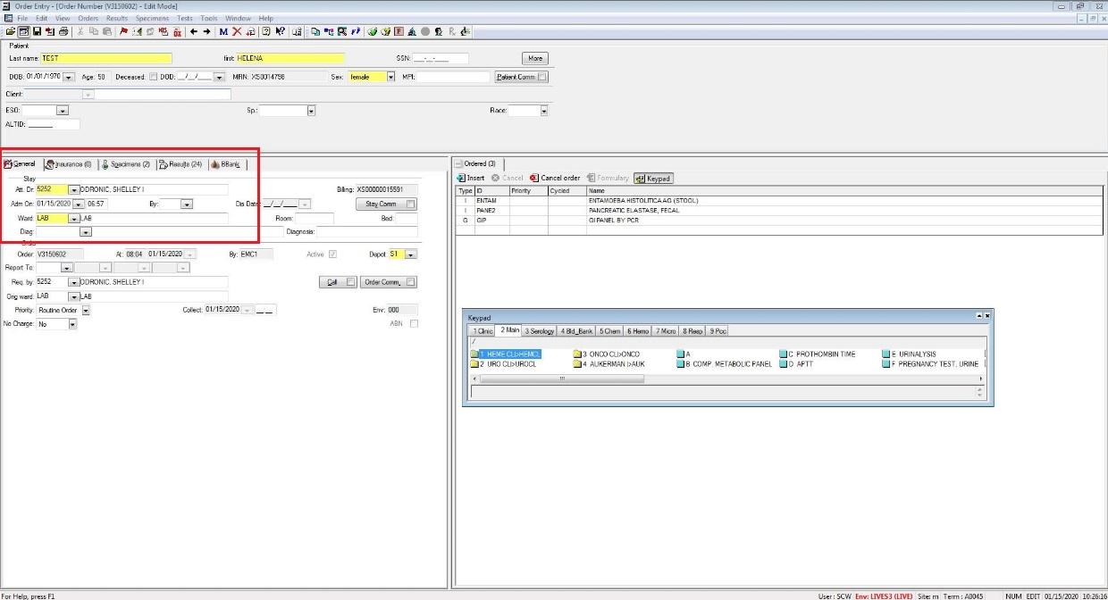

1. **Cancel the GIP and order a REJCT if >72 hrs since admission**

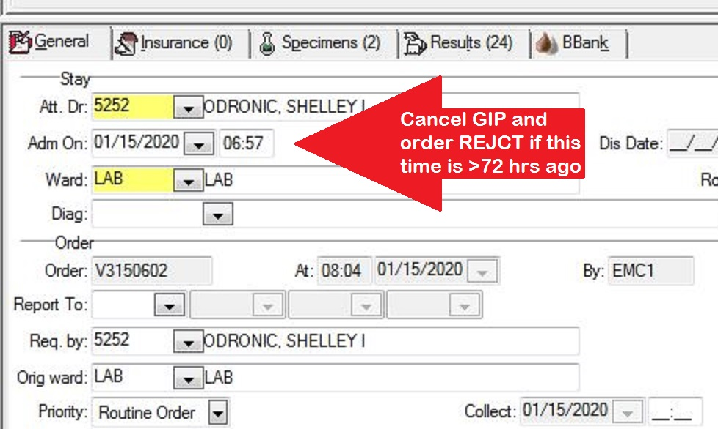

1. **In addition, the following report will now print at 04:35am on the chemistry printer if any GIPs have been ordered >72 hrs after a patient admission.**

**If you find this report on the printer, you must pull up the orders in question and cancel them, order a REJCT.**

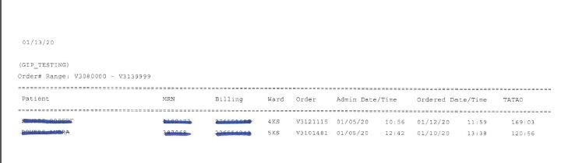

1. **You may answer the REJCT with the @HIST option**

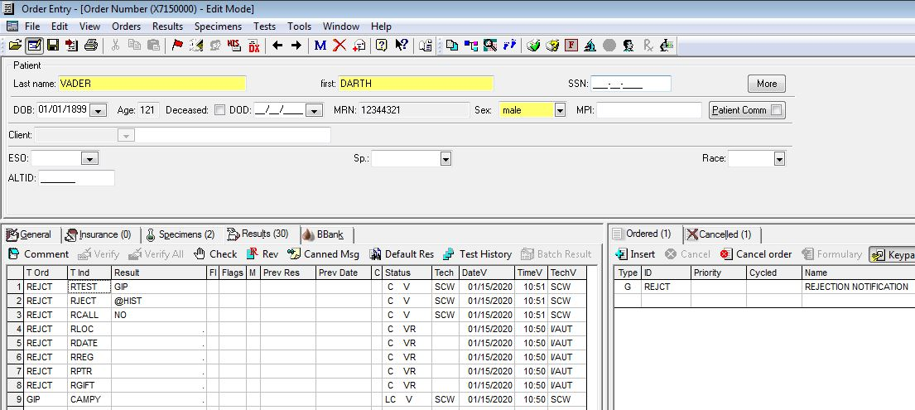

***If there is a clinical need to perform the panel greater than 3 days after admission, it will require pathologist approval.***