# BIOFIRE RECALL:

# DO NOT report Proteus on Anaerobic Blood Culture Bottles!

BioFire Diagnostics, LLC (BioFire) has issued a product recall after identifying elevated rates of false-positive results for *Proteus*, specifically from Anaerobic BACT/ALERT® bottles, while using the BioFire Blood Culture ID panel by PCR. The most probable cause for this risk is the presence of an increased level of nucleic acid from non-viable *Proteus* spp. bacteria in BACT/ALERT® blood culture bottles.

# What do I need to do?

Continue to report BIPs as usual, unless you detect ***Proteus*** on an **Anaerobic** bottle:

1. If you do, when you go to enter results, close the keypad that pops up

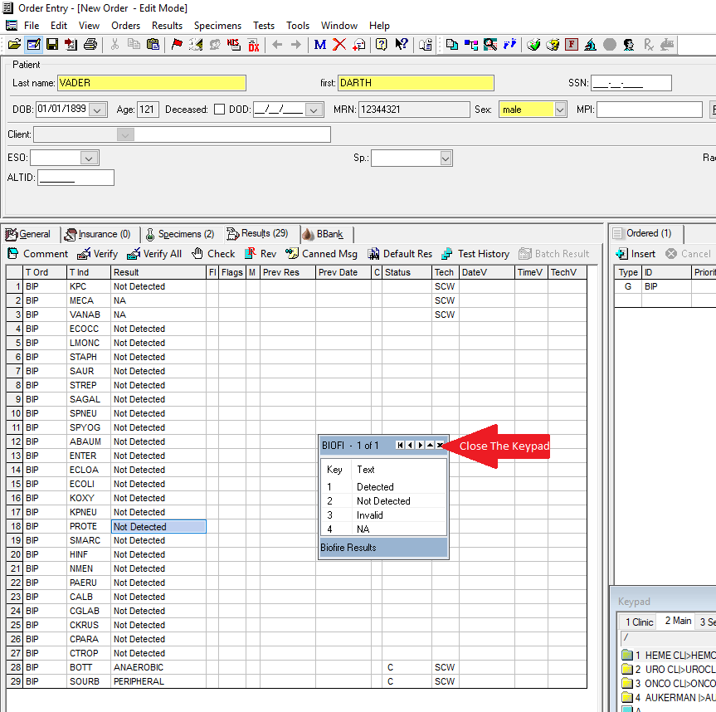

1. Delete the defaulted result, and manually type @SEE

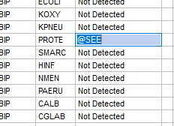

1. Press the \ key on your keyboard, located below the backspace key, to bring up the manual comment window. Manually type in the following comment:  
   Proteus testing is performed on culture. See separate culture report.

and click OK

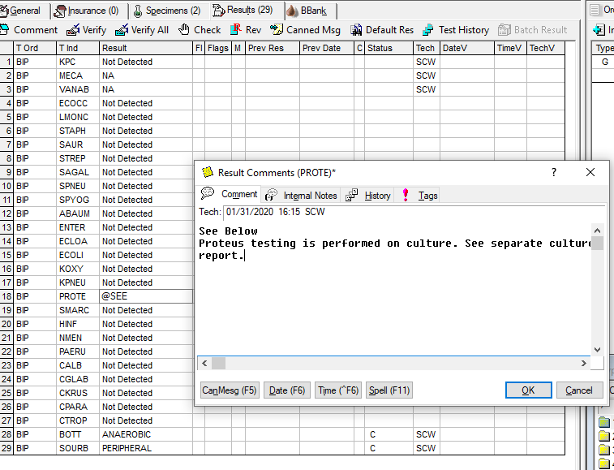4. 4. You may now verify this result.

5. DO NOT FAX INSTRUMENT PRINT OUT TO PHARMACY, instead print the instant report from LIS and fax that report to pharmacy.