# How to Use the Biofire Interface



1. When the run is complete, the Biofire will still print the results.  
   Open the interface (pictured below), and match the paper printout with the result in the interface, using 2 identifiers.  
   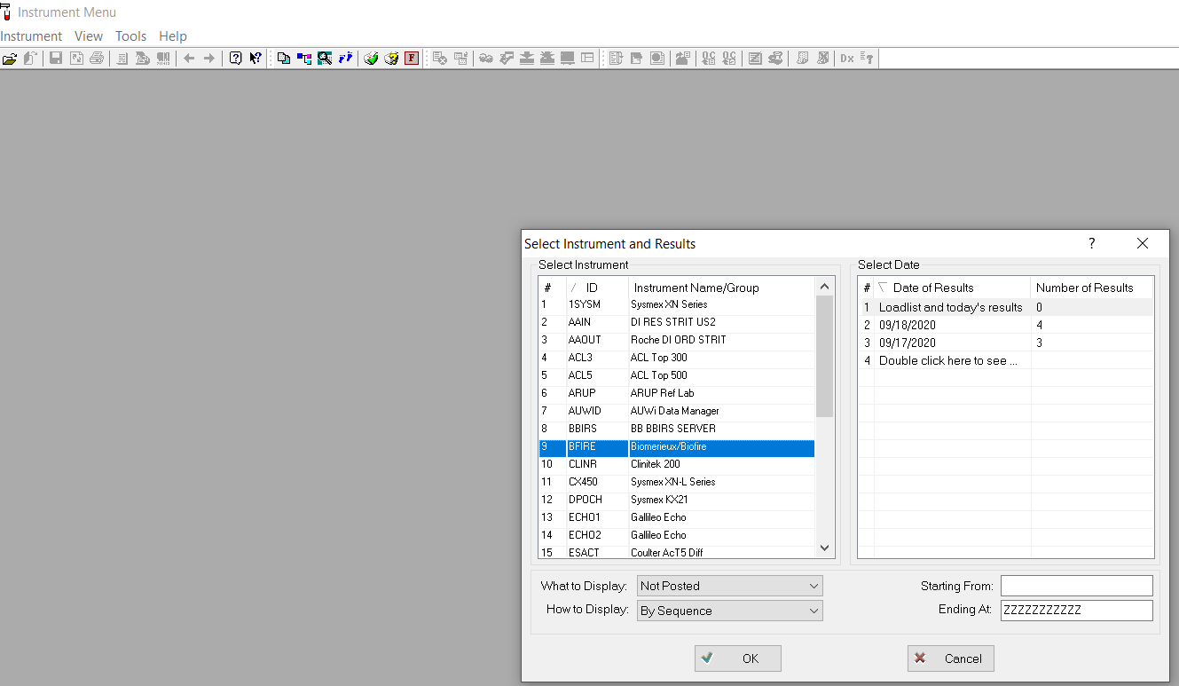

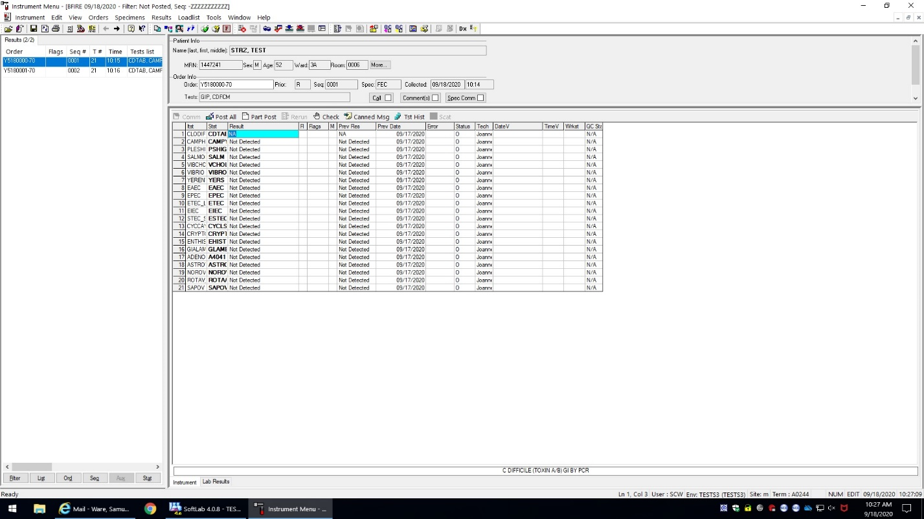

1. *POST* results, using the [ Alt ] + [ \ ] keybind, as you would from the AUWI. Do not verify results directly from the interface.  
     
   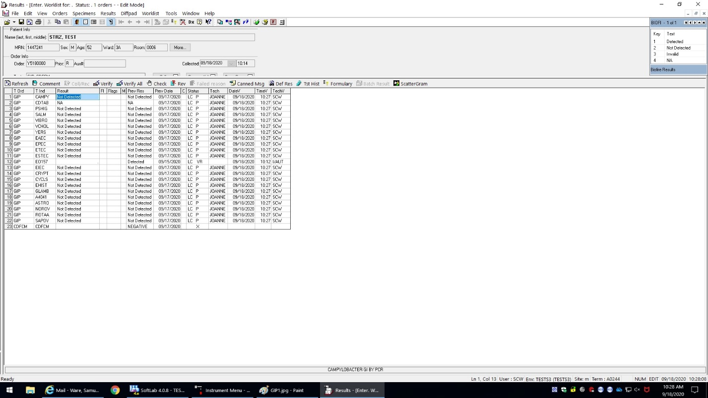
2. Once the results are posted to the order, verify their accuracy by comparing to the print-out, complete any pending portions of the order (such as Bottle Type for BIP, Specimen Type for PNIP), then *VERIFY ALL*.

Note that some fields may now be default answered with a period to ensure smooth reporting, such as EO157 in the image above.