After opening, mark the shortened expiration date on the item
XN Check | 7 days
XN Check BF | 30 days
PFA test pouches | 30 days
CellChex (Hemacytometer QC) | 30 days
Sickle Screen QC | Stable to printed expiration date

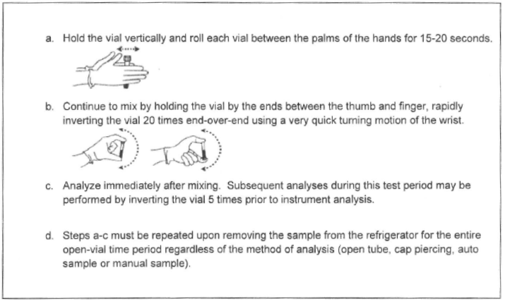
Sysmex QC should sit at room temperature for 15 prior to analysis. Follow instructions below after vials equilibrated to room temperature.

