**What is it?**

* The test code ‘UNFRA’ in Softlab is the Anti-Xa test, used for monitoring unfractionated heparin therapy.
* Pharmacy’s goal for most patients receiving heparin therapy will be to achieve levels of **0.3** to **0.7** IU/mL.   
  (Patients in this therapeutic range would historically show high aPTT values, of 60-95 seconds).
* Patients not on heparin, who would historically show normal aPTT values of 22-38 seconds, will likely yield a result of <0.04 IU/mL (no heparin present).

**Why are we switching?**

The aPTT test only measures the intrinsic coagulation pathway, as it is altered by heparin.

The Anti-Xa test *directly* measures the level of heparin, providing pharmacy better information to improve patient care.

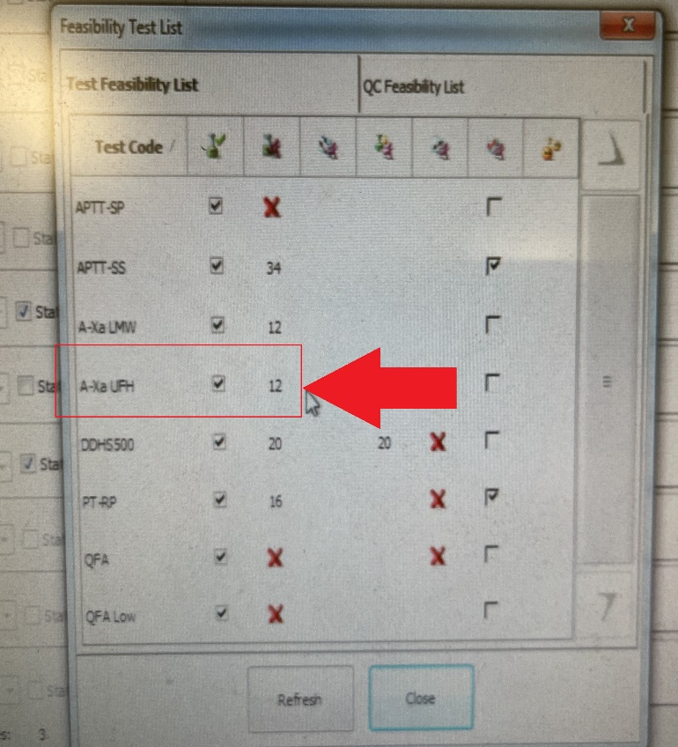**What do I need to do?**

-Run UNFRA QC at start of shift

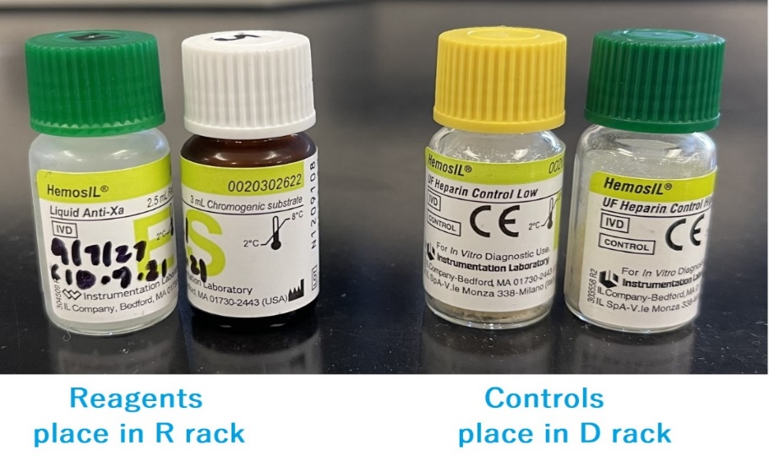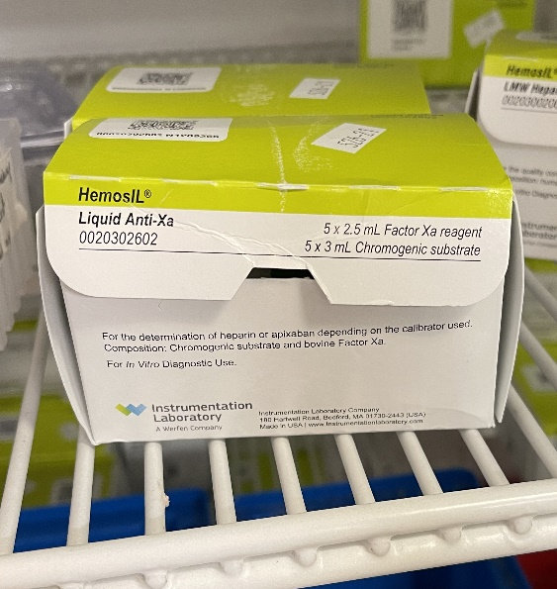-Keep Anti-Xa reagents onboard the ACL TOP.  
-Reagent set has 2 vials, found in box in heme fridge  
-Gently mix before loading. Stable 5 days onboard.

**-**Like all other Coag reagents: run QC at start of shift, and if new vials are loaded

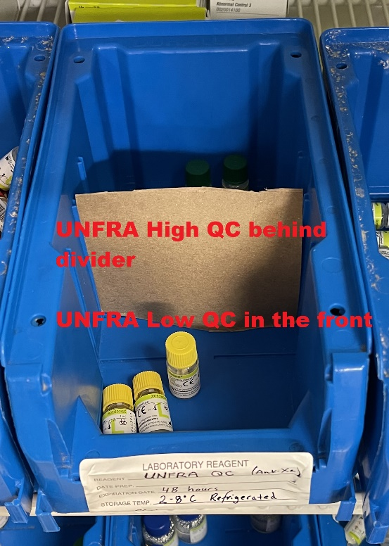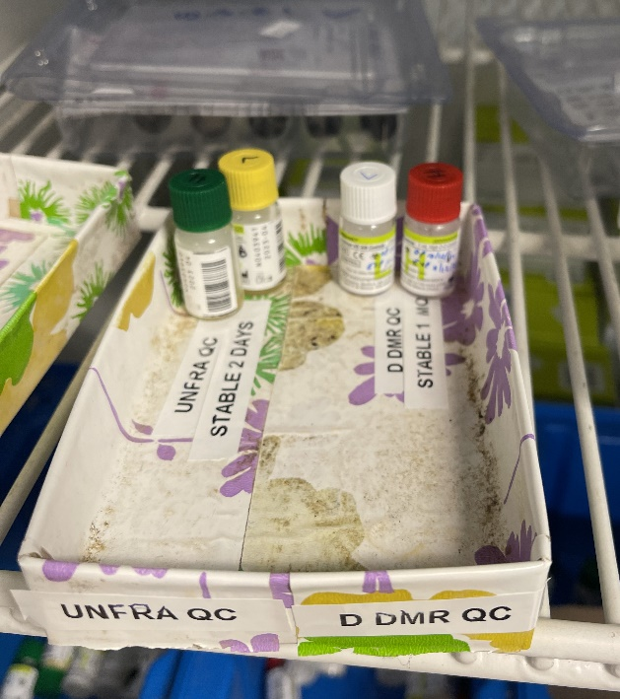-QC made up by dayshift and ready to go, kept with D-Dimer QC in fridge when not in use.

-QC is only stable for 2 days.

-New QC vials found in blue bin  
 if needed

-QC vials require constitution

with 1mL of reagent H2O, just like  
 daily normal and abnormal QC.

**What else do I need to know?**

* Anti-Xa has a shorter stability than aPTT – only 2 hours. Avoid add-ons >2 hours.
* Anti-Xa is a *chromogenic* (color-based) test. As such, GROSSLY hemolyzed specimens with >300mg/dL hemoglobin should be rejected and recollected. 300mg/dL hemoglobin is equivalent to “H-300” in Roche Specimen Indices, a dark cherry red color.
* Like aPTT, patients with very high results should be called to floor as critical.   
  Corresponding UNFRA **critical high** result is **>1.0** IU/mL and will be flagged in LIS
* Anti-Xa is linear from 0.04 – 2.0 IU/mL.

-Report results less than 0.04 IU/mL as “<0.04”

-Report results greater than 2.0 IU/mL as “>2.0”

* While we expect to see UNFRA orders daily, the other orderable Anti-Xa test “LMWH” will remain rarely ordered. LMWH uses the same reagents, but the LMWH specific controls should be run when an LMWH is ordered. LMWH QC may be found in the heme fridge. You do not need to run LMWH QC every shift.
* The full policy for Anti-Xa is available in the binder on the bench, or on the G:Drive in pol app / SRMC / Technical / Hematology / nvml.hem.006c