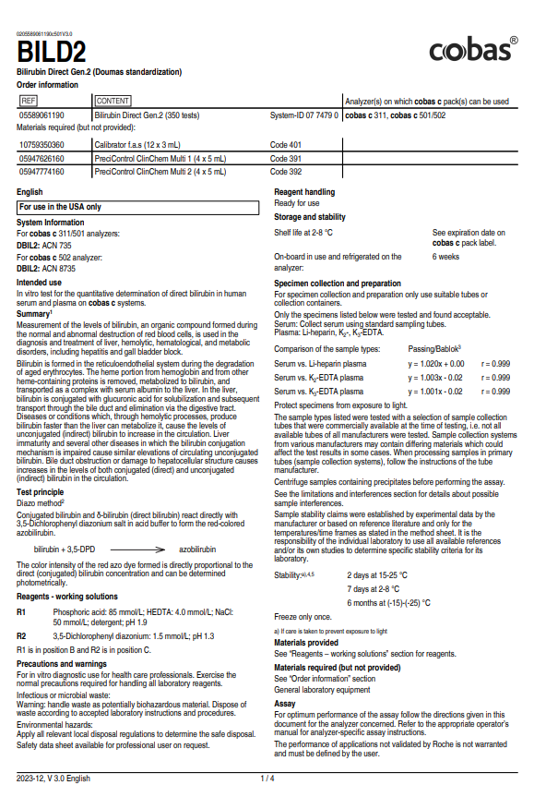
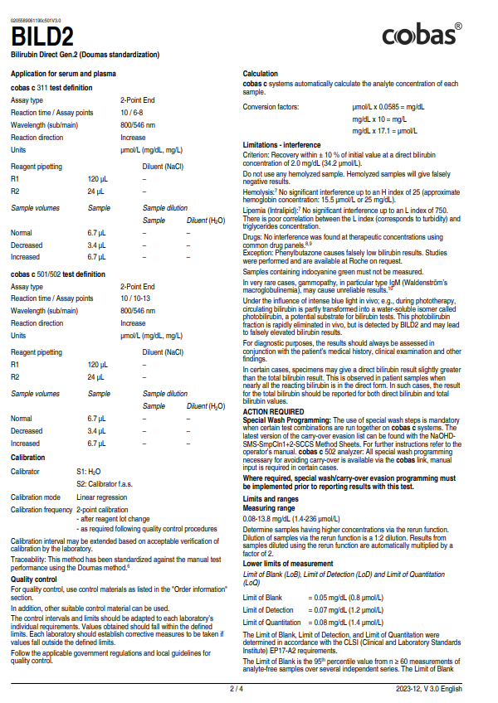
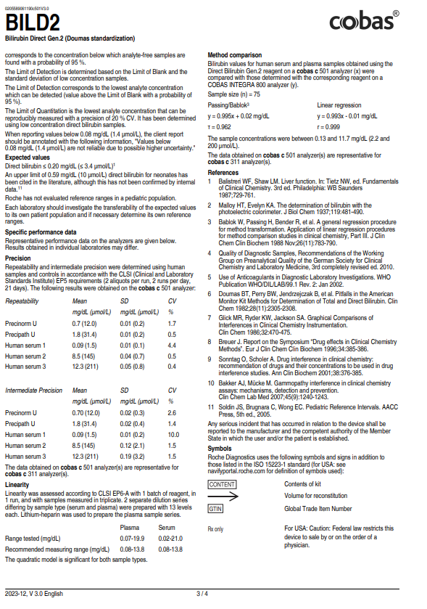
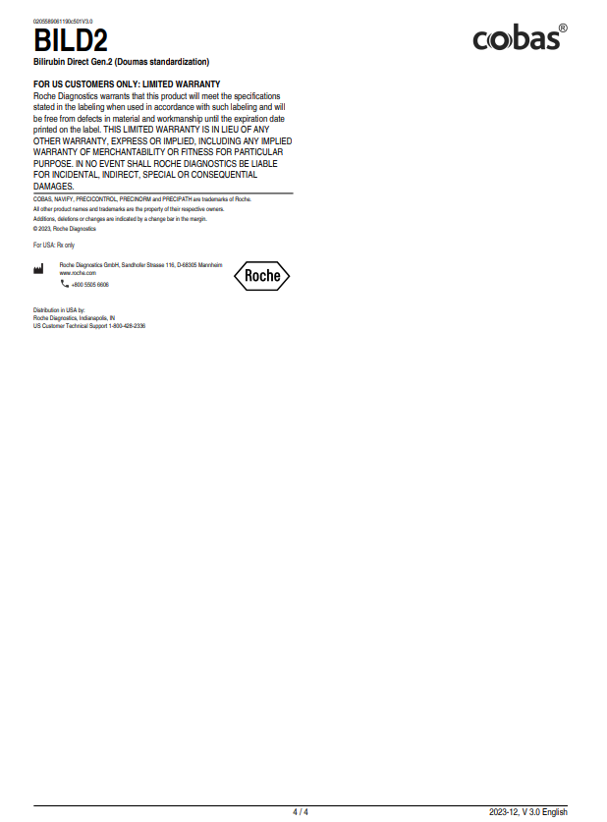
New Vision Medical Laboratories St. Rita’s Medical Center Lima, Ohio Technical Procedure


Procedure Number: nvml.chem.t.329.0
Policy Initiated: 02.25.14

SUBJECT: Direct Bilirubin
PROCEDURE: (Addendum to the above pages)
- Rejection Criteria:
- Specimens that are improperly labeled or of the incorrect specimen type must be rejected.
- Quality Control:
- Controls must be run on each day that this test is requested and are good for 24 hours unless trouble is encountered that requires another evaluation. See posted Quality Control information sheet for levels of control to be run. Follow guidelines for Quality Control using the 2 SD ranges, which are posted and available in the LIS.
- Quality Control Failure:
1. Unacceptable QC results should be entered into the computer along with appropriate actions taken.
2. Various corrective actions include:
a. Check reagent expiration dates and check for proper storage conditions.
b. Rerun QC (use same reagent).
c. Calibrate and run freshest control material
d. Open new reagent and run qc
e. Call hotline for assistance and document actions taken
f. Inform a Technical Specialist
- Calculations:
- N/A
- Interpretation:
- No interpretation is required.
- Normal Range:
- 0.0-0.3 mg/dl
- Analytical Measureable Range:
- 0.1 – 13.8 mg/dl
- Clinical Reportable Range:
- 0.1 – 13.8 mg/dl
- Critical Values:

- Reporting Results:
- Results may be entered directly into the LIS.
- Backup for Inoperable System:
- Use backup analyzer.
- Referral of Specimens:
- Use backup analyzer.
- Submission and Handling of Referral Specimens:
- See requirements of reference lab.
- Method Validation:
- This test was validated by means of startup studies (on file). Subsequent validation is by virtue of QC and CAP surveys.

