# SUBJECT: SPECIMEN LABELING

**POLICY: All personnel shall follow the prescribed labeling procedure to ensure correct identification of all specimens from collection through final disposition.**

**PROCEDURE:**

* 1. All specimens must be legibly labeled, at the point of collection (in the presence of the patient) with at least TWO patient identifiers. The following may be used as identifiers:
     1. Full Name (proper name – no nicknames)
     2. Date of Birth
     3. Medical Record number (or other patient specific number)
     4. Patient specific Barcode on the ID band.

1. Improperly labeled or unlabeled specimens will not be accepted for testing (see Specimen Rejection/Test Cancellation policy nvml.jtdmh.LAB106). Any specimen that does not have TWO patient identifiers on the specimen or if the identifiers on the specimen does not match the identifiers on the order.
   1. Collecting person is responsible for labeling the specimen.
   2. No unlabeled specimens will be labeled by laboratory personnel and no corrections will be made to inaccurately labeled specimens by laboratory personnel.
   3. Unlabeled or inaccurately labeled specimens will not be accepted but will be held until the issue is completely resolved. The sender will be notified immediately that an unacceptable specimen was received by the laboratory.
      1. **EXCEPTION:**
         1. Specimens that are impossible or difficult to recollect (eg. Sterile body fluids, surgical specimens, etc.) should be brought to the attention of the Lab Leadership (below) for appropriate identification follow up.
            1. Lab leadership: Phlebotomy Lead, Technical Lead, General Supervisor, LIS Coordinator or Lab Manager
            2. If deemed necessary, Lab leadership will direct the issue to a pathologist for follow-up with the ordering physician.
         2. If the specimen is deemed “difficult to recollect”, by lab leadership, the collector may come to the lab and properly identify the specimen so it may be accepted by the laboratory.
         3. A *MFSUPSERV Specimen Relabeling Document* form will be initiated by lab personnel and must be completed by responsible collection personnel prior to specimen be acceptable for testing. If specimen stability is an issue, testing may be ran offline but not reported.
         4. Lab personnel must document in LIS the resolution and record who was consulted.
2. Surgical specimens must have a label affixed when received in the laboratory. The label must include specimen type.
3. Slides for blood smears, gram stains, semen analysis, etc. must be labeled using a pencil or permanent marker on the frosted end of the slide with the patient’s last name and a unique identifying number.
4. All specimens must be uniquely identified through all phases of testing
   1. Aliquot specimens must be labeled using the LIS generated aliquot label or with complete written labeling consistent with the initial specimen labeling.
   2. Dilution tubes must be labeled with the patient’s last name and a unique identifying number.
      1. Labels on dilutions must also show the dilution factor
   3. Samples on an automated instrument must be labeled with identifying labels such as barcodes.
   4. Exception: Do not label collection containers when issuing supplies to patient for future collections. Do not place returned unused collection containers to the stock supplies.
5. Essential Label Information and alternative procedures:
   1. Patient's Name – Patients name must be present on all specimens but when not available as in an emergency situation a temporary name and number may be assigned (e.g. Jane Doe #1 or John Doe #2)
   2. Identification Number – Date of Birth is preferred as an identifications number, however, if unavailable use Medical Record Number or Registration visit number.
      1. In an emergency, a blood bank band can provide a temporary unique identification number. Place the blood bank number on all specimens and test requisitions.
   3. Date, Time & By Whom Specimen was Collected -
      1. Should appear on all specimens and test requisitions.
      2. It is recommended that this information also appear on specimens collected by nursing units and physicians, particularly when multiple sites, sources and samples are to be collected. The lab will accept specimens not labeled with date, time, and by whom collected, if the specimen is received in the laboratory physically attached to a properly completed test requisition.

**Exception to G. 2.:**

**Urine** specimens need to have the LIS label applied in an **up/down direction** to allow the label to be scanned for testing – the LIS label should be **applied to the right of the last name** on the registration label - See pictures below

* + 1. When specimens are accessioned prior to collection and receipt in the lab (with LIS generated barcode labels) electronic specimen verification is acceptable.

1. Specimens accepted with labeling other than the bar-coded LIS labels must have the correct LIS label applied over the existing label so that the names on both labels are showing. Laboratory staff will:
   1. Verify specimen patient information and generate or retrieve bar-coded LIS label.
   2. Verify the identification of the specimen and apply the LIS label over the existing label so that the names on both labels are showing. It is the sole responsibility of the accepting staff to verify that the identification on the existing label and the LIS barcode label are the same prior to placing the label on the specimen.
2. Specimen labeling errors resulting in disciplinary action:
   1. Any laboratory employee who labels an unlabeled specimen or makes corrections to an incorrect label will receive disciplinary action with possible termination for any subsequent occurrence.
   2. Anyone who misidentifies a specimen by:
      * 1. Over-labeling with the wrong label on a specimen (mislabeled specimen)
        2. Failure to place any patient information on the specimen (unlabeled specimen)
        3. Places the wrong patient’s information on the specimen (mislabeled specimen)
      1. will receive disciplinary action with possible termination for any subsequent occurrence.

**Policy Review:** Michele R. Homan MLT/ASCP

Support Services Lead

**Date:** 2/21/24

**Policy Approval:** Dr. Patrick Feasel, MD

Laboratory Medial Director

**Date:** 3/19/24

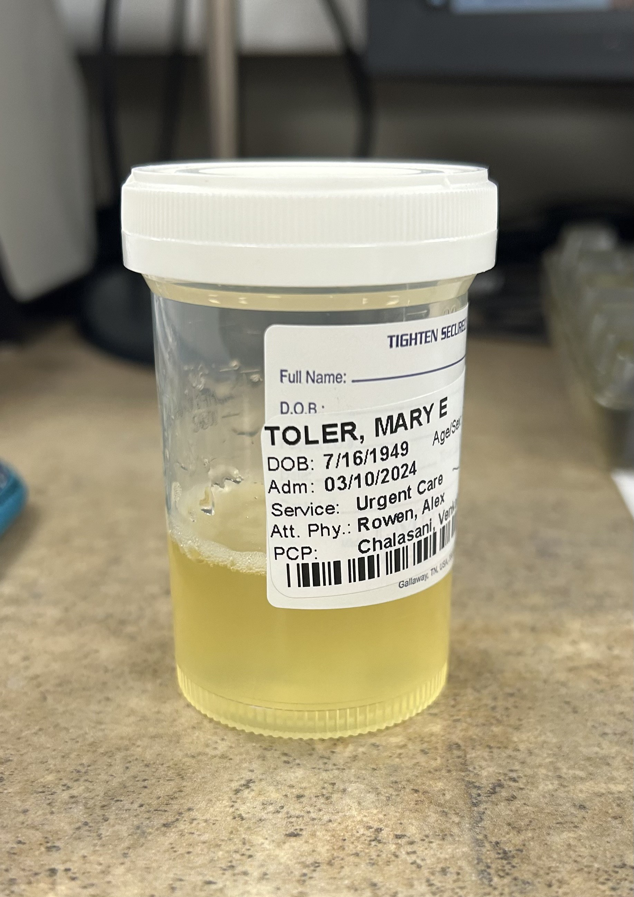

Prior to receiving in LIS

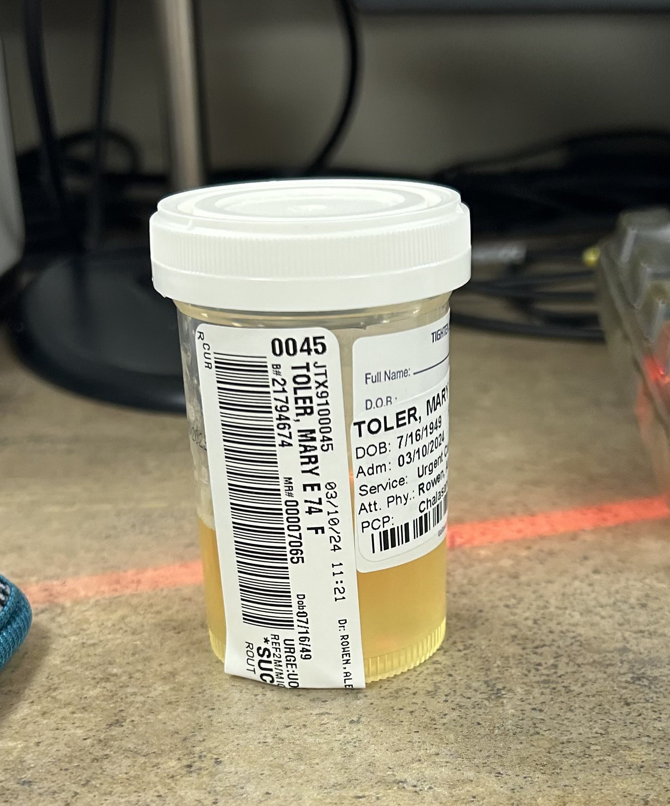

After LIS collection & receiving