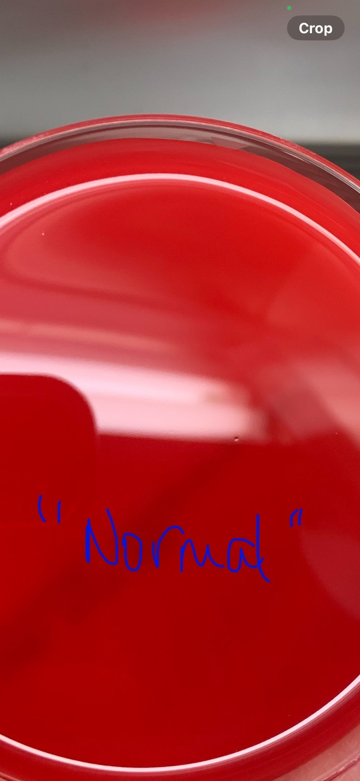

Acceptable plate.

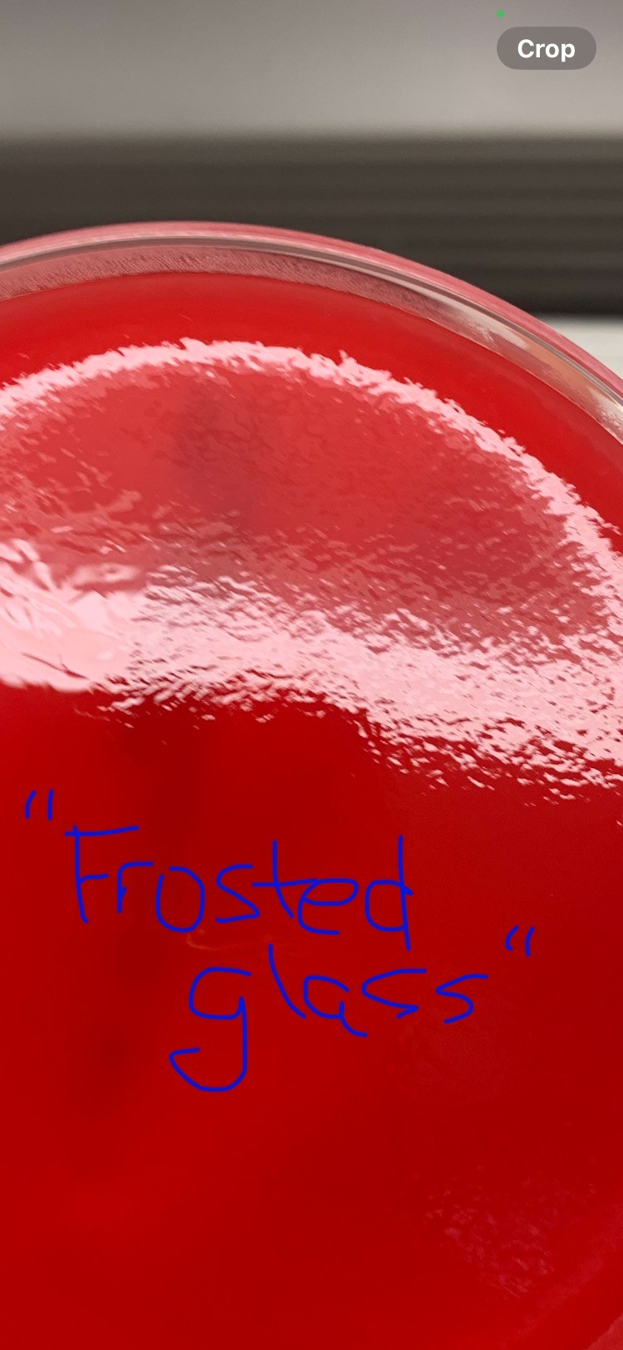

Unacceptable plate – **Do NOT use!**

Remel® does not recommend using the affected media as it may have been frozen through transport.

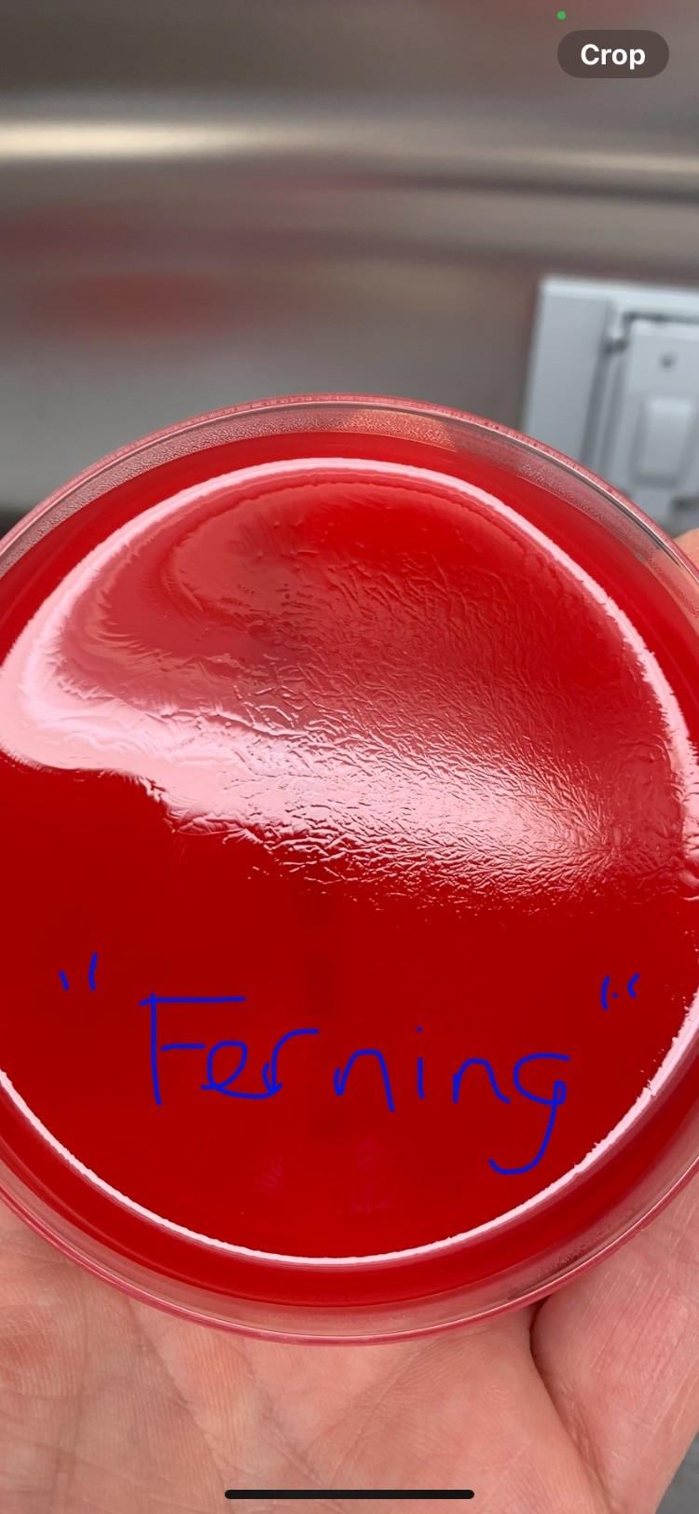

Unacceptable plate – **Do NOT use!**

Remel® does not recommend using the affected media as it may have been frozen through transport.