This procedure is electronically produced, revised, monitored, reviewed and/or retired. For a full document history of initiation, revisions, and reviews with electronic signatures and dates, please open document in the procedure publishing software.

SUBJECT: Immunochemical Fecal Occult Blood

1. PRINCIPLE:

The QuickVue iFOB (immunochemical Fecal Occult Blood) test is an immunochemical device intended for the qualitative detection of fecal occult blood. It is useful in determining gastrointestinal (GI) bleeding found in a number of gastrointestinal disorders, such as: diverticulitis, colitis, polyps, and colorectal cancer. This test is recommended for use in: (1) routine physical examinations or when hospital patients are first admitted, (2) hospital monitoring for GI bleeding in patients, and (3) screening for colorectal cancer or gastrointestinal bleeding from any source.
The QuickVue iFOB test is a one-step lateral flow chromatographic immunoassay. The test strip consists of a burgundy colored conjugate pad containing mouse anti-hHb antibodies conjugated with colloidal gold and a nitrocellulose membrane strip containing a Test line (T-line) and a Control line (C-line). The T-line is coated with anti-hHb antibodies, and the C-line is coated with goat anti-mouse IgG antibodies.
When the correct volume of test specimen is dispensed into the sample well of the device, the test specimen migrates across the test strip. If the concentration of hHb in the specimen is at or above 50 ng hHb/mL or 50μg hHb/g feces, the T-line appears as a visible burgundy line. If the concentration of hHb in the specimen is below the detectable level, no T-line develops.
The C-line is coated with goat anti-mouse antibody, which binds to the conjugated monoclonal antibody, regardless of the presence of hHb in the specimen.
The QuickVue iFOB test is an FDA-cleared CLA-waived rapid immunochemical diagnostic tool intended for the detection of blood in stool specimens. Blood in the stool is an indication of a number of gastrointestinal disorders, including colorectal cancer. The QuickVue iFOB test provides results in 5 to 10 minutes and requires only one specimen. It is specific to human hemoglobin, and patients are not required to strict dietary or medication restrictions prior to testing. This test is also less likely to react to bleeding from the upper digestive tract, such as the stomach.

2. CLINICAL SIGNIFICANCE:

Excluding skin cancers, colorectal cancer is the third most common cancer diagnosed in men and in women in the United States. Colorectal cancer is the second leading cause of cancer-related deaths in the United States. This disease surpasses both breast and prostate cancer in mortality, second only to lung cancer in the number of cancer deaths.
The American Cancer Society recommends that beginning at age 50, men and women should be screened for colorectal cancer. A yearly fecal occult blood test is one of five screening options recommended by the American Cancer Society.
According to the Center for Disease Control (CDC), half of Americans over the age of 50, the most at-risk group for colorectal cancer, have not been screened for the disease. Many cite fears or reservations about the invasive, costly, and generally uncomfortable colonoscopy procedure used for colorectal screening. Emerging in popularity are annual preemptive screening methods like the QuickVue rapid iFOB (Immunochemical Fecal Occult Blood Test). The results from these tests direct individuals to undergo a colonoscopy if the results are positive or to continue yearly screening and skip an invasive procedure if the iFOB test is negative.
The QuickVue iFOB test requires only one specimen, and because it is specific to human hemoglobin, patients are not required to adhere to strict dietary or medication restrictions. The result is a more patient friendly test that is easier to complete and produces fewer false positives. Additionally, immunochemical FOB tests are more analytically sensitive than traditional Guaiac based methods. The QuickVue® iFOB test has the potential to increase patient compliance and offers superior analytical performance (as compared to Guaiac tests) to positively impact both patient care and satisfaction.

3. SPECIMEN:
A. COLLECTION AND PROCESSING:

The specimen used in this assay is feces. Collect specimen in clean bedpan, a clean cup, or any clean container.
Typically, only one specimen is required per year (exceptions are per medical necessity).
NOTE: a) Do not collect specimen if bleeding hemorrhoids, or if menstrual, constipation, or urinary bleeding are present.
b) Do not perform iFOB test on a visibly bloody stool or a liquid stool.
c) Do not allow specimen to come in contact with toilet water or urine.
1. Enter the Patient Identification information on the Collection Tube label.
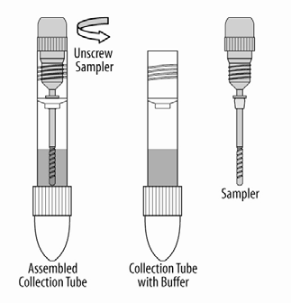
2. Unscrew the Sampler from the Collection Tube.

3. Randomly pierce the specimen with the grooved end of the Sampler in at least five (5) different sites.
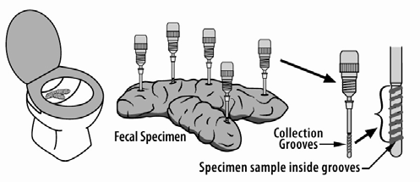

4. Insert the Sampler into the Collection Tube and firmly tighten it.

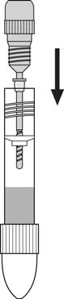
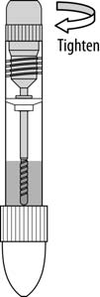

5. Shake the tube to mix the specimen and the FOB buffer.
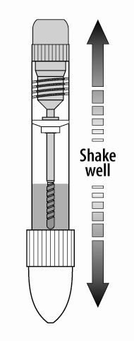

NOTE: Specimens collected may be stored up to eight (8) days at ambient temperatures
below 95°F (35°C), six (6) months at 36–46°F (2–8°C) or two (2) years at -4°F ( -20°C).

B. REJECTION:
Do not collect specimen if bleeding hemorrhoids, or if menstrual, constipation, or urinary bleeding are present.
Do not perform iFOB test on a visibly bloody stool, or a liquid stool.
Do not allow specimen to come in contact with toilet water or urine.
C. STORAGE AND PRESERVATION:

- Store the kit at room temperature 59–86°F (15–30°C), out of direct sunlight.
- Do not expose kit components to temperatures over 86°F (30°C).
- Kit contents are stable until the expiration date printed on the outer box.
- Do not freeze kit.
- Specimens may be stored up to eight (8) days at ambient temperatures below 95°F (35°C), six (6) months at 36–46°F (2–8°C) or two (2) years at -4°F ( -20°C).

4. REAGENTS, STANDARDS, AND CONTROLS:
A. PREPARATION:

All Test Cassettes and clinical specimens must be at room temperature before beginning the test.

B. CONTROL PROCEDURE:

QUALITY CONTROL

Internal Control Features
The QuickVue iFOB test contains a built-in control feature, the Control line (C-line). The presence of this burgundy C-line indicates that an adequate specimen volume was used and that the reagents migrated properly. If a C-line does not form, the test is considered invalid. In this case, review the entire procedure and repeat the test with a new device.
The internal positive and negative control should be tested with each sample and the controls recorded on the LIS QC program with each run, but no more often than once per shift.

External Quality Control
External quality controls assure the functionality of reagents and proper performance of the test procedure. For this purpose, use the QuickVue iFOB Control Set (Catalog Number: 20197).
At least two levels (Positive & Negative) of Quality Control MUST be run with each new lot number or shipment, and recorded appropriately.
Reagent performance and adequacy MUST BE VERIFIED BEFORE PLACING THE MATERIAL IN SERVICE or concurrent with use. Various methods, such as direct analysis, use of reference materials, or parallel testing of old versus new reagents, are acceptable. The results of verification checks must be recorded appropriately.
If the controls do not perform as expected, repeat the test or contact Quidel Technical Support before testing patient specimens.

5. EQUIPMENT:
A. INSTRUMENTS:

Not applicable

B. MICROSCOPIC EXAMINATIONS (AND REJECTIONS):

Not applicable

6. PROCEDURE:
A. PERFORMANCE:

All Test Cassettes and clinical specimens must be at room temperature before beginning the test.

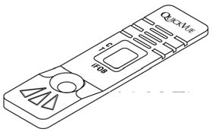
■ Remove the Test Cassette from the pouch and place
it on a clean, flat, dry, level surface.

■ Shake the Collection Tube to mix the specimen and the FOB buffer.

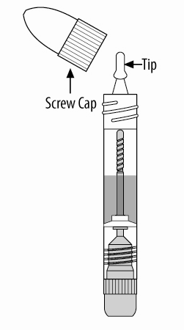
■ Hold the Collection Tube upright, as shown.
■ Remove the light blue screw cap by turning.

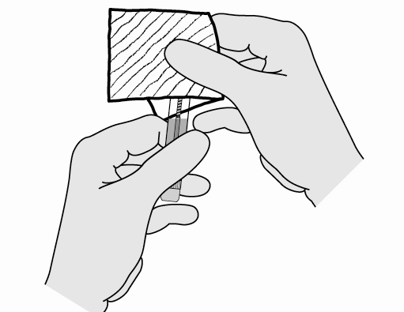

- Fully cover tip with absorbent material to
avoid contamination.

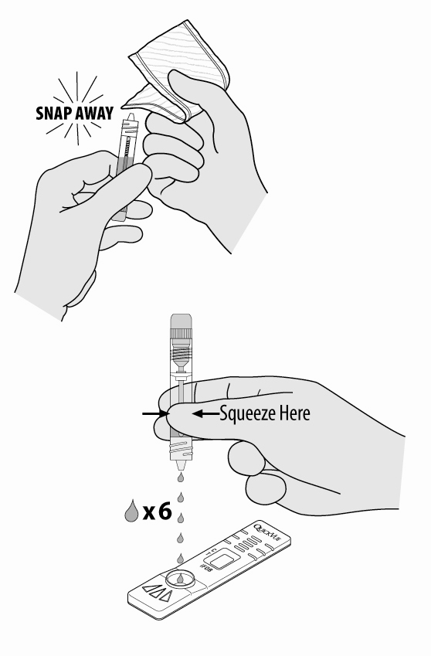

■ QUICKLY snap off tip.
■ DO NOT TWIST.

■ Holding the Collection Tube vertically, dispense
six (6) drops of specimen solution from the
Collection Tube into the center of the Sample Well.

■ READ RESULTS AT 5–10 MINUTES.
Some positive results may be seen earlier.

IMPORTANT: Do not read the test results after ten (10) minutes.

B. CALCULATIONS:

Not applicable

C. INTERPRETATION OF RESULTS:

Refer to the Procedure Card for visual color interpretation of the Test and Control Lines.
Both the T-line and the C-line present as the same burgundy color.
Positive Result:
If both a C-line and a T-line are present, the result is positive.
A positive result indicates the level of hHb in the specimen is at or above the detection level.
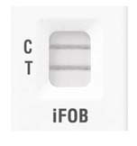

Positive

Negative Result:
If only the C-line develops in the control region of the test strip, the result is negative.
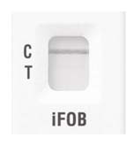

Negative

Invalid Result:
If no C-line appears within 5 minutes, the result is invalid and the assay should be repeated with a new device.

NOTE: The test line may or may not be present. However, the absence of a control line indicates an
invalid test.
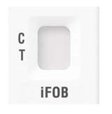
Invalid
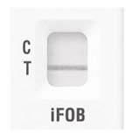
7. QC PERFORMANCE POLICY:

Internal Control Features
The QuickVue iFOB test contains a built-in control feature, the Control line (C-line). The presence of this burgundy C-line indicates that an adequate specimen volume was used and that the reagents migrated properly. If a C-line does not form, the test is considered invalid. In this case, review the entire procedure and repeat the test with a new device.
The internal positive and negative control should be tested with each sample and the controls recorded on the LIS QC program with each run, but no more often than once per shift.

External Quality Control
External quality controls assure the functionality of reagents and proper performance of the test procedure. For this purpose, use the QuickVue iFOB Control Set (Catalog Number: 20197).
At least two levels (Positive & Negative) of Quality Control MUST be run with each new lot number or shipment, and recorded appropriately.
Reagent performance and adequacy MUST BE VERIFIED BEFORE PLACING THE MATERIAL IN SERVICE or concurrent with use. Various methods, such as direct analysis, use of reference materials, or parallel testing of old versus new reagents, are acceptable. The results of verification checks must be recorded appropriately.
If the controls do not perform as expected, repeat the test or contact Quidel Technical Support before testing patient specimens.

A. CALIBRATION AND CALIBRATION VERIFICATION

Not applicable

B. FAILURE/REMEDIAL ACTION:
Internal Control
If a C-line does not form, the test is considered invalid. In this case, review the entire procedure and repeat the test with a new device.

External Quality Control
If the controls do not perform as expected, repeat the test or contact Quidel Technical Support before testing patient specimens.

8. EXPEXCTED RESULTS:

The QuickVue iFOB test will show positive results if there is a detectable amount of human hemoglobin in the specimen. The detection level is 50 ng hHb/mL buffer or 50 μg hHb/g feces.

A. REPORTABLE RANGE:

Positive or Negative

B. REFERENCE RANGE:

Not applicable

C. CRITICALVALUES:

Not applicable

9. REPORTING RESULTS:

A. NORMAL VALUES:

Positive or Negative

B. CRITICAL VALUES:

Not applicable

- PROCEDURAL NOTES:

  - If the patient has visibly bloody stool, do not use this test.
  - The sensitivity of the test is 50 ng hHb/mL buffer or 50 μg hHb/g feces.
  - Accuracy. Reference Laboratory and Physicians' Office Laboratory (POL) Studies:
One hundred (100) hHb-free feces extraction specimens collected in-house were divided into 5 groups of 20 each. The five groups of extraction specimens were spiked with hHb for five different concentrations, respectively: 0, 37.5 ng hHb/mL, 50 ng hHb/mL, 62.5 ng hHb/mL, and 2000 ng hHb/mL. Those specimens were blind labeled and tested with the QuickVue iFOB test at three (3) Physicians' Office Laboratories and a Reference Laboratory.
The results obtained from the three POL sites by persons with diverse educational background and work experience were 97.7% accurate, and the results from the Reference Laboratory were 99% accurate. Thus, overall the accuracy of the QuickVue iFOB test is 98%.
  - Specificity. The QuickVue iFOB test is specific to human hemoglobin. The following substances,
when spiked in both positive and negative specimens, did not interfere with the test results.
Substance Concentration (μg/mL) Beef Hemoglobin 2,000
Chicken Hemoglobin 500 Fish Hemoglobin (meat extract) 100
Horse Hemoglobin 500 Goat Hemoglobin 500
Pig Hemoglobin 500 Rabbit Hemoglobin 60
Sheep Hemoglobin (meat extract) 100 Horseradish Peroxidase 20,000
Red radish Aqueous extract Raw turnip Aqueous extract
Cauliflower Aqueous extract Broccoli Aqueous extract
Parsnip Aqueous extract Cantaloupe Aqueous extract
Vitamin C (ascorbic acid) supplement Iron supplement
  - The following is a comparison of two methods for occult blood testing. The Immunochemical Fecal Occult Blood (iFOB) uses an antibody to detect human hemoglobin in stool. The Hemoccult test is the standard guaiac-based test to detect hemoglobin in the stool.
Researchers conclude that iFOB detects many more colorectal cancers than guiac-based occult blood testing.
Among patients with colorectal cancer or advanced adenomas, the iFOB was positive more often than the guiac test (GFOB). The iFOB detected 100% of the colorectal cancers and 51% of the advanced adenomas. In contrast, the GFOB detected 52% of the colorectal cancers and 18% of the advanced adenomas.

Occult Blood  Assays | iFOB | HEMOCCULT
Specimen Collection | The specimen used in this assay is feces.  (Note: Package insert refers to only one specimen, multiple specimens not required.) | Patients using the Hemoccult II® screening test should collect fecal specimens from bowel movements on three different days.
Performance Characteristics | SENSITIVITY  The sensitivity of the test is 50 ug hHb/gm feces.  ACCURACY  Overall accuracy of the QuickVue iFOB test is 98%.  SPECIFICITY  The QuickVue iFOB test is specific to human hemoglobin. | Based on in vitro studies in which fecal samples from asymptomatic, normal volunteers were spiked with fresh whole blood, Hemoccult® gave positive test results about 50% of the time at 0.3 mg Hb/gm of feces  (Note: 0.3 mg Hb/gm of feces = 300 ug Hb/gm of feces.)
Expected Results | The QuickVue iFOB test will show positive results if there is a detectable amount of human hemoglobin in the specimen. The detection level is 50 ug Hb/gm feces. | In a general screening population of highly compliant asymptomatic individuals, the Hemoccult® test will yield a positivity rate of approximately 2 to 5%. The false-positivity rate in such a population would be approximately 1 to 2%.
Interfering Substances | The following substances, when spiked in both positive and negative specimens DID NOT INTERFERE with the test results:  Substance Concentration  Beef Hemoglobin 2000 ug/mL  Chicken Hemoglobin 500 ug/mL  Fish Hemoglobin 100 ug/mL  Horse Hemoglobin 500 ug/mL  Goat Hemoglobin 500 ug/mL  Pig Hemoglobin 500 ug/mL  Rabbit Hemoglobin 500 ug/mL  Sheep Hemoglobin 100 ug/mL  Horseradish Peroxidase 20000 ug/mL  Vitamin C (Ascorbic Acid) Dietary  Supplement  Iron Dietary  Supplement | Substances that CAN CAUSE false-positive test results:  • Red meat (beef, lamb and liver)  • Aspirin (greater than 325 mg/day)  • Corticosteroids, phenylbutazone, reserpine, anticoagulants, antimetabolites, and cancer chemotherapeutic drugs  • Alcohol in excess  Dietary iron supplements will not produce false-positive test results with Hemoccult® tests.  Acetaminophen is not expected to affect test results.  Substances which can cause false-negative test results:  • Ascorbic acid (vitamin C) in excess of 250 mg/day  • Excessive amounts of vitamin C enriched foods (citrus fruits and juices)  • Iron supplements which contain quantities of vitamin C in excess of 250 mg per day

A. BACKUP FOR INOPERABLE SYSTEM

Not applicable

B. REFERAL OF SPECIMENS:

Not applicable
C. SUBMISSION/HANDLING OF REFERRAL SPECIMENS:

Not applicable

11. LIMITATIONS AND INTERFERRING SUBSTANCES:

- The QuickVue iFOB test is for in vitro diagnostic use.
- If the patient has visibly blood stool, do not use this test.
- Do not use the kit contents beyond the expiration date printed on the outside of the box.
- Dispose of containers and used contents in accordance with Federal, State and Local requirements.
- Use of Nitrile or Latex gloves is recommended when handling potentially infectious fecal specimens.
- Follow proper hand washing hygiene after handling potentially infectious fecal specimens.
- The Test Cassette must remain sealed in the foil pouch until just prior to use.
- Treat all specimens and used assay materials as if they are infectious.
- To obtain accurate results, you must follow the Package Insert instructions.
- The QuickVue iFOB test is intended only for the detection of human hemoglobin in feces.
- Results cannot be considered conclusive evidence of the presence or absence of gastrointestinal bleeding or pathology. A positive result should be followed up with additional diagnostic procedures to determine the exact cause and source of the occult blood in the feces.
- A negative result can be obtained even when a gastrointestinal disorder is present. For example, some polyps and colorectal cancers may bleed intermittently or not at all during certain stages of the disease.
- False negative results may occur when occult blood is not uniformly distributed throughout the bowel movement and the formation of a fecal specimen. Repeat testing is recommended if a pathological condition is suspected.
- Patients with the following conditions should not be considered for testing, as these conditions may interfere with test results.
■ Menstrual bleeding
■ Bleeding hemorrhoids
■ Constipation bleeding
■ Urinary bleeding
However, these patients may be considered for testing after such bleeding ceases.
- Alcohol and certain medications such as aspirin, indomethacin, reserpine, phenylbutazone, corticosteroids and nonsteroidal anti-inflammatory drugs may cause gastrointestinal irritation and subsequent bleeding in some patients.

12. METHOD VALIDATION:

January 2012 & February 2012
13. REFERENCES:

- American Cancer Society, Inc. Cancer Reference Information: Can Colon and Rectum Cancer Be Found Early? [Online] Available: http://www.cancer.org.
- Allison JB, Takawa IS, Ransom LJ, Adrian AL. A comparison of fecal occult blood tests for colorectal-cancer screening. N Engl J Med 1996; 334:155–159.
- Saito H. Screening for colorectal cancer by immunochemical fecal occult blood testing (Review). Jpn J Cancer Res 1996; 87:1011–1024.
- Recommendations for the Prevention of HIV Transmission in Health Care Settings, Morbidity and Mortality Weekly Report, Centers for Disease Control, August, 1987.
- Biosafety in Microbiological and Biomedical Laboratories, 4th Edition. U.S. Department of Health and Human Services, CDC, NIH, Washington, DC (1999).

Quidel Technical Support number, (800) 874-1517 (toll-free in the U.S.A.) or (858) 552-1100,
Monday through Friday, between 7:00 a.m. and 5:00 p.m. Pacific Time, U.S.A. If outside
the United States, contact your local distributor or technicalsupport@quidel

