Saratoga Hospital Laboratory
211 Church Street, Saratoga Springs, NY 12866
Competency Assessment Procedure, Phlebotomy
Purpose:
This procedure provides instruction, as well as the expectations for competency assessment, and to ensure staff requiring retraining are identified.

Scope:
This procedure applies to Saratoga Hospital, Main Lab, Phlebotomy staff.

Policy:
The Competency Assessment Procedure includes the following.
- Staff members are provided the intervals in which competency assessment must be performed.
- Competency assessments are assigned during these intervals.
- Competency assessments are completed on time.
- Employees are aware of who can perform competency assessment.
- Those performing competency assessments have instructions on how to document satisfactory competence, and recommendations for retraining.

Competency Assessment Assignment Procedure:
Competency Assessments are stored on the Medtraining web site, http://medtraining.org/ltac3/Secure/Login.aspx. Each Main Lab Phlebotomist employee is loaded into the training site during orientation with the department. Instruction on how to access assignments is provided during initial training.
Note: Saratoga Hospital Content is loaded by the phlebotomy supervisor.
Note: Competency Assessments are assigned by phlebotomy staff with administrative Medtraining privileges.
- Sign into your Medtraining account.
- Under Manage, select Users.
- Select the user or users by clicking on the  next to their name. The selected box will appear with a check mark ✓ in it once selected.
- Select Assign from the options listed above the users.
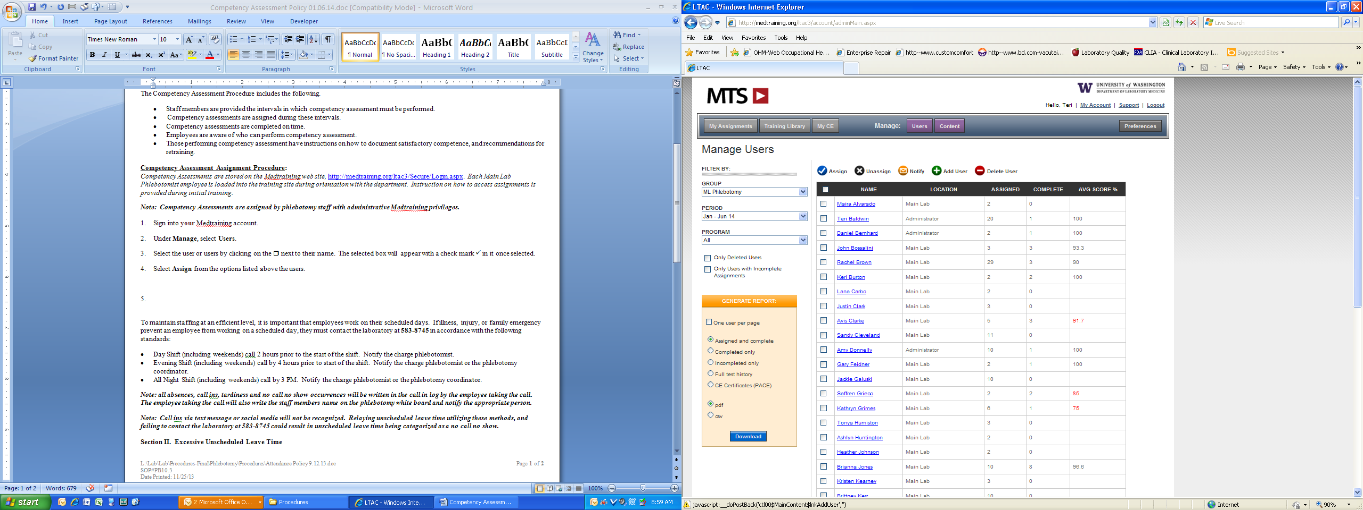
- Click the  next to the competency assessment that is to be assigned. The following groups have been created under the Saratoga Hospital Content tab on the Medtraining site.
  - Initial Competency Assessment
  - Initial Procedure Review
  - 6 Month Competency Assessment
  - Annual Competency Assessment 20** (Annual assessments are year specific.)
  - Annual Procedure Review
  - Chain of Custody

- To complete the assignment process, click on Assign.
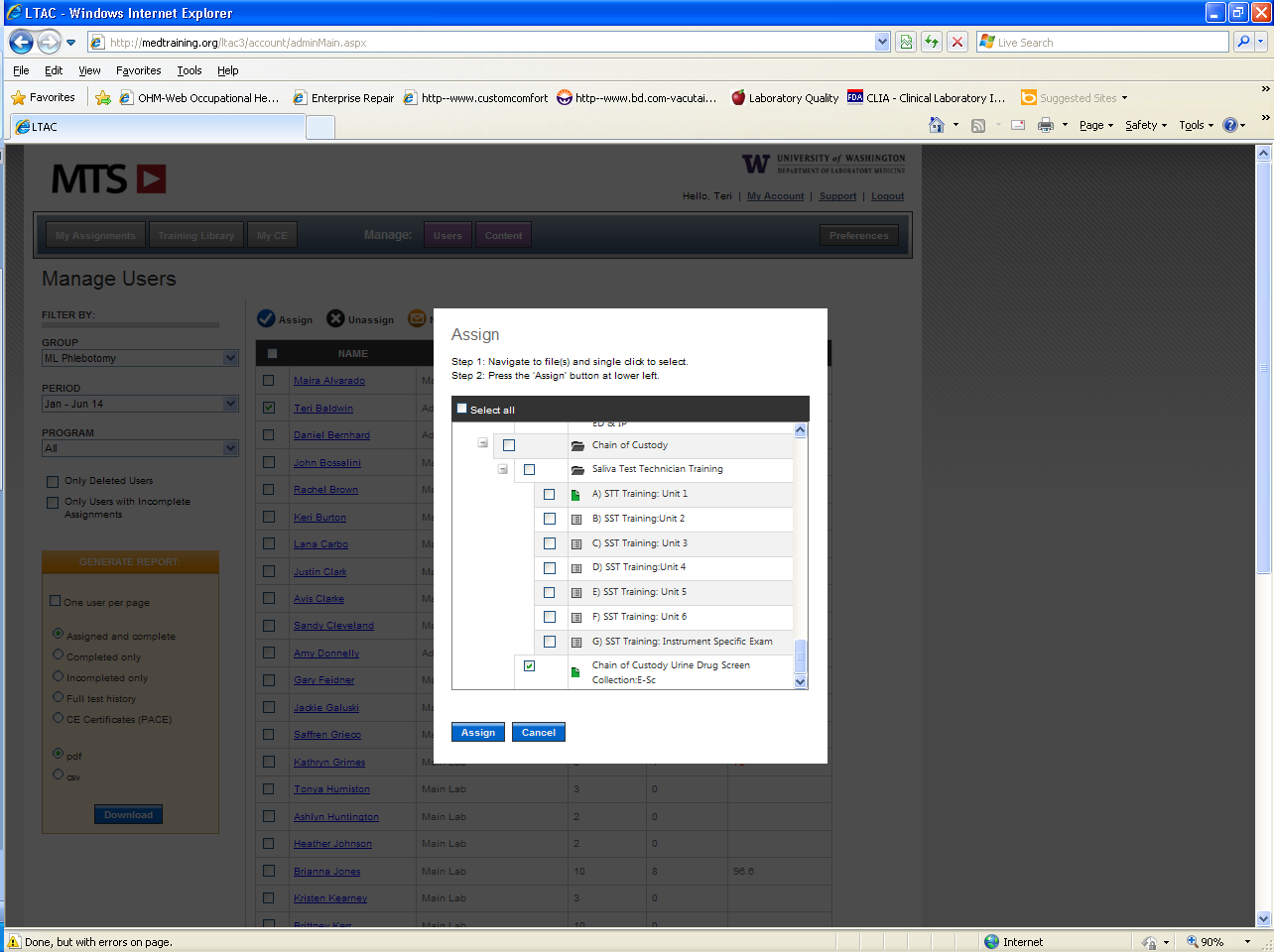
- Competency assessment assignments must be entered on the Clinical Laboratory Assistant (CLA) employee spreadsheet, located at the following file path.
L:\Lab\Lab\General Forms\Phlebotomy\MTS Competencies
Under the employee’s sheet, enter the assignment, along with the due date.
Phlebotomist’s Name
Competency Name | Due Date | Competency Performed By | Date
D.O. Phleb Competency Assessment-Phlebotomy | 06/30/14
D.O. Phleb Competency Assessment- Miscellaneous | 06/30/14
R.D. Phleb Comp Asses - BB Spec Collect MobiLAB | 06/30/14

- Send an e-mail to the employee letting them know they have assignments pending, with a copy to their CLA.
Note: While the employee is ultimately responsible for completing the Competency Assessment by the due date, their CLA is responsible for providing follow-up to ensure the assignment is completed by the deadline.
Competency Assessment Procedure:
Competency Assessments can only be performed by staff who have earned a star sticker  on their badge.
Note: Employees who have been designated to sign off on staff competency assessment are responsible for becoming familiar with the competency assessment content and process.
Note: All CLAs and Phlebotomy Specialists are designated as staff who can sign employee competency assessments.
- Assess the competency assessment method according to the following table.
Abbreviation | Method | Method Description
D.O. | Direct Observation | The employee is observed performing the actual act.
R.D. | Return Demonstration | The employee demonstrates the actions on an employee. All materials involved in the act must be used in the demonstration. Many return demonstrations are performed using test patients. As the employee demonstrates the act, they must also tell the assessor the reasons why they are performing the act.
R.R. | Review of Records | Patient records are reviewed to determine the employee’s ability to perform specific duties.
V | Verbalization | The employee verbalizes how the task is to be completed.

- Perform the assessment.
Note: It may be necessary to print a hard copy of the assessment to refer to while the employee performs the act. Hard copies of the competency assessments are kept at the following file path.
L:\Lab\Lab\General Forms\Phlebotomy\MTS Competencies
- Sign into the employee’s Medtraining site.
- Under the My Assignments tab select the competency assessment that is being assessed.
- Answer the questions of the competency assessment test according to the employee’s performance.
Note: If Fail has been selected for any of the answers, the employee must be recommended for retraining. The assessor will fill out Attachment 1: Retraining Required Documentation and submit it to the Phlebotomy Supervisor.
- On the “L” drive, go to the CLA’s spreadsheet to which the employee is assigned.
L:\Lab\Lab\General Forms\Phlebotomy\MTS Competencies
- In the employee’s sheet, sign off that the employee’s competency assessment was performed, by entering your name in the Competency Performed By column followed by the date.
Competency Name | Due Date | Competency Performed By | Date
D.O. Phleb Competency Assessment-8. Miscellaneous | 06/30/14
R.D. Phleb Comp Asses - BB Spec Collect MobiLAB | 06/30/14 | Teri Baldwin | 01/06/14
R.D. Phleb Comp Asses - BB Spec Label Typenex bnd | 06/30/14

Note: Competency Performed By & Date must be filled out by the staff assessing the competency.

- The phlebotomy supervisor will be notified by an e-mail from Medtraining, that the employee’s competency assessment has been completed.
- The phlebotomy supervisor and the employee will use the Competency Sign Off section in Medtraining to do one of the following.
  - Certify that the employee is competent to perform the task.
  - Certify that the employee is not competent to perform the task and requires training.

Procedural Notes:
Employees who do not complete their competencies by the due date:
- Will automatically be marked as noncompetent for that task and require retraining in addition to competency assessment before they are able to perform the duties outlined by that particular competency assessment.
- Will lose points on their evaluation, specifically for not meeting Mandatory Training requirements.

Attachments:
Attachment 1: Retraining Required Documentation

Date of Origin: | 01/07/14 |  | Prepared By: |  |  | Teri Baldwin
Date Placed in Service:
Approved by:
 | Phlebotomy Supervisor  Teri Baldwin |  |  | Date |  | Laboratory Medical Director  William E. Field II, MD |  |  | Date
 | Laboratory Administrative Director  Richard Vandell |  |  | Date

Saratoga Hospital Laboratory
211 Church Street, Saratoga Springs, NY 12866

Attachment 1: Retraining Required Documentation
Name: |  |  |  | Date:
 |  | Print
Assessor:
 |  | Print |  |  | Sign
Supervisor Review:
 |  |  | Print |  | Sign

TASK/ASSESSMENT | Select Task Needing Improvement | Comments

