Saratoga Hospital Laboratory  211 Church Street, Saratoga Springs, NY 12866 |  | Saratoga Hospital Lab-Wilton  3040 Route 50 North  Saratoga Springs, NY 12866
Procedure for Managing Pediatric Pain During Blood Specimen Collection

Purpose:
This procedure provides instruction for minimizing the discomfort of blood specimen collection for pediatric patients.

Scope:
This procedure applies to all laboratory employees who collect blood specimens from pediatric patients.

Policy:
Saratoga Hospital and its affiliated laboratories ensure pain management for pediatric patients during blood specimen collection through the utilization of parental education as well as non-pharmacologic interventions.

Materials:

- Pediatric Services: Keeping Your Child Comfortable
- Working Together to Comfort your Child During a Blood Sampling Procedure
- DVD and DVD Player
- Pacifier
- Sweet-Ease
- Books
- Bariatric Style Chairs (Parent/Child Seating)
- Toys (Bead Sifter, Keypad Sorter, ect…)
- Pain Management Audit for Phlebotomy Form

Procedure:

- Provide parents the Pediatric Services: Keeping Your Child Comfortable guide, and Attachment 1: Working Together to Comfort your Child During a Blood Sampling Procedure.

- The phlebotomist will make every attempt to minimize the patient’s wait time by keeping pediatric supplies stocked in phlebotomy carts and outpatient areas at all times.

- When patients are introduced to a new surrounding for blood specimen collection, allow time for the parent and child to adjust to their new surroundings.

- Ask parents what activities they do with their child to comfort them.

- Offer divisional activities to the child. See Attachment 2: Age Specific Non-Pharmacologic Interventions chart for guidance.
Note: See Attachment 3: Sweet-Ease Procedure for specific instructions regarding the use of this product.

- Depending on the age of the child, determine the best position to place them for the blood specimen collection.
Note: The pediatric patient may sit in a chair, be held in a lap, or cradled while lying on a table.

- After the collection has been completed, assess both the parent and the patient.
Note: Follow Code Green protocol if parent or patient becomes light headed, or nauseous.

- When patient and parent are comfortable, procedure is completed.

- Record patient information and interventions used on Attachment 4: Pain Management Audit for Phlebotomy and deliver to laboratory supervisor. The supervisor will review and forward form to director of A3 (pediatric unit).

References:
Saratoga Hospital. •Pediatric Services: Keeping your child comfortable.
Celadon, T. (2011, Jan). Sweet ease sucrose solution for infant pain management. Women's Health

Attachments:
Attachment 1: Working Together to Comfort your Child During a Blood Sampling Procedure
Attachment 2: Age Specific Non-Pharmacologic Interventions
Attachment 3: Sweet-Ease Procedure
Attachment 4: Pain Management Audit for Phlebotomy

Date of Origin: | 01/14/13 |  | Prepared By: |  |  | Teri Baldwin
Date Placed in Service:
Approved by:
 | Teri Baldwin, Supervisor |  |  | Date |  |  | Dr William E. Field II, Laboratory Director |  |  | Date

 | Rhea Jamro, Supervisor |  | Date |  | Dr Bernard NG, Laboratory Director |  | Date

Approved by:
 | Philip Weissman, Supervisor |  | Date

Saratoga Hospital Laboratory  211 Church Street, Saratoga Springs, NY 12866 |  | Saratoga Hospital Lab-Wilton  3040 Route 50 North  Saratoga Springs, NY 12866
Working Together to Comfort Your Child During a Blood Sampling Procedure.

- Your physician has requested that we obtain a blood sample in order to better care for your child.

- We are committed to minimize the discomfort of this procedure.

- We encourage your participation and assistance during the procedure to help in promoting your child’s comfort and minimizing their stress.

- Together with you, we will make every effort to keep your child as comfortable as possible during this procedure.

- We will make every attempt to minimize your child’s waiting time in the waiting room.

- We will allow you and your child a few minutes together in the drawing room to adjust to your surroundings.

- We will offer you music & or DVD’s or TV to allow for a more relaxed environment.

- Depending upon the age of the child, we can have them sit in a chair, hold them on your lap or can cradle them while they are lying on a table.

- The phlebotomist will ask you what activities that you do with your child that can comfort them. These may be helpful during the blood sampling.

- Other interventions that may be of assistance based on your child’s age are:

Infants: Rocking, singing, soothing music, holding, gentle massage, pacifier. A sugar solution (Sweet-Ease) has been found to decrease the pain from venipuncture. Sweet-Ease may be used with your permission in conjunction with the above to decrease pain.

Toddlers: Rocking, holding, listening to music, playing or acting out the procedure.

Preschoolers: Talking about the procedure, story-telling, distraction tools (books, toys) playing or acting out the procedure.

School-age: Breathing techniques, visual imagery, music, distracting objects, reading, and massage.

Adolescents: Breathing techniques, visual imagery, videotapes, music, distracting objects, reading, massage.

Thank you,
The Saratoga Hospital Laboratory

Saratoga Hospital Laboratory  211 Church Street, Saratoga Springs, NY 12866 |  | Saratoga Hospital Lab-Wilton  3040 Route 50 North  Saratoga Springs, NY 12866

Attachment 2: Age Specific Non-Pharmacologic Interventions

Age Group | Non-Pharmacologic Interventions
Infants | - Rocking  - Singing  - Soothing Music  - Holding | - Gentile Massage  - Pacifier  - Sweet-Ease  See Attachment 3
Toddlers | - Rocking  - Holding  - Listening to Music  - Playing or Acting Out the Procedure
Preschoolers | - Talking About the Procedure  - Story-Telling  - Distracting Tools: Books, DVD  - Playing or Acting Out the Procedure
School-Age | - Breathing Techniques  - Visual Imagery  - Music  - Distracting Objects: Books, DVD  - Reading  - Massage  - Story-Telling
Adolescents | - Breathing Techniques  - Visual Imagery  - DVD  - Music  - Distracting Objects  - Reading  - Massage

Saratoga Hospital Laboratory  211 Church Street, Saratoga Springs, NY 12866 |  | Saratoga Hospital Lab-Wilton  3040 Route 50 North  Saratoga Springs, NY 12866

Saratoga Hospital Laboratory  211 Church Street, Saratoga Springs, NY 12866 |  | Saratoga Hospital Lab-Wilton  3040 Route 50 North  Saratoga Springs, NY 12866
Attachment 3: Sweet-Ease Procedure

A variety of nonpharmacologic pain-prevention and -relief techniques have been shown to effectively reduce pain from minor procedures in neonates. Concentrated oral sucrose has been widely studied. Oral sucrose eliminates the electroencephalographic changes associated with a painful procedure in a neonate. Sweet-Ease does not require an order for use except for unstable or compromised neonates. Use should not exceed 8 times per day.

- Determine the age of the pediatric patient. If the age fits the infant age group, offer the parents Sweet-Ease.
Note: “To help the baby’s discomfort during the specimen collection, we offer a sugar solution.”

- Assess infant for pain before and after procedure.

- Sweet-Ease is kept in the Saratoga Hospital, Wilton Medical Arts, and Malta Medical Arts outpatient draw stations.

- Use Sweet-Ease is in conjunction with other non-pharmacologic methods to decrease pain in infants who are undergoing painful procedures such as, but not limited to skin puncture or venipuncture.

- Up to 2 ml of Sweet-Ease is administered 2 minutes before a painful procedure via pacifier, dropper or syringe. Dipping the pacifier into a small, single use cup of Orca-Sweet is the preferred method. Smaller volumes of 0.5 ml up to 1 ml may be effective for preterm infants.

- Use one of the following comments after administering Sweet-Ease.

  - Meditech Comment

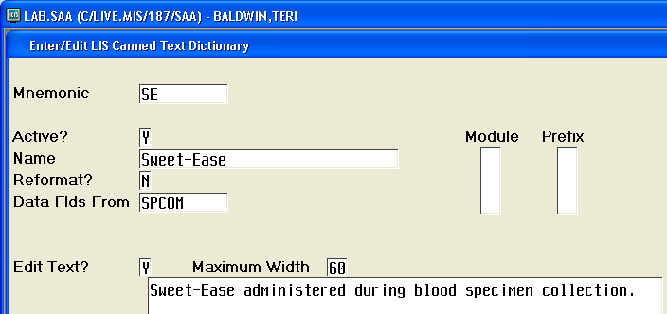

  - MobiLAB Comment

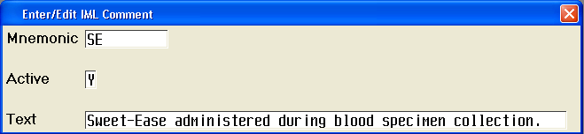

Saratoga Hospital Laboratory  211 Church Street, Saratoga Springs, NY 12866 |  | Saratoga Hospital Lab-Wilton  3040 Route 50 North  Saratoga Springs, NY 12866

Attachment 4: Pain Management Audit for Phlebotomy

 |  | Place Aliquot | Place Aliquot | Place Aliquot | Place Aliquot | Place Aliquot
 | Interventions | Check All That Apply
 | Questioned parent for best interventions for comfort.
 | Minimal wait time.
Infants  (< than 12 mo.) | Rocking
Infants  (< than 12 mo.) | Singing
Infants  (< than 12 mo.) | Soothing Music
Infants  (< than 12 mo.) | Holding
Infants  (< than 12 mo.) | Gentle Massage
Infants  (< than 12 mo.) | Pacifier
Infants  (< than 12 mo.) | Sweet-Ease
Toddlers  (12-36 mo.) | Rocking
Toddlers  (12-36 mo.) | Holding
Toddlers  (12-36 mo.) | Listening to Music
Toddlers  (12-36 mo.) | Playing or Acting Out the Procedure
Pre-Schoolers  (3-5 yrs.) | Talking About the Procedure
Pre-Schoolers  (3-5 yrs.) | Story-Telling
Pre-Schoolers  (3-5 yrs.) | Distracting Tools: Books, DVD
Pre-Schoolers  (3-5 yrs.) | Playing or Acting Out the Procedure
School  (6-12 yrs.) | Breathing Techniques
School  (6-12 yrs.) | Visual Imagery
School  (6-12 yrs.) | Music
School  (6-12 yrs.) | Distracting Objects: Books, DVD
School  (6-12 yrs.) | Reading
School  (6-12 yrs.) | Massage
School  (6-12 yrs.) | Story-Telling
Adolescents  (13-<18 yrs.) | Breathing Techniques
Adolescents  (13-<18 yrs.) | Visual Imagery
Adolescents  (13-<18 yrs.) | DVD
Adolescents  (13-<18 yrs.) | Music
Adolescents  (13-<18 yrs.) | Distracting Objects
Adolescents  (13-<18 yrs.) | Reading
Adolescents  (13-<18 yrs.) | Massage

Phlebotomist:

