Saratoga Hospital Laboratory

211 Church Street, Saratoga Springs, New York 12866

# Syringe Blood Collection Process

**Purpose:**

This procedure provides instruction for the proper collection of blood specimens utilizing a syringe.

**Scope:**

In cases where veins are fragile, thread-like, or rolling, in addition to collecting from children < 2 years old a syringe may be used instead of evacuated tubes and holder.

**Materials:**

* Test requisition and/or labels generated from Meditech or MobiLab.
* Tourniquet, gloves, marking pen.
* Appropriate size syringe.
* Disposable Eclipse™ needle.
* Alcohol prep pad or alternate antiseptic wipe.
* 2 x 2 inch dry gauze sponge.
* Surgical/adhesive tape or band-aid.
* Blood Transfer Device or Blood Culture Device, with Female Luer Adapter.
* Appropriate blood collection tubes.
* Approved biohazard sharps container.

**Procedure:**

1. Greet the patient. Employee must introduce themselves and inform the patient they are going to be performing Skin Puncture procedure.
2. Wash hands according to Hand Washing and Hand Care procedure (Infection Control Manual D001).
3. Identify the patient using a minimum of 2 identifiers following the guidelines established by Administrative Policy II-49 Patient Identification.
4. Assemble supplies.
5. Put on protective gloves.

***Note: Gloves must stay intact for the duration of the procedure.***

1. Position patient in chair or bed, arm outstretched and supported, in a manner both comfortable to the patient and accessible to the phlebotomist.
2. Apply tourniquet (or other restrictive device) 3-4 inches above venipuncture site. If

blood pressure cuff is used, inflate to 40 mm Hg.

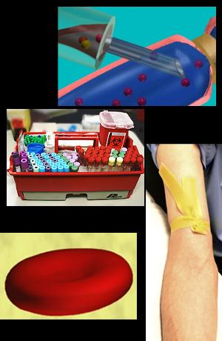

***Note: Tourniquet should remain in place 1 minute or less*.**

1. If necessary, ask patient to “make a fist” but avoid “pumping”.
2. Identify the appropriate site for venipuncture by palpating the vein.

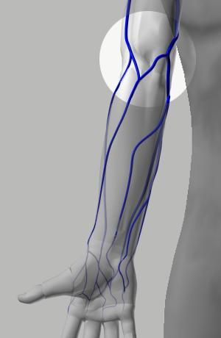

*Note: The preferably mid-antecubital fossa*

**Guidelines:**

* + **Avoid**→**Healed Burns, Extensive Scarring, or Hematomas.**
  + **Do Not→Draw from an arm on the same side as a mastectomy without physician approval.**
  + **Do Not→Draw from an arm having a Cannula, Fistula, or Vascular Graft without physician approval.**

**Avoid Nerves:**

* + **Keep in mind where nerves are found, and avoid these areas.**

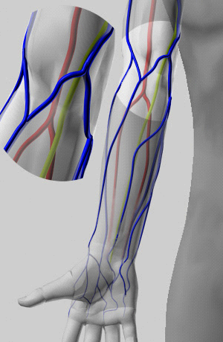

The lime green areas are the Medial Nerve. Make a note of where it lies in relation to the veins in the arm.

1. Open an alcohol pad and rub the site, working in concentric circles from the inside out. An iodine prep may be used in cases where the patient is allergic to alcohol or an alcohol study is being performed. Allow to air dry.
2. Assemble equipment according to the following.

***Disposable Eclipse™ Needle***

* 1. Attach needle luer to the syringe.
  2. Pull back on safety cover to remove the needle.

***Push Button Blood Collection Set (“Butterfly”)***

1. Peel back package at arrow exposing the back end of the wing set.
2. With thumb and middle finger, grasp the rear barrel of the wingset and remove from the package.
3. Attach the luer to the syringe.
4. Perform the phlebotomy:
   1. Stabilize the vein (with your non-dominant hand), using the thumb to draw the skin taut distal to the puncture site.

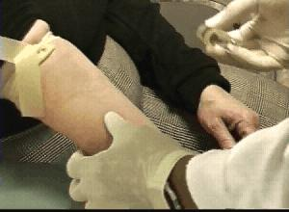

1. Loosen syringe plunger. Be sure to depress the plunger and expel all of the air prior to phlebotomy.
2. Holding the needle assembly in the dominant hand, remove the protective sheath from the needle. Forewarn patient that the venipuncture is about to occur. Hold the assembly with the bevel facing up, and insert the needle, at no more than a 30 degree angle.

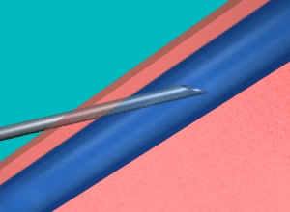

1. After insertion into the vein, gently pull back on the plunger until the syringe is filled with the required amount of blood.
2. If not already done, remove the tourniquet.
3. Withdraw the needle from the vein and immediately apply pressure to the venipuncture site using a folded 2 x 2 gauze.

***Note: Applying pressure before the needle is completely clear of the skin will cause the patients arm to be cut or scratched.***

1. Ask the patient to apply pressure for 3-5 minutes, and then check the site for bleeding. When bleeding has completely stopped, apply a bandage to the site. Advise the patient to remove it no sooner than 15 minutes.

***Note: Applying the bandage before bleeding has completely stopped could create a hematoma.***

1. Engage safety device according to the following.

***Disposable Eclipse™ Needle***

* 1. Use a one handed technique, center thumb or forefinger on the textured finger pad and push the safety cover forward over the needle until a lock can be felt and heard.

*Note: Activate away from self and others to guard against blood splatter.*

* 1. Visually confirm that the needle is covered.

***Push Button Blood Collection Set (“Butterfly”)***

1. Place gauze on the puncture site so that the nose and front of the barrel is covered.
2. **While needle is still in the vein**, grasp the body with the thumb and middle finger. Activate the button with the tip of the index finger.
3. Visually confirm the needle is covered.
4. Disengage syringe from disposable needle or push button collection set. Discard sharps into appropriate container.
5. Thread syringe onto one of the following adapters containing a **Female Luer Adapter**.
   1. Saf-T Holder Blood Culture Device
   2. 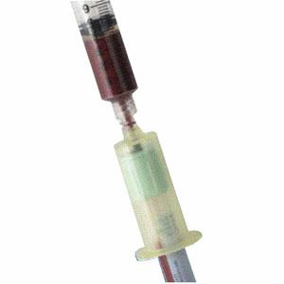BD Vacutainer Blood Transfer Device
6. Engage collection tube(s) following NCCLS guidelines with respect to order of draw:

* Blood Culture Bottles
* Coagulaton Tubes (**blue** top)
* Serum Tubes (with or without clot activator)
* Heparin Tubes (**green** top, with or without plasma separator)
* EDTA Tubes (**lavender** top)
* Glycolytic Inhibitor Tube (**gray** top)

***Note: The goal is to minimize/prevent cross contamination of tube additives. Be sure to repeatedly invert (not shake) additive tubes.***

1. Disengaged the last tube from the hub.
2. Discard syringe and adapter in the appropriate container.
3. Label the tubes according to Administrative Policy II-68 Specimen Labeling.

***Note: All specimens must be labeled in the presence of the patient. (JCAHO patient safety goal)***

1. Wash hands according to Hand Washing and Hand Care procedure (Infection Control Manual D001).

**Troubleshooting:**

* If necessary, the needle may be inserted further or pulled back a bit, as appropriate but under no circumstances should the needle be manipulated laterally.
* No more than 2 attempts will be made. Another person should attempt the collection, preferably in the other arm or distal to the first site attempted.
* When difficulty is encountered finding a vein, you may attempt the following:

1. Apply a heel-warmer or warm wet towel to the arm for 5 minutes to aid in dilating the vein.
2. Massage the arm from wrist to elbow to force blood into the vein.

**Procedural Notes:**

* Skin puncture (capillary collection) is recommended when venous collection is not a reasonable option.
* Results drawn from a line must be reviewed with care. See Attachment 1: Blood Collected From IV Arm for guidance.
* Specimens collected from an arm with an IV should be collected distal to (below) the site of the IV infusion. See Attachment 1: Blood Collected From IV Arm for guidance.
* Certain tests require special handling. Be sure to check Service Directory or other available references when drawing unfamiliar/unusual tests.
* Under no circumstances will a phlebotomist perform an arterial stick.
* No phlebotomist will perform a venipuncture on lower appendages without the physician’s consent and expressed permission of a laboratory supervisor. Using the appropriate canned comment, document draw site in Meditech collection comments.

|  |  |  |  |  |  |  |  |
| --- | --- | --- | --- | --- | --- | --- | --- |
|  | |  |  | | | | |
| Date of Origin: | 01/26/05 |  | Prepared By: | | | Brian Staring | |
| Revised: | 02/28/13 |  | By: | | | Teri Baldwin | |
|  | |  |  | | | | |
| **Date Placed in Service:** | |  |  | | | | |
|  | |  |  | | | | |
| **Approved by:** |  | |  |  |  | |  | |  |  |
|  | Supervisor | |  | Date |  | | Laboratory Director | |  | Date |

Saratoga Hospital Laboratory

211 Church Street, Saratoga Springs, New York 12866

**Attachment 1: Blood Collection From IV Arm**

*Specimen Collected Proximal or Distal to an IV*

* Specimens collected from an arm with an IV should be collected distal to (below) the site of the IV infusion. Apply the tourniquet between the IV site and the venipuncture site.
* If the sample must be collected proximal to (above) the IV or from the IV itself, the infusion must be stopped by nursing unit staff for a **minimum of three (3) minutes.**

***Note:*** *Collecting a specimen while the IV is still running or without waiting a minimum of (3) minutes will cause erroneous results.*

* It is necessary that a **Canned Comment** is entered by the phlebotomist. This is very important. Possible dilution effects must be considered along with variations associated with IV components (i.e., glucose concentrations in IV solutions may exceed 5,000% that of fasting plasma levels.)The only way anyone can identify the specimen was collected proximal or distal to an infusion site is by phlebotomy entered comments.

|  |  |  |
| --- | --- | --- |
| **System** | **Pneumonic** | **Comment** |
| **MobiLAB** | IV | Drawn proximal or distal to IV site. IV held for 3+ min. |
| **Meditech** | LIV | Drawn above IV |

*Specimen Collected from an IV Line*

* It is necessary for nursing staff to flush the IV prior to blood collection from a line.
  + Saline solution is recommended.
  + A minimum of 5cc should be wasted prior to blood collection.
  + When collecting samples for coagulation studies (i.e., PT,/PTT) from a line previously flushed with heparin, it is important for nursing staff to flush with a minimum of 5cc saline and waste 5cc of blood prior to collecting the sample.
* Results drawn from a line must be reviewed with care. Possible dilution effects must be considered along with variations associated with IV components (i.e., glucose concentrations in IV solutions may exceed 5,000% that of fasting plasma levels.) It is up to the phlebotomy staff to enter the canned comment “**LLINE”** during the receiving phase of specimen handling.

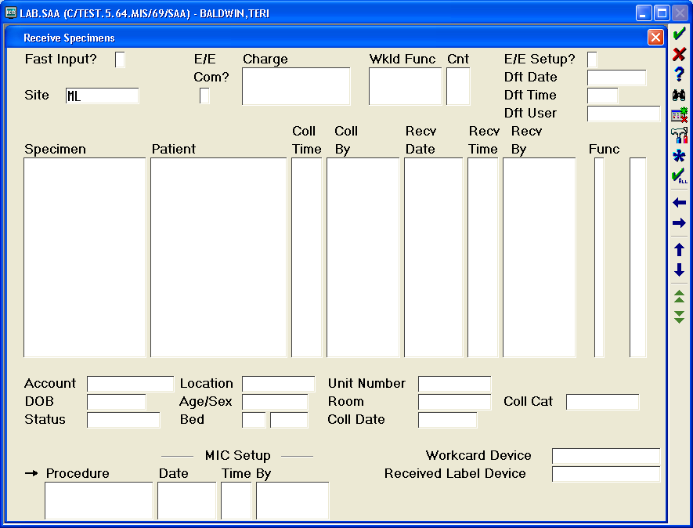

Place a “Y” in this box. Only enter specimens from this specific draw. Comment will be entered for all specimens.

* The phlebotomist may assist nursing staff in the collection of blood sample from a venous access line.
  + When more than one individual is involved in the collection process and samples change hands, read-back and verify must be performed. Nursing staff accessing the sample must read aloud the name, D.O.B. and H0 number directly from the wristband. The phlebotomist or other assistant will match and read-back this information as entered on the sample labels. If in agreement, the phlebotomist may place the barcoded labels on the samples. Nursing staff initials will be placed on the labels with the date and time of collection and a comment made in Meditech that read-back and verify was performed.