Saratoga Hospital Laboratory
211 Church Street, Saratoga Springs, New York 12866

Blood Specimen Collection Process Procedure

Purpose:
The purpose of this procedure is to provide instruction for the proper collection of blood specimens by venipuncture.

Principle:
Accurate, timely test results are vital with respect to diagnosis, treatment and overall health maintenance of the Saratoga Care Community. Laboratory testing begins with proper blood collection and accuracy is dependent upon specimen integrity.

Materials:
- Test requisition and/or labels generated from Meditech or MobiLab.
- Tourniquet, gloves, marking pen.
- Disposable needle holder w/Eclipse needle.
- Alcohol prep pad or alternate antiseptic wipe.
- 2 x 2 inch dry gauze sponge.
- Surgical/adhesive tape or band-aid.
- Appropriate blood collection tubes.
- Approved biohazard sharps container.

Procedure:

Note: Specimens will be rejected if patient specimens are not collected and labeled according to established procedure. See the laboratory’s “Specimen Rejection Protocol” for instructions on handling rejected specimens.

Note: See Attachment 1: Blood Collection From IV Arm

- Greet the patient. Employee must introduce themselves and inform the patient they are going to be performing venipuncture procedure.

- Wash hands according to Hand Washing and Hand Care procedure (Infection Control Manual D001).

- Identify the patient using a minimum of 2 identifiers following the guidelines established by Administrative Policy II-49 Patient Identification.
Note: See MobiLab Procedure.

- Assemble supplies specific for patient’s age and condition.
  - Choose appropriate tubes for the tests ordered. See Service Directory for test requirements.
Note: The Service Directory can be found at the following link: http://www.saratogahospital.org/index.cfm?contentID=223&itemID=429

- Put on protective gloves.
Note: Gloves must stay intact for the duration of the procedure.

- Position patient in chair or bed, arm outstretched and supported, in a manner both comfortable to the patient and accessible to the phlebotomist.

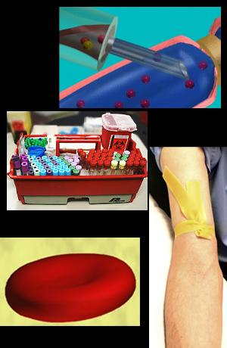
- Apply tourniquet (or other restrictive device) 3-4 inches above venipuncture site. If
blood pressure cuff is used, inflate to 40 mm Hg.

Note: Tourniquet should remain in place 1 minute or less.

- If necessary, ask patient to “make a fist” but avoid “pumping”.

- Identify the appropriate site for venipuncture by palpating the vein.

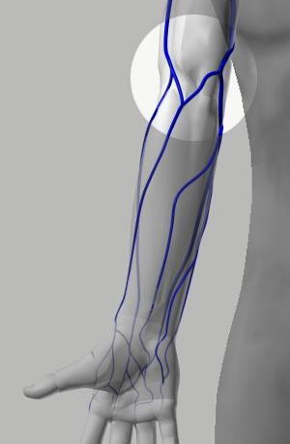
Note: The preferably mid-antecubital fossa

Guidelines:
  - Avoid→Healed Burns, Extensive Scaring, or Hematoma
  - Do Not→Draw from an arm on the same side as a mastectomy without physician approval.
  - Do Not→Draw from an arm having a Cannula, Fistula, or Vascular Graft without physician approval.

Avoid Nerves:
  - Keep in mind where nerves are found, and avoid these areas.

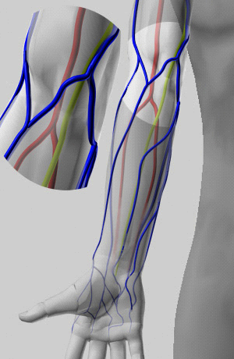
The lime green areas are the Medial Vein. Make a note of where it lies in relation to the veins in the arm.

- Open an alcohol pad and rub the site, working in concentric circles from the inside out. An iodine prep may be used in cases where the patient is allergic to alcohol or an alcohol study is being performed. Allow to air dry.

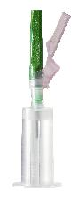
- Thread Eclipse Needle into disposable needle holder as per package insert.
  - Twist to remove cap
  - Securely screw holder onto needle
  - Rotate safety shield back toward the holder

- Perform the phlebotomy:
  - Stabilize the vein (with your non-dominant hand), using the thumb to draw the skin taut distal to the puncture site.
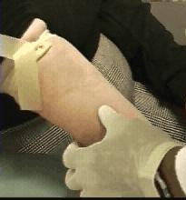

- Holding the needle assembly in the dominant hand, remove the protective sheath from the needle. Forewarn patient that the venipuncture is about to occur. Hold the assembly with the bevel facing up, and insert the needle, at no more than a 30 degree angle.
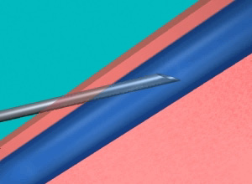

- Engage collection tube(s) following NCCLS guidelines with respect to order of draw (See Attachment2: Order of Draw Chart):
- Blood Culture Bottles
- Coagulaton Tubes (blue top)
- Serum Tubes (with or without clot activator)
- Heparin Tubes (green top, with or without plasma separator)
- EDTA Tubes (lavender top)
- Glycolytic Inhibitor Tube (gray top)

Note: When using a winged blood collection set, you must draw a discard tube first (need not be filled) to account for dead space in collection tubing. This should be either a non-additive or coagulation tube.

Note: The goal is to minimize/prevent cross contamination of tube additives. Be sure to repeatedly invert (not shake) additive tubes.

- Disengaged the last tube from the needle.

- If not already done so, remove the tourniquet.
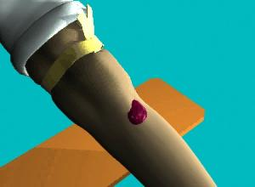
Note: Removing the needle prior to removing the tourniquet will cause excessive bleeding at the puncture site.

- Withdraw the needle from the vein and immediately apply pressure to the venipuncture site using a folded 2 x 2 gauze.
Note: Applying pressure before the needle is completely clear of the skin will cause the patients arm to be cut or scratched.

- Engage needle safety device.

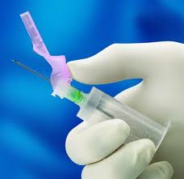

- The needle assembly should be disposed of as a whole, into an appropriate sharps container. Do not remove needle from or reuse holder.

- Ask the patient to apply pressure for 3-5 minutes, then check the site for bleeding. When bleeding has completely stopped, apply a bandage to the site. Advise the patient to remove it no sooner than 15 minutes.
Note: Applying the bandage before bleeding has completely stopped could create a hematoma.

- Label the tubes according to Administrative Policy II-68 Specimen Labeling.
Note: All specimens must be labeled in the presence of the patient. (JCAHO patient safety goal)

- Wash hands according to Hand Washing and Hand Care procedure (Infection Control Manual D001).

Troubleshooting:
- If necessary, the needle may be inserted further or pulled back a bit, as appropriate but under no circumstances should the needle be manipulated laterally.
- No more than 2 attempts will be made. Another person should attempt the collection, preferably in the other arm or distal to the first site attempted.
- When difficulty is encountered finding a vein, you may attempt the following:
- Apply a heel-warmer or warm wet towel to the arm for 5 minutes to aid in dilating the vein.
- Massage the arm from wrist to elbow to force blood into the vein.

Procedural Notes:
- Skin puncture (capillary collection) is recommended when venous collection is not a reasonable option.
- Results drawn from a line must be reviewed with care. Possible dilution effects must be considered along with variations associated with IV components. See Attachment 1: Specimen Collected from an IV Line.
- Specimens collected from an arm with an IV should be collected distal to (below) the site of the IV infusion. See Attachment 1: Blood Collection From IV Arm.
- Certain tests require special handling. Be sure to check Service Directory or other available references when drawing unfamiliar/unusual tests.
- Tubes should be filled as far as the vacuum permits.
- Under no circumstances will a phlebotomist perform an arterial stick.
- No phlebotomist will perform a venipuncture on lower appendages without the physician’s consent and expressed permission of a laboratory supervisor. Using the appropriate canned comment, document draw site in Meditech collection comments.

References:
NCCLS Procedures for the Handling and Processing of Blood Specimens; Approved Guideline-Second Edition, document H-18-A2, 940 West Valley Road, Ste. 1400, Wayne PA 19087-1898, 1999

NCCLS Procedures for the Collection of Diagnostic Blood Specimens by Venipuncture: Approved Standard-Fifth Edition, document H3-A5, 940 West Valley Road, Ste. 1400, Wayne PA 19087-1898, 2003.

Garza, Diana, EdD., MT(ASCP), CLS and Becan-McBride, EdD, MT(ASCP), “Phlebotomy Handbook, Blood Collection Essentials” 6th Edition, Prentice Hall, 2002

Read DC Viera H Arkin C: Effect fo Drawing Blood Specimens Proximal to an In-Place but Discontinued Intravenous Solution. Am J Clin Path. 1988 Dec;90(6): 702-706

Watson KR D.O. O’Kell RT M.D.: Data regarding Blood Drawing Sites in Patients Receiving Intravenous Fluids.
Am J Clin Path. Vol 79 #1 : 119-121

Ong YY Boykin SF Barnett RN: You Can Draw Blood from the “IV Arm” below the Intravenous Needle if You Put a Tourniquet in Between. Am J Clin Path. 1979 Jul; 72(1):101-102

Attachments:
Attachment 1: Blood Collection From IV Arm
Attachment2: Order of Draw Chart

Date of Origin: | 01/25/05 |  | Prepared By: |  |  | Brian Staring
Revised: | 01/17/08 |  | By: |  |  | Brian Staring
 | 07/13/12 |  | By: |  |  | Teri Baldwin
Date Placed in Service:
Approved by:
 | Supervisor |  |  | Date |  |  | Laboratory Director |  |  | Date

Saratoga Hospital Laboratory
211 Church Street, Saratoga Springs, New York 12866

Attachment 1: Blood Collection From IV Arm

Specimen Collected Proximal or Distal to an IV

- Specimens collected from an arm with an IV should be collected distal to (below) the site of the IV infusion. Apply the tourniquet between the IV site and the venipuncture site.

- If the sample must be collected proximal to (above) the IV or from the IV itself, the infusion must be stopped by nursing unit staff for a minimum of three (3) minutes.

Note: Collecting a specimen while the IV is still running or without waiting a minimum of (3) minutes will cause erroneous results.

- It is necessary that a Canned Comment is entered by the phlebotomist. This is very important. Possible dilution effects must be considered along with variations associated with IV components (i.e., glucose concentrations in IV solutions may exceed 5,000% that of fasting plasma levels.)The only way anyone can identify the specimen was collected proximal or distal to an infusion site is by phlebotomy entered comments.
System | Pneumonic | Comment
MobiLAB | IV | Drawn proximal or distal to IV site. IV held for 3+ min.
Meditech | LIV | Drawn above IV

Specimen Collected from an IV Line

- It is necessary for nursing staff to flush the IV prior to blood collection from a line.
  - Saline solution is recommended.
  - A minimum of 5cc should be wasted prior to blood collection.
  - When collecting samples for coagulation studies (i.e., PT,/PTT) from a line previously flushed with heparin, it is important for nursing staff to flush with a minimum of 5cc saline and waste 5cc of blood prior to collecting the sample.

- Results drawn from a line must be reviewed with care. Possible dilution effects must be considered along with variations associated with IV components (i.e., glucose concentrations in IV solutions may exceed 5,000% that of fasting plasma levels.) It is up to the phlebotomy staff to enter the canned comment “LLINE” during the receiving phase of specimen handling.

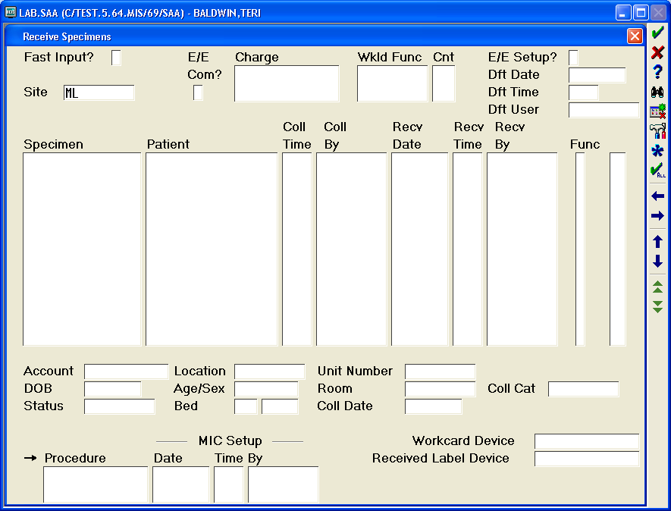
Place a “Y” in this box. Only enter specimens from this specific draw. Comment will be entered for all specimens.

- The phlebotomist may assist nursing staff in the collection of blood sample from a venous access line.
  - When more than one individual is involved in the collection process and samples change hands, read-back and verify must be performed. Nursing staff accessing the sample must read aloud the name, D.O.B. and H0 number directly from the wristband. The phlebotomist or other assistant will match and read-back this information as entered on the sample labels. If in agreement, the phlebotomist may place the barcoded labels on the samples. Nursing staff initials will be placed on the labels with the date and time of collection and a comment made in Meditech that read-back and verify was performed.

Saratoga Hospital Laboratory
211 Church Street, Saratoga Springs, New York 12866
Attachment2: Order of Draw Chart
1 | 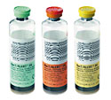  Blood Cultures
2 | 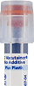  Discard tube  3 mL "no additive" must be used ONLY if drawing a citrate (blue) tube  with a tube holder and butterfly needle. Used only to remove air from tubing.
3 | 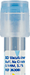  Light Blue top tube1.8 mL (Na Citrate) |  |  | 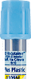  Light Blue top tube 2.7 mL (Na Citrate)
4 | 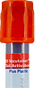  Red top tube5 mL (Clot Activator)
4 | 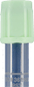  Light Green top tube 4.5 mL (gel Lithium Heparin) (Plasma Separator Tube - PST)
6 | 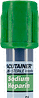  Green top tube - 4 mL ( Na Heparin) |  |  | 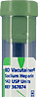  Green top tube-10 mL (only Na Heparin)
7 | 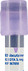  Lavender top tube-3 mL (K2-EDTA) | 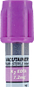  Lavender top tube-4 mL (K2-EDTA) |  | 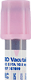  Pink top tube-6 mL (K2-EDTA) | 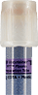  White top tube5 mL (gel K2-EDTA)
8 | 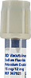  Gray top tube-6 mL (Na Flouride)
9 | 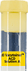  Yellow top tube-8.5 mL (ACD solution A)
10 | 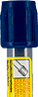  Dark Blue top tube-2 mL Fibrin Degradation Product (FDP) tube; soy trypsin or soy trypsin inhibitor.
Draw Royal Blue top tubes in the order indicated by the additive.

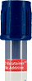  7 mL (No additive) - Red strip on label - Draw as #4 |  |  | 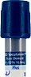  6 mL (K2-EDTA) - Blue strip on label - Draw as #7
Note: It is also important to ensure a discard tube is drawn when a blood collection set is used and only a citrate tube is ordered, as the tubing may contain up to 0.5 mL of air that will be drawn into the tube and displace blood volume.

