Saratoga Hospital Laboratory
211 Church Street, Saratoga Springs, New York 12866

Blood Specimen Collection Process by Skin Puncture

Purpose:
This procedure provides instruction for the proper collection of blood specimens by capillary puncture.

Scope:
In cases where venous access is limited (i.e. burned, obese or geriatric patients) or when quantity is a concern (i.e. premature infants), blood collection by skin puncture may be an alternative.

Materials:
- Test requisition and/or labels generated from Meditech or MobiLab
- Marking pen
- BD Microtainer Quikheel Lancet or BD Microtainer Genie Lancet
- Alcohol prep pad or alternate antiseptic wipe
- Gloves
- 2 x 2 inch dry gauze sponges
- Surgical/adhesive tape or Band-Aid
- Appropriate microcollection tubes/devices
- Medichoice liquid infant heel warmer
- Approved biohazard sharps container.

Procedure:

- Greet the patient. Employee must introduce themselves and inform the patient they are going to be performing Skin Puncture procedure.

- Wash hands according to Hand Washing and Hand Care procedure (Infection Control Manual D001).

- Identify the patient using a minimum of 2 identifiers following the guidelines established by Administrative Policy II-49 Patient Identification.

- Assemble supplies.
  - Use Quickheel Lancet for heel puncture.
  - Use Genie Lancet for finger puncture.

- Put on protective gloves.
Note: Gloves must stay intact for the duration of the procedure.

- Choose the puncture site:
  - Adults or children over one year old: Palmar surface of the middle or ring finger’s distal phalanx (see figure 1.).

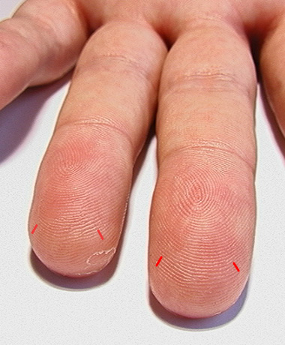

  - Neonates and infants: Lateral or medial plantar surface of the heel.

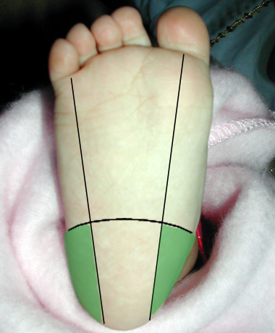

- If necessary, warm the site using Medichoice heel warmer.
Note: Directions for use are found on each warmer.

- Position patient.
  - If performing heelstick, lay infant supine on flat surface.

- Open an alcohol pad and rub the site, working in concentric circles from the inside out. An iodine prep may be used in cases where the patient is allergic to alcohol or an alcohol study is being performed. Allow to air dry.

- Puncture the heel/finger across the print grain.

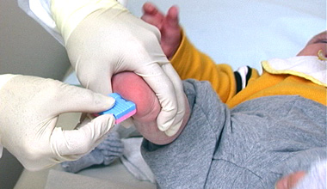

- Using a gauze pad, wipe away the first drop of blood.

- Holding puncture site downward, gently apply intermittent pressure to the surrounding tissue or in the case of a fingerstick,
proximal to the puncture site.

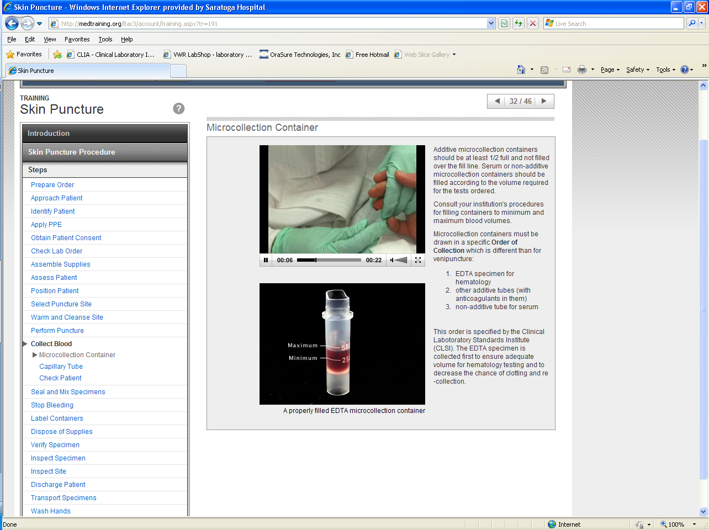
Note: . Avoid strong, repetitive“milking.”

- Touch the tip of a microcollection device/tube to the formed drop, allowing it to fill via capillary action. Repeat for additional collection tubes.

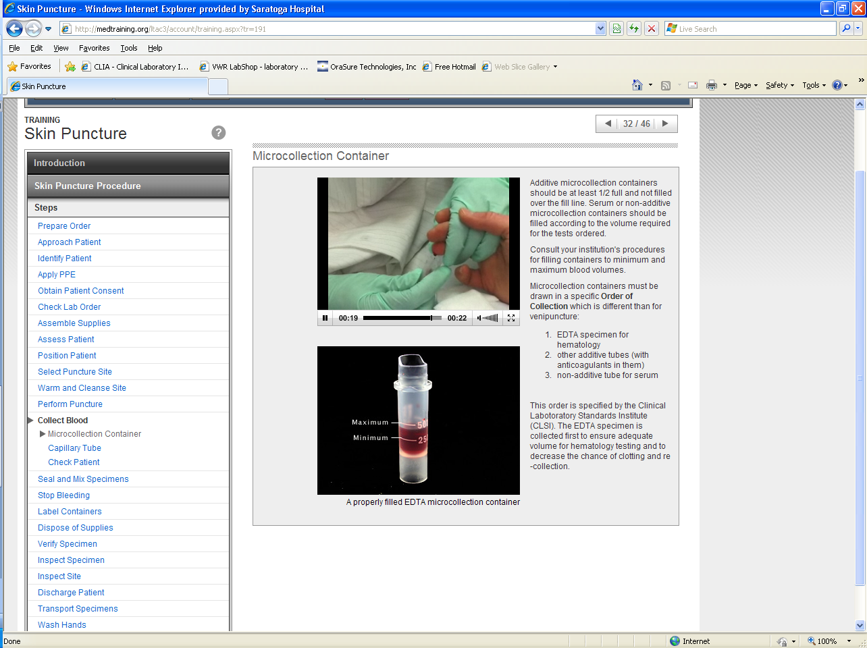

- Collect specimens using correctorder of draw.

Note: Skin Puncture order of draw is not the same as Venipuncture order of draw.
- EDTA
- Other Additive
- TubesSpecimens Requiring Serum

Note: EDTA/anticoagulated samples must be immediately capped and gently inverted.

After collection, apply pressure for 3-5 minutes, then check the site for bleeding. When bleeding has completely stopped, apply a bandage to the site. Advise the patient to remove it no sooner than 15 minutes.
Note: Do not apply adhesive bandages on children less than 2 years old

- Dispose of lancet in approved sharps container.

- Label the tubes according to Administrative Policy II-68 Specimen Labeling.
Note: All specimens must be labeled in the presence of the patient. (JCAHO patient safety goal)

- Wash hands according to Hand Washing and Hand Care procedure (Infection Control Manual D001).

References:
NCCLS Procedures and Devices for the Collection of Diagnostic Capillary Blood specimen; Approved Standard-Fifth edition, document H4-A5, 940 West Valley Road, Ste. 1440, Wayne, PA 19087-1898, 2004

Gray, Jack; The Phlebotomy Tutorial-Capillary Puncture, Finger & Heel Stick Procedures
http://www.phlebotomy-tutorial.com 2004

Date of Origin: | 03/09/12 |  | Prepared By: |  |  | Brian Staring
Revised: | 07/13/12 |  | By: |  |  | Teri Baldwin
Date Placed in Service:
Approved by:
 | Supervisor |  |  | Date |  |  | Laboratory Director |  |  | Date

