Saratoga Hospital Laboratory

211 Church Street, Saratoga Springs, NY 12866

**ED/OUT Board**

**Purpose:**

To provide phlebotomy staff with instruction on how to set up specimen tracking screen to monitor Outpatient and Emergency Department patient flow.

**Scope:**

This procedure applies to all phlebotomy staff members working in The Saratoga Hospital Laboratory.

**Ed/Out Board Procedure:**

See ***Attachment 1: LABTVP*** for instructions on how to sign in to the TVP screen.

1. From the Laboratory Main Menu in Meditech, choose **52. Management Reports**.
2. From the Lab Management Reports screen, choose **5. Pending Specimen Tracking Screen**.
3. In the LAB Pending Specimen Tracking: Selection, enter through until the cursor is in the Elapsed Time Since field. Change **Received** to **Order**.

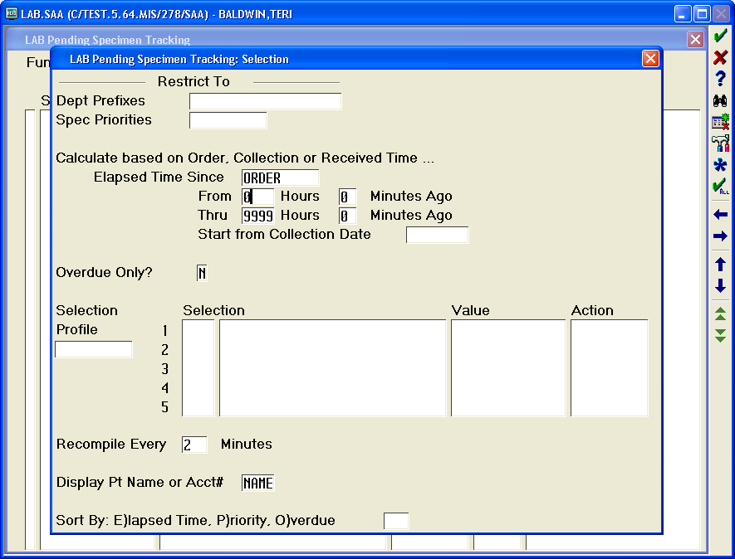

1. Continue to enter through until the cursor is in the Thru field. Change **9999** to **24**.
2. Enter through until the cursor is in the Selection Profile field. Press the F9 key and select the following.

**8 EDOUT ED AND OUTPATIENT NOT RECEIVED LMB**

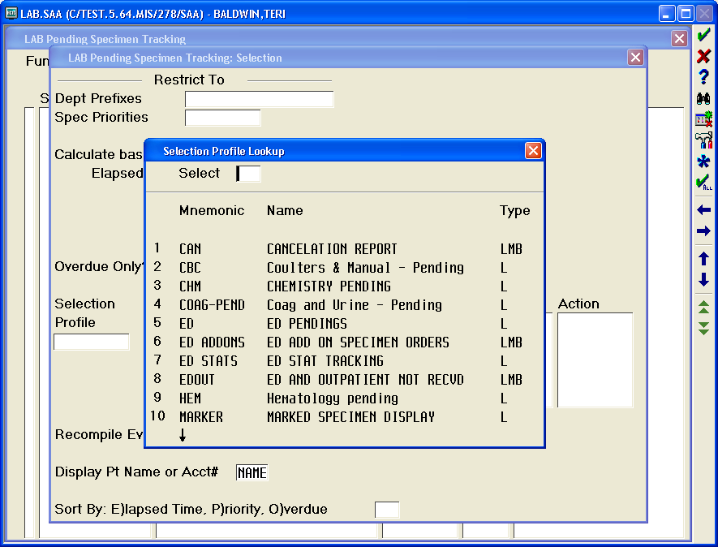

1. Press F12 on the key board. The LAB Pending Specimen Tracking screen will be displayed.

**Procedural Notes:**

* Order to draw times for Outpatients and the Emergency Room should be within 15 minutes. This is equivalent to .25 hours on the tracker.
* Excessive overdue specimen collections (>0.5) must be investigated. If the investigation does not provide sufficient explanation for the delay, the charge person must be notified.

**Attachments**

Attachment 1: LABTVP

|  |  |  |  |  |  |  |  |  |  |
| --- | --- | --- | --- | --- | --- | --- | --- | --- | --- |
| Date of Origin: | 03/20/13 | |  | Prepared By: | | Teri Baldwin | | | |
|  |  | |  |  | |  | | | |
|  | | |  |  | | | | | |
| **Date Placed in Service:** | | |  |  | | | | | |
|  | | |  |  | | | | | |
| **Approved by:** | |  | |  |  |  |  |  |  | |
|  | | Supervisor | |  | Date |  | William E. Field II, MD |  | Date | |

Saratoga Hospital Laboratory

211 Church Street, Saratoga Springs, NY 12866

**Attachment 1: LABTVP**

1. Sign into the TVP desk top.

*Note: User Name is* ***LABTVP*,** *Password is* ***phlebotomy1***

1. Once the desk top has loaded, click on **Meditech 3.26**
2. Sign into Meditech.

*Note: User Name is* ***LAB.TVP****, Password is* ***PATHOLOGY10***