Saratoga Hospital Laboratory

211 Church Street, Saratoga Springs, NY 12866

**Morning Rounds Procedure**

**Purpose:**

The purpose of this procedure is to standardize the times and order of morning blood collection.

**Scope:**

This procedure applies to all laboratory employees involved in the collection, receiving or distribution of samples at the Saratoga Hospital and client sites as well as to blood specimen collection and distribution.

**Specimen:**

This procedure applies to all specimen types collected at the Saratoga Hospital and client sites.

**Materials:**

|  |  |
| --- | --- |
| 1. Specimen Requisitions 2. Meditech Terminal 3. Barcode Labels 4. Sample Racks 5. Phlebotomy Carts and Trays | 1. Mobile Phone 2. MobiLAB Handheld 3. Wireless Zebra Printer 4. Phlebotomy Supplies |

**Quality Control:**

Monthly review of QA documentation, training records and competencies.

**Procedure:**

* **Start times of Floors and Sites:**

|  |  |
| --- | --- |
| Floor/Site | Time/Day |
| ICU | 4 am |
| Wesley | 4:45 am MWF, 5 am TTH (on site) |
| D3ORTHO/Timed Draws on C3 | 4:30 am |
| D1 | 5 am |
| Westmount | 5:30 am Thurs (on site) |
| A3 | 6 am |
| C3 | 6 am |
| Four Winds | 6 am |
| Maplewood | 6 am Mon, 7 am Tues-Fri (on site) |
| G1, D2 | 6:30-7 am |

* **Inpatients draws:**

1. Obtain a tray, cart, phone, and MobiLAB handheld with wireless zebra printer.   
   ***Note:*** *make sure the handheld and zebra printer have adequate battery life (more than 50%) as well as a sufficient amount of labels.*
2. Write assigned location on the phlebotomy white board along with phone extension.
3. Configure MobiLab.
   1. Hold the red button located on the front right corner of the MobiLAB handheld device. Allow time for start-up.

***Note:*** *Quick Start straight into MobiLAB when device is in standby/sleeper mode by quickly tapping the red button.*

* 1. Gently pull out the wand located on the back left side of the MobiLAB handheld device.
  2. With the end of the wand gently touch the screen on the word ***MobiLAB*** at the top left of the screen.
  3. Allow time for the Iatric System to load.
  4. The following screen will appear.

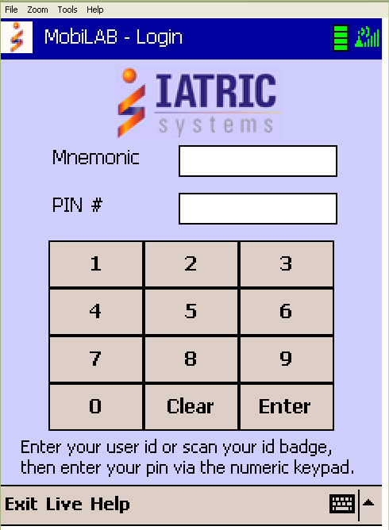

* 1. Enter your user ID or scan your ID badge, then enter your pin via the numeric keypad. At bottom right corner tap the keyboard to bring up a keyboard to allow you to enter in your mnemonic if unable to scan in ID badge.
  2. The handheld device will communicate with the Meditech system to validate the user and compile the Draw List based upon the user’s previous configuration settings.
  3. Tap the ***Config*** button to select the appropriate patient locations and label printer you have chosen.

***Note:*** *Due to the volume of morning draws, it is necessary to configure the MobiLab to only display the draws for the floor the phlebotomist has been assigned.*

* 1. The ***Select Configuration Option*** screen will appear.

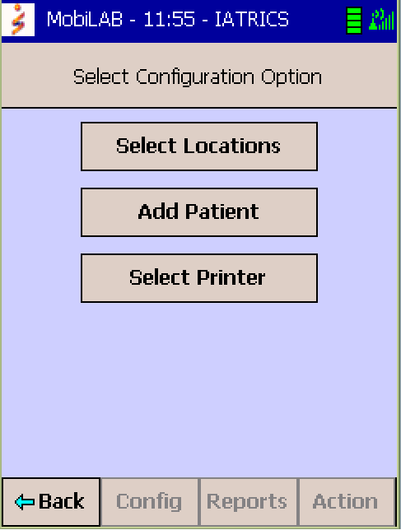

* 1. Tap the ***Select Locations*** button to display a list of the patient locations.
  2. Tap ***Action*** button located at bottom right corner. A pop-up box will appear. Select or deselect patient locations based on your phlebotomy assignment (see aforementioned *Start times of Floors and Sites* diagram).

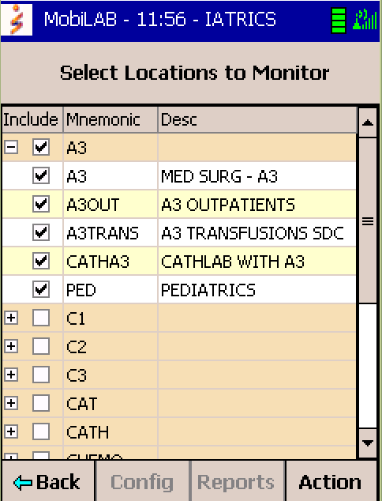

* 1. Tap the ***Set*** button to save changes and the back button to return to the ***Select Configuration Option*** screen.

1. Proceed to the floor and begin your collections following Blood Specimen Collection Process Procedure and Iatric System’s MobiLab Procedure.

*Note: Do not wait for another phlebotomist unless training is involved.*

1. When finished drawing patients, return to the lab, receive the specimens according to Iatric System’s MobiLab Procedure and deliver specimens to the departments.

***Note:*** *ICU and D3 ORTHO specimens should be brought to the laboratory as soon as possible. Results for ICU must be completed by 6am, D3 ORTHO by 6am and the other floors by 8am.*

1. When more patient draws are pending, proceed to the next floor.

***Note:*** *Phlebotomists must call Receiving when changing floor so that the white board will accurately show their location.*

1. At 6:30 am check the outpatient area for coverage or assist any phlebotomists still on the floors.
2. Stock all trays and carts after morning draws are completed.

* **Off-Site Draws:**
  + Plan to arrive at the facility 10 minutes prior to collection starting time.
* Maplewood, Westmount and Wesley
  + All supplies are on site and should be restocked as needed by the Phlebotomist assigned to the site.
  + Chemistry specimens must be spun after they clot. Process the chemistry specimens before you return to the main lab.

***Note:*** *Chemistry specimens should be completely clotted before spinning or they may be rejected. Therapeutic drug specimens must have the serum transferred to a pour off tube before returning to the main lab. All specimens must be labeled with the patient’s full name and DOB.*

* Four Winds
  + There is a draw box that should be restocked every day after returning to the main lab.
  + Therapeutic Drugs should be spun immediately upon returning to the main lab and separated into pour off tubes to avoid rejection. These specimens must be handled IMMEDIATELY!

***Note:*** *Therapeutic drug specimens must have the serum transferred to a pour off tube before returning to the main lab. All specimens must be labeled with the patient’s full name and DOB.*

* Result must be available the sites by 10:30am.

|  |  |  |  |  |  |  |  |
| --- | --- | --- | --- | --- | --- | --- | --- |
|  | |  |  | | | | |
| Date of Origin: | 01/26/10 |  | Prepared By: | | | | Roger Brodeur |
| Revised: | 04/23/10 |  | By: | | | | Roger Brodeur |
| Revised: | 10/06/10 |  | By: | | | | Teri Baldwin |
| Revised: | 07/13/12 |  | By: | | | | Teri Baldwin |
|  | |  |  | | | | |
| **Date Placed in Service:** | |  |  | | | | |
|  | |  |  | | | | |
| **Approved by:** |  | |  |  |  |  | | |  |  |
|  | Supervisor | |  | Date |  | Laboratory Director | | |  | Date |