Saratoga Hospital Laboratory
211 Church Street, Saratoga Springs, NY 12866

Iatric System’s MobiLAB

Principle:

The purpose of this document is to identify a Standard Operating Procedure for the Iatric MobiLAB Handheld Device and printer. Phlebotomists will be apprised of orders arising from Order Entry (OE) in inpatient care areas as well as the Emergency Department Module (EDM) in real-time on the MobiLAB device. Phlebotomists may only generate labels by scanning patient wristband and correctly identifying patient. The use of MobiLAB should virtually eliminate patient identification errors.

Scope:

This procedure applies to all phlebotomists located at Saratoga Hospital’s main lab responsible for collection of specimens from inpatients and outpatients in the emergency department.

Procedure:

Section I. Starting the MobiLAB device:
- Hold the red button located on the front right corner of the MobiLAB handheld device. Allow time for start-up.
Note: Quick Start straight into MobiLAB when device is in standby/sleeper mode by quickly tapping the red button.

- Gently pull out the wand located on the back left side of the MobiLAB handheld device.

- With the end of the wand gently touch the screen on the word MobiLAB at the top left of the screen.

- Allow time for the Iatric System to load.

- The following screen will appear.

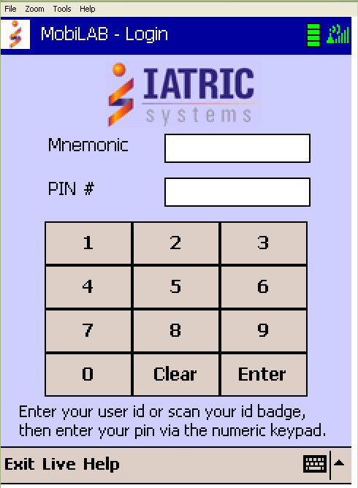

- Enter your user ID or scan your ID badge, then enter your pin via the numeric keypad. At bottom right corner tap the keyboard to
bring up a keyboard to allow you to enter in your mnemonic if unable to scan in ID badge.

- The handheld device will communicate with the Meditech system to validate the user and compile the Draw List based upon the user’s previous configuration settings.

- Tap the Config button to select the patient locations and label printer you have chosen.

- The Select Configuration Option screen will appear.

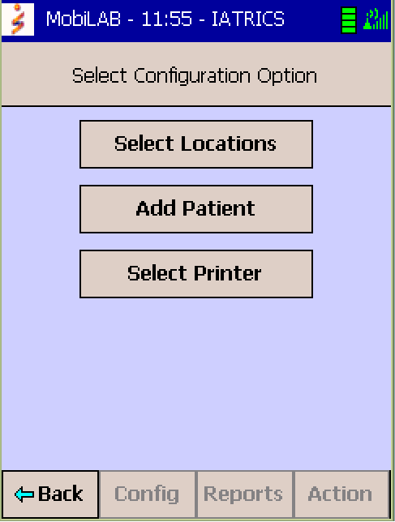

- Tap the Select Locations button to display a list of the patient locations. Select or deselect patient locations based on your phlebotomy assignment.

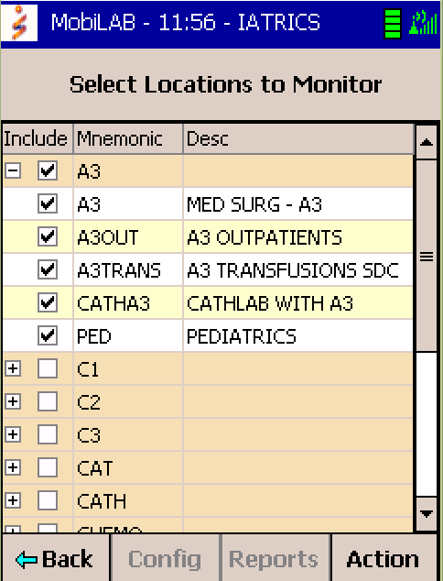
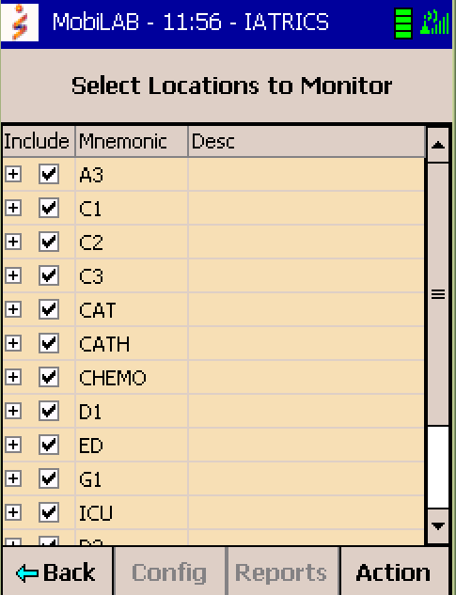

- Tap Action button located at bottom right corner. A pop-up box will appear.

- Tap the Set button to save changes and the back button to return to the Select Configuration Option screen.

- Tapping Sel None will deselect all locations, Sel All will select all locations and Refresh will clear entries and select the locations designated before edits began.

- At Select Configuration Option Screen tap Select Printer button to select the appropriate label printer. You may scan in the printer to be used by pressing and holding down either orange button located on the sides of the handheld (same button for turning the device on). A red beam will appear, hold this beam about 6-7 inches away from the bar-coded label located on the handheld device. The printer chosen is now designated for that handheld device. Selecting a printer can also be done by tapping the down button to select your printer from the list provided.

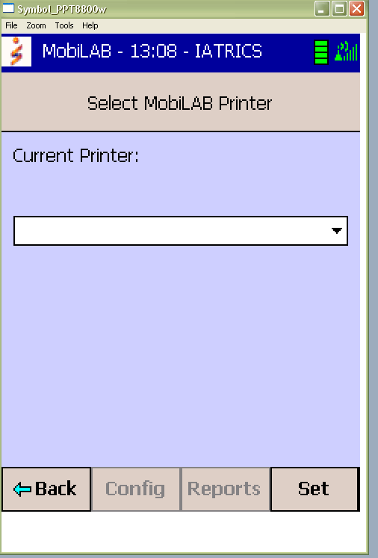

- Tap the Set button located at bottom right corner to set the printer for that handheld device.

- Then tap Back button located at bottom left corner to exit out of screen.

- The Draw List will recompile and display specimens for patients admitted to the locations you have selected.

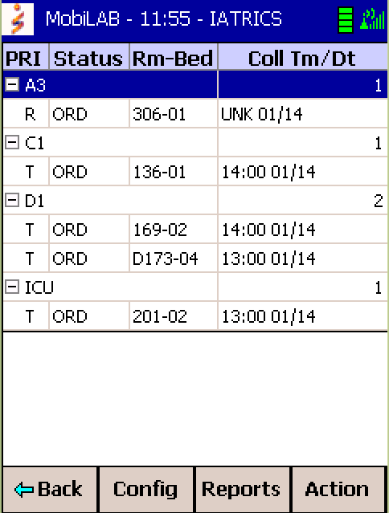

- Tap the screen to select the room/bed of a patient.

- If there are any Special Instructions this will appear. The phlebotomist acknowledges the specimen instructions before advancing to the next screen by tapping the GO button in the lower right corner.

Example: GREEN TUBE SODIUM HEPARIN ON ICE

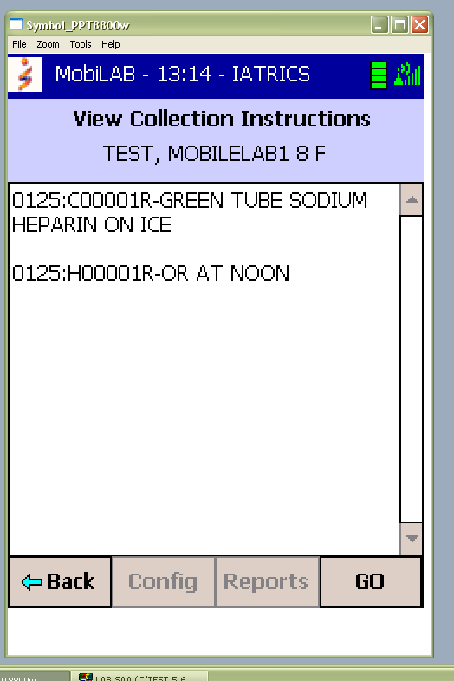

Section II. Drawing a patient:

- Enter the patient room, greet the patient, identify yourself, and tell the patient you are here from the laboratory to draw their blood.

- Ask the patient to state their name. Upon confirmation, scan the barcode on their wristband by depressing either of the yellow buttons located on the side of the handheld device.

- If the wristband scanned matches the patient on the screen, the user will advance to the Secondary Identification Required screen.
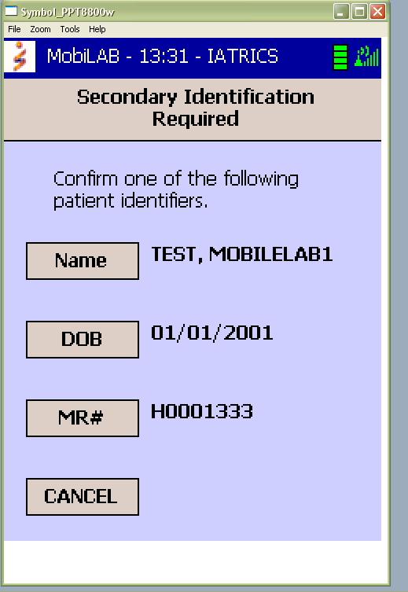
- Ask the patient to state their date of birth (DOB) and confirm secondary identification by tapping DOB.

- If Cancel button is selected, the phlebotomist will be returned to the previous screen and the patient identification process canceled.

- After a secondary identifier is selected, the handheld communicates back to the Meditech system to confirm the patient has been positively identified.

- The Patient Screen displays demographic information at the top, followed by the specimen numbers, test names, and containers to be drawn.

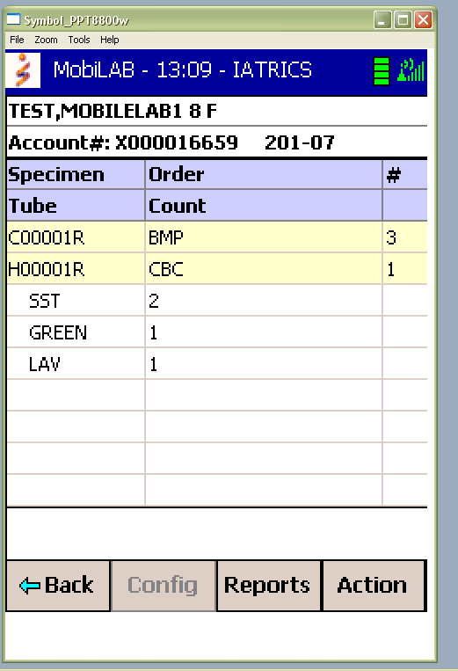

- Once positive patient identification has been verified, the demographic portion of the patient screen turns green and specimen labels print.

- The containers display and specimen labels print with the phlebotomist’s mnemonic, the time, and date in the preferred order of draw defined in the customer defined parameters.

- Perform phlebotomy according to Blood Specimen Collection Process. Affix specimen labels to collected tubes. Discard unused labels in blue confidential bin.

- Perform specimen verification by scanning each labeled specimen tube. Press and hold down the yellow button at the side of the handheld to verify each labeled specimen tube. The handheld will communicate with Meditech following each scan, verifying that the specimen label matches the patient whose wristband was scanned and documents the collection information (date, time, and phlebotomist user mnemonic).

- The specimen number turns green, indicating a positive specimen to patient verification and the tube count in the # column decreases by one.

- The Apply Specimen Charge screen appears. Tap appropriate box to apply Charge or tap drop down list provided. A No Charge option is available on the third button.

- Collection charges are entered into the Meditech LIS along with specimen collection date/time, phlebotomist user ID, and comments via the MobiLAB receive routine.

- The specimen status will change from ORD to COLL and will be removed from the Pending Draw List screen.

- Tap Action, followed by the All button, to change the view of the Draw List screen to include draws that are pending as well as collected that have not been received in Meditech. The Collection TM/Dt column will update from the scheduled collection time and date to the actual collection time and date.

- Tap Action, followed by the Pending buttons, to return to the Draw List Screen that includes specimens that have not been collected.

Section III. Warning Messages:

The phlebotomist is notified if errors occur during the collection process. A brief explanation of the display is included for the errors depicted.

Scenario 1: Incorrect Patient Wristband Scanned
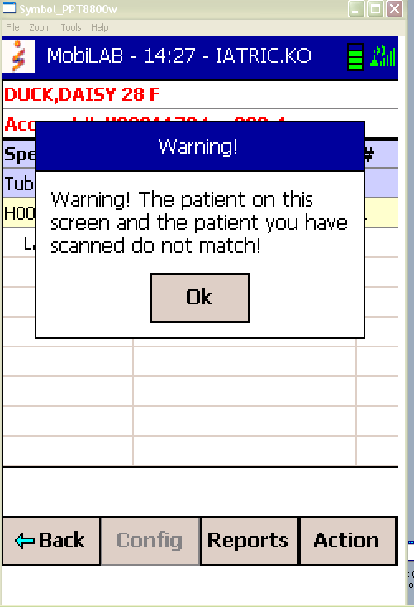
- Warning message displays for the phlebotomist.
- Patient demographics turn red.
- All function buttons are disabled until the user taps OK to acknowledge the message and remove the dialog box.
- The screen does not advance to request a secondary identifier.
- Specimen labels do not print.
- If the Action button is selected, all label printing and specimen verification buttons are disabled.
- Verification error is documented.

Scenario 2: Cancel button selected on Secondary Identifier Screen

- Patient demographics remain black indicating positive patient identification has not been completed.
- Specimen labels do not print.
- All label printing and specimen verification buttons are disabled.

Scenario 3: Incorrect Specimen Label Scanned

- Warning message appears.
- All function buttons are disabled until the user taps OK to acknowledge the message and remove the dialog box.
- Specimen remains unverified.
- Verification error is documented.

Scenario 4: All Specimen Labels not Scanned

- If the user attempts to return to the Draw List by tapping the Back button before all specimen labels have been scanned, the Confirm Exit message displays.
- If the user taps the Yes button, they will be required to enter a not drawn reason comment from the drop down list of the Specimen Not Drawn Reason screen.
- The draw will appear teal noting that a phlebotomist attempted to draw the patient and will record a viewable reason why.
- If the phlebotomist taps the No button, they will be returned to the patient screen to continue scanning labeled tubes.
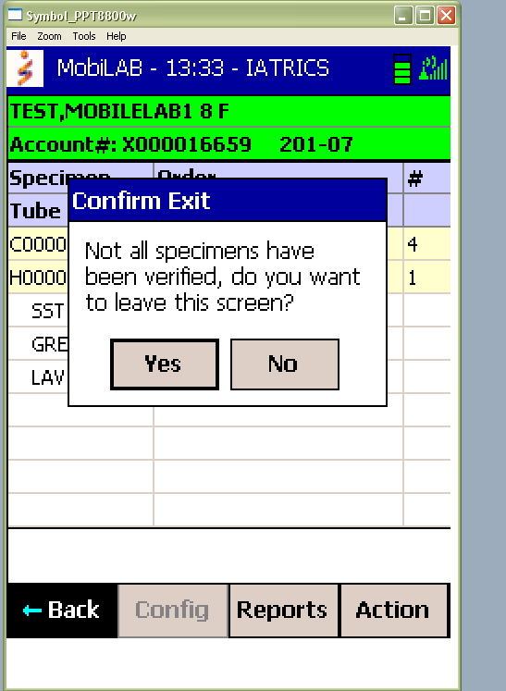
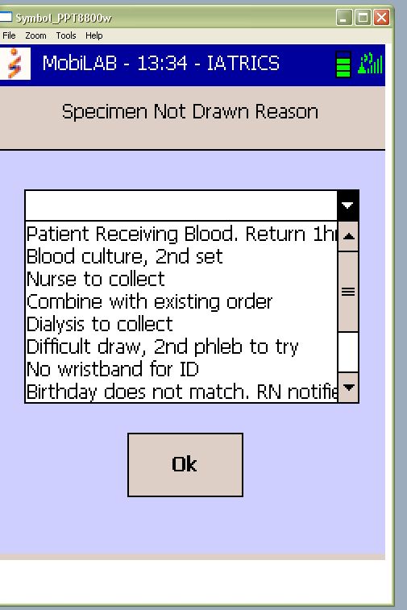

Section IV. Recieving Procedure
- Enter the MobiLAB Phleb Menu, option 101 on the laboratory Meditech menu.

- Select MobiLAB Receive Specimens, option 1.

- Create a new batch by entering “N” under batch.

- Scan tubes. Phlebotomist’s user mnemonic, time of collection, patient name and account number will appear in the appropriate fields.

- In order to be sure all specimens have been received, press the spacebar on the keyboard followed by enter.
Note: Check the EDOUT board to be sure all specimens have been received for ED patients.

- Press enter and select yes when prompted to receive specimens.

- Labels will print on printer LABLBL for tests where a label is required for the department.

- Deliver specimens and labels to the appropriate department.

Section V. Special Function Screens

Function 1. Combine Screen
The Combine Screen warns the user of future collections scheduled for the patient within the time interval defined in the parameters. The purpose of this feature is to provide the user an opportunity to combine specimens into a single blood draw, if clinically appropriate, and avoid additional venipuncture to the patient. Ie Routine PTP ordered for later collection than the current draw.

- If the time of specimen collection is equal for multiple specimens, they will be selected on the Combine Screen.
- If all of the specimens are for the same collection time, they will display as a single entry on the Draw list and the Combine Screen will not display.

- Tap individual specimens, or tap Action and then Sel All or Sel None to select or de-select specimens on the Combine Screen.
- Tap Go to continue to the Patient screen and begin the patient identification process with the selected specimens in the preferred order of draw defined in the parameters.
Function 2. Stat Paging
- Handheld devices will beep and vibrate when a new stat order is entered in Meditech.
- Stat orders are viewed as either assigned or unassigned. Assigned stat orders are stat orders for patients whose location is currently being monitored by one or more handheld devices. Unassigned stat orders are stat orders for patients admitted to locations defined in the parameters as eligible for collection using MobiLAB which are not currently being monitored by any handheld device.

Assigned Stat Alerts
All handheld devices currently assigned to monitor a particular patient location will be alerted when a new stat order is entered for a patient admitted to that location.

- The handheld device will beep and vibrate
- Tap the OK and then the Back button to return to the Draw List.
- The Draw List display will be updated with the stat order in red.
Unassigned Stat Alerts
If no handheld device is currently assigned to monitor a patient location defined in the MobiLAB parameters and a stat order is entered for a patient admitted to that location, all active devices of users defined in an Access group with Poll Stat?=Y will be alerted.

- The handheld device will beep and vibrate. The Unassigned Stat Orders screen will display.
- Tap the Back button or Action, then Accept buttons to accept the stat order.

The first user to accept the order will receive the message “Assign IML Stat OK” when they return to the Draw List.

That user’s handheld will beep and vibrate a second time and the assigned stat screen will display, confirming acceptance. The user’s Draw List screen will then be updated with the stat order.

All other users attempting to accept the stat will be notified it has already been accepted by another user.

If the phlebotomist deselects the stat by removing the check mark in the Sel box and taps the Back button a warning message displays, “You are choosing to not accept these Stat Orders”.

To confirm refusal of the stat order, acknowledge the warning message, and exit the screen, tap OK. The Draw List will not be updated with the stat order.

Tap Cancel to clear the warning message and accept the stat order following the steps listed above.

*****STAT orders will be monitored by accessioning and logged in the STAT Call Log*****

Function 3. Specimen Look Back

MobiLAB has the ability through a customer defined parameter to define a window of time, in minutes, for which previously collected specimens can be displayed on the handheld. This notifies the phlebotomist if an opportunity exists to perform the current test request on a specimen in the laboratory. Following discussion with the nurse or physician, if clinically appropriate, testing can be performed on the previously collected sample and additional venipuncture to the patient avoided.

- Upon entering the patient screen, the specimen look back is performed.
- If the patient had specimens collected within the time interval defined in the parameters, an asterisk will display following the patient name.
- Tap the patient name to view the list of previously collected specimens.
- If the current test request will be performed on a previously collected specimen, tap the IN LAB button.
- Enter the appropriate Not Drawn Reason.

The status of the current specimen will update from ORD to LAB and will be removed from the draw list screen when it is received or canceled in the Meditech LIS. Notification will print in lab on lab.chem1.

Function 4. Specimen Comments
Prior to scanning the specimen(s) with the MobiLAB device, the phlebotomist may note any special conditions surrounding the draw. For example, if the source was not venous, this is noted by selecting Action and Cmt and then the appropriate comment from the drop down menu. Available comments are listed below:

- Culture drawn from left arm
- Culture drawn from right arm
- Patient receiving blood during draw
- Drawn during dialysis
- @ Extra tubes drawn (viewable by lab only)
- Finger stick collection
- Heal stick collection
- Drawn proximal or distal to IV site: IV held for 3+ minutes
- REVIEW RESULTS WITH CAUTION: specimen collected from line
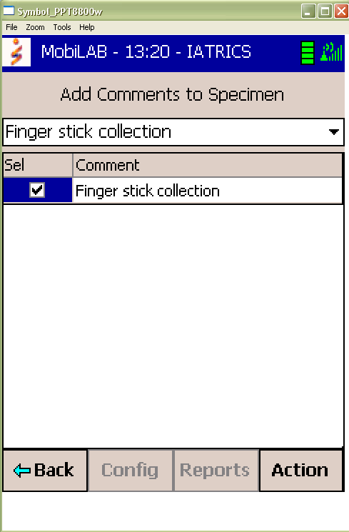
Function 5. View Meditech User Notes
Enables the user to view additional test information or special instructions defined in Meditech User Notes.
- From the Patient screen, tap the specimen, then Action and Notes buttons to display user notes defined for the ordered test(s).

Function 6. MobiLAB Reports
The System Activity, Specimen Management and Workload Reports allow supervisory and management personnel to monitor and track the specimen collection process. They provide information on device utilization, specimen handling, turn around time and productivity enabling you to effectively manage specimen collection activities. These reports can be run out of the Iatric NPR database or added to an NPR menu.

Section VI. Loading media (labels)
- Obtain replacement roll of labels (stored in accessioning).

- Push black button located on the side of the printer in the middle.

- Latch will raise, pull back media cover.

- Pull media supports apart.

- Take out old roll of media and insert new roll. (see figures 1-3 below)

- Labels should face towards the front of the printer rolling upwards from underneath

Figure 1  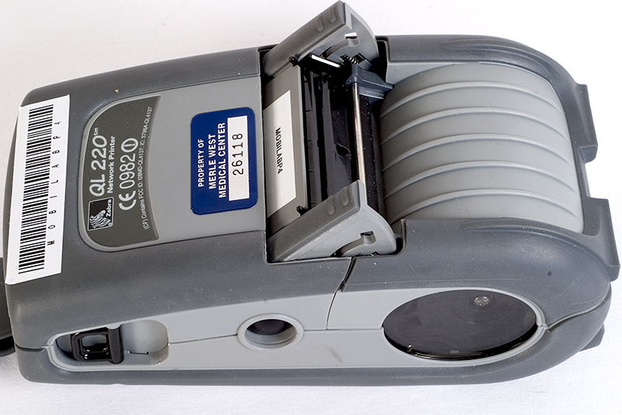 | 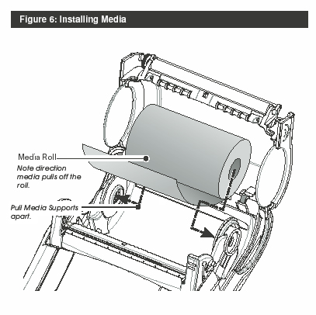  Figure 3
Figure 2
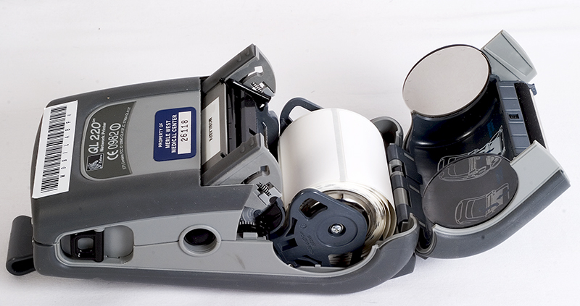

Section VII. Cleaning the MobiLAB Device

- The meter should be handled with care. Sudden shocks caused by dropping or rough treatment may affect performance. If the MobiLAB device is dropped check the device to make sure it works by turning on both the device and the program.

- The MobiLAB must be cleaned between patients with a dampened (not wet) Asepti-Wipe TM II

Note: Do not spray the MobiLAB device directly with solution, as this could cause solution to enter the case and damage the electronic components.)

Section VIII. Troubleshooting

Warm boot
A warm boot will reboot the system. To do a warm boot hold and press down the small red button located on the front on the MobiLAB device. Use this button if the MobiLAB device is locked up. A warm boot might be needed after changing the batteries.

Cold boot
A cold boot will reboot the whole device, thus restoring all files. This is done if the warm boot does not work. Contact the Superusers or I.S. if this is needed. Document user name, handheld number, date, time of flaw in MobiLAB troubleshooting log located in accessioning.

Down MobiLAB
If a meter is not working, fill out Attachment 1: MobiLAB Repair Form, rubberband it around the unit and leave the package on the table where the mobiLABs are kept. The phlebotomy supervisor will follow up with Iatrics for consultation, in case there is a problem with the program itself, otherwise the device will need to be sent back to the vendor, RMS Omega. Iatric System number is 978-805-4126, our contact is Linda Trask, Product Manager, Application Support Team, Application Software Division.

Related procedures:
Saratoga Hospital Inpatient Specimen Collection

Attachments:
Attachment 1: MobiLAB Repair Form
Attachment 2: MobiLAB Procedure Fast Find Table

Date of Origin: | 1/15/10 |  | Prepared By: |  |  | Jon Patrick Ford
Revised: | 07/13/12 |  | By: |  |  | Teri Baldwin
Date Placed in Service:
Approved by:
 | Supervisor |  |  | Date |  |  | Laboratory Director |  |  | Date

Saratoga Hospital Laboratory
211 Church Street, Saratoga Springs, New York 12866

Attachment 1: MobiLAB Repair Form

Date: |  |  | Repair Initiated By: |  |  |  | Unit #:
Issue:
Unit Repaired & Placed Back in Service: |  |  |  | €
Unit Sent to IS: |  |  |  | € | Date Sent: |  |  | Date Returned:
Unit Sent to Motorola: |  |  |  | € | Date Sent: |  |  | Date Returned:
RMA#:

Saratoga Hospital Laboratory
211 Church Street, Saratoga Springs, New York 12866

Attachment 2: MobiLAB Procedure Fast Find Table

Section Name | Page #
Starting the MobiLAB device | 1
Drawing a patient | 3
Warning Messages: Incorrect patient wristband scanned | 5
Cancel button selected on Secondary Identifier Screen | 5
Incorrect specimen label scanned | 5
All Specimen labels not scanned | 5
Recieving Procedure | 5
Special Function Screens: Combine Screen | 6
Special Function Screens: Stat Paging | 6
Special Function Screens: Specimen Look Back | 7
Special Function Screens: Specimen Comments | 7
Special Function Screens: View Meditech User Notes | 8
Special Function Screens: MobiLAB Reports | 8
Loading media (labels) | 8
Cleaning the MobiLAB Device | 8
Warm boot | 9
Cold boot | 9

