Saratoga Hospital Laboratory

211 Church Street, Saratoga Springs, NY 12866

**Night Shift Phlebotomy Procedure**

**Purpose:**

The purpose of this procedure is to standardize maintenance and daily processes for the night shift phlebotomist.

**Scope:**

This procedure applies to all laboratory employees involved in the ordering, collecting, receiving or distribution of samples at The Saratoga Hospital laboratory, as well as to all specimen types received at the laboratory including pathology specimens.

**Materials:**

|  |  |
| --- | --- |
| * Phlebotomy supplies * Meditech terminal * Barcode label printer * MobiLAB * Wireless Zebra Printer | * Sample racks and bins * Refrigerator * Caviwipes * TelephoneOffice supplies, |

**Quality Control:**

Maintenance and temperature logs are reviewed monthly. Turn around time is reviewed by the Quality Assurance Supervisor.

**Procedure:**

1. **11pm-12am**

* Receive report from evening phlebotomist and check outstanding report.
* Clean area with Caviwipes including racks, bins, refrigerator, carts, and chairs.
* Dispose of blood and urine samples from the previous day in a biohazard container.
* Complete all specimen collections due before midnight.
* On Sunday night replace the paper on LABLPT in the front office with yellow holed paper

1. **12:10am**

* Generate Uncollected Report.
  + 101 MOBILAB PHLEB MENU
  + 2 MOBILAB SPECIMEN MANAGEMENT REPORTS
  + UNCOLLECTED SPECIMENS
  + Fill in blanks according to the following.

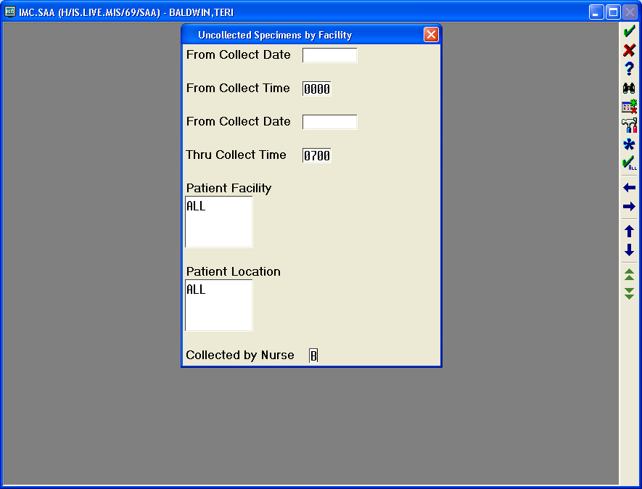

**Today’s Date**

**Today’s Date**

* Highlight duplicate orders in the Uncollected Specimen report.
* Cancel duplicate orders and combine multiple “C” and “H” numbers.
* If possible try to combine early morning draws with morning rounds to save the patient multiple sticks. Consult with the unit secretaries about this.

*See Attachment 1for instructions to be used during MobiLab Downtime.*

***Note:*** Dinner/break time- any draws that come in, must still be completed during this time.

1. **03:30 am**

* Generate new Uncollected Specimen report using same process previously described.

***Note:* This reports main objective is to assess any test orders placed in Meditech since 12:10 am.**

* Highlight duplicate orders in the Uncollected Specimen report.
* If possible try to combine early morning draws with morning rounds to save the patient multiple sticks. Consult with the unit secretaries about this.

1. **4am-5am**

* Begin ICU draws at 4am.
* Receive ICU specimens in lab and deliver to the departments.

Begin D3ORTHO draws. *Note: D3ORTHO draws can begin at 4:30 if ICU is done.*

* Receive D3ORTHO spec**i**mens in lab and deliver to the departments.

1. **5am-6:30am**

* Phlebotomist must be in the accessioning area to receive stats from ED and AMS. All AMS specimens are treated as STAT.
* Receive specimens for other phlebotomists as time permits and deliver to the departments.
* Following the Hand-off Communication in the Laboratory procedure (SOP#:BAR), give report to the day shift CLA or charge phlebotomist.

***Note:*** *The Night Shift phlebotomist must be available to cover the outpatient area until 7am unless another phlebotomist is down from the floors.*

**Other Tasks (as time permits):**

* Fill physician orders
* Put stock away
* If there are not many collections in ICU and D3ORTHO, start the collections on D1 after receiving D3ORTHO specimens.
* ED phlebotomist should assist with AM draws by drawing D3ORTHO and Stats

|  |  |  |  |  |  |  |  |
| --- | --- | --- | --- | --- | --- | --- | --- |
|  | |  |  | | | | |
| Date of Origin: | 01/08/10 |  | Prepared By: | | | | Roger Brodeur |
| Revised: | 10/06/10 |  | By: | | | | Teri Baldwin |
| Revised: | 07/16/12 |  | By: | | | | Teri Baldwin |
|  | |  |  | | | | |
| **Date Placed in Service:** | |  |  | | | | |
|  | |  |  | | | | |
| **Approved by:** |  | |  |  |  |  | | |  |  |
|  | Supervisor | |  | Date |  | Laboratory Director | | |  | Date |

Saratoga Hospital Laboratory

211 Church Street, Saratoga Springs, NY 12866

**Attachment 1: MobiLab Downtime**

* Print labels for morning rounds in Meditech. *10 laboratory*
* *11 Specimen Collection*
* *13 Preview and Create*

1. Separate labels according to floor, making sure the times are correct and all draws for the patient are due at the same time.

* Cancel duplicate orders and combine multiple “C” and “H” numbers.
* If possible try to combine early morning draws with morning rounds to save the patient multiple sticks. Consult with the unit secretaries about this.

|  |  |
| --- | --- |
| ***From Category***  ***Thru Category***  ***From Location #***  ***Thru Location #***  ***Priority*** | **Hit the Enter Key**  **Hit the Enter Key**  **Hit the Enter Key**  **Hit the Enter Key**  **Hit the Enter Key** |
| * **Arrow down to the MSURG Category** * **Check the MSURG Category by pressing the 0500,0600,0700, & POOL and press Ctrl on the keyboard creating a √ next to each Category** * **Press F12 on the keyboard and follow prompts to print the labels** | |
| **Collection Batch Preview (Work List)** | |
| **From Category BEGINNING**  **Thru Category END Last Compile Time 1444**  **From Location # BEGINNING**  **Thru Location # END**  **Priority SUTR Recompile After 5 Minutes**  **-Current- -Tomorrow- -After T+1-**  **Category Spec Pat Spec Pat Spec Pat**    √  √  √  √  0000000000  0  0  0  0  0  0  0  0  0  0  0  0  0  0  0  0  0  0  0  0  5  1  22  3  4  5  6  7  0  5  1  2  3  4  5  6  7  0  1  5  1  2  3  4  5  6  7  0  1  0500  0600  0700  1800  1830  2000  POOL  OUTDR  PROF  WMA | |