Saratoga Hospital Laboratory

211 Church Street, Saratoga Springs, NY 12866

**Total Allowable Blood Volume Limits for Pediatric Patients**

**Purpose:**

To provide phlebotomy staff with the guidelines on the total allowable blood volume limits for pediatric patients.

**Principle:**

Iatrogenic anemia is a condition resulting from repeated venipunctures, for the purpose of obtaining specimens, for laboratory testing. This type of anemia is not uncommon and is most often seen in, pediatric patients due to their small blood volume, as well as seriously ill patients.

**Scope:**

This procedure applies to all phlebotomy staff members working in The Saratoga Hospital Laboratory, or any of its Patient Service Centers.

**Procedure:**

1. Prior to any pediatric phlebotomy procedure, review the patient’s history to determine any specimen volume drawn within the last 30 days.
2. Carefully review the orders to calculate the volume of blood to draw and select the necessary blood tubes.

For patients under the age of 14, determine the following using ***Attachment 1: Maximum Allowable Total Blood Draw Volumes Chart.***

* 1. Maximum allowable blood draw volume for a 24 hr period
  2. The allowable blood draw volume for a 30 day period for repeat patients using

***Note: If the minimum amount required for testing exceeds the maximum allowable, the ordering provider must be notified. The provider will determine which tests should be performed.***

***Note: Blood draw volumes in excess of the maximum allowable must be approved by the ordering physician and such approval documented using the provided canned comment “LLBVOK” in Meditech through enter/edit requisition.***

1. All volumes must be recorded according to ***Attachment 2: Entering Total Volume Collect for Patients < 14 years***.
2. Every attempt will be made to minimize unnecessarily large blood draw volumes. The following is a list of steps that will be taken to minimize blood draw volumes.
   1. Use smaller collection tubes when possible.
   2. Share single tubes for multiple tests.
   3. Combine orders when approved by patient care staff.

**References:**

North Shore LIJ. (2013, January 15). *Maximum blood draw limits*. Retrieved from http://www.feinsteininstitute.org/wp-content/uploads/2013/02/Maximum-Blood-Draw-Limits.pdf

**Attachments:**

***Attachment 1: Maximum Allowable Total Blood Draw Volumes Chart.***

***Attachment 2: Entering Total Volume Collect for Patients < 14 years***.

|  |  |  |  |  |  |  |  |  |  |
| --- | --- | --- | --- | --- | --- | --- | --- | --- | --- |
| Date of Origin: | 03/01/07 | |  | Prepared By: | | Brian Staring | | | |
|  | 06/08/09 | |  | Revised By: | | Roger Brodeur | | | |
|  | 03/20/13 | |  | Revised By: | | Teri Baldwin | | | |
|  |  | |  |  | |  | | | |
|  | | |  |  | | | | | |
| **Date Placed in Service:** | | |  |  | | | | | |
|  | | |  |  | | | | | |
| **Approved by:** | |  | |  |  |  |  |  |  | |
|  | | Supervisor | |  | Date |  | William E. Field II, MD |  | Date | |

Saratoga Hospital Laboratory

211 Church Street, Saratoga Springs, NY 12866

***Attachment 1: Maximum Allowable Total Blood Draw Volumes Chart.***

|  |  |  |  |
| --- | --- | --- | --- |
| **Body Wt. (lbs)** | **Total Blood Volume (mL)** | **Max allowable volume in a 24 hour period (mL)\*\*** | **Max allowable volume in a 30-day period (mL)\*\*** |
| **2.2** | 100 | 2.5 | 5 |
| **4.4** | 200 | 5 | 10 |
| **6.6** | 240 | 6 | 12 |
| **8.8** | 320 | 8 | 16 |
| **11** | 400 | 10 | 20 |
| **13.2** | 480 | 12 | 24 |
| **15.4** | 560 | 14 | 28 |
| **17.6** | 640 | 16 | 32 |
| **19.8** | 720 | 18 | 36 |
| **22** | 800 | 20 | 40 |
| **24-33** | 880-1200 | 22-30 | 44-60 |
| **35-44** | 1280-1600 | 32-40 | 64-80 |
| **46-55** | 1680-2000 | 42-50 | 64-100 |
| **57-66** | 2080-2400 | 52-60 | 104-120 |
| **68-77** | 2480-2800 | 62-70 | 124-140 |
| **79-88** | 2880-3200 | 72-80 | 144-160 |
| **90-99** | 3280-3600 | 82-90 | 164-180 |
| **101-110** | 3680-4000 | 92-100 | 184-200 |
| **112-121** | 4080-4400 | 102-110 | 204-220 |
| **123-132** | 4480-4800 | 112-120 | 224-240 |
| **134-143** | 4880-5200 | 122-130 | 244-260 |
| **145-154** | 5280-5600 | 132-140 | 264-280 |
| **156-165** | 5680-6000 | 142-150 | 284-300 |
| **167-176** | 6080-6400 | 152-160 | 304-360 |
| **178-187** | 6480-6800 | 162-170 | 324-340 |
| **189-198** | 6880-7200 | 172-180 | 344-360 |
| **200-209** | 7280-7600 | 182-190 | 364-380 |
| **211-220** | 7680-8000 | 192-200 | 384-400 |

**The above chart information was obtained from North Shore LIJ.**

Saratoga Hospital Laboratory

211 Church Street, Saratoga Springs, NY 12866

***Attachment 2: Entering Total Volume Collect for Patients < 14 years***.

**Pediatric Volume Entry:**

1. From the Meditech Laboratory Main Menu, choose **11. Specimen Collection**.
2. From the LIS Specimen Collection Menu, under Receive, choose **21. By Specimen**.
3. Enter through until the cursor is in the E/E COM? Field. Type **Y** in the space and hit Enter. The Default Specimen Comments screen will pop up.

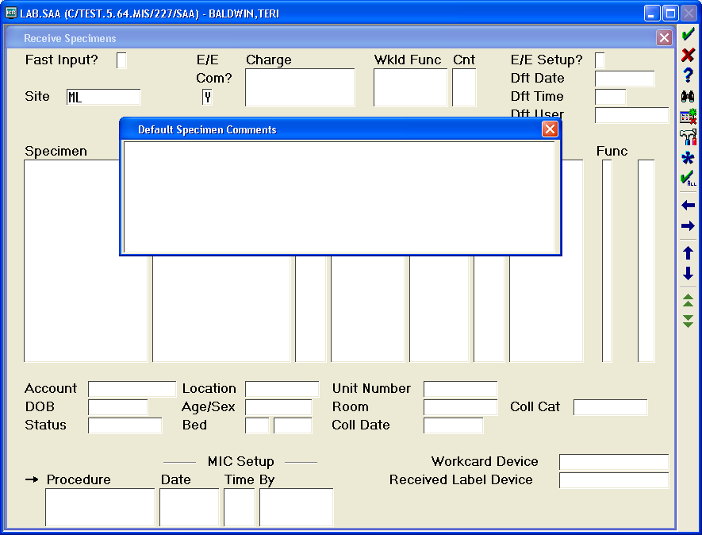

1. Press the F4 key and type **LLBV**, followed by the Enter key. The following canned comment will be displayed in the Default Specimen Comments screen.

**@Total blood volume collected:**

**@Patient weight:[ ]**

1. Type the amount of blood in mL collected from the patient. The curser will move to the second line of the comment.
2. Type the patient’s weight, followed by the enter key.
3. Press the ESC key to close the Default Specimen Comments box.
4. Enter through the fields until the curser is in the Specimen field.
5. Receive specimens according to the Receiving Procedure.

***Note: There is no way to enter the volume collected, through the MobiLAB.***