Saratoga Hospital Laboratory

211 Church Street, Saratoga Springs, NY 12866

Accessioning Area

ACCESSIONING OF LABORATORY SPECIMEN DROP-OFFS [SDO]

MEDITECH OUTREACH

**Purpose:**

The purpose of this procedure is to provide instructions on the receipt, order entry and distribution of the laboratory SDOs using the Meditech Outreach Module.

**Scope:**

This procedure applies to all laboratory employees involved in the ordering, receiving or distribution of samples within the laboratory. It applies to all specimens received from physician’s offices and clients.

**Policy:**

In order for testing to be completed, all patient specimens must be registered in the Meditech computer system. To ensure efficient and timely processing and reporting of laboratory results, outreach specimens (SDOs) are registered using the Meditech Outreach module. This allows the lab to complete an abbreviated registration so that specimen processing can proceed without delay.

Once the specimen is registered in Meditech outreach module, the requisitions are forwarded to Admitting or the Laboratory Registrar for completion.

**IMPORTANT NOTE: *To ensure that the patient bill is processed appropriately, ALL outreached requisitions must have a full registration completed by midnight of the same day!! Failure to complete the registration prior to the deadline will result in inaccurate billing or the patient receiving a bill as a self pay.***

**Procedure:**

*Receipt and Accessioning of Specimens:* (Accessioner)

1. Specimens are delivered to the accessioning area.
2. Requisitions and specimens are triaged upon receipt. Stats are separated and processed first.

NOTE: Each requisition is completely processed before proceeding to the next requisition. This includes verification of order, registration of test order and labeling of specimens.

1. Each order is checked individually to ensure that:
   * Specimen information matches the information on the requisition.
   * A correct specimen is submitted for each test requested.
   * The complete name, DOB, physician signature, and diagnosis are present.

NOTE: Requisitions with the following criteria cannot be registered with outreach. Forward the requisitions to the lab registrar or admitting.

* + - Missing DOB,
    - Patient is not in the Meditech system,
    - Provider is not in the Meditech system.

1. Enter patient and test orders in Meditech via the outreach module:

* Select Lab module.
* Select Outreach routine.
* Option #10 Requisition
* Option #10 Requisition
  + Req. # N = New
  + Bill Type – Enter “P” for SDO

Enter “C” for Client

***Note: Selecting the correct bill type is imperative for correct billing. Be sure that the “Bill To”field automatically fills in with the client mnemonics.***

**The client must automatically fill in.**

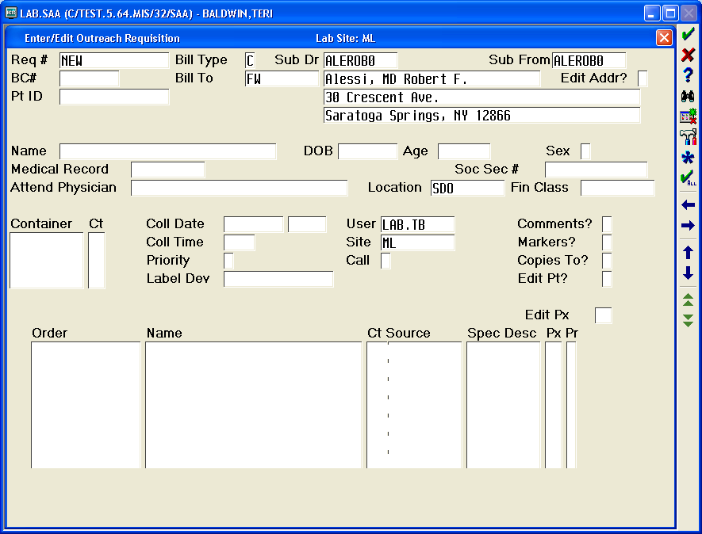

* + Sub Dr = Doctors name (F 9 for look-up)
  + Patients full name
  + Date Of Birth (if there is no DOB give requisition to admitting)
  + Age- defaults from date of birth
  + Sex- M or F
  + Medical Record-review Master Patient Index [MPI] for previous visit. History:
    - * If patient name and DOB match select patient. If available, social security number can be used as an additional identifier.
      * If the system states *“Medical Record name is different from* *name on req, Continue?”* there may be a discrepancy with an initial, etc. Enter “Y”, press “Enter” twice. Enter “C” for copy the medical record. **NEVER UPDATE THE MEDICAL RECORD**.

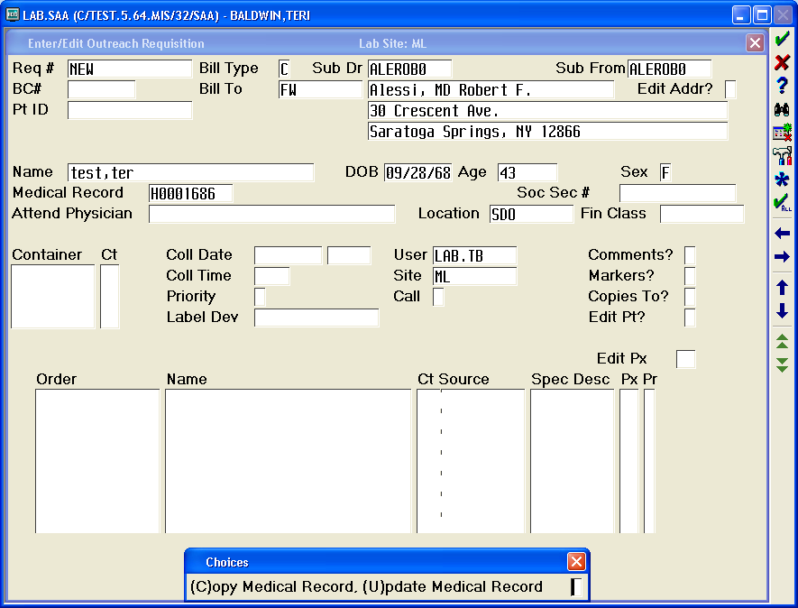

* + - * If no match is found, the medical record field defaults to “NEW”.

Note: Selecting the correct patient is critical to preserving the integrity of patient’s medical record. If you are unsure about which record to choose, contact admitting for assistance.

* + Location – “SDO” for specimen drop-off.

* Choose F9 for clients and select the appropriate location, (e.g. For Catlin, mnemonic FW-CATLIN)

* Draw station locations must be entered, (e.g. Corinth SDOAR).

***Note: Selecting the correct location is imperative for proper delivery of reports.***

* + Container (F9 look-up will help you choose)
  + Date, Time
  + Priority (R=routine, S= stat)
  + Label Device = LABLBL
  + User- defaults automatically entered
  + Site- defaults to main lab
  + Order- Enter the requested test order, using the *Look-up* function of the *Test Dictionary* when necessary.
  + Edit “Px”- required only if edits are needed to collection information.
  + Comments (include fax, call results, and/or faxes, duplicate report requests, etc.)
  + Copies to: select additional physician as requested on requisition.
  + Enter Y for yes at the “*File?”*  prompt.

1. Place aliquot labels on the corresponding requisition and the barcode label on the appropriate specimen.
2. Deliver samples to the appropriate laboratory section.
3. Tech Check requisitions according to the Clerical Error Detection procedure.
4. Count requisitions and document on the tracking record.
5. Take the requisitions and the white copy of the tracking record to Admitting and placed in the lab SDO box.
6. Place the yellow copy of the tracking record in the lab registrar box that is located in the front office.

Notes:

* Client registrations for Wesley, Skidmore, Maplewood, and Rubin will be admitted by laboratory registrar. Both copies of the tracking form go to the Lab Registrar. If the lab registrar is not available, bring the requisitions to Admitting for processing.

*Follow-up on Outreach Requisitions:*  (Lab Registrar)

1. Admitting will return requisitions to the laboratory front office. Count requisitions and document on the tracking record. All requisitions **must** be accounted for prior to signing off on the record

**NOTE: If admitting needs to follow-up on a requisition:**

* Admitting will document problem on tracking log.
* Make a copy of the requisition and return requisition to the lab.

1. To ensure that all requisitions are accounted for, match the yellow and white copies. Refer any discrepancies to the supervisor. File tracking forms in the laboratory requisition file by date.

*Medicare ABN Review:*

1. Lab registrar will:
   * Generate NPR Outreach report for Medicare patients.
   * Retrieve requisitions for all Medicare patients who were registered under outreach.
   * Perform Medical Necessity Check as per SOP.

Date of Origin: 9/22/04 Prepared by: Outreach Implementation Team

Date revised: 2/18/09, 2/9/12 Revised by: Madeline LaPierre/Joe Kaz

Placed in service:_________________

Approved by:

__________________________ __________ ___________________________ _________

Supervisor Date Laboratory Office Manager Date

___________________________ _________

Laboratory Director Date