Saratoga Hospital Laboratory

211 Church St. Saratoga Springs, N.Y. 12866

Accessioning Procedure

**Principle:**

The purpose of this procedure is to standardize order entry, receipt, and distribution of specimens in the laboratory.

**Scope:**

This procedure applies to all laboratory employees involved in the ordering, receiving, or distribution of samples within the laboratory.

**Specimen:**

This procedure applies to all specimen types received in the laboratory excluding pathology specimens.

**Materials:**

1. Specimens
2. Requisitions
3. Computer Terminal
4. Barcode Label Printer
5. Sample Racks and Bins
6. Centrifuge
7. Aliquot Tubes
8. Refrigerator / Freezer
9. Time Clock
10. Telephone
11. Office supplies, not limited to, but including pens, markers, labels, note pads and notebook.

**Quality Control:**

* All requisitions will be reviewed by phlebotomy staff for accuracy.
* Unreceived specimen reports will be reviewed and resolved each shift.
* Test orders are written and processed in accordance with NYS guidelines, CMS and other federally funded payer guidelines.

*Authorization*

Requisitions must be requested by a licensed physician, designated staff or other authorized persons by law:

* Physician
* Dentist
* Chiropractor
* Physician Assistant & Certified Nurse-Midwife provided the supervising physician authorizes such examination
* Nurse Practitioner
* Police Officer provided such examination is incident to arrest for alcohol or drug impairment
* Judge for paternity test under the Family Court Act

*Written Request*

All required elements are outlined as follows:

* Provider Name, Address, & Telephone Number
* Provider or Designee Signature

*Note: Electronic signature with pixel background is acceptable. Stamps are* ***NOT*** *acceptable.*

* Date of Order

*Note: Date of order must be less than 6 months old.*

* Patient Full Name & Date of Birth
* Diagnosis for Each Requested Test
* Test Name

*Note: Legible & Itemized*

* Every effort must be made to clarify each test prior to draw. Patient must return if the provider/office is unavailable to confirm information.
* Confirmation must be documented on the requisition.
  + Confirmed Information
  + Authorized Providing Contact Name
  + Date & Time Information Provided
  + Initials of Person Requesting Clarification
* Refer to *Processing Incomplete Requisition* policy for detailed instructions.

*Verbal*

* Document on Verbal Order Form 15.
* Must be followed with a written order within 48 hours.

*Note: Fax is acceptable, within 24 hours or if the event occurs on a weekend, fax is acceptable next available business day.*

* Any non-compliance is recorded on a CQI and submitted to QA for resolution.

**Procedure:**

1. All specimen drop offs will be delivered to the laboratory Receiving area.
2. Staff working in Receiving separate the drop into the following categories.
   * Specimen Drop Off Requests already accessioned and labeled with Meditech labels.
   * STAT Specimen Drop Off Requests already accessioned and labeled with Meditech labels.
   * Specimen Drop Off Requests which need to be logged into Meditech.
   * STAT Specimen Drop Off Request which need to be logged into Meditech.
3. Specimen Drop Off Requests and STAT Specimen Drop Off Requests already accessioned and labeled with Meditech labels are processed according to the Receiving Procedure.
4. Initial triaging of the Specimen Drop off Requests and STAT Specimen Drop Off Requests which need to be logged into Meditech is performed by Receiving Staff According to the Receiving Procedure.

* Stats are separated from routines.

*Note: Stat requests will be processed first*. See *Specimen Drop Off Request STAT* in this procedure.

* Specimens which require immediate processing for optimal results (ie centrifuging or frozen).

*Note: Specimens requiring processing must be taken care of immediately. Delays will result in specimen recollection.*

*Note: Refer to Attachment 1: Process for Aliquotting Specimens regarding specimens which require aliquotting from the parent tube.*

*Specimen Drop Off Request to be Logged Into Meditech*

1. Routine Specimen Drop Off Requests which need to be logged into Meditech are placed in a drop bin. The drop bin is delivered to Accessioning by Receiving staff according to Receiving Procedure.

*Note:* ***Requisitions*** *from the following specimen drop off requests will be time stamped when received into the laboratory.*

* *Single Specimen Drop Offs*
* *Wesley Draws*
* *Four Winds Draws*

1. Upon receipt of the drop bin, Accessioning staff is responsible for performing a second specimen triage.
   * STATS are removed from the bin and processed according to *Specimen Drop Off Request* *STAT to be Logged Into Meditech* in this procedure.
   * Specimens requiring processing are removed and processed. See Attachment 1: *Process for Aliquotting Specimens*.
2. Unregistered, non-outreachable requests will have the receipt time either hand written or stamped on the back of the requisition numbered in sequential order (Wesley Nursing Home will arrive pre-numbered by the collecting phlebotomist) and taken to the registration area. The corresponding specimen will be given the same number as the requisition. Tubes will be placed in appropriate racks in sequential order, urines will be refrigerated and all other samples will remain sealed and placed in the appropriate bin.

*Note: The only client to be outreached is* ***Morning*** *Four Wind draws. All other requisitions from clients, ie Rubin, Wesley, must be registered and accessioned.*

*Note: If requisitions are not returned from registration within 2 hours, go to the registration area and ask for them. If they are not yet available check with a supervisor for further instruction.*

*Note: If requisition is able to be outreached, follow ACCESSIONING of LABORATORY SPECIMEN DROP-OFFS (SDO) MEDITECH OUTREACH PROCEDURE.*

*Specimen Drop Off Request STAT to be Logged Into Meditech*

1. Receiving staff separate STAT Specimen Drop Offs to be logged into Meditech, time stamp the requisition, and place in the STAT bin located in Accessioning according to the Receiving Procedure.
2. Accessioning staff process STAT requests first. A STAT label must be placed on the requisition.
3. Unregistered, non-outreachable requests are labeled with the receipt time on the back of the requisition, taken to the lab

registrar or other designated registrar and informed of the STAT request.

*Note: If requisition is able to be outreached, follow ACCESSIONING of LABORATORY SPECIMEN DROP-OFFS (SDO)*

*MEDITECH OUTREACH PROCEDURE.*

1. Time stamp a note card and place specimens and time stamp card in the STAT rack in the STAT bin. The stamped note card

serves as a reminder to accessioning staff that a STAT is being registered.

1. Allow 20 minutes for registration. Follow up with registrar if the requisition is not returned in the allotted time frame.

*Accessioning Requisition into Laboratory Module Procedure*

1. From the ***LABORATORY*** module of Meditech, under ***Basic Routines*** select ***10.Requisitions.***
2. Under ***Requisitions*** select ***11. Enter/Edit***.
3. In the ***Patient*** section, enter the account number (X0…..) provided by registration.

*Note: If the requisition comes from registration with a Form 4235, scan the account number instead of typing it in under Patient.*

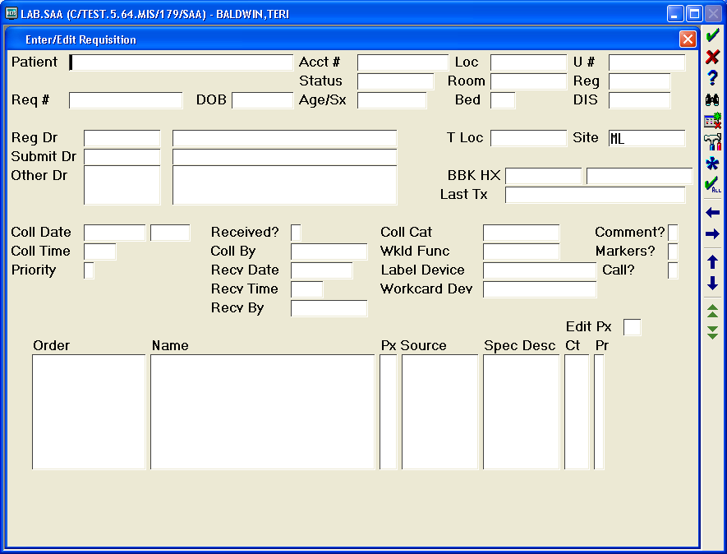

**X0…..**

1. Enter through the ***Req#*** section.

*Note: NEW will default into the Req# section.*

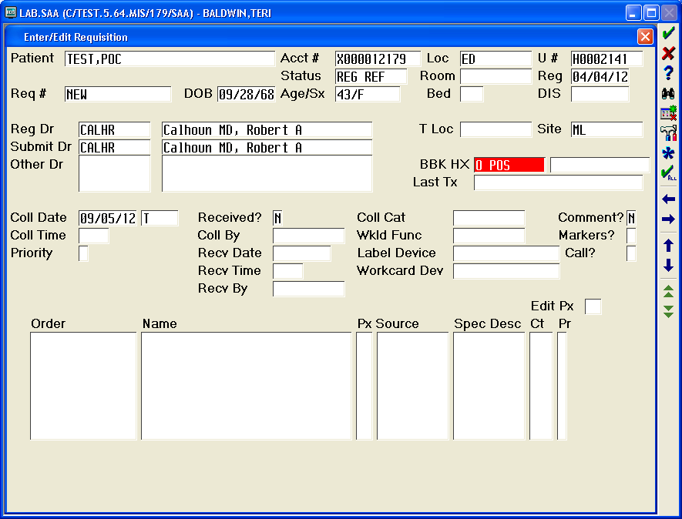

1. For requisitions requiring multiple provider entry, see *Procedure for Entering Multiple Providers*.
2. If registration has entered ***OTH*** under ***Reg Dr*** follow *“OTHER” Doctor Procedure.*
3. If ***RegDr*** matches the provider on the requisition, enter through to ***Coll Date***. Enter the collection date from the requisition.
4. Enter the collection time from the requisition in the ***Coll Time*** section.

*Note: If the collection date or time is missing on the requisition, the originating office must be contacted. See section under Written Request of this procedure for instructions on how to record information obtained for an incomplete requisition.*

1. Enter either ***R*** for routine or **S** for STAT in the ***Priority*** section. For STAT see *Specimen Drop Off Request STAT to be Logged Into Meditech* in this procedure.
2. Backspace the ***N*** out of the ***Received*** section, and enter a ***Y***.
3. Enter the initials of the person who collected the specimen in the ***Coll By*** section.

*Note: Specimens collected by lab staff must be entered as LAB.***.*

1. Enter the laboratory stamped date located on the requisition in the ***Recv Date*** section.
2. Enter the laboratory stamped time located on the requisition in the ***Recv Time*** section.
3. The initials of the accessioner will default into the ***Recv By*** section.
4. Enter through to the ***Comment*** section. Enter any comments found on the requisition by backspacing the ***N*** and entering a ***Y***. Example would be ***POST*** for a Rubin Dialysis specimen.

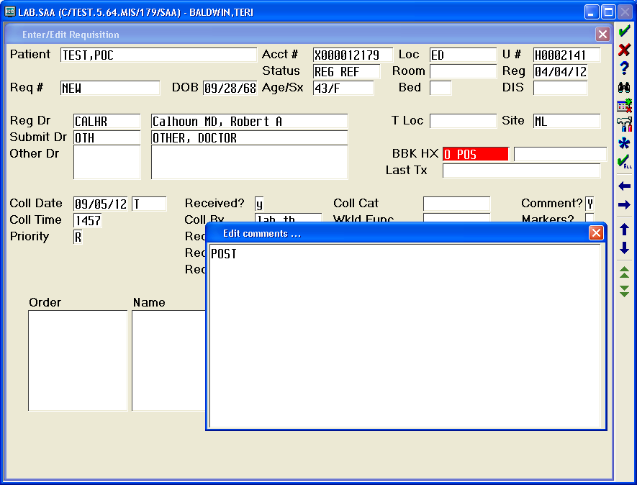

1. If the results are to be called, enter a ***Y*** in the ***Call?*** Section.

*Note: Specimens and Meditech labels for results that are to be called must be marked with a* ***Call Results*** *label.*

1. Under ***Order*** enter the mnemonicof the test marked on the requisition.

*Note:*  *The F9 look up feature can be used when the mnemonic is not known. Type in the first 3 letters of the test followed by F9. The test dictionary will pop up to the section beginning with the letters entered.* ***DO NOT GUESS what test is to be ordered!***

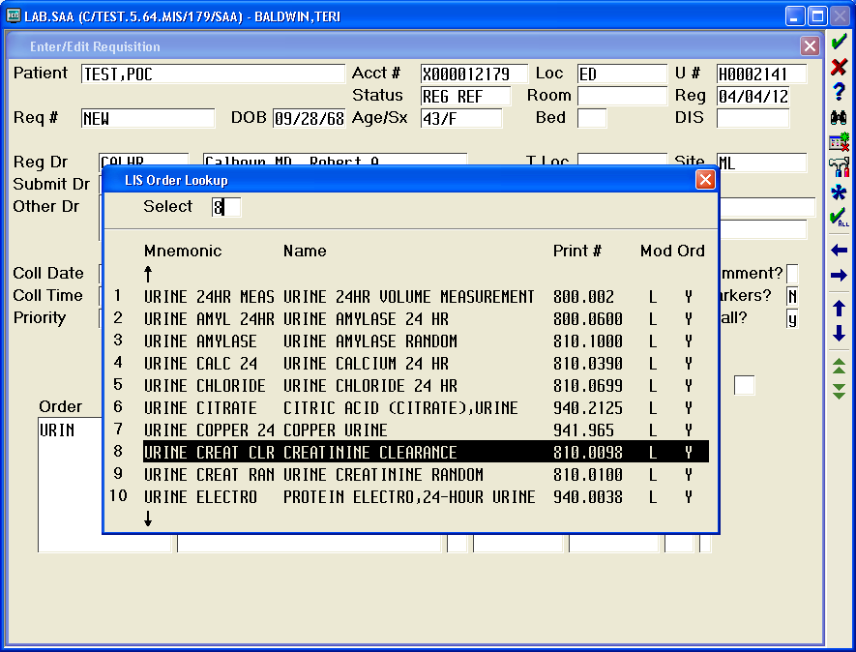

1. With the exception of clients, if the specimen was collected by laboratory staff, a ***VPOP*** test must be entered.
2. After all the tests have been put in, enter through until ***File?*** Pops up. Enter ***Y*** to file and complete the accessioning process.

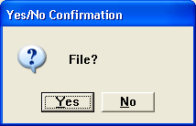

1. Place aliquot labels on the corresponding requisition and the barcode label on the appropriate specimen.

*Note: All specimens must be labeled with 2 patient identifiers according to the Specimen Labeling Policy. Some specimens will arrive at the laboratory without a label or with a label that does not match the name on the requisition. It is impossible for the laboratory to properly determine patient identification when this happens. See Specimen Rejection Policy for guidance when specimens are not labeled according to the Specimen Labeling Policy.*

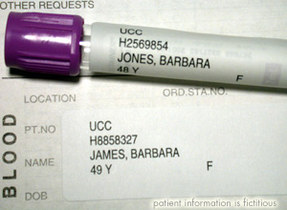

1. Separate samples for distribution to the appropriate laboratory section.

*Note: Each laboratory section has a separate STAT bin. Staff must notify technical staff when dropping off a STAT specimen, AND receive a response. This will ensure STAT specimens are processed according to the STAT TESTING PROTOCOL.*

*Note: Microbiology specimens are stored according to the labeled bins. Some specimens must be placed on the room temperature counter i.e. swabs, while some specimens must be placed in the refrigerator i.e. urines. If unsure where to place the specimen, ASK the tech working in that section.*

***Note: When delivering specimens to a section with no technical staff present, for example a Rapid Strep during the night shift, it is the responsibility of the staff delivering the specimen to let technical staff know they have dropped off a specimen.***

1. Have the requisitions tech checked according to Clerical Error Detection procedure.
2. Place the requisition in the “to be filed” box.

**Procedural Notes:**

* It is the accessioning person’s responsibility to contact the requesting physician’s location to resolve any questions or issues. If resolution is not possible during a given shift then the accessioning person must make a note in the Accession Problem Log Notebook located in the file stacker in Receiving. These notes must be signed and dated. It is the responsibility of the designated charge person to resolve all issues in the notebook within 24 hrs or to notify their supervisor.
* The accessioner must also ensure the following:
  + The name on the aliquot label matches the name on the requisition.
  + Appropriate diagnosis is documented on the requisition.
  + Physician’s signature is on the requisition.

*Note: Requisitions requiring additional information/signature should be flagged for Follow-up by the front office staff with a POST-IT that notes what additional information is needed.*

* Any problems or discrepancies should be documented in the specimen comment section of the *Order/Entry* screen.
* All Pathology requisitions should be placed in the large bin in the cytology section.

**Attachments:**

Attachment 1: *Process for Aliquotting Specimens*

|  |  |  |  |  |  |  |  |
| --- | --- | --- | --- | --- | --- | --- | --- |
|  | |  |  | | | | |
| Date of Origin: | 02/19/03 |  | Prepared By: | | | Lori Shaver | |
| Revised: | 10/22/03 |  | By: | | | Lori Shaver | |
| Revised: | 05/14/05 |  | By: | | | Brian Staring | |
| Revised: | 12/11/12 |  | By: | | | Teri Baldwin | |
|  | |  |  | | | | |
|  | |  |  | | | | |
| **Date Placed in Service:** | |  |  | | | | |
|  | |  |  | | | | |
| **Approved by:** |  | |  |  |  | |  | |  |  |
|  | Supervisor | |  | Date |  | | Laboratory Director | |  | Date |

Saratoga Hospital Laboratory

211 Church St. Saratoga Springs, N.Y. 12866

Attachment 1: *Process for Aliquotting Specimens*

*Blood Specimens*

Blood, in the form of whole blood, plasma or serum, is the most common specimen submitted for testing. In order to obtain serum or plasma, the whole blood specimen must be centrifuged. Some tests require the serum or plasma to be poured off into a separate tube.

1. Centrifuge specimens requiring serum or plasma. Centrifuging causes the heavier cellular components to sink to the bottom of the tube leaving the serum or plasma on the top.

|  |  |
| --- | --- |
| http://medtraining.org/ltac3/account/media/sproc/centrifugedTube.jpg | Serum or Plasma |
| Red Cells |

1. Label aliquot tube with patient’s full name, and date of birth, according to Admin Policy II-68 *Specimen Labeling*.

*Note: The aliquot containers must not contain any additive.*

1. Group source specimens with their aliquot tube.

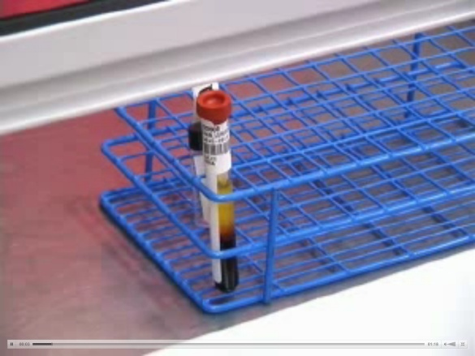

1. Match the source specimen **Name** and **Date of Birth** on both the specimen and the aliquot tube.
2. Carefully remove the cap off of the source specimen.
3. Draw the serum or plasma from the source specimen with a pipette, and transfer it into the aliquot tube.
4. Cap both tubes.
5. The person who aliquotted must put their initials on the aliquot tube.
6. Label the aliquot tube as plasma or serum.
7. Deliver both the source specimen and the aliquot tube to the testing department.

*Urine Specimens*

When urine specimens are received into the laboratory and must be poured into a Kova Tube or glass aliquot tube, follow this process before delivering them to the appropriate testing department:

*Note: Urine drug of abuse specimens must not come in contact with plastic. Transfer urine into a glass tube with a glass pipette.*

1. Label aliquot tube with patient’s full name, and date of birth, according to Admin Policy II-68 *Specimen Labeling*.
2. Match the source specimen **Name** and **Date of Birth** on both the specimen and the aliquot tube.
3. Transfer specimen into the aliquot tube.
4. The person who aliquotted must put their initials on the aliquot tube.
5. Deliver the aliquot tube to the testing department.