### The Saratoga Hospital Laboratory

### 211 Church Street, Saratoga Springs, NY 12866

**Procedure for Processing Specimens to be Tested at WMA or MMEC**

**Purpose:**

This procedure provides instruction for sending specimens from the Main Laboratory to the Wilton Medical Arts Laboratory or Malta Med Emergent Care Laboratory.

**Scope:**

This procedure applies to all laboratory employees of the Main Laboratory Phlebotomy Department.

**Policy:**

During instrument downtime, it may be necessary for specimens to be sent to Wilton Medical Arts Laboratory or Malta Med Emergent Care Laboratory. It is essential for billing and resulting purposes to adhere to the following procedure.

**Procedure:**

# The process for sending specimens to WMA or MMEC will be initiated by the technical department with the down analyzer.

# Phlebotomy staff notify the charge phlebotomist.

# Phlebotomy staff notify the courier by calling 580-2516.

*Note: The Courier Department will dispatch a courier to transport specimens stat to the performing laboratory.*

# The technical departments deliver specimens to be sent out to the Phlebotomy Department.

# Phlebotomy staff change the performing site of the specimen depending on where the specimen will be run.

1. Sign into Meditech.
2. Under **10 Requisitions**, select **83 Specimen Batches**.
3. In the **Select** box type **“.SEL”** followed by the **Enter** key.

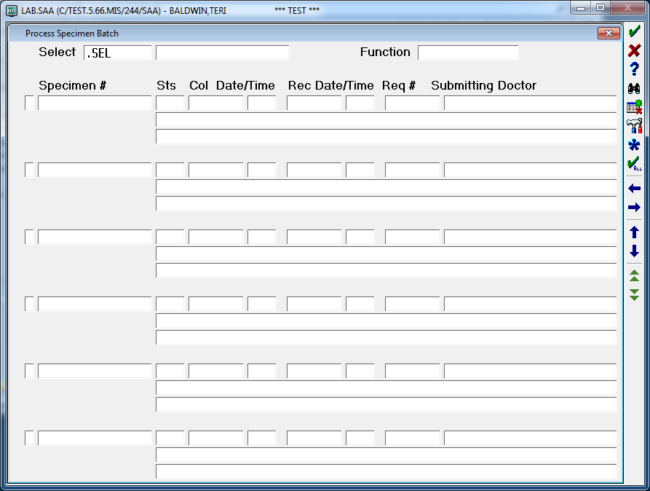

1. In the **Select Specimens** field enter the specimens to be sent to the alternate laboratory for testing, followed by the **Enter** key.

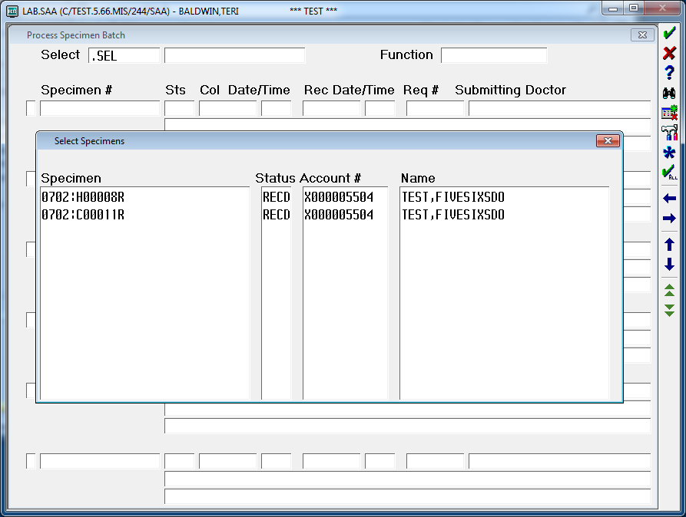

1. The **Process Specimen Batch** screen will show all of the specimens including collection and demographic information. Select specimens to be processed at the alternate laboratory by clicking on the little box to the left of the specimen number.

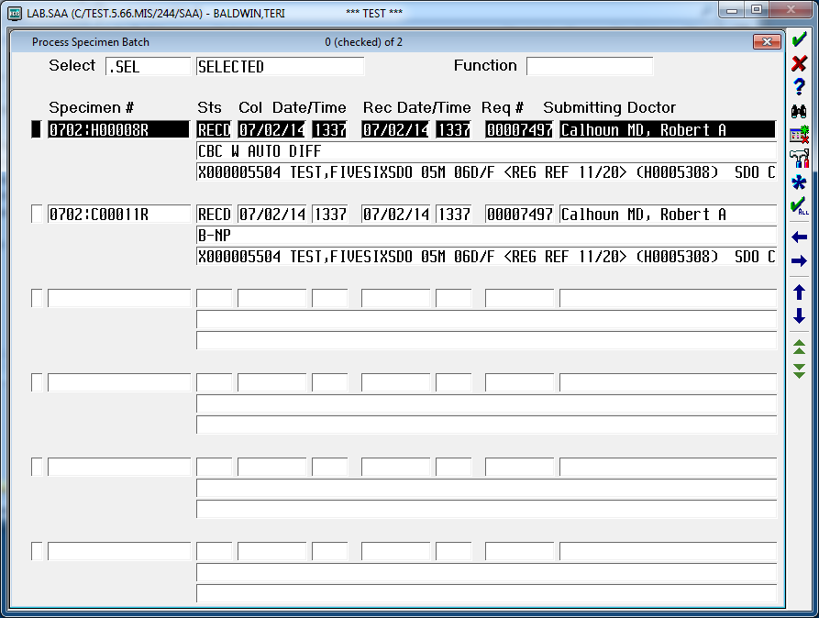

1. Once all specimens have been selected, type **CS** in the **Function** field followed by the **Enter** key.

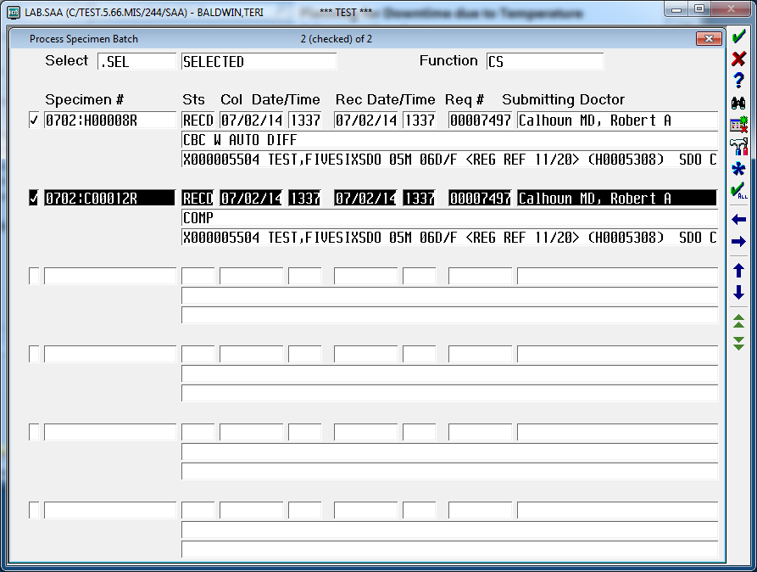

1. Once the **Enter** key has been selected, the **Change Site** screen appears. Enter the following to complete the Change Site process.
   1. At Site: **ML**
   2. To Site: **WMA or HCP**
   3. LAB Tests: **Enter the tests that will be performed at the alternate site. This is only necessary when a specimen will have tests performed at different sites.**

*For example, C14 has a TSH, CA125, B12 & Folate. Entering mnemonic TSH in this field will limit the test’s site change to the TSH only. The CA125, B12 and Folate will still be processed at the Main Laboratory.*

* 1. Change Site: **Y**

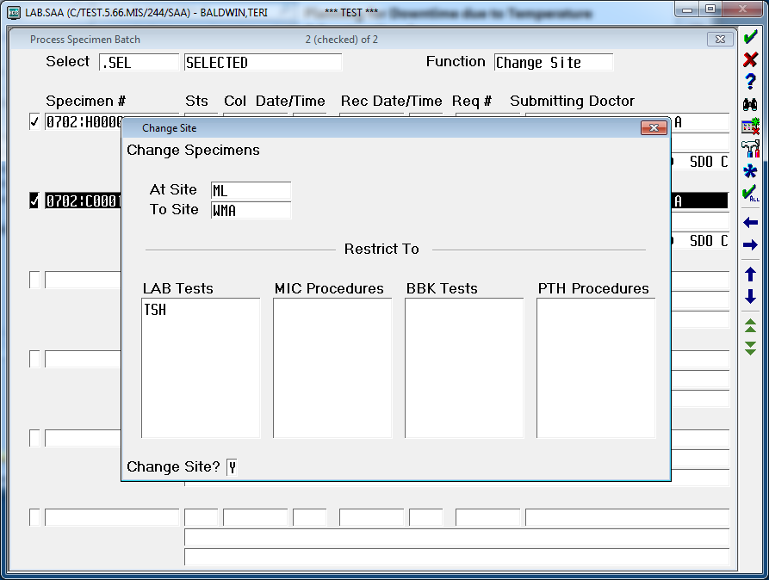

1. Exit out of the **Process Specimen Batch** screen.
2. Create a batch to be sent to the alternate laboratory.
   1. Select **34 Specimen Site** from the meditech Laboratory Main Menu.
   2. Select **11 Enter/Edit** from the LIS Specimen Site Menu.
   3. Once the **Enter** key has been selected, the **Enter/Edit Site Batch** screen appears. Enter the following to complete the batch process.
      1. Batch Date: **T** for today
      2. Batch Number: **New** is the default
      3. Send From Site: **ML**
      4. Send To Site: **WMA or HCP**
   4. Scan the specimen numbers that are to be sent to the alternate laboratory.
   5. In the **Batch Status** field type **S** for SENT and file.

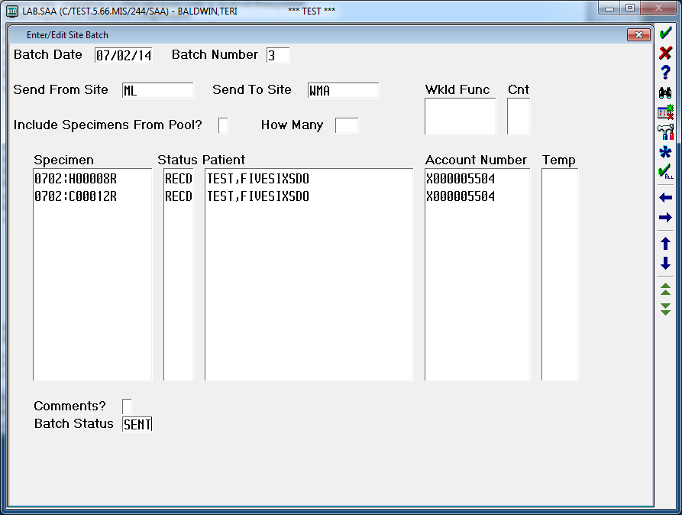

* 1. Choose **Specimen**, and print the batch.

1. Rack specimens according to the Site Batch Report.
2. Package rack and Site batch Report in a large Labcorp bag for the courier to deliver to the alternate site.

|  |  |  |  |  |  |  |  |  |  |
| --- | --- | --- | --- | --- | --- | --- | --- | --- | --- |
|  | |  | |  | | | | | |
| Date of Origin: | 07/02/14 |  | | Prepared By: | | | Teri Baldwin | | |
|  |  |  | |  | | |  | | |
| **Date Placed in Service:** | | |  | |  | | | | | |
| **Approved by:** |  | | | |  |  | |  |  | | |  |  |
|  | Phlebotomy Supervisor  Teri Baldwin | | | |  | Date | |  | Laboratory Medical Director  William E. Field II, MD | | |  | Date |
|  |  | | | |  |  | |  |  | | |  |  |
|  | Laboratory Administrative Director  Richard Vandell | | | |  | Date | |  |  | | |  |  |