Saratoga Hospital Laboratory

211 Church Street, Saratoga Springs, New York 12866

**Attachment 1: Blood Collection From IV Arm**

*Specimen Collected Proximal or Distal to an IV*

***Note: Collecting specimens in an arm with an IV should only be done as a last resort. The following guidelines must be followed to ensure accurate results when drawing from an arm with an IV.***

* ***It is not recommended that specimens for coagulation tests such as APTT be drawn from a Heparin infused arm. Avoiding this requires the phlebotomist to investigate what infusion fluids are running PRIOR to collection of coagulation tests. Do not collect an APTT proximal to a Heparin infusion, even if the IV has been turned off for 3 minutes.***
* ***Collecting specimens proximal to an IV should be avoided. In situations where it is not possible to collect distal to an IV, the IV must be turned off for 3 minutes and a discard tube must be drawn prior to testing tubes.***

***For all cases when collecting specimens in an arm with an IV, the phlebotomist must enter the appropriate comment.***

|  |  |  |
| --- | --- | --- |
| **System** | **Pneumonic** | **Comment** |
| **MobiLAB** | IVPROX | Drawn proximal to IV site. IV held for 3+ min and discard tube used. |
| IVDIS | Specimen collected distal to IV site. |
| IVCOAG | Specimen drawn from a Heparin infused arm. Nurse notified. |
| **Meditech** | IVPROX | Drawn proximal to IV site. IV held for 3+ min and discard tube used. |
| IVDIS | Specimen collected distal to IV site. |
| IVCOAG | Specimen drawn from a Heparin infused arm. Nurse notified. |

*Specimen Collected from an IV Line*

* It is necessary for nursing staff to flush the IV prior to blood collection from a line.
  + Saline solution is recommended.
  + A minimum of 5cc should be wasted prior to blood collection.
  + When collecting samples for coagulation studies (i.e., PT,/PTT) from a line previously flushed with heparin, it is important for nursing staff to flush with a minimum of 5cc saline and waste 5cc of blood prior to collecting the sample.
* Results drawn from a line must be reviewed with care. Possible dilution effects must be considered along with variations associated with IV components (i.e., glucose concentrations in IV solutions may exceed 5,000% that of fasting plasma levels.) It is up to the phlebotomy staff to enter the canned comment “**LLINE”** during the receiving phase of specimen handling.

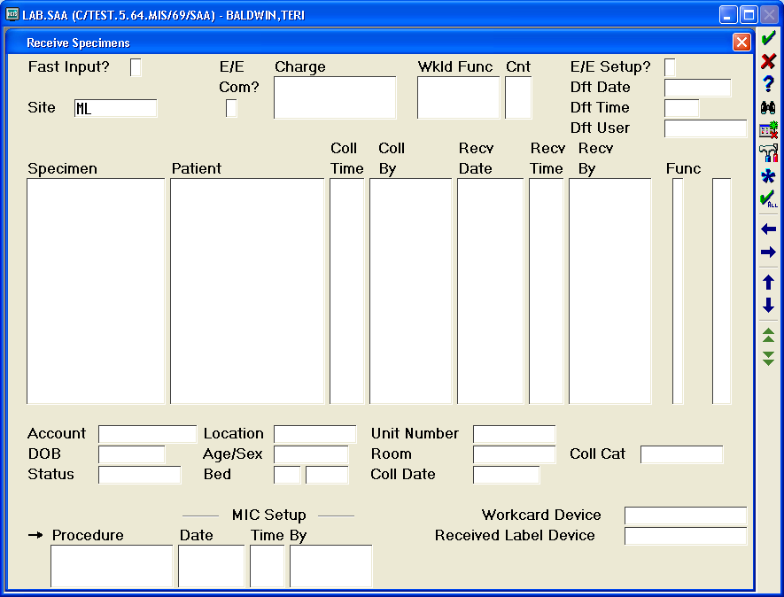

Place a “Y” in this box. Only enter specimens from this specific draw. Comment will be entered for all specimens.

* The phlebotomist may assist nursing staff in the collection of blood sample from a venous access line.
  + When more than one individual is involved in the collection process and samples change hands, read-back and verify must be performed. Nursing staff accessing the sample must read aloud the name, D.O.B. and H0 number directly from the wristband. The phlebotomist or other assistant will match and read-back this information as entered on the sample labels. If in agreement, the phlebotomist may place the barcoded labels on the samples. Nursing staff initials will be placed on the labels with the date and time of collection and a comment made in Meditech that read-back and verify was performed.