Saratoga Hospital Laboratory

211 Church St. Saratoga Springs, N.Y. 12866

Receiving Procedure

**Principle:**

The purpose of this procedure is to standardize the order entry, receipt, and distribution of specimens in the laboratory.

**Scope:**

This procedure applies to all laboratory employees involved in the receiving or distribution of samples within the laboratory.

**Specimen:**

This procedure applies to all specimen types received in the laboratory.

**Materials:**

1. Phlebotomy ED/Out Board
2. Specimens
3. Requisitions
4. Computer Terminal
5. Barcode Label Printer
6. Sample Racks and Bins
7. Centrifuge
8. Aliquot Tubes
9. Refrigerator/Freezer
10. Time Clock
11. Telephone
12. Office supplies, not limited to, but including pens, markers, labels, note pads and notebook.

**Quality Control:**

* Unreceived specimens reports will be reviewed and resolved each shift.
* Phlebotomy ED/OUT board is monitored for unreceived specimens.

**Procedure:**

* All specimens will either be delivered by courier, transportation or pneumatic tube system to the laboratory Receiving area.
* Staff working in Receiving separate specimens into the following categories.
  + Routine Specimens Obtained Through the Pneumatic Tube System.
  + STAT Specimens Obtained Through the Pneumatic Tube System.
  + Specimen Drop Off Requests already accessioned in Meditech.
  + STAT Specimen Drop Off Requests already accessioned in Meditech.
  + Specimen Drop Off Requests which need to be logged into Meditech.
  + STAT Specimen Drop Off Request which need to be logged into Meditech.
  + Pathology Specimens
* Specimen Drop Off Requests and STAT Specimen Drop Off Requests to be logged into Meditech are processed according to the Accessioning Procedure or Accessioning of Laboratory Specimen Drop-Offs Meditech Outreach.
* All Pathology specimens are delivered to a designated area in the Cytology Department.
* See Attachment 1: *Process for Aliquotting Specimens* for instructions on transferring specimen from one container to another.

*Specimens Obtained Through the Pneumatic Tube System*

Specimens obtained through the tube system will already be accessioned into Meditech.

1. Receiving is alerted of specimen arrival through pneumatic tube system by alarm.
2. Alarm is acknowledged according to Pneumatic Tube Procedure.
3. Specimens are removed from canister.
4. Specimens are inspected and determined to be one of the following.
   * STAT or Routine
   * Drawn Using MobiLAB or Drawn with Meditech Labels
5. Specimens must be received in Meditech prior to testing.

*Note: STATS must be received immediately in order to meet turnaround times specified in STAT TESTING PTOTOCOL.*

*Note*: *Instructions for receiving specimens into Meditech are in the following attachments.*

* *Attachment 2: Receiving Specimens Drawn With MobiLAB*
  + *Attachment 3: Receiving Specimens Drawn With Meditech Labels*

1. Separate samples for distribution to the appropriate laboratory section.

*Note: Each laboratory section has a separate STAT bin. Staff must notify technical staff when dropping off a STAT specimen, AND receive a response. This will ensure STAT specimens are processed according to the STAT TESTING PROTOCOL.*

*Note: Microbiology specimens are stored according to the labeled bins. Some specimens must be placed on the room temperature counter ie. swabs, while some specimens must be placed in the refrigerator ie. urines. If unsure where to place the specimen, ASK the tech working in that section.*

***Note: When delivering specimens to a section with no technical staff present, for example a strep screen during the night shift, it is the responsibility of the staff delivering the specimen to let technical staff know they have dropped off a specimen.***

*Specimen Drop Off Requests by Courier or Transportation, Already Accessioned into Meditech*

1. Specimens are dropped off by courier or transportation to the Receiving area.

*Note: Staff dropping specimens off must notify laboratory staff of STAT specimens. This must be acknowledged by laboratory staff.*

1. Specimen labels and manifest logs which accompany the specimens are time stamped and placed in the appropriate bin.

*Note: STAT specimens are placed in the bin labeled “STAT”.*

1. Specimens are checked against the accompanied manifest logs.

*Note: The Receiving staff must immediately contact the originating department when differences between the specimens and the manifest occur.*

1. Receive specimens according to *Attachment 2: Receiving Specimens Drawn With Meditech Labels*
2. Separate samples for distribution to the appropriate laboratory section.

*Note: Each laboratory section has a separate STAT bin. Staff must notify technical staff when dropping off a STAT specimen, AND receive a response. This will ensure STAT specimens are processed according to the STAT TESTING PROTOCOL.*

*Note: Microbiology specimens are stored according to the labeled bins. Some specimens must be placed on the room temperature counter ie. swabs, while some specimens must be placed in the refrigerator ie. urines. If unsure where to place the specimen, ASK the tech working in that section.*

***Note: When delivering specimens to a section with no technical staff present, for example a strep screen during the night shift, it is the responsibility of the staff delivering the specimen to let technical staff know they have dropped off a specimen.***

**Procedural Notes:**

It is the responsibility of the staff assigned to Receiving to oversee the ED/OUT board and investigate outstanding lab test as well as monitor overdue specimen collections for the ED and Outpatients. Excessive overdue specimen collections (>0.5) must be investigated. If the investigation does not provide sufficient explanation for the delay, Receiving staff must bring the delay to the attention of the charge person.

**Attachments:**

Attachment 1: *Process for Aliquotting Specimens*

Attachment 2*: Receiving Specimens Drawn With MobiLAB*

Attachment 3*: Receiving Specimens Drawn With Meditech Labels*

|  |  |  |  |  |  |  |  |
| --- | --- | --- | --- | --- | --- | --- | --- |
|  | |  |  | | | | |
| Date of Origin: | 12/11/12 |  | Prepared By: | | | Teri Baldwin | |
|  | |  |  | | | | |
| **Date Placed in Service:** | |  |  | | | | |
|  | |  |  | | | | |
| **Approved by:** |  | |  |  |  | |  | |  |  |
|  | Supervisor | |  | Date |  | | Laboratory Director | |  | Date |

Saratoga Hospital Laboratory

211 Church St. Saratoga Springs, N.Y. 12866

Attachment 1: *Process for Aliquotting Specimens*

*Blood Specimens*

Blood, in the form of whole blood, plasma or serum, is the most common specimen submitted for testing. In order to obtain serum or plasma, the whole blood specimen must be centrifuged. Some tests require the serum or plasma to be poured off into a separate tube.

1. Centrifuge specimens requiring serum or plasma. Centrifuging causes the heavier cellular components to sink to the bottom of the tube leaving the serum or plasma on the top.

|  |  |
| --- | --- |
| http://medtraining.org/ltac3/account/media/sproc/centrifugedTube.jpg | Serum or Plasma |
| Red Cells |

1. Label aliquot tube with patient’s full name, and date of birth, according to Admin Policy II-68 *Specimen Labeling*.

*Note: The aliquot containers must not contain any additive.*

1. Group source specimens with their aliquot tube.

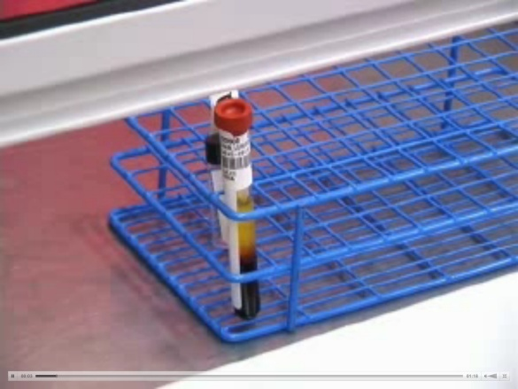

1. Match the source specimen **Name** and **Date of Birth** on both the specimen and the aliquot tube.
2. Carefully remove the cap off of the source specimen.
3. Draw the serum or plasma from the source specimen with a pipette, and transfer it into the aliquot tube.
4. Cap both tubes.
5. The person who aliquotted must put their initials on the aliquot tube.
6. Label the aliquot tube as plasma or serum.
7. Deliver both the source specimen and the aliquot tube to the testing department.

*Urine Specimens*

When urine specimens are received into the laboratory and must be poured into a Kova Tube or glass aliquot tube, follow this process before delivering them to the appropriate testing department:

*Note: Urine drug of abuse specimens must not come in contact with plastic. Transfer urine into a glass tube with a glass pipette.*

1. Label aliquot tube with patient’s full name, and date of birth, according to Admin Policy II-68 *Specimen Labeling*.
2. Match the source specimen **Name** and **Date of Birth** on both the specimen and the aliquot tube.
3. Transfer specimen into the aliquot tube.
4. The person who aliquotted must put their initials on the aliquot tube.
5. Deliver the aliquot tube to the testing department.

Saratoga Hospital Laboratory

211 Church St. Saratoga Springs, N.Y. 12866

**Attachment 2: Receiving Specimens Drawn With MobiLAB**

Procedure:

1. Log into Meditech.
2. Go to **101. MOBILAB PHLEB MENU**
3. Go to **1. MobiLAB Receive Specimens**

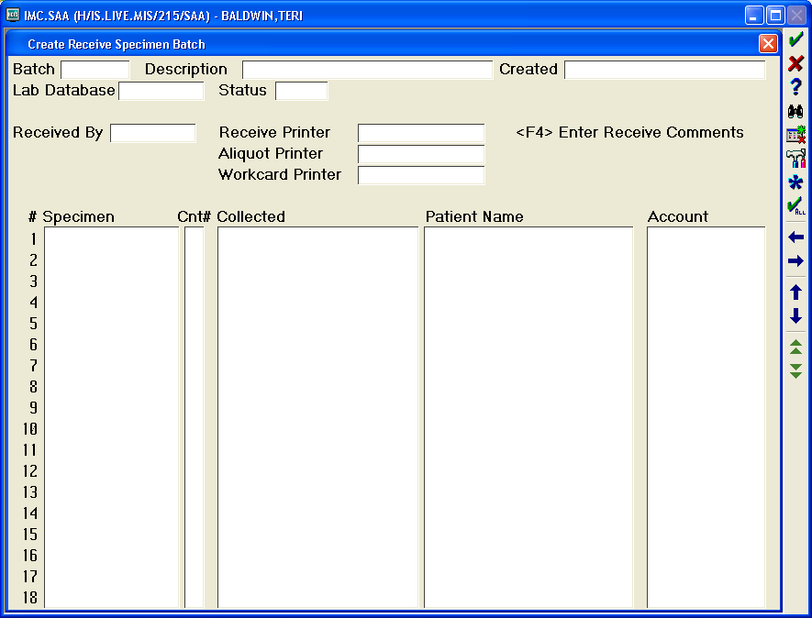

1. Type “**N**” for **NEW**

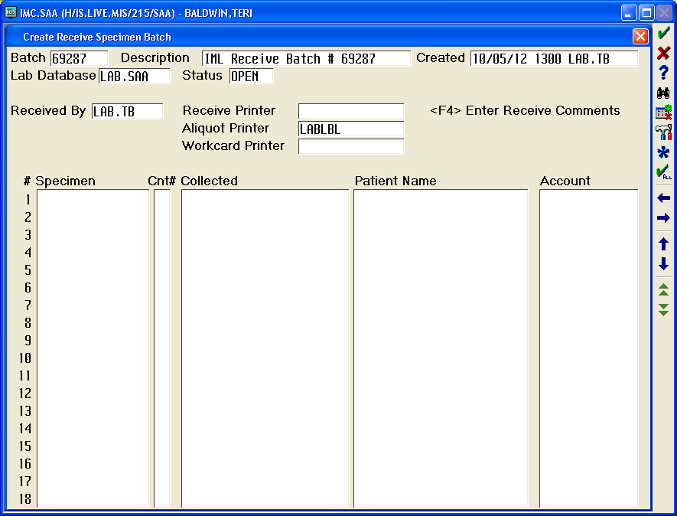

1. Scan the barcode labels on all specimens. The Collect Time, Patient Name & Account will fill in.
2. After the last specimen for each patient has been scanned, hit **SPACEBAR** followed by the **ENTER** on the keyboard.
3. Review all specimens against the specimens listed under the patient’s account.
4. Select any specimens that are not listed in the specimen batch.
5. Repeat **SPACEBAR** followed by the **ENTER** on the keyboard until all specimens are listed in the specimen batch.

Saratoga Hospital Laboratory

211 Church St. Saratoga Springs, N.Y. 12866

**Attachment 3: Receiving Specimens Drawn With Meditech Labels**

Procedure:

1. Log into Meditech.
2. Go to **11. SPECIMEN COLLECTION**
3. Go to **21. BY SPECIMEN**
4. Enter through until curser is in **Specimen** box.

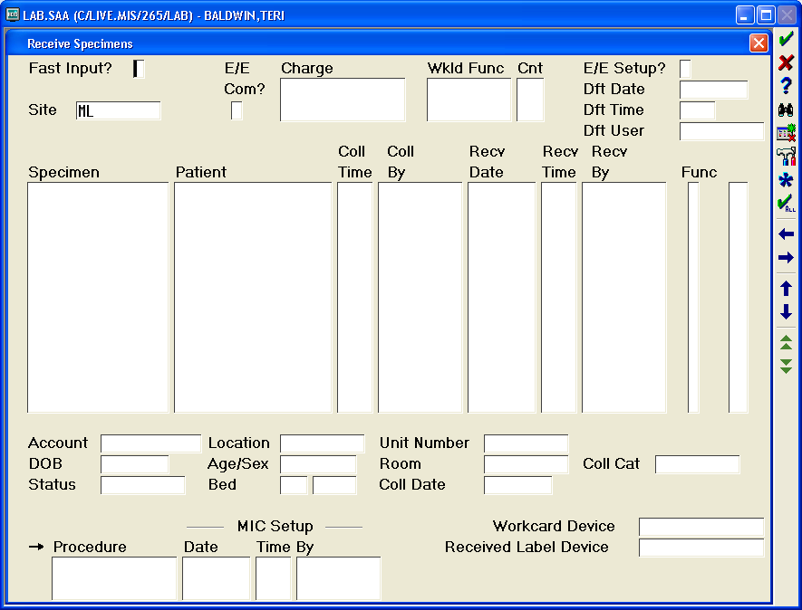

1. Scan the barcode label on the first specimens. The Patient Name will automatically fill in.
2. Enter the following information in the corresponding section.
   * The correct collection time found on the specimen label.
   * The initials of the collector (LAB.initials or the DEPARTMENT SPECIMEN ORIGINATED FROM.initials).
   * The time stamped on the label set or manifest under the RECV TIME.
   * 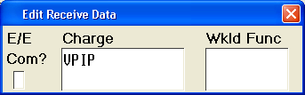Enter through to **Func**. If the specimen was drawn by one of the phlebotomists, enter **E** and press **Enter**. The **Edit Receive Data** box will appear. Enter through to **Charge**. If the specimen you are receiving belongs to an inpatient, enter **VPIP**. If the specimen belongs to an outpatient, enter **VPOP**.
3. Hit the **ENTER** key the cursor will shift back to the **SPECIMEN** column.
4. Scan the next specimen and repeat the above process until all specimens have been scanned and entered.

*Note*: *After the last specimen for each patient has been scanned, hitting* ***SPACEBAR*** *followed by the* ***ENTER*** *on the keyboard will ensure all specimens for each patient are received.*

1. After last specimen has been scanned and entered, enter through the screen until Receive Aliquot Device box pops up.

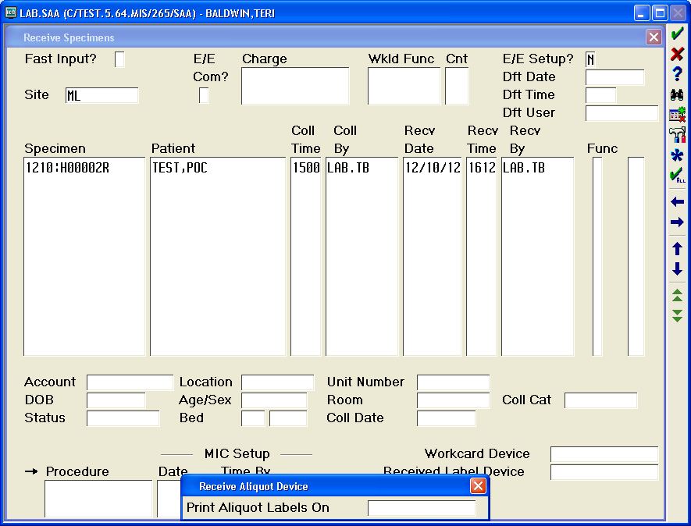

1. Press the **ENTER** key to go through the box.
2. Enter Y for yes at the *Receive?* prompt.

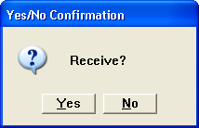

1. Press the **ENTER** key to enter through the *Receiving process has been started* box.

