Saratoga Hospital Laboratory  211 Church St., Saratoga Springs, N.Y. 12866 |  | Saratoga Hematology Oncology Laboratory  3 Care Lane, Saratoga Springs, N.Y. 12866

Future Requisitions

Purpose:
The purpose of this procedure is to provide instructions for the creation of future requisitions using the Meditech Outreach Module.

Scope:
This procedure applies to all Saratoga Hospital employees involved in the ordering, receiving or distribution of samples with future requisitions.

Procedure:

- A patient list for a future date is generated by practice staff. The list must contain the following:
  - Patient’s full name.
  - Date of birth.
  - Patient’s sex.
  - Ordering provider.
  - Tests which need to be ordered.
The list will be faxed to the Saratoga Hospital Laboratory Phlebotomy department at 580-2806.

- Enter/Edit Future Outreach Requisition: (Saratoga Hospital Laboratory Phlebotomy Staff )
From the provider’s patient list:
- Enter patient and test orders in Meditech via the outreach module:
  - From the Meditech main menu
  - Select Outreach routine (36)
  - Option #30 Future Orders
  - Option #10 Enter/Edit
    - Req. # N = New
    - Bill Type – Enter “P”
♫ Note: Selecting the correct bill type is imperative for correct billing.
    - Sub Dr = Doctor’s name (F 9 for look-up)
    - Patient’s Full Name
    - Date Of Birth (if there is no DOB contact office staff for this information)
    - Age- defaults from date of birth
    - Sex- M or F
    - Medical Record-review (F9 for look-up) Master Patient Index [enter Y] History:

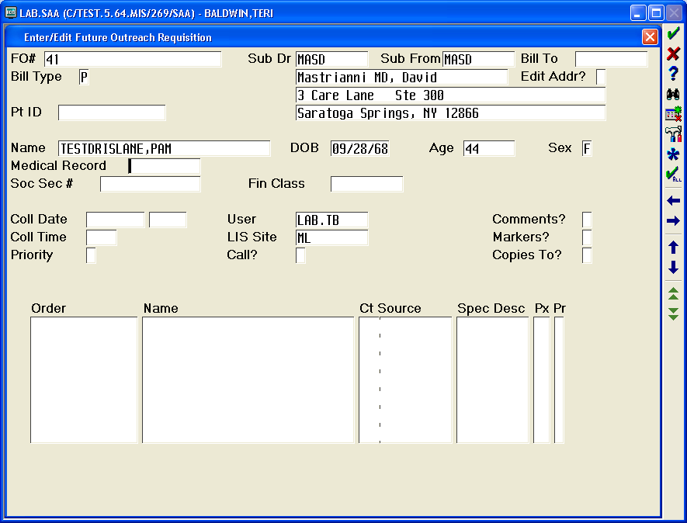
F9 Look Up Here to Enter Master Patient Index

      - If patient name and DOB match select patient. If available, social security number can be used as an additional identifier.
      - The patient chosen from the Master Patient Index will automatically populate the Patient Name and DOB section of the Enter/Edit Future Outreach Requisition screen.
      - If there is no matching Medical Record in the system you must contact Admitting registration at 8432 (or 8435) to obtain an account number (X0…).
    - Enter the correct collection date (T+1) or appropriate date, approximate collection time or enter UNK, and the priority (“S” for Stat and “R” for Routine).
♫ Note: If the patient is on the practice schedule, enter the time of their appointment under collection time.
    - Enter ALL appropriate test orders for that patient.
♫ Note: OCBC is the mnemonic for CBC for SHOLAB. Orders for INR will not be Future Ordered.
    - File the orders.
    - Enter all subsequent patient orders from the provider list.
    - When all patient orders have been entered as Future Orders, exit all the way out of Meditech.

- Generate a Future Orders List and print the list. (Saratoga Hematology Oncology Laboratory (SHOL) Staff )
  - From the Meditech main menu
  - Select Outreach routine (36)
  - Option #30 Future Orders
  - Option #30 List

- To generate Outreach Orders and specimen labels. (Saratoga Hematology Oncology Laboratory (SHOL) Staff )
- Load the Future Orders and change the sample location to SHOLAB
  - From the Meditech main menu select Outreach routine (36)
- Option #30 Future Orders
- Option #40 Load
- Enter the FO# from the list (see #3 above)
- Press F12. This transforms the Future Order into an Outreach Requisition.
♫ Note: The Collection Date and time will default to the time the requisition was transformed into an Outreach requisition.
- The Enter/Edit Outreach Requisition screen will appear
- You must edit the Location field to SHOLAB by Entering through this field or clicking on it with the
mouse.
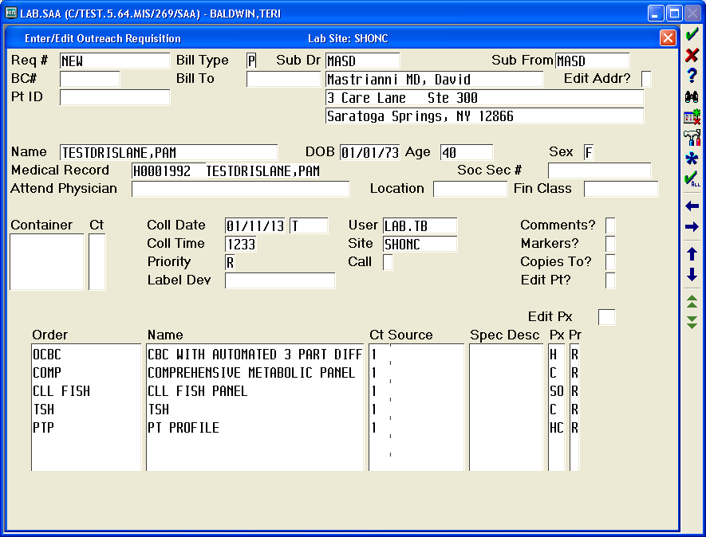
- Make sure there is a label device entered
- Verify test orders and file
- Enter any additional orders (if necessary) and select OK (F12)
  - Enter all appropriate subsequent FO#s from the Future Orders list.

- To Generate Site Batch and Manifest. (Saratoga Hematology Oncology Laboratory (SHOL) Staff )
- For specimen testing not performed on site prepare a rack of samples and site batch
  - From the Meditech LIS Main Menu, select # 10 - Laboratory.
  - From the Laboratory Main Menu, select # 34 - Specimen Site.
  - From the LIS Specimen Site, select # 11- Enter/Edit.
  - Batch Date, enter T (today).
  - Batch Number, New will appear - leave at New.
  - Send from site, SHONC automatically comes up.
  - Send to site, type in ML (main lab).
  - "Include Specimens From Pool?": ignore.
  - "How Many": ignore.
  - The cursor will go to the specimen column.
  - "Scan" in all the specimens. Any specimens rubber banded together should be checked to
make sure they have the same SO number.
  - When the last specimen has been entered, the cursor will go to Comments. Ignore this prompt and press enter.
  - Batch Status: "lookup" (F9) and select "Sent".
  - "File" prompt: type in "Y" (yes).
  - Sort Specimens by (S) Specimen #.
  - Mark Batch as Received: Y (Yes).
  - "Print On" prompt; select the appropriate printer.
  - Forward a copy of the Site Batch Report AND all the original requisitions with the samples to the Main Lab.

- To Receive Site Batch and Manifest. (Saratoga Hospital Laboratory Phlebotomy Staff )
- Upon receipt of specimens at the Main Lab the Site Batch Report is checked against the samples received. If there are no discrepancies the batch should be received. Any Site batch discrepancies must be addressed by contacting lab staff at the sending location.
- For receipt of site batch
  - From the Meditech LIS Main Menu, select # 10 - Laboratory.
  - From the Laboratory Main Menu, select # 34 - Specimen Site.
  - From the LIS Specimen Site, select # 14 Receive.
  - Type in the date from the manifest under Batch Date.
  - Type in the Batch Number from the manifest.
  - Select F12 and Yes to Receive Specimens.
  - Print Batch Report and attach it to the manifest received from the practice.

- Deliver samples to the appropriate laboratory section.
- Take all original requisitions to the registrar for Outreach registration completion.
- Admitting will return requisitions to the laboratory front office.

- Lab registrar will:
- Generate NPR Outreach report for Medicare patients.
- Retrieve requisitions for all Medicare patients who were registered under outreach.
- Perform Medical Necessity Check as per SOP.

Date of Origin: | 01/04/13 |  | Prepared By: |  |  | Lori Shaver/Teri Baldwin
Date Placed in Service:
Approved by:
 | Phlebotomy Supervisor |  |  | Date |  |  | Saratoga Hospital Laboratory Director |  |  | Date
 | Saratoga Hematology Oncology Laboratory Director |  |  | Date

