Saratoga Hospital Laboratory

211 Church Street, Saratoga Springs, NY 12866

**Off Shift Glucometer Replacement Procedure**

**Purpose:**

To provide phlebotomy staff with instruction on how to replace a problematic meter with a functional back-up meter in the event that Point of Care staff is not available to do so.

**Scope:**

This procedure applies to all phlebotomy staff members working in The Saratoga Hospital Laboratory.

**Glucometer Replacement Procedure:**

1. 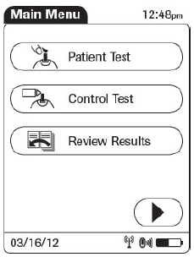If a patient care department makes a request for a replacement meter, attempt to contact a Point of Care staff member by calling either extension **5954** or **5490**.
2. If a Point of Care staff member is not available to provide assistance, inform the patient care unit that a replacement meter will be delivered to them.
3. Acquire one of the docked back-up meters located in the ED Lab Room. Ensure the meter is charged by powering it on and looking for the battery icon.
4. Deliver the back-up meter to the requesting patient care department. Acquire the name of the person who is accepting the meter. Document accepting staff member’s name, your name, the serial number of the problem meter, the serial number of the replacement meter, the date and time on Attachment 1: **Off Shift Glucometer Replacement Log** located on the Accessioning Office bulletin board.
   1. 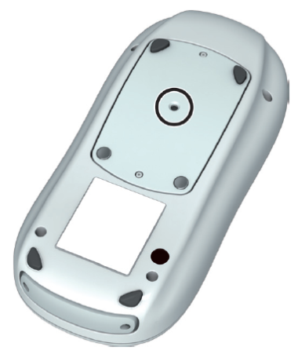The meter serial number is located at the bottom of the informational sticker on the back of the meter. It will begin with “UU 130_ _ _ _ _”.
5. Take the problem meter and the Off Shift Glucometer Replacement log back to the ED Lab Room. Dock the meter and leave the log for Point of Care Staff.

**References:**

* Accu-Chek Inform II Quick Reference Guide
* Accu-Chek Inform II Operator’s Manual

Roche Diagnostics, 2012.

|  |  |  |  |  |  |  |  |  |  |
| --- | --- | --- | --- | --- | --- | --- | --- | --- | --- |
| Date of Origin: | 03/15/13 | |  | Prepared By: | | Daniel Bernhard | | | |
|  |  | |  |  | |  | | | |
|  | | |  |  | | | | | |
| **Date Placed in Service:** | | |  |  | | | | | |
|  | | |  |  | | | | | |
| **Approved by:** | |  | |  |  |  |  |  |  | |
|  | | Supervisor | |  | Date |  | Laboratory Director |  | Date | |

Saratoga Hospital Laboratory

211 Church Street, Saratoga Springs, NY 12866

Attachment 1: Off Shift Glucometer Replacement Log

|  |  |  |  |  |  |
| --- | --- | --- | --- | --- | --- |
| **Phlebotomist Replacing Meter** | **Staff Member Accepting Replacement Meter** | **Serial Number of Problem Meter** | **Serial Number of Replacement Meter** | **Date** | **Time** |
|  |  |  |  |  |  |
|  |  |  |  |  |  |
|  |  |  |  |  |  |
|  |  |  |  |  |  |
|  |  |  |  |  |  |
|  |  |  |  |  |  |
|  |  |  |  |  |  |
|  |  |  |  |  |  |
|  |  |  |  |  |  |
|  |  |  |  |  |  |
|  |  |  |  |  |  |
|  |  |  |  |  |  |
|  |  |  |  |  |  |
|  |  |  |  |  |  |
|  |  |  |  |  |  |
|  |  |  |  |  |  |