Saratoga Hospital Laboratory

211 Church Street, Saratoga Springs, NY 12866

**Procedure for Obtaining ABNs for Walk-in Patients**

**Purpose:**

Medicare uses national and local coverage decisions to determine whether a test is medically necessary. These coverage decisions list the test and what diagnosis must be present in order for Medicare to pay for the test. Saratoga Hospital uses Meditech Medical Necessity software to compare the tests to the diagnosis submitted by the provider. If the diagnosis is not included in the coverage decision for that test, an Advanced Beneficiary Notice (ABN) will be generated.

This procedure provides instructions for generating and presenting the ABNs to laboratory outpatients.

**Procedure:**

***Performing the Medical Necessity Check:***

1. Patient will present to Admitting for registration. Admitting will register and code the patient diagnosis as per admitting protocol. Patient is sent to the laboratory.
2. Clerical staff will order the tests. If the patient is Medicare, the Medical Necessity Check screen will appear:

***NOTE:***  *The diagnosis listed under the “Visit Diagnoses” screen comes from the Meditech Abstracting Module (not the Admitting module). The diagnosis in the Abstracting module is sent to Medicare along with the test codes for billing.*

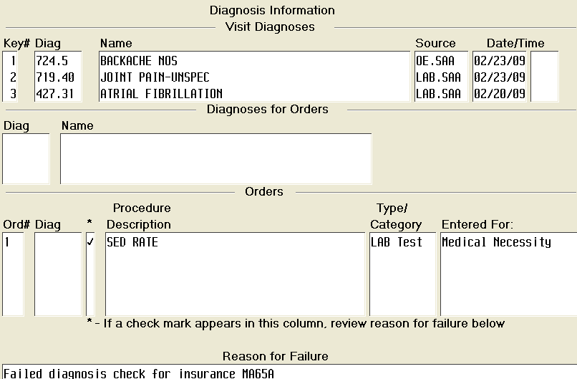

1. Under the “Orders” section, enter the diagnosis in the “**Diag**” field and press enter. If there are multiple diagnosis codes listed be sure you try all codes for a failed test before generating an ABN. (Exception: See Handling Problem Requisitions).

*Handling Problem Requisitions:*

|  |  |  |
| --- | --- | --- |
| **Requisition** | **Meditech Visit Screen** | **Action** |
| Diagnosis listed on the requisition. | **No** diagnosis visible | * Contact the admitting department or lab registrar and ask them to enter the diagnosis into the Meditech abstracting module. * **Do not** have the patient sign the ABN. This needs to be resolved **before** the patient is drawn. |
| **No** diagnosis on the requisition and admitting is not able to obtain one. | **No** diagnosis visible | * Enter 799.9 for the diagnosis. * Inform patient that without a diagnosis Medicare will not cover the test. * Treat this as a failed medical necessity check and obtain the signed ABN from the patient. |
| Diagnosis listed on the requisition | Diagnosis is visible **but** does not match the requisition. | * Notify the Admitting department or the laboratory registrar that the diagnosis needs correction. * NOTE: Entering the “correct” diagnosis in the Medical Necessity screen **does not** enter the diagnosis in the abstracting Module. **The bill will be incorrect.** |
| Requisition from multiple physicians | Diagnosis from both requisitions will be visible. | * Use only the diagnosis submitted by the ordering provider for that test. |

1. If the test fails the medical necessity check, generate the ABN form.
2. A pop-up box will appear asking if the ABN has been signed. Press the down arrow key and select “Not Signed” and file the requisition.

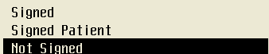

1. Check the box that states "Medicare does not pay for this service for the diagnosis provided".
2. Stamp the requisition with the “ABN” stamp.
3. Place the ABN and "Diagnostic Laboratory Testing Ordered by your Provider" letter on the clipboard.

***Presenting the ABN to the Patient:***

1. The phlebotomist will present the ABN to the patient using the following requisitioned statement:

*"We have entered your test orders into our computer and based on the diagnosis supplied by your doctor; this test may not be covered by Medicare (point to the test on the ABN). Please read this information, check one of the boxes and sign the form.”*

This should be considered a confidential conversation with the patient. If there is someone else in the drawing room, draw the curtain before giving the patient the ABN. If they have any questions, consult with a supervisor. They will contact the Patient Accounts. Do not attempt to answer billing questions.

1. The patient must read the ABN and select one of the options in the OPTION box. **This must be checked of by the patient.**
2. The patient must sign and date the form indicating that they have received the notice and understands it.

|  |  |
| --- | --- |
| **Situation** | **Resolution** |
| Patient completes option box. | Make a copy of the signed ABN and give it to the patient.  *NOTE: The patient must receive a signed copy in order for the ABN to be valid.* |
| Patient refuses to complete the form. | * Under the “Additional information” section, write *“patient refused to complete the form”,* your name, date and time. * The patient does not get a copy of the ABN. |
| Patient request that blood be drawn and that we check with provider prior to performing the test | Explain to the patient that they will need to complete the form. We are not able to draw their blood until they make a decision. |
| Patient is not competent to sign the form. | * Under the “Additional information” section, write *“patient not competent to complete the form”,* your name, date and time. * The patient does not get a copy of the ABN. |

1. Attached the ABN to the requisition and file as per protocol.

***Key points to remember:***

* Only the diagnosis listed in the “Visit Diagnoses” screen can be used to check the medical necessity. Entering a different diagnosis defeats the purpose of checking for medical necessity.
* Remember to check the box that states "Medicare does not pay for these tests for your condition”. The patient must also check the appropriate option box, date and sign the ABN. Failure to complete the form is one of the primary reasons why the ABN is being rejected.
* A properly completed ABN must be signed **prior** to collecting the specimen. Once the collection process begins, you are **not** allowed to ask the patient to sign the ABN or sign a corrected ABN.
* Do not attempt to answer billing or insurance questions. If the patient has questions, get a supervisor. They will contact the Patient Accounts for assistance. The number is listed on the "Diagnostic Laboratory Testing Ordered by your Provider" letter.
* The patient must get a **signed** copy of the ABN. If he/she does not receive one, the ABN is **not** valid.
* Make sure to give the patient the "Diagnostic Laboratory Testing Ordered by your Physician" sheet. This describes how we handle failed ABNs and gives them a contact number for billing.
* Use the requisitioned language as written in #9 of the protocol. Do not offer additional information or opinions. Do not assure the patient that the test will covered.

**Attachments:**

* + Example of an Advanced Beneficiary Notice
  + Diagnostic Testing Ordered by your Physician

**References:**

* Medicare Claims Processing Manual; Chapter 30-Financial Liability Protections

**Date of origin: 9/16/06** **Written by**:

**Latest Revision: 10/24/11**  **Revised by:**

**Date Placed in Service:_____________**

**Approved by: ________________________ ______ _________________________ _______**

**Supervisor Date Laboratory Director Date**