Saratoga Hospital Laboratory

211 Church Street, Saratoga Springs, NY 12866

Accessioning of Laboratory Specimen Drop-Offs [SDO] Meditech Outreach

**Purpose:**

The purpose of this procedure is to provide instructions on the receipt, order entry and distribution of the laboratory SDOs using the Meditech Outreach Module.

**Scope:**

This procedure applies to all laboratory employees involved in the ordering, receiving or distribution of samples within the laboratory. It applies to all specimens received from physician’s offices and clients.

**Policy:**

In order for testing to be completed, all patient specimens must be registered in the Meditech computer system. To ensure efficient and timely processing and reporting of laboratory results, outreach specimens (SDOs) are registered using the Meditech Outreach module. This allows the lab to complete an abbreviated registration so that specimen processing can proceed without delay.

Once the specimen is registered in Meditech outreach module, the requisitions are forwarded to Admitting or the Laboratory Registrar for completion.

**IMPORTANT NOTE: *To ensure that the patient bill is processed appropriately, ALL outreached requisitions must have a full registration completed by midnight of the same day!! Failure to complete the registration prior to the deadline will result in inaccurate billing or the patient receiving a bill as a self pay.***

**Procedure:**

***Receipt of Specimens:***

1. Specimens are delivered to the Receiving area.
2. Requisitions and specimens are triaged upon receipt by Receiving staff. Stats and Priority specimens are separated and processed first.

***Note: Each requisition is completely processed before proceeding to the next requisition. This includes verification of order, and registration of test order.***

1. Each order is checked individually to ensure that:

* Specimen information matches the information on the requisition.
* A correct specimen is submitted for each test requested.
* The complete name, DOB, physician signature, and diagnosis are present.

***Note: Requisitions with the following criteria cannot be registered with outreach. Forward the requisitions to the lab registrar or admitting.***

* ***Missing DOB,***
* ***Patient is not in the Meditech system,***
* ***Provider is not in the Meditech system.***

***Accessioning of Specimens***

1. Enter patient and test orders in Meditech via Outreach Module:
2. Select **36. Outreach** routine.
3. Option **10. Requisition.**
4. Option **10. Requisition.**
5. In the **Req #** field type **N** for **New.**
6. In the **Bill Type field** .
7. Enter **P** for Patient.
8. Enter **C** for Client.

***Note: Selecting the correct bill type is imperative for correct billing. Be sure that the “Bill To”field automatically fills in with the client mnemonics.***

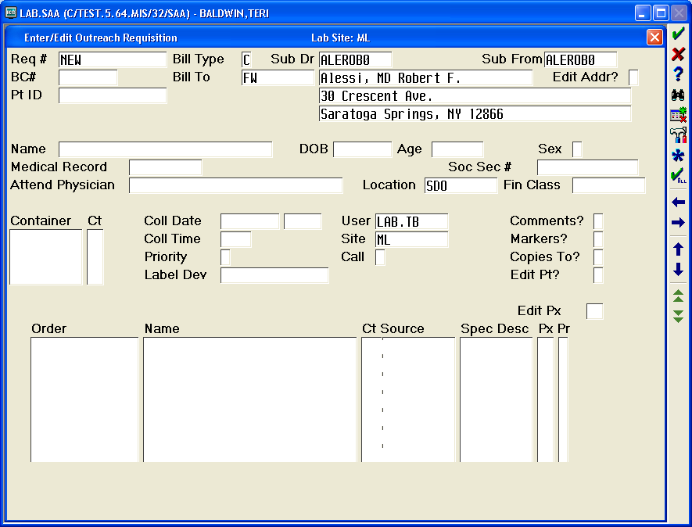

**The client must automatically fill in.**

1. In the **Sub Dr** field type **N*first three letters of the provider’s last name*** and **F 9** for look-up.
2. In the **Name** field, type the **Patient’s Full Name.**
3. In the **DOB** field type the **patients 8 digit date of birth** (if there is no DOB give requisition to admitting). Age- defaults.
4. In the **Sex** field type **M** for Male or **F** for female.
5. Pressing the **ENTER** key while in the **Medical Record** field will automatically bring up the **Master Patient Index** **(MPI).**
6. If the Patient Name and Date of Birth match ⇒ Select the patient. If available, the social security number can be used as an additional identifier.

***Note: Verify the patient does not already have an X# for the date of entry. If the patient already has an X#, use this account number and enter the requisition according to the Accessioning Procedure.***

1. If the system states **Medical Record name is different from name on the req, Continue?** There may be a discrepancy with an initial, ect. Enter **Y,** press **ENTER** twice.
2. Type **C** for **Copy the Medical Record.**

**NEVER UPDATE THE MEDICAL RECORD**

***Note: I The requisition will have to go through the Registration process.***

1. In the **Location** field enter the location the specimen originated from. . **SDO** (specimen drop off) is the default location.

***Note: Selecting the correct location is imperative for proper delivery of reports.***

1. In the **Container** field enter the appropriate containers received as well as the number received.
2. In the **Coll Date** field enter the **Specimen Date**.
3. In the **Coll Time** field enter the **Time of Specimen Collection**.
4. In the **Priority** field enter **R** (routine), **S** (STAT), or **T** (timed).
5. In the **Label Dev** enter the label device that is being used. This field is defaulted to the label devices adjacent to the accessioning computers.
6. If the results are to be called, enter a Y in the Call? Section.

***Note: Specimens and Meditech labels for results that are to be called must be marked with a Call Results label.***

1. In the **Order** field, enter the requested test orders.

***Note: The F9 look up feature can be used when the mnemonic is not known. Type in the first 3 letters of the test followed by F9. The test dictionary will pop up to the section beginning with the letters entered. DO NOT GUESS what test is to be ordered!***

***Note: When ordering a blood culture, enter through the blood volume queries. These must be entered after the requisition has been filed and the specimen numbers become available. See Attachment 1: Entering Blood Culture Volumes.***

1. The **Edit Px** field is required only if edits are needed to collection information.
2. The **Comments?** field is used for phone numbers, and/or fax numbers, duplicate report requests, etc.
3. The **Copies To?** field is required when the requisition lists other providers to receive results. Select additional physician as requested on requisition.

***Note: For providers not listed in the Meditech directory, it is required that at least a fax number be entered.***

1. Enter **Y** for yes at the “*File?”*  prompt.

***Note: If accessioning a blood culture, follow instructions on Attachment 1: Entering Blood Culture Volumes.***

*Specimen Labeling for SDO Procedure*

1. Tech Check the requisition according to the Clerical Error Detection Procedure.
2. Place aliquot labels on the corresponding requisition and the barcode label on the appropriate specimen.

***Note: All specimens must be labeled with 2 patient identifiers according to the Specimen Labeling Policy. Some specimens will arrive at the laboratory without a label or with a label that does not match the name on the requisition. It is impossible for the laboratory to properly determine patient identification when this happens. See Specimen Rejection Policy for guidance when specimens are not labeled according to the Specimen Labeling Policy.***

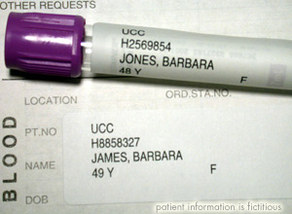

1. Separate samples for distribution to the appropriate laboratory section.

***Note: Each laboratory section has a separate STAT bin. Staff must notify technical staff when dropping off a STAT specimen, AND receive a response. This will ensure STAT specimens are processed according to the STAT TESTING PROTOCOL.***

***Note: Microbiology specimens are stored according to the labeled bins. Some specimens must be placed on the room temperature counter i.e. swabs, while some specimens must be placed in the refrigerator i.e. urines. If unsure where to place the specimen, ASK the tech working in that section.***

***Note: When delivering specimens to a section with no technical staff present, for example a Rapid Strep during the night shift, it is the responsibility of the staff delivering the specimen to let technical staff know they have dropped off a specimen.***

1. Place the requisition in the “to be filed” box.

***Registration of Outreach Requisitions***

1. Count requisitions and document on the tracking record.
2. Take the requisitions and the white copy of the tracking record to Admitting and placed in the lab SDO box.
3. Place the yellow copy of the tracking record in the lab registrar box that is located in the front office.

***Note: Client registrations for Wesley, Skidmore, Maplewood, and Rubin will be admitted by laboratory registrar. Both copies***

***of the tracking form go to the Lab Registrar. If the lab registrar is not available, bring the requisitions to Admitting for***

***processing.***

***Follow-up on Outreach Requisitions:*  (Lab Registrar)**

1. Admitting will return requisitions to the laboratory front office. Count requisitions and document on the tracking record. All requisitions **must** be accounted for prior to signing off on the record

***Note: If admitting needs to follow-up on a requisition:***

* ***Admitting will document problem on tracking log.***
* ***Make a copy of the requisition and return requisition to the lab.***

1. To ensure that all requisitions are accounted for, match the yellow and white copies. Refer any discrepancies to the supervisor. File tracking forms in the laboratory requisition file by date.

***Medicare ABN Review:***

1. Lab registrar will:

* Generate NPR Outreach report for Medicare patients.
* Retrieve requisitions for all Medicare patients who were registered under outreach.
* Perform Medical Necessity Check as per SOP.

**Attachments:**

Attachment 1: Entering Blood Culture Volumes

|  |  |  |  |  |
| --- | --- | --- | --- | --- |
|  | |  |  | |
| Date of Origin: | 09/22/04 |  | Prepared By: | Outreach Implementation Team |
| Revised: | 02/18/09 |  | By: | Madeline LaPierre/Joe Kaz |
| Revised: | 02/09/12 |  | By: | Madeline LaPierre/Joe Kaz |
| Revised: | 07/12/14 |  | By: | Teri Baldwin |
|  | |  |  | |
| **Date Placed in Service:** | |  |  | |

|  |  |  |  |  |  |  |  |
| --- | --- | --- | --- | --- | --- | --- | --- |
| Approved by: |  |  |  |  |  |  |  |
|  | Phlebotomy Supervisor  Teri Baldwin |  | Date |  | Clerical Services Coordinator  Jeanne Leonard |  | Date |
|  |  |  |  |  |  |  |  |
|  | Laboratory Medical Director  William E. Field II, MD |  | Date |  | Laboratory Administrative Director  Richard Vandell |  | Date |

Saratoga Hospital Laboratory

211 Church St. Saratoga Springs, N.Y. 12866

**Attachment 1: Entering Blood Culture Volumes**

**Procedure:**

*Blood culture volumes are either directly off of the blood culture bottle. Use the an uncollected blood culture bottle to estimate the blood volume in all blood cultures that do not have the initial volume marked.*

1. From the ***LABORATORY*** module of Meditech, under ***Basic Routines*** select ***10.Requisitions.***
2. Under ***Requisitions*** select ***11. Enter/Edit***.
3. In the ***Patient*** section, enter the blood culture number.

*Note: For example 14 BC153*

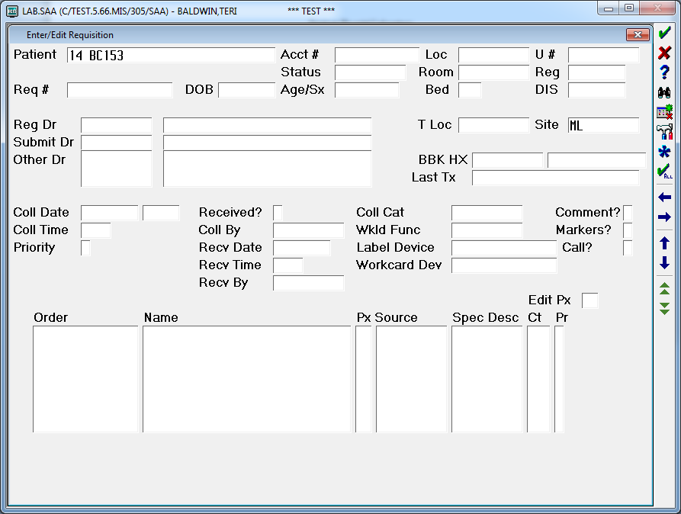

***Note: If entering the volume of a blood culture from a req that was just entered, press the Space Bar and the Enter key to bring up the last patient entered.***

1. Enter through the requisition until the blood culture query becomes available.

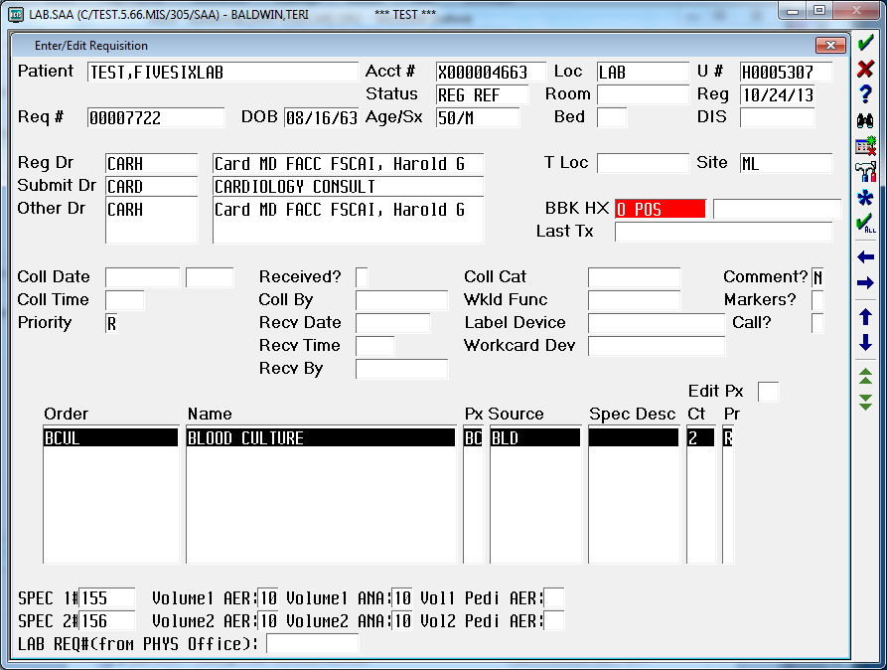

1. Enter the specimen number of the blood culture set, followed by the volumes collected in the blood culture bottles, in the query.

***Note: The accessioner must accurately record the volume in Meditech. If there is a question regarding volume, contact the office who drew the specimen or the charge phlebotomist.***



1. Select **F12** from the keyboard, and **Yes** to file the updated requisition.
2. Load blood culture bottles into the BacT/ALERT ® 3D according to the Receiving Procedure, Attachment 4: Receiving Blood Culture Specimens.