Saratoga Hospital Laboratory

211 Church Street, Saratoga Springs, New York 12866

# Blood Culture Specimen Collection Process Procedure

**Purpose:**

To provide instruction for the aseptic collection of blood culture specimens by venipuncture.

**Clinical Relevance**:

When the number of microorganisms in the blood exceed the ability of the reticuloendothelial system to remove them, serious illness occurs. Rapid recognition and treatment is essential. Laboratory diagnosis of bacteremia and/or fungemia is dependent on blood cultures.

**Principle**:

Inoculated bottles are placed in the BacT/Alert where they are incubated, as well as monitored, for the presence of microorganisms encountered in blood and normally sterile body fluids.

**Materials:**

* Test Requisition or Labels
* BacT/Alert® FA Aerobic & BacT/Alert® FN Anaerobic Blood Culture Bottles
* BacT/Alert® PF Blood Culture Bottles
* ChloraPrep® Single SwabStick Applicator
* Alcohol Prep Pads
* Tourniquet
* 2 x 2 Inch Dry Gauze Sponge
* BacT/Alert Blood Collection Adaptor Cap & Insert
* BD Vacutainer Push Button Blood Collection Set
* Syringe
* Approved Biohazard Sharps Container
* Surgical/Adhesive Tape or Band-Aid

**Specimen:**

|  |  |  |
| --- | --- | --- |
| **Neonates to 1 year** | 0.5 to1.5 ml/bottle…at least 1.0 ml is preferred | **BacT/ALERT® PF Bottle** |
| **Children: 1 to 6 yrs** | 1 ml per year of age, (divided between 2 blood culture orders) |
| **Children**  **Weighing 30 to 80 lbs** | **10 to 20 ml total, (divided between 2 blood cultures orders)** | |
| 4 ml in each BacT/ALERT® PF bottle x 2 draws = 8ml total  **-or-**  5ml in each BacT/ALERT® FA, FN bottles x 2 = 20ml |  |
| **Adults and children**  **weighing >80 lbs** | **7.5 to 10 ml in each BacT/ALERT® FA and BacT/ALERT® FN bottle**  *\* 5 to 7.5 ml in each BacT/ALERT® FA and BacT/ALERT® FN bottle is minimal* | |

***Note: See Saratoga Hospital Specimen Rejection Policy for additional specimen rejection criteria.***

**Procedure:**

***Note: Specimens will be rejected if patient specimens are not collected and labeled according to established procedure. See the laboratory’s “Specimen Rejection Protocol” for instructions on handling rejected specimens.***

***Note: See Attachment 1: Blood Collection From IV Arm.***

1. Greet the patient. Employee must introduce themselves and inform the patient they are going to be performing venipuncture procedure.
2. Wash hands according to Hand Washing and Hand Care procedure (Infection Control Manual D001).
3. Identify the patient using a minimum of 2 identifiers following the guidelines established by Administrative Policy II-49 Patient Identification.

***Note: See MobiLab Procedure.***

1. Assemble supplies specific for patient’s age.

***Note: See table under Specimen section of this procedure.***

***Note: ChloraPrep is not to be used as a disinfectant for patients under 2 months of age. Alcohol prep pads are to be substituted for these patients.***

1. Mark bottles with the initial volume.
2. Remove metal stoppers from the bottles. Clean each rubber stopper with individual alcohol pads. Put a new alcohol pad on top of the rubber stopper. Do not remove protective alcohol pad until just prior to bottle being collected.
3. Put on protective gloves.

***Note: Gloves must stay intact for the duration of the procedure.***

1. Position patient in chair or bed, arm outstretched and supported, in a manner both comfortable to the patient and accessible to the phlebotomist.
2. Apply tourniquet (or other restrictive device) 3-4 inches above venipuncture site. If blood pressure cuff is used, inflate to 40 mm Hg.

***Note: Tourniquet should remain in place 1 minute or less*.**

1. Identify the appropriate site for venipuncture by palpating the vein.

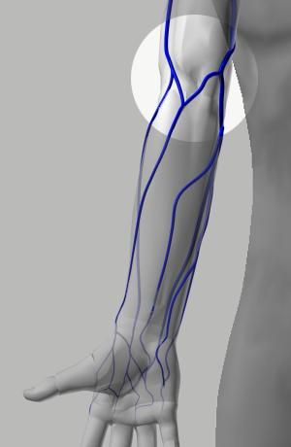

***Note: The preferably mid-antecubital fossa***

1. If necessary, ask patient to “make a fist” but avoid “pumping”.

**Guidelines:**

* + **Avoid**→**Healed Burns, Extensive Scaring, or Hematoma**
  + **Do Not→Draw from an arm on the same side as a mastectomy without physician approval.**
  + **Do Not→Draw from an arm having a Cannula, Fistula, or Vascular Graft without physician approval.**

**Avoid Nerves:**

* + **Keep in mind where nerves are found, and avoid these areas.**

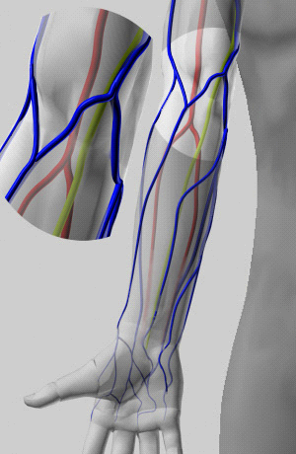

The lime green areas are the Medial nerve. Make a note of where it lies in relation to the veins in the arm.

1. Prepare site for venipuncture using the following steps.

***Note: The site must prepare as instructed.***

***Age: Birth – 2 Months***

***Note: Alcohol prep pads are used on this age group to push bacteria away from the venipuncture site. Using Chloraprep could cause irritation or chemical burns.***

1. Open alcohol prep pad, and place directly on the venipuncture site.
2. Move the alcohol prep pad in concentric circles away from the venipuncture site.
3. Allow area to dry for approximately 30 seconds. Do not blot or wipe away.

***Age: Greater Than 2 Months***

***Note: ChloraPrep is used on this age group to disinfect the venipuncture site. The maximum treatment area for one applicator is 2.5 inches by 2.5 inches. See box below.***

1. Tear ChloraPrep applicator pouch at side notch to reveal applicator handle. Do not touch foam applicator tip. Place foam flat side down on the venipuncture area.
2. Completely wet the venipuncture area.
3. Gently use repeated back and forth strokes of the applicator for approximately **30 seconds**. Allow area to dry for approximately 30 seconds. Do not blot or wipe away.
4. Discard applicator after single use.
5. Perform the phlebotomy:
6. Stabilize the vein (with your non-dominant hand), using the thumb to draw the skin taut distal to the puncture site.

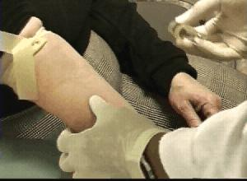

1. Holding the needle assembly in the dominant hand, remove the protective sheath from the needle. Forewarn patient that the venipuncture is about to occur. Hold the assembly with the bevel facing up, and insert the needle, at no more than a 30 degree angle.

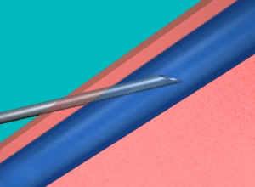

1. Using non-dominant hand, sequentially engage each BacT/Alert bottle into collection adaptor cap. See table below for correct order of draw.

|  |  |
| --- | --- |
| **Collection Method** | **Order of Blood Culture Bottles** |
| Attachment 1: BD Vacutainer Push Button Blood Collection Set with **Adapter** | 1. **Aer**obic Bottle (FA) 2. **Ana**erobic (FN) |
| Attachment 2: Blood Collection with **Syringe** | 1. **Ana**erobic (FN) 2. **Aer**obic Bottle (FA) |

1. Specimens are sent to the Receiving area of the Main Laboratory. Blood culture volumes are recorded into Meditech according to the following procedures.
   * Accessioning of Laboratory Specimen Drop-Offs [SDO] Meditech Outreach
   * Accessioning Procedure
   * Receiving Procedure
2. BacT/Alert bottles are placed into the BacT/Alert® 3D instrument according to Attachment 4: Receiving Blood Culture Specimens of the Receiving Procedure.

**Special Considerations:**

* Use a providone-iodine prep pad per package instructions on patients with a sensitivity to alcohol and/or chlorhexidine.
* Newborns and small infants are at increased risk of developing hypothyroidism from exposure to iodine. Due to the permeable nature of their skin and increased sensitivity to iodine, iodine pads should not be used on patients under the age of 1 year.

**References:**

ASM, Clinical Microbiology Procedures Handbook, 2nd Edition

BacT/ALERT® 3D Signature™ System Training Manual, January 2006

Bact/ALERT® TIPS, Supplemental Resource Manual, Part #: 60-00072-0, January 2006

bioMérieux. (2006, July 1). *Recommendations for blood culture collection*. Retrieved July 8, 2014, from <http://www.biomerieux-diagnostics.com/sites/clinic/files/recommandation-for-collection.pdf>

CareFusion. (2014). *Chloraprep® swabstick*. Retrieved from http://www.carefusion.com/medical-products/infection-prevention/skin-preparation/chloraprep-swabstick.aspx

Principles and Procedures for Blood Cultures; Proposed Guideline, CLSI Publication M47-P, Vol. No.31

Cumitech 1C, Blood Cultures IV, 2005

**Attachments:**

Attachment 1: BD Vacutainer Push Button Blood Collection Set with Adapter

Attachment 2: Blood Collection with Syringe

|  |  |  |  |  |
| --- | --- | --- | --- | --- |
| Date of Origin: | 02/22/05 |  | Prepared By: | Brian Staring |
| Revised: | 06/06/07 |  | By: | Brian Staring |
|  | 07/09/14 |  | By: | Teri Baldwin |
|  |  |  |  |  |
| **Date Placed in Service:** | |  |  | |

|  |  |  |  |  |  |  |  |
| --- | --- | --- | --- | --- | --- | --- | --- |
| **Approved by:** |  |  |  |  |  |  |  |
|  | Phlebotomy Supervisor  Teri Baldwin |  | Date |  | Microbiology Supervisor  Deborah Petrie |  | Date |
|  |  |  |  |  |  |  |  |
|  | Laboratory Administrative Director  Richard Vandell |  | Date |  | Assistant Medical Laboratory Director  Nicole Durie, M.D. |  | Date |
|  |  |  |  |  |  |  |  |
|  | Laboratory Medical Director  William E. Field II, MD |  | Date |  |  |  |  |

Saratoga Hospital Laboratory

211 Church Street, Saratoga Springs, New York 12866

**Attachment 1: BD Vacutainer Push Button Blood Collection Set with** **Adapter**

***Note: When collecting blood cultures in the ED, place a small round green sticker on the patient’s wristband after the first set of cultures have been drawn.***

1. Using non-dominant hand, sequentially engage each BacT/Alert bottle into collection adaptor cap.
2. Collect blood culture bottles in the following order.
   1. **Aer**obic Blood Culture Bottle / **Ped**iatric Blood Culture Bottle
   2. **Ana**erobic Blood Culture Bottle / **Ped**iatric Blood Culture Bottle

***Note: The following are the optimal volumes.***

* + ***10 mL from adult patients into each Aerobic / Anaerobic bottle.***
  + ***4 mL from pediatric patients into each Pediatric bottle.***

***Note: Avoid overfilling bottles. This could cause a false alarm on the Bac-T-Alert.***

1. Disengage last bottle. If additional blood is required for other testing, place the adaptor insert in to the adaptor cap and snap into place. Sequentially insert vacuum collection tubes as required using the following order of draw.
2. Coagulaton Tubes (**blue** top)
3. Serum Tubes (with or without clot activator)
4. Heparin Tubes (**green** top, with or without plasma separator)
5. EDTA Tubes (**lavender** top)
6. Glycolytic Inhibitor Tube (**gray** top)
7. Disengaged the last tube from the adapter assembly.
8. If not already done so, remove the tourniquet.

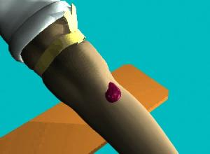

***Note: Removing the needle prior to removing the tourniquet will cause excessive bleeding at the puncture site.***

1. Engage push button safety device (see package insert) and immediately apply pressure to the venipuncture site using a 2 x 2 gauze.
2. Apply pressure for 3-5 minutes, then check the site for bleeding. When bleeding has completely stopped, apply a bandage to the site. Advise the patient to remove it no sooner than 15 minutes.

***Note: Applying the bandage before bleeding has completely stopped could create a hematoma.***

1. Discard the assembly into a sharps container.
2. Invert the blood culture bottles 3-5 times.
3. Label the specimens according to Administrative Policy II-068 Specimen Labeling.

***Note: See MobiLab Procedure.***

1. Wash hands according to Hand Washing and Hand Care procedure (Infection Control Manual D001).

Saratoga Hospital Laboratory

211 Church Street, Saratoga Springs, New York 12866

**Attachment 2: Blood Collection with Syringe**

***Note: When collecting blood cultures in the ED, place a small round green sticker on the patient’s wristband after the first set of cultures have been drawn.***

1. Draw specimen into syringe. When syringe has reached desired amount, if not already done so, remove the tourniquet, and then remove needle.



***Note: Removing the needle prior to removing the tourniquet will cause excessive bleeding at the puncture site.***

1. Engage the needle safety device.
2. Immediately apply pressure to the venipuncture site using a 2 x 2 gauze. Apply bandage. Advise the patient to remove it no sooner than 15 minutes.

***Note: Applying the bandage before bleeding has completely stopped could create a hematoma.***

1. Attach the syringe to collection adaptor cap.
2. Insert blood culture bottles into the collection adaptor cap in the following order.
   1. **Ana**erobicBlood Culture Bottle / **Ped**iatric Blood Culture Bottle
   2. **Aer**obic Blood Culture Bottle / **Ped**iatric Blood Culture Bottle

***Note: The following are the optimal volumes.***

* + ***10 mL from adult patients into each Aerobic / Anaerobic bottle.***
  + ***4 mL from pediatric patients into each Pediatric bottle.***

***Note: Avoid overfilling bottles. This could cause a false alarm on the Bac-T-Alert.***

1. Disengage last bottle. If additional blood is required for other testing, place the adaptor insert in to the adaptor cap and snap into place. Sequentially insert vacuum collection tubes as required using the following order of draw.
   1. Coagulaton Tubes (**blue** top)
   2. Serum Tubes (with or without clot activator)
   3. Heparin Tubes (**green** top, with or without plasma separator)
   4. EDTA Tubes (**lavender** top)
   5. Glycolytic Inhibitor Tube (**gray** top)
2. Disengaged the last tube from the adapter assembly.
3. Apply pressure for 3-5 minutes, then check the site for bleeding. When bleeding has completely stopped, apply a bandage to the site. Advise the patient to remove it no sooner than 15 minutes.

***Note: Applying the bandage before bleeding has completely stopped could create a hematoma.***

1. Discard the assembly into a sharps container.
2. Invert the blood culture bottles 3-5 times.
3. Label the specimens according to Administrative Policy II-068 Specimen Labeling.

***Note: See MobiLab Procedure.***

1. Wash hands according to Hand Washing and Hand Care procedure (Infection Control Manual D001).