|  |  |
| --- | --- |
| Saratoga Hospital Laboratory  211 Church Street, Saratoga Springs, NY 12866 | Saratoga Hospital Lab-Wilton  3040 Route 50 North, Saratoga Springs, NY 12866 |

**Procedure for Scheduling, Requisitioning, and Specimen Collection for Oral Glucose Tolerance Tests**

**Policy:**

Oral Glucose Tolerance Testing (OGTT) requires patients to remain at the site of collection for the duration of the procedure. OGTT performed by Saratoga Hospital is to be scheduled through the Laboratory Clerical Services Department. On the date of the appointment, the laboratory site enters the requisition into the lab information system. Depending on what screening test the provider orders, specimen collection staff give the patient an oral glucose drink, as well as collect timed blood glucose samples.

**Scope:**

This procedure applies to all laboratory employees involved with the requisitioning of provider orders for oral glucose tolerance testing, as well as those participating on the collection and handling of blood specimens for this testing.

**Materials:**

* Meditech Information System
* Passport System
* Medicon
* Office Supplies
* Glucose Tolerance Beverage (50g, 75g, 100g)
* Laboratory Requisition
* Specimen Labels
* Hour Labels (FBS, 1, 2, 3)
* Specimen Tubes (GRNLITHIUM, GREY)
* Tourniquet, Gloves, Alcohol Prep Pad, Dry Gauze Sponge
* Disposable Needle Holder w/Eclipse Needle
* Surgical/Adhesive Tape or Band-Aid
* Approved Biohazard Sharps Container
* Patient Centered Environment (Comfortable Seating, TV, Blanket, Pillow)

**Scheduling & Mock Pre-Registration Procedure:**

It is recommended that all requisitions containing oral glucose tolerance testing orders be inputted into the Medicon system by faxing them to (518)693-4543. Prior to testing, patients are encouraged to schedule an appointment with the Laboratory Clerical Services Department, by calling (518)580-2542. See Attachment 1: Procedure for Scheduling & Pre-Registering Oral Glucose Tolerance Tests for details.

**Requisitioning Procedure:**

Prior to the patient’s appointment, laboratory staff enter the test requisition in the Meditech Information System according to the following procedures.

* Accessioning Procedure (wmaPHLEB1 & ACC1)
* Processing Laboratory Orders for Outpatients (Walk-Ins)

**Patient Management Procedure**

1. Patients will be instructed to check in according to the location where they present.
   * ***Saratoga Hospital***: Check in at the Clerical Support Service’s Wndow.
   * ***Wilton Medical Arts:*** Check in at the WMA Reception.

***Note: Patients must complete the full registration prior to the end of their appointment.***

1. The patient will be escorted to a drawing room.
2. Proceed according to Attachment 2: Guidelines for the Collection of Oral Glucose Tolerance Tests. The patient has 5 minutes to finish drinking the Glucose Tolerance Beverage.
3. After the Glucose Tolerance Beverage has been administered, check the condition of the patient often. Follow the Phlebotomy Adverse Reaction Procedure if it is suspected the patient is experiencing an adverse reaction.

***Note: The drink can make some patients feel* nauseous*, cold and tired.***

1. Once the last specimen has been collected, ask the patient to have a seat back in their waiting area until results are obtained.
   * Provide the patient with a Café coupon, or available crackers, snacks and/or juice.
   * The patient is free to leave if results are >50, however if they are below the normal range of 74 mg/dL instruct them to get something to eat or drink as soon as possible.

**References**

American Diabetes Association. (2015). Standards of Medical Care in Diabetes - 2015. Retrieved August 3, 2015. <http://care.diabetesjournals.org/content/38/Supplement_1>

|  |  |  |  |  |
| --- | --- | --- | --- | --- |
|  | |  |  | |
| Date of origin: | 08/03/15 |  | Prepared By: | Teri Baldwin |
|  | |  |  | |
| **Date Placed in Service:** | |  |  | |

|  |  |  |  |  |  |  |  |
| --- | --- | --- | --- | --- | --- | --- | --- |
| **Approved by:** |  |  |  |  |  |  |  |
|  | **Laboratory Support Services Manager**  **Teri Baldwin** |  | **Date** |  | **Wilton Medical Arts Laboratory Supervisor**  **Rhea Jamro** |  | **Date** |
|  |  |  |  |  |  |  |  |
|  |  |  |  |  |  |  |  |
|  | **Laboratory Administrative Director**  **Richard Vandell** |  | **Date** |  | **Laboratory Medical Director**  **William E. Field II, MD** |  | **Date** |
|  |  |  |  |  |  |  |  |
|  |  |  |  |  |  |  |  |
|  | **Laboratory Medical Director**  **Josenia Tan, M.D.** |  | **Date** |  |  |  |  |

|  |  |
| --- | --- |
| Saratoga Hospital Laboratory  211 Church Street, Saratoga Springs, NY 12866 | Saratoga Hospital Lab-Wilton  3040 Route 50 North, Saratoga Springs, NY 12866 |

Attachment 1: Procedure for Scheduling Oral Glucose Tolerance Tests

**Scheduling Procedure:**

1. Patient will be instructed to call (518)580-2542 to schedule an appointment for the OGTT for all locations.
2. Write the patient’s name, date of birth, and phone number on the date they wish to schedule, on the time line they are requesting for testing, in the GTT Book.

|  |  |  |
| --- | --- | --- |
| **Site** | **Hours** | **Number of Seats** |
| **Saratoga Hospital** | 7a- 3p (Last Apt @ 12p) | 2 |
| **Wilton Medical Arts** | 9a-3p (Last Apt @ 12p) | 1 |

1. With the patient still on the phone, verify they have a requisition in Medicon.

**Mock Pre-registration Procedure**

Thepatients scheduled for OGTT will be pre-registered.

1. Sign into Meditech.
2. Select **1 ADM.SAA**
3. Select **11. PRE-REGISTRATION/EDIT**
4. In the **Patient** field, look up the patient by name.
5. Select **F12**, and go to page **2 Demographic Information.** Verify the patient’s name, date of birth, and phone number.

***Note: There are 2 required fields on this screen.***

|  |  |
| --- | --- |
| **&** |  |

1. Enter through **Page 2**, and go to page **Page 4 Insurance & Guarantor**. Verify the insurance information on file through **Passport**.
2. Continue to **Page 5 ADM FACESHEET**.

***Note: There is 1 required field on this screen. Enter******N.***

|  |
| --- |
|  |

1. Continue to **Page 6 Additional Billing Info.**

***Note: There is 1 required field on this screen. Enter AOP.***

|  |
| --- |
|  |

1. Continue to **Page 7** **Doctor & Location Information.**

***Note: There are several required fields on this screen.***

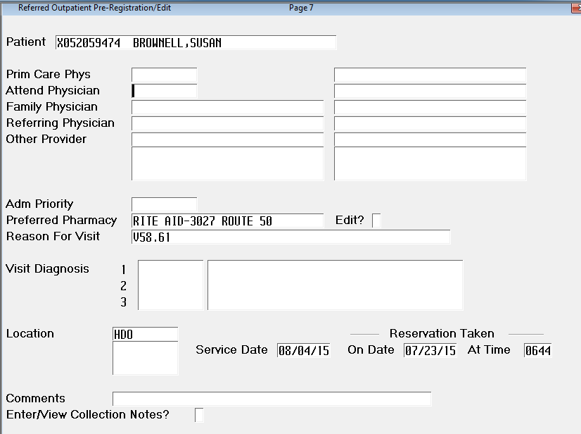

1. ***Attend Phys:*** *Enter the ordering provider.*
2. ***Adm Priority:*** *Enter* ***OUTREF***
3. ***Reason For Visit:*** *Enter diagnosis.*
4. ***Location:*** *Depending on the appointment location enter* ***LAB*** *or* ***LABWMA***
5. ***Service Date:*** *Enter the appointment date*
6. ***Comments:*** *Enter your initials*
7. The day prior to the patient’s appointment, call and remind them of the appointment.

***Scripting:***

* + ***Instruct all patients to arrive 15 minutes prior to their appointment. They must bring their insurance cards, government issued photo ID, and their payment obligation.***
  + ***Mock Pre-registered Saratoga Hospital patients may check in at the Clerical Support Services window.***
  + ***Wilton Medical Arts Patients check in at the Reception desk.***

1. Provide the WMA Lab a list of mock pre-registered patients each day, for the following day.
2. Provide the Admitting Department a list of mock pre-registered patients each day, for the following day.

|  |  |
| --- | --- |
| Saratoga Hospital Laboratory  211 Church Street, Saratoga Springs, NY 12866 | Saratoga Hospital Lab-Wilton  3040 Route 50 North, Saratoga Springs, NY 12866 |

Attachment 2: Guidelines for the Collection of Oral Glucose Tolerance Tests

|  |  |  |  |  |
| --- | --- | --- | --- | --- |
| ***Adult (greater than 16 yrs old, or 95 lbs) Guideline*** | | | | |
| **Test Ordered** | **Fasting/Nonfasting** | **Collect Fasting Prior to Beverage** | **Administer Glucose Beverage** | **Time Specimens are to be Collected \*** | |
| **1 hr Glucose Challenge** | Nonfasting | No | 50-g | 1 hr | |
| **2 hr OGTT** | Fasting | Yes | 75-g | Fasting **, 1 hr, 2 hr | |
| **3 hr OGTT (pregnancy)** | Fasting | Yes | 100-g | Fasting **, 1 hr, 2 hr, 3 hr | |

**\*Collect all specimens in a tube containing Sodium Fluoride Potassium Oxalate (Grey Top), or Lithium Heparin (GRNLITHIUM).**

**\*\*Specimen collection staff must wait to hear from the Chemistry Technologist before administering the glucose beverage for all OGTT requiring fasting. Fasting results ≥126 mg/dL require the Chemistry Technologist to contact the ordering provider to ascertain if the OGTT is to proceed.**

**\*\*\*When a critical result is obtained during any OGTT, a code green is initiated.**

|  |  |  |  |
| --- | --- | --- | --- |
| ***2 hr GTT Beverage Guide (less than 16 yrs old, or 95 lbs)***  ***Determination of glucose beverage ounces to be administered must be done by supervisory staff.*** | | | |
| **Body Weight (lbs)** | **Body Weight (kg)** | **Glucose (g)** | **Glucose Beverage (oz)** |
| **30** | 14 | 24 | 2 |
| **35** | 16 | 28 | 3 |
| **40** | 18 | 32 | 3 |
| **45** | 20 | 36 | 4 |
| **50** | 23 | 40 | 4 |
| **55** | 25 | 44 | 4 |
| **60** | 27 | 48 | 5 |
| **65** | 30 | 52 | 5 |
| **70** | 32 | 56 | 5 |
| **75** | 34 | 60 | 6 |
| **80** | 36 | 64 | 6 |
| **85** | 39 | 68 | 7 |
| **90** | 41 | 72 | 7 |
| **95** | 43 | 76 | 7 |