Saratoga Hospital Laboratory

211 Church Street, Saratoga Springs, NY 12866

**MRSA Nasal Screen Culture Specimen Type and Collection**

**Purpose:**

To provide phlebotomy staff, with instruction on how to coach patients in the inoculation of a Cepheid Collection Device (Copan Transystem Transport Swab), for MRSA Nasal Screen Culture testing.

**Scope:**

This procedure applies to all phlebotomy staff members working in The Saratoga Hospital Laboratory.

**Materials:**

* Test Requisition
* Cepheid Collection Device (Copan Transystem Transport Swab)
* Mirror
* Gloves

**Patient Self-Collecting Procedure**

**Collection MUST be done by the patient. Laboratory personal are not permitted to collect nasal screen specimens.**

1. Greet the patient. Employee must introduce themselves and inform the patient that they are going to be obtaining the specimen by swabbing their own nose.
2. Wash hands according to Hand Washing and Hand Care procedure (Infection Control Manual D001).
3. Identify the patient using a minimum of 2 identifiers following the guidelines established by Administrative Policy II-49 Patient Identification.
4. 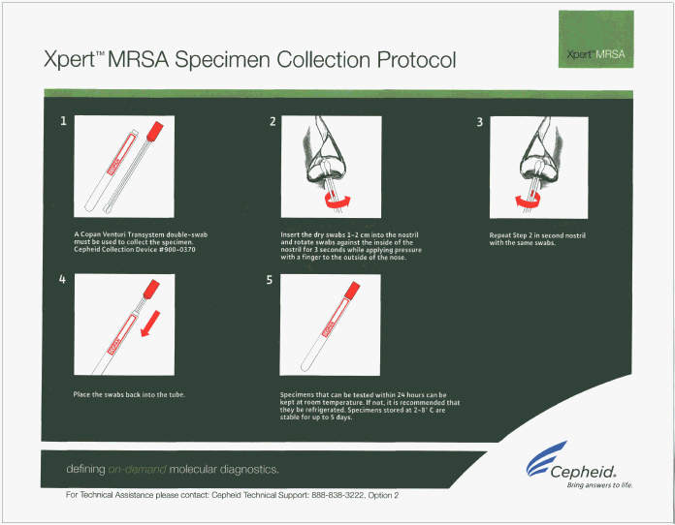Assemble supplies.
   1. Cepheid Collection Device (Copan Transystem Transport Swab)
   2. Mirror
   3. Gloves
5. Open the Cepheid Collection Device by peeling back the outer packaging.
6. Hand the swabs to the patient.
7. Hold the mirror, so that the patient is able to see their face in it.
8. Ask the patient to do the following.
   1. Insert the swabs approximately 1-2 cm into one of the nostrils.
   2. Rotate the swabs against the inside of the nostril for 3 seconds, while applying slight pressure with a finger on the outside of the nose.

*Note: Outside pressure is needed to ensure good contact between the swab and the inside of the nose.*

**

1. **Using the same swabs**, repeat the above steps for the other nostril. Do not touch the swabs on anything but the inside of the nose.
2. Remove the plastic transport tube from the package. Twist off the tube cap and discard it.
3. Take the swabs from the patient, and insert them into the plastic transport tube.

*Note: The swabs should go all the way into the tube until they rest on top of the sponge at the bottom of the tube. Make sure the red cap is on tightly.*

*Note: Make sure the swab is short enough to allow the cap is on tightly. The swabs should stay attached to the red cap at all times.*

1. Label specimen according to Administrative Policy II-68 Specimen Labeling.
2. Store swab specimen at room temperature (15-30°C) if it will be processed within 24 hours, otherwise store swab at 2-8°C. The swab specimen is stable up to 5 days when stored at 2-8°C.

**Procedural Notes**

* In some cases the patient may not have the ability to perform or may refuse to collect the specimen. When that occurs use the following guidelines.

|  |  |  |
| --- | --- | --- |
| Time | Department to Notify | Extension |
| 07:30 am – 05:30 pm | PPT |  |
| After 05:00pm | D3ORTHO | 4600 |

**References**

Cepheid. (2011). *Cepheid xpert mrsa assay procedure*.

|  |  |  |  |  |
| --- | --- | --- | --- | --- |
| Date of Origin: | 04/11/13 |  | Prepared By: | Teri Baldwin |
|  |  |  |  |  |
|  | |  |  | |
| **Date Placed in Service:** | |  |  | |

|  |  |  |  |  |  |  |  |
| --- | --- | --- | --- | --- | --- | --- | --- |
| **Approved by:** |  |  |  |  |  |  |  |
|  | Phlebotomy Supervisor  Teri Baldwin |  | Date |  | Laboratory Medical Director  William E. Field II, MD |  | Date |
|  |  |  |  |  |  |  |  |
|  | Laboratory Administrative Director  Richard Vandell |  | Date |  |  |  |  |