
New Site Preview

Some exciting new changes are coming to MTS that we would like to share with you. You will soon notice a whole look and the site functions will be greatly improved. The purpose of these changes is to create a more fluid and user friendly experience, as well as to allow administrators additional options to customize their accounts.

Preview of the screen you will see upon logging in:
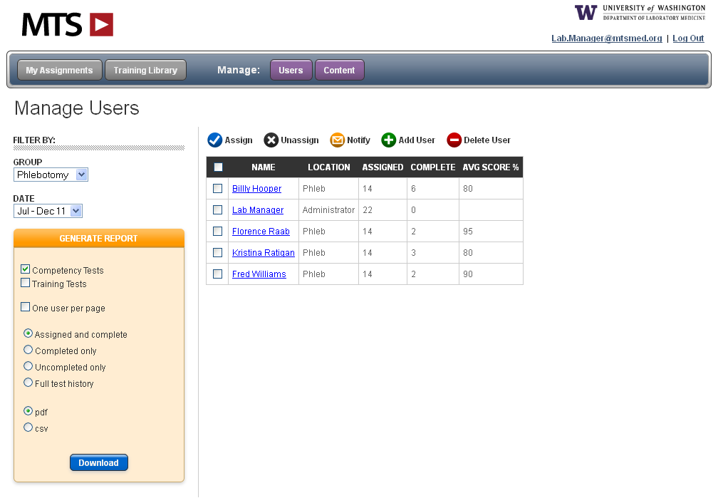
The user’s experience will also be enhanced. When they login they will see only their assignments, those Competency Assessments and Training Courses that have been assigned to them. They will still have the option to view the whole Library by selecting the “Training Library” button. Another benefit will be the slide status button; this will allow users to know how far they are in the training module, and how many slides they have left. It will also show them how many questions each test has and what question number they are currently on. Here are a few screen shots of these new features:
This will be the first screen you see when you login. From here you can select your users, assign their tests and with those users still selected choose to send them an email notification.
From this screen you get a quick view of your users’ test completion status. You can further click on their names to see assignments, completed tests and scores.
From the left side of the page you filter the information you see on the right side of the page. You can choose to view one group at a time, or all groups, and for what time period. You can also generate your report right from this same screen.
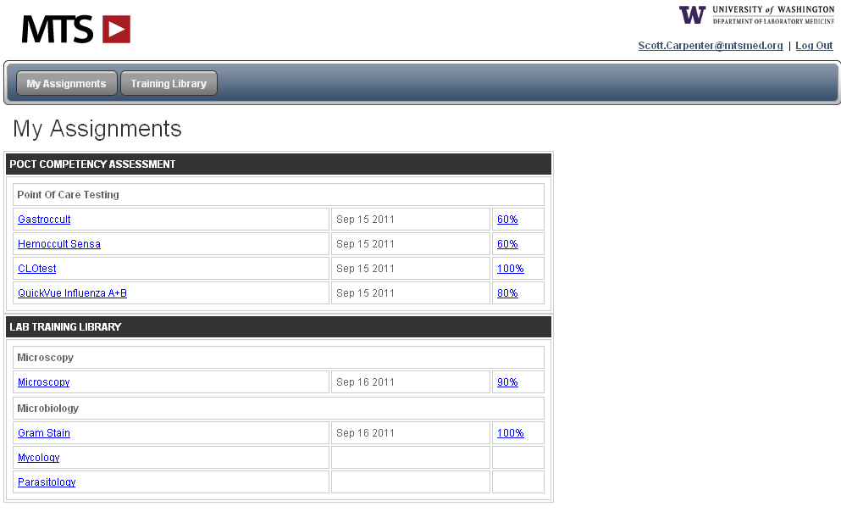
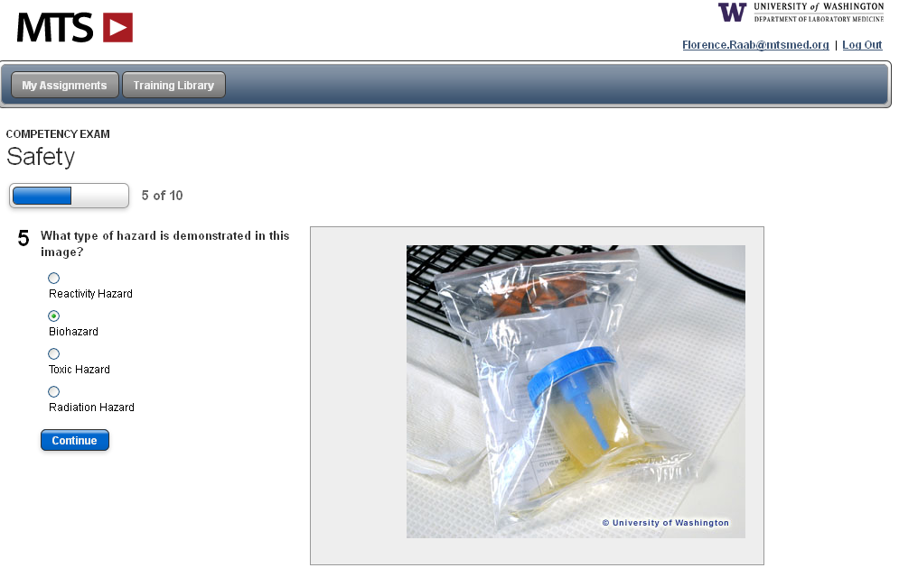
When users login they will see their assignments broken out into categories. They will no longer see the whole Training Library, only those modules which have been assigned to them. They can still click on “Training Library” at the top of their screen to view the Training Library.
Test takers will now always know how far along in the test they are.

We have listened to your requests to make the MTS site more customizable. With the new site you will have the ability to:
- Easily edit the current MTS Competency Assessments and Training Modules
- Create your own Training Modules
- Upload PowerPoint presentations, Word Documents, etc to assign to your users. You will have the option to create a custom test for the document or request a “Read Receipt” upon completion.

Look for these changes to take place within the next 2-4 months. As always, we welcome your feedback and suggestions.

Please send any questions or comments to:

Megan Hinch
MTS
Customer Support Manager
866-681-6700 x2
meganh@medtraining.org

