Welcome

MTS Lab Training and Competency programs equip labs with a comprehensive online resource for training staff and building competency.

As an administrator for your account, you can add, edit, delete users, send email notifications, reset tests and create and print reports for training and competency documentation. Accounts can have more than one administrator which allows for added flexibility in managing the account.

Administrators can also group users by department, location, or shift to make tracking progress quick and simple. With groups, administrators are empowered with increased account administration flexibility and coordination.

Users and administrators have unlimited access 24/7 from home, work, or school to:

Training courses with engaging video and animation worth over 50 hours of continuing education credit. Specimen images make an ideal reference tool.

Competency Assessment tests for meeting regulatory requirements. Test questions change twice annually.
Getting Started
Log In:
To access the account, Administrators and Users must log in:
1.) Open an internet browser window and go to www.medtraining.org
2.) Log in with your e-mail/UserID and password provided by MTS.
3.) Click Sign in.

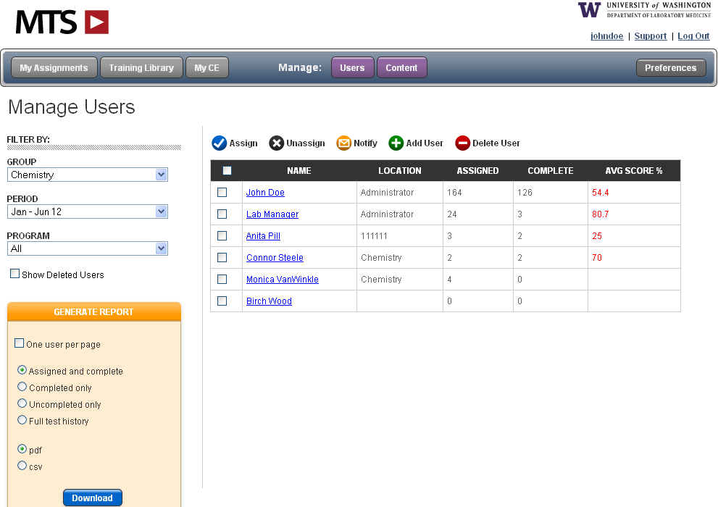

Administrator Menu:
After log in, you will see the screen shown above. From here you will be able to add/edit/delete users, assign tests, send email notifications, create reports, etc. (Users do not have access to the Manage tabs.)

Step 1: Organizing your account
A good way to get started is to determine how you would like to organize your account. For larger accounts (30+ users) it might be helpful to arrange your account into groups such as: Core Lab, Phlebotomy, 3rd Shift, etc. The diagram below illustrates a sample account that utilizes groups to organize and manage their account. You may add as many groups as needed and at anytime.

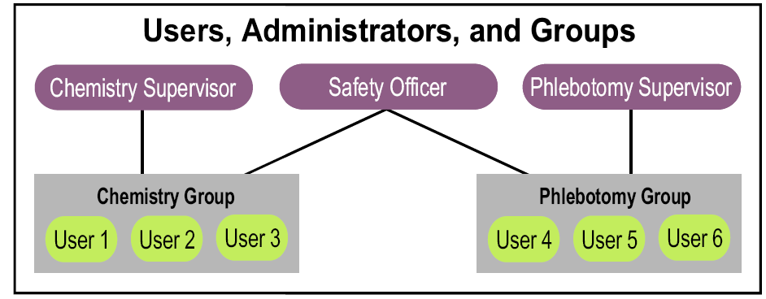

To set up groups within your account, please contact customer service at support@medtraining.org

Administrators: There is no limit to the number of administrators on each account. Larger accounts might find it easier to assign one or two administrators to each group, and have one person as the primary administrator who is set up over all groups. You may set up administrative duties any way that works best for your facility.

To give a current user administrative status, select the user from the Manage Users screen and then click the Edit button in the lower left corner. Click the Request Admin permissions box, select the group(s) they should have access to and hit Save. Customer Support will process your request with 1 business day and notify you and the new Administrator by email.

Step 2: Adding your users
In order to access the Lab Training and Competency resources, a User must have an account. Accounts can only be created by an Administrator using the Add User function from the Admin Menu. To add a user:
Log in to your account, select and enter:
- Your new users’ first and last names.
- Email/user id - a valid email address is recommended as this will enable other useful features of the system, such as E-mail Notification. (If a user does not have email, a unique UserID should be created such as lisarobbins76 or an employee ID#)
- Department (optional) - This can be used to organize users by location, specialization, shift, etc.
- Group - If an Administrator manages more than one group users must be assigned to a group. Groups are useful for managing large accounts with multiple Administrators. This option does not appear if an Administrator only manages one group.
- Password - Choose a password for your user. You may give all your users the same initial password, such as change or password. Users can then personalize their password after they login for the first time. Note: Password is not case sensitive.
- Assign Tests - From here, or you may wait until all users have been added to process assignments in a batch, which we will go over in the next step.

Hint: If you have more than 10 users to add this can be pretty time consuming. Instead of entering your users one by one please email customer service at support@medtraining.org to request a User Upload Spreadsheet. You will enter all of your users on the spreadsheet, return to MTS and your users will be uploaded to your account that same day.

Step 3: Assigning tests
Competency tests can be assigned/unassigned to individual users or to an entire group.
To Assign to the whole group:
- From the left side of the page select the group from your Group drop box
- Click the select all box at the top of the user list, this will put a checkmark next to all users
- Click the button
- From the program drop box select Training Library or Competency Assessment
- Click the box next to the test(s) you would like to assign and hit Save
To Assign to an individual:
- From the left side of the page select the group from your Group drop box
- Click the box next to the users’ name and click the button
- From the program drop box select Training Library or Competency Assessment
- Click the box next to the test(s) you would like to assign and hit Save
You may un-assign tests in the same order as above, and by clicking the button
Hint: To verify that the tests “took” click on the Users’ name. You will then see all tests that have been assigned to this user.

A.
B

C

Step 4: Notify users of assigned tests

Email notification is a method for notifying users that they have been assigned competency or training tests. Notification emails are generated within the system and include a log-in link, which allows a user to log in simply by clicking on the link. The users’ email/UserID and password are also included for manual log in.
To send an email notification:
- From the Group drop box on the left side of your page select the group you would like to notify
- Click the box next to the user you would like to notify or click the select all box to notify all users
- Click the Notify icon above your user list
- Select the email template you would like to send, or create a new one
- Hit send, you will receive a confirmation that your email was sent.
Hint: If a user’s UserID is not an email address, the email will be sent to the administrator. The administrator may then print the email and deliver it to the user.
Hint2: To see a sample notification email, the administrator should select only his/her own name and send a test email.

Step 5: Reset test scores
Administrators can reset test scores if a user scores below passing (80%).
- From the Manage Users screen notice the Avg Score% column. If a user has any test score below 80% their Avg Score will be highlighted in red.
- Click on a user name, you will see all assigned and completed tests. Completed tests will have the completed score and date
- Click on any low score and then on the Reset Score link in the upper right corner

Administrators may also grant their users permission to reset their own test scores.
- Click your Preferences button on the right side of your screen
- Select the group
- You may grant users the rights to reset training tests, competency or both.

Step 6: Generating Reports
Administrators can create several different reports for tracking and documenting user activity. Created in pdf or csv format, reports are easily printed, saved or emailed.

To create a report:
- From the Manage Users screen select your group from the Group drop box on the left side of the page
- Select the user(s) you would like to create the report for
- Select the test period(s) you would like the report to show from the Date drop box
- Select the programs(s) you would like the report to show from the Program drop box
- Select what you would like the report to show you:
- Assigned and complete – will show all assignments for each user, if they have completed a test you will see the completed date and score
- Completed only – will only show tests that have been completed
- Uncompleted only – will show all tests that have not been completed
- Full test history – will show all assigned and completed as well as any tests that have been reset
- Select your report format: PDF or CSV
- Click the Download button to generate your report

These are the basic 6 steps that you will use as an administrator. Below you will find some more general information and helpful hints.

Creating Custom Tests and uploading Custom Documents:
To create a custom test:
- Click on the Content button at the top of your screen
- Click the “Add Custom Test” button
- Add a title, topic and author for your test. Select the testing period you would like your test to be active in. Hit Save.
- Click the “Edit Questions” link to get started adding your questions
- For question 1, type in your question, answer choices and explanation (optional). Upload images if desired. Images must be in .jpg format.
- To add question number 2, and so on click the Add button and continue adding your questions, explanations, answer choices and images.
- Once you are finished with your test hit Save. You can then preview the test.
- The final step is to mark your test Active, click the Edit button, mark your test Active and then hit the Save Changes button. Your test is now ready to assign.
To upload a custom document:
- Click on the Content button at the top of your screen
- Click the Add Custom Document button
- Add a title, start date, end date, topic(optional), author(optional) and description(optional).
- Click the Browse button to locate the document in your files
- If you would like a read receipt click the request read receipt box, use the default read receipt or edit the wording
- Hit Save
- You can now add a test to follow the document review if you’d like. Scroll down and click the “Add Test” link and then follow the directions as above for creating a custom test.

Deleting and Restoring Deleted Users: To delete one of more users from your account
- From the Manage Users screen, click the box next to the user(s) you would like to delete
- Click the “Delete User” button
Hint: Deleting users removes them from your account view. However, deleted users may be recovered. To restore a deleted user, on the left side of the page below the Program drop box click the “Show Deleted Users” box. Any users that have been deleted in the past will be visible, click on a name, click the Edit button on the lower left side of the page and then unclick the Deleted box and hit Save.

Edit User: You can easily edit a user’s name, email address or password. To do so:
- From the Manage Users screen select a user’s name
- The User’s Profile will appear on the left side of the screen, scroll down and hit the Edit button in the lower left corner
- You can now update their name, email, department, group and/or password
- Click on the Save Changes button

If you are experiencing technical difficulties please check the following:

System Requirements:
- The website can be accessed using any of the popular web browsers including Internet Explorer, Firefox, Safari, Chrome etc. The site is accessible from both Macintosh and PC computers.
- In Internet Explorer, Privacy must be set to Medium or lower. Open IE and click Tools — Internet Options — Privacy. Lower the setting and click OK.
- If you are clicking on a link in a course management program (e.g. WebCT, Blackboard), you should open a new browser window and go directly to www.medtraining.org to login
Video Player:
- When using Internet Explorer version 7 or earlier, videos are played using Windows Media Player. The most recent version of Media Player should be installed in order to play the videos. This can be downloaded for free from: www.microsoft.com/mediaplayer. If you already have the most recent version, reinstalling it may resolve any problems
- Accessing the site using Internet Explorer Version 8, Safari, Firefox, Chrome etc might also solve any video problems. These browsers use Adobe Flash to play the videos, which can be downloaded from: http://get.adobe.com/flashplayer/

If you continue to have problems, please contact your IT department and verify that the firewall is not blocking www.medtraining.org or www.playstream.org (Playstream is a third-party vendor that hosts the videos found in the training content and tests.) If your IT department does not detect any firewall issues please contact MTS support at 866-681-6700 x2.

