Clinical Microscopy
2015 CMP-A (Body Fluids)
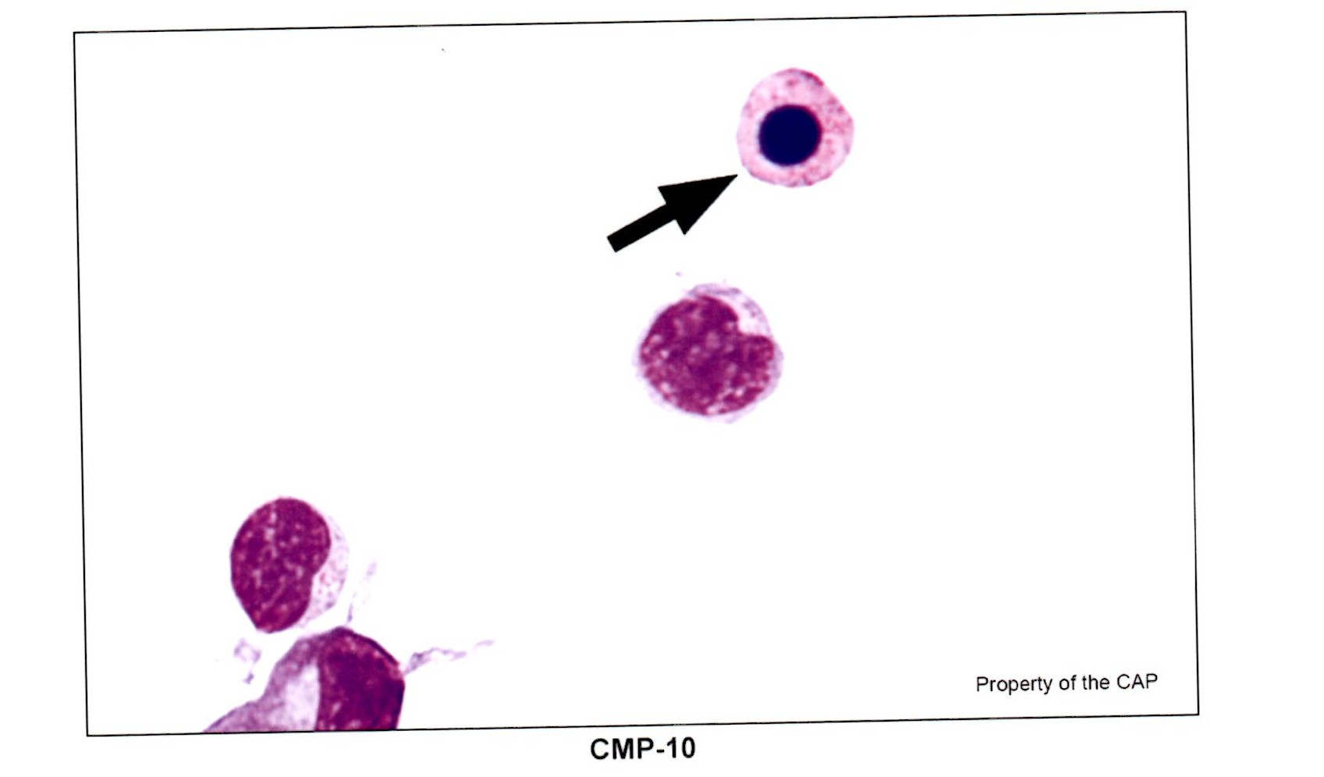

This image was identified incorrectly on the CAP Proficiency Survey CMP-A. Many called this image a Nucleated Red Blood Cell. The cell identified by the arrow, however, is actually a neutrophil. It is a degenerating neutrophil. Note the pinkish granules located in the cytoplasm to help identify this particular cell. Also, remember that the sample is a body fluid, so seeing an NRBC would be an extremely rare event, especially with no other normal RBC’s around as well.

