[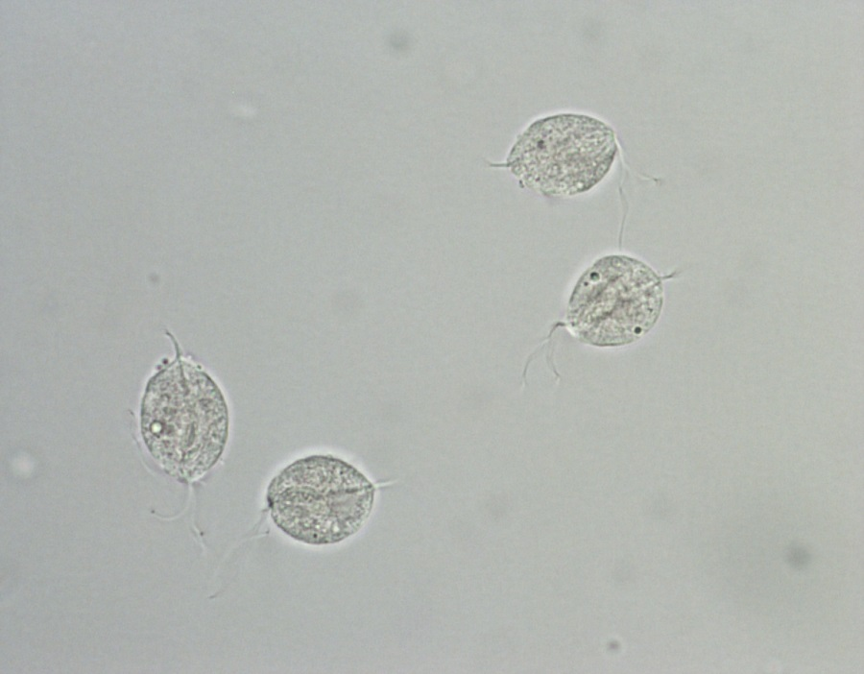](http://www.google.com/url?sa=i&rct=j&q=&esrc=s&frm=1&source=images&cd=&cad=rja&uact=8&ved=0ahUKEwjI_PSvxcLJAhUC62MKHaCKB2oQjRwIBw&url=http://dx.doi.org/10.15570/actaapa.2015.3&psig=AFQjCNEI9LFv1ms5xPmomzyAFZYE96m25w&ust=1449330047063017)

**Trichomonas vaginalis**

[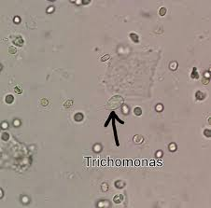](http://www.google.com/url?sa=i&rct=j&q=&esrc=s&frm=1&source=images&cd=&cad=rja&uact=8&ved=0ahUKEwiY1NnBx8LJAhXDVyYKHWP5BfEQjRwIBw&url=http://pixgood.com/trichomonas-vaginalis-in-urine.html&bvm=bv.108538919,d.cGc&psig=AFQjCNFA14KcwJ-n2cNBWNyCjszyaR6Z6Q&ust=1449330245600039)

Please review the images of Trichomonas vaginalis. The Protozoa are approximately the size of a white cell and slightly larger, with motile flagella protruding from the ends. Note that motility must be present on the prepared slide in order to identify and report them from the wet prep. You may view the video attached in MTS to see the motility. When in doubt, have a second tech review before releasing results that are questionable.

[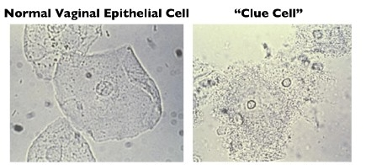](http://www.google.com/url?sa=i&rct=j&q=&esrc=s&frm=1&source=images&cd=&cad=rja&uact=8&ved=0ahUKEwiX9NuPw8LJAhUL6WMKHeBfAUkQjRwIBw&url=http://www.tasiaaudre.com/word-of-the-week/2015/1/9/word-of-the-week-bacterial-vaginosis&psig=AFQjCNFjg3EfylguwrYPRy74eM4UHXhSBQ&ust=1449329342636251)

**“Clue Cells”**

[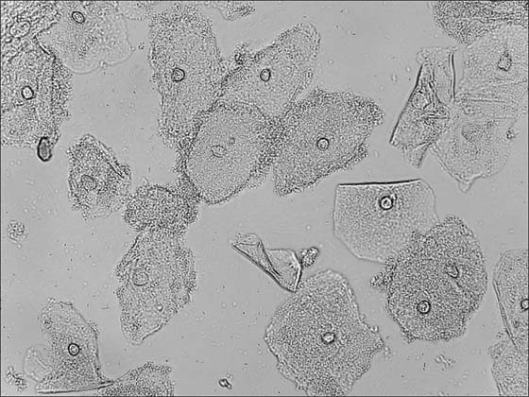](http://www.google.com/url?sa=i&rct=j&q=&esrc=s&frm=1&source=images&cd=&cad=rja&uact=8&ved=0ahUKEwjqjqCnw8LJAhUB_mMKHXa1Bl8QjRwIBw&url=http://www.mtnstopshiv.org/lab/wetmount_training/index.php?slide%3D4&psig=AFQjCNFjg3EfylguwrYPRy74eM4UHXhSBQ&ust=1449329342636251)

These pictures are representative of both clue cells and normal vaginal epithelial cells. Note the differences between the two cell types.

Normals vaginal epithelial cells have distinct edges with clear outlines. There may be some bacteria present on the cell, but not covered as the clue cell is.

Clue cells have a jagged, rough appearance on the outer membrane, sometimes called a “tattered flag” appearance. There is no linear quality to the outer membrane of the clue cells.