TITLE Renuzyme Foam Spray – Instrument Pre-treatment

PRINCIPLE/PURPOSE:

Renuzyme foam spray is a ready-to-use, foaming, dual-enzyme, instrument pre-treatment.

SCOPE:

This guideline specifies the steps to be followed when using Renuzyme Foam Spray for soiled and contaminated instruments.

EQUIPMENT AND MATERIALS:

Equipment: PPE (gloves, safety shield or safety glasses, lab coat), Red Biohazard Bin

Materials: Renuzyme Foam Spray

Preparation: Ready-to-Use

Storage Requirements: Store at room temperature.

PROCEDURE - STEPWISE:

1. Don gloves and safety glasses (or shield).

[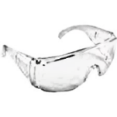](http://www.google.com/imgres?imgurl=https://kandodental.com.au/images/products/kando/1/large/82/6782.jpg&imgrefurl=https://kandodental.com.au/products/safety-glasses-clear&h=800&w=800&tbnid=h3WV3JLeCfCIhM:&docid=FURGmz2JO7lU7M&ei=7kC2VdPsEMGrgwSSzKuQAQ&tbm=isch&ved=0CAwQMygJMAk4ZGoVChMI05uPwsP7xgIVwdWACh0S5goS)[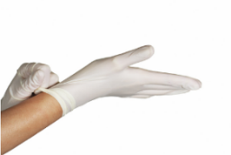](http://www.google.com/url?sa=i&rct=j&q=&esrc=s&frm=1&source=images&cd=&cad=rja&uact=8&ved=0CAcQjRxqFQoTCL6u2L_X9MYCFYGBDQodHqcAzQ&url=http://www.oasisdiscussions.ca/2013/05/27/wh-3/&ei=W6qyVf6ULIGDNp7OgugM&bvm=bv.98717601,d.eXY&psig=AFQjCNEPDCGCYneSmVuKYan1Dar33w5zCg&ust=1437858777002494)

1. Open red biohazard container.

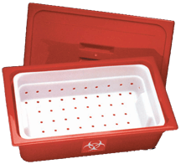

1. Place soiled and contaminated instruments inside of the red biohazard container.

[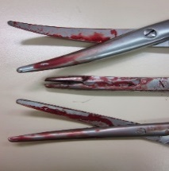](http://www.google.com/url?sa=i&rct=j&q=&esrc=s&frm=1&source=images&cd=&cad=rja&uact=8&ved=0CAcQjRxqFQoTCM7zp6zC-8YCFUKsgAodIC8C9A&url=http://www.veterinarypracticenews.com/10-Steps-to-Protect-a-Big-Investment/&ei=tD-2Vc7JBsLYggSg3oigDw&bvm=bv.98717601,d.eXY&psig=AFQjCNFWTwbU8z7A8D-Yrw2FoXavEwIZjw&ust=1438093581832579)

1. Turn the ready-to-use Renuzyme spray nozzle to the FOAM setting. (DO NOT use spray option)

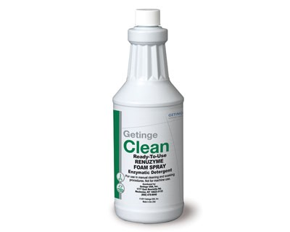

1. Foam directly onto soiled instruments copiously.
2. Place the red biohazard lid on securily and close.
3. Take red biohazard to central sterile when full or at least weekly for decontamination.

PROCEDURE NOTES:

* Do not add bleach, disinfectants, detergents or other chemicals to solution of this product. An added chemical may destroy the effectiveness of the cleaner.

REFERENCES:

1. Instructions for use product insert; Getinge Renuzyme Foam Spray.

|  |  |  |  |
| --- | --- | --- | --- |
| Review Date | Signature | Mgmt. | Director |
|  |  |  |  |
|  |  |  |  |
|  |  |  |  |
|  |  |  |  |
|  |  |  |  |
|  |  |  |  |
|  |  |  |  |
|  |  |  |  |
|  |  |  |  |
|  |  |  |  |
|  |  |  |  |
|  |  |  |  |
|  |  |  |  |
|  |  |  |  |
|  |  |  |  |
|  |  |  |  |
|  |  |  |  |
|  |  |  |  |
|  |  |  |  |
|  |  |  |  |

SOP HISTORY PAGE

SOP Number:

SOP Title:

Written By: Jacee Farmer

Manual in which Hard Copy of this SOP is located: Microbiology Manual II

Distribution: Sharepoint

Supersedes Procedure:

SOP CHANGE CONTROL

|  |  |  |  |  |  |
| --- | --- | --- | --- | --- | --- |
|  | Approvals | |  | Action | In |
| Mgmt. | Date | Director | Date |  | Effect |
|  |  |  |  |  |  |
|  |  |  |  |  |  |
|  |  |  |  |  |  |
|  |  |  |  |  |  |
|  |  |  |  |  |  |
|  |  |  |  |  |  |
|  |  |  |  |  |  |
|  |  |  |  |  |  |
|  |  |  |  |  |  |
|  |  |  |  |  |  |
|  |  |  |  |  |  |
| Date archived: _______________________________ | | | | |  |
| Reason: ____________________________________ Initials:__________ | | | | |  |
|  |  |  |  |  |  |