TITLE Battery Disposal

PRINCIPLE/PURPOSE:

To provide a safe method of recycling applicable batteries as required by the U.S. Department of Transportation (DOT).

SCOPE:

This policy provides laboratory staff with instruction for the appropriate disposal of batteries in the laboratory.

PROCEDURE:

1. Determine battery type. Refer to Table 1.
2. If the battery is alkaline, dispose of in regular trash. If not alkaline, continue to step 3.
3. If the battery type is determined to be a regulated, hazardous, and/or recyclable, according to Table 1, it must be placed in the container labeled “Waste Batteries”. The container is located in the cabinet above the clean sink at the front of the lab.
4. Place the battery in plain, plastic (not biohazard) bag.
5. Label the bag with the current date.
6. Once the battery is sealed inside of the plastic bag, place it in the “Waste Batteries” container.
7. If this is the first battery placed in the container, record the start date of accumulation on the appropriate label. Note: Accumulation must not exceed 12 months.
8. On the label below the start date label, write the date 12 months from the start date.
9. Once the container is full or if the start date indicates it has been 12 months since the start of collection, call Plant Operations (336-538-7777) for pick up.

Table 1

|  |  |
| --- | --- |
| Battery Type | Typical Source(s) of Generation |
| Lithium | calculators, glucometers, timers |
| Mercury oxide (button cell) | Timers, calculators |
| Silver oxide (round, flat batteries) | medical electronics, calculators, timers |

PROCEDURE NOTES:

* Collection container must be structurally sound, closeable, and lack evidence of leakage, spillage, or damage that could cause leakage.
* Used batteries shall not be stored more than 12 months.
* For a list of more battery types, refer to OP-SAF-2007-07 BATTERY DISPOSAL (located on Cone Connects).

RELATED PROCEDURES:

OP-SAF-2007-07 BATTERY DISPOSAL

SUPPLEMENTAL MATERIALS/ADDENDUM:

Addendum 1. Battery Disposal Container Label

Addendum 2. Container Label Template

REFERENCES:

1. Hazardous Material Regulations (HMR) 49 CFR Parts 171-180.
2. OP-SAF-2007-07 BATTERY DISPOSAL (CONE CONNECTS).

Addendum 1

Battery Disposal

Each battery must be placed in a separate plastic bag, then

placed in the container.

Label each bag with the date.

Place in individual bags and in this container:

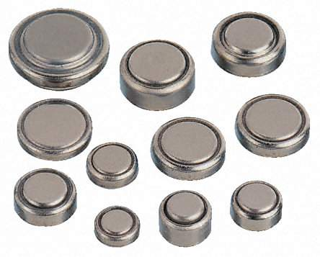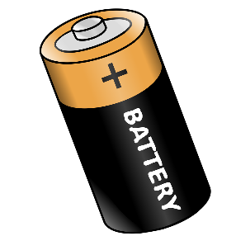

Silver Oxide and Lithium

Mercury Oxide

Place in regular trash:



Alkaline

Addendum 2

|  |  |  |  |  |
| --- | --- | --- | --- | --- |
| Waste  Batteries |  | Accumulation Start Date:  ______________________ |  | Call Plant Ops (336-538-7777) for pick up when full or by ______________________ |
| Waste  Batteries |  | Accumulation Start Date:  ____________________ |  | Call Plant Ops (336-538-7777) for pick up when full or by ______________________ |
| Waste  Batteries |  | Accumulation Start Date:  ____________________ |  | Call Plant Ops (336-538-7777) for pick up when full or by ______________________ |
| Waste  Batteries |  | Accumulation Start Date:  ____________________ |  | Call Plant Ops (336-538-7777) for pick up when full or by ______________________ |
| Waste  Batteries |  | Accumulation Start Date:  ____________________ |  | Call Plant Ops (336-538-7777) for pick up when full or by ______________________ |
| Waste  Batteries |  | Accumulation Start Date:  ____________________ |  | Call Plant Ops (336-538-7777) for pick up when full or by ______________________ |
| Waste  Batteries |  | Accumulation Start Date:  ____________________ |  | Call Plant Ops (336-538-7777) for pick up when full or by ______________________ |
| Waste  Batteries |  | Accumulation Start Date:  ____________________ |  | Call Plant Ops (336-538-7777) for pick up when full or by ______________________ |

|  |  |  |  |
| --- | --- | --- | --- |
| Review Date | Signature | Mgmt. | Director |
|  |  |  |  |
|  |  |  |  |
|  |  |  |  |
|  |  |  |  |
|  |  |  |  |
|  |  |  |  |
|  |  |  |  |
|  |  |  |  |
|  |  |  |  |
|  |  |  |  |
|  |  |  |  |
|  |  |  |  |
|  |  |  |  |
|  |  |  |  |
|  |  |  |  |
|  |  |  |  |
|  |  |  |  |
|  |  |  |  |
|  |  |  |  |
|  |  |  |  |

SOP HISTORY PAGE

SOP Number: SAFE-1059

SOP Title: Battery Disposal

Written By: Jacee Farmer

Manual in which Hard Copy of this SOP is located: Safety Manual

Distribution: None

Supersedes Procedure: n/a

SOP CHANGE CONTROL

|  |  |  |  |  |  |
| --- | --- | --- | --- | --- | --- |
|  | Approvals | |  | Action | In |
| Mgmt. | Date | Director | Date |  | Effect |
|  |  |  |  |  |  |
|  |  |  |  |  |  |
|  |  |  |  |  |  |
|  |  |  |  |  |  |
|  |  |  |  |  |  |
|  |  |  |  |  |  |
|  |  |  |  |  |  |
|  |  |  |  |  |  |
|  |  |  |  |  |  |
|  |  |  |  |  |  |
|  |  |  |  |  |  |
| Date archived: _______________________________ | | | | |  |
| Reason: ____________________________________ Initials:__________ | | | | |  |
|  |  |  |  |  |  |