BODY FLUIDS PROCESSING FOR CYTOLOGY

BACKGROUND: Body fluids collected from the pleural, peritoneal or pelvic cavities are often split between the ARMC clinical lab and LabCorp cytology. Correlation of the results from each lab is needed. The purpose of this procedure is to outline a process to ensure correlation between the Wright stain and cytology slides and to provide additional diagnostic material.

SCOPE: This procedure applies to all pleural, peritoneal/abdominal and pelvic fluids submitted for cytological review and diagnosis at ARMC. An order for a cell count may also accompany these specimens and the fluid is split between the ARMC clinical lab and LabCorp cytology.

POLICY: All pleural, peritoneal/abdominal and pelvic fluids submitted for cytology processing at LabCorp will also have a smear with a Wright stain prepared by the ARMC clinical lab prior to being sent to LabCorp for processing. TV/SMR, which prompts for the total estimate volume received and preparation of a Wright stain smear is attached to LCA cytology orders 9050, 9043, and 9159.

DEFINITION:

Pleural fluids - may also be labeled as thoracentesis

Peritoneal/Abdominal fluids - may also be labeled paracentesis or ascites fluid

EQUIPMENT AND MATERIALS:

Fluid Log Sheet (Supplemental Materials #1)

Body Fluid Worksheet (Supplemental Materials #2)

Pathology Body Fluid Specimen Log (Supplemental Materials #3)

Body Fluid Type Reference Guide (Supplemental Materials #4)

PROCEDURE:

1. Fluids are submitted to the clinical lab and logged into the "Fluid Log Sheet" (Supplemental Materials #1) in the accessioning area.
2. The clinical lab staff will verify the orders and if needed, enters orders into the clinical lab LIS.
   1. When placing an order specimen in hand:
      1. Place the order as normal
      2. On line 19, "Clinical Info [ ]": Enter the estimated total volume (see Figure 1)

Figure 1

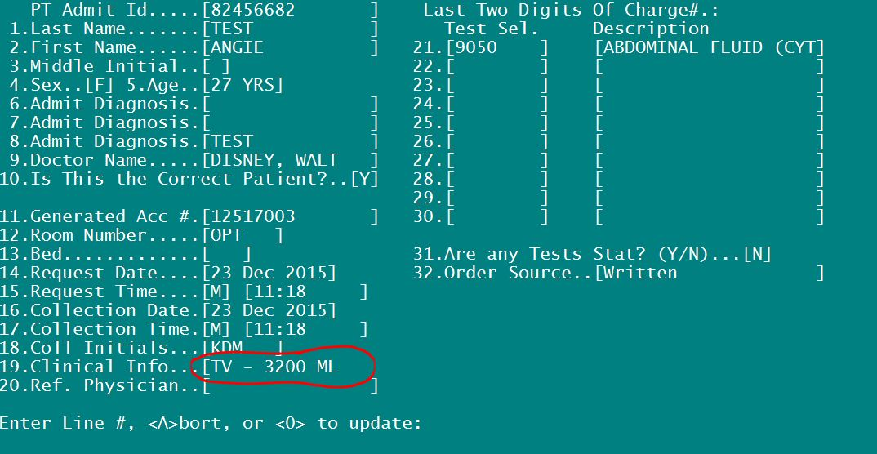

* 1. When verifying:
     1. On line 14: "Do you want to put in special comments through scroll [Y]". Put in a [Y] (see Figure 2)

Figure 2

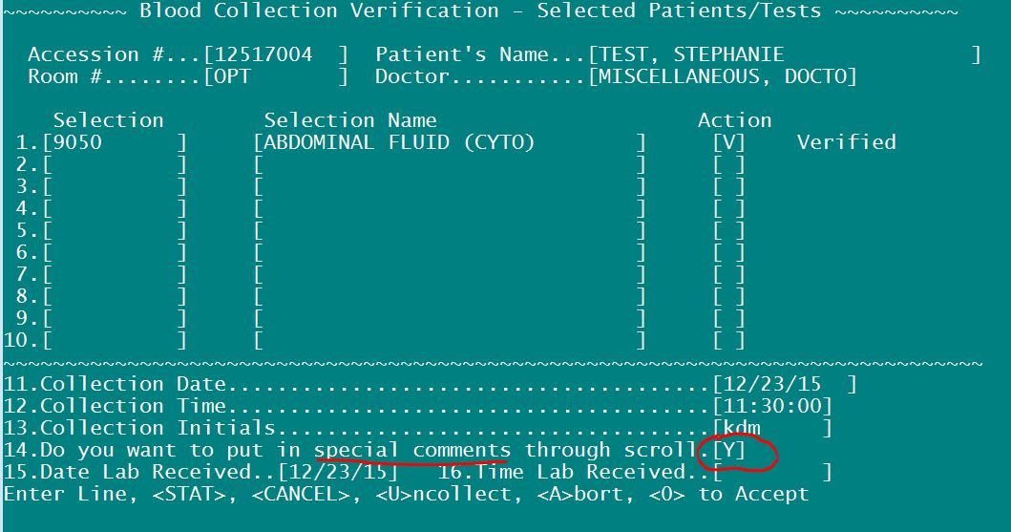

* + 1. Follow through and verify the specimen and when the "Comment" section appears enter the estimated total volume in the TV/SMR comment section (see Figure 3)

Figure 3

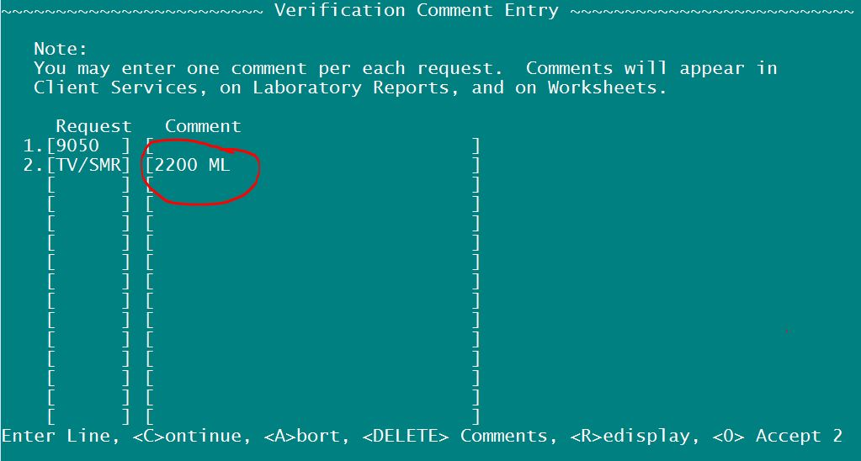

1. A label is printed and placed on the specimen and a patient demographic sheet is printed, if one is not provided by the submitting department.
2. The fluid is mixed well and aliquoted for clinical lab tests (cell count and/or Wright stain smear). The total volume is written on the aliquot and the aliquot and body fluid worksheet is delivered to Hematology.

1. The technician in Hematology process the aliquot per the orders:
   1. If a cell count is ordered in addition to cytology, a Wright stain smear is prepared and a cell count performed. The Wright stain slide and a Body Fluid worksheet (Supplemental Materials #2) will then be placed in the box for pathologist review.
   2. If a cell count is not ordered, a Wright stain smear is prepared and the slide and Body Fluids worksheet is placed in the box for pathologist review; a cell count is not performed.

Note: The Body Fluid worksheet will alert the pathologist that a concurrent cytology case is pending for the specimen.

1. The remainder of the specimen is delivered to the ARMC pathology lab labeled with a barcode label, LabCorp Cytology request form and demographic. The specimen is placed in the designated area and entered on the ARMC Cytology Specimen Log (Supplemental Materials #3).
2. The specimen is accessioned into the PowerPath, the pathology LIS, as an ARC case and sent to LabCorp, via courier, for processing. The case is assigned to the pathologist who is covering frozen sections for the day.
3. The Pathologists' Assistant completes the top portion of the ARMC Cytology worksheet, dictates the body fluid template into PowerPath and prints out the appropriate number of cassettes.

Note: If multiple containers are received from the same specimen source, they should be designated by number, i.e. if you containers of fluid are received from the abdomen,designate one container as 1 and one container as 2. A cell block should be performed on each container received. Cassettes A1 and A2 would be printed for the example case above.

1. The specimen, requisition, ARMC Cytology worksheet and cassette(s) are sent via LCA courier to Powell South for processing.
2. A cytotech reviews the slides and completes the lower portion of the ARMC Cytology worksheet.
3. The slides are then returned to the ARMC pathology lab by LCA courier and the assigned pathologist will review both the Wright stain and the cytology slides and entering an interpretation and diagnosis for each into the case in PowerPath.

If a cell count was ordered in addition to cytology, the pathologist will also enter a note into the clinical lab LIS, referencing the ARC cases results in SCM for pathologist's interpretation of the Wright stain.

Note: If a cytology order is not received, the pathologist will enter the Wright stain interpretation directly into the clinical lab LIS.

PROCEDURE NOTES:

None

RELATED PROCEDURES:

LIMITATIONS OF THE PROCEDURE:

None

SUPPLEMENTAL MATERIALS/ADDENDUM:

Supplemental Materials #1

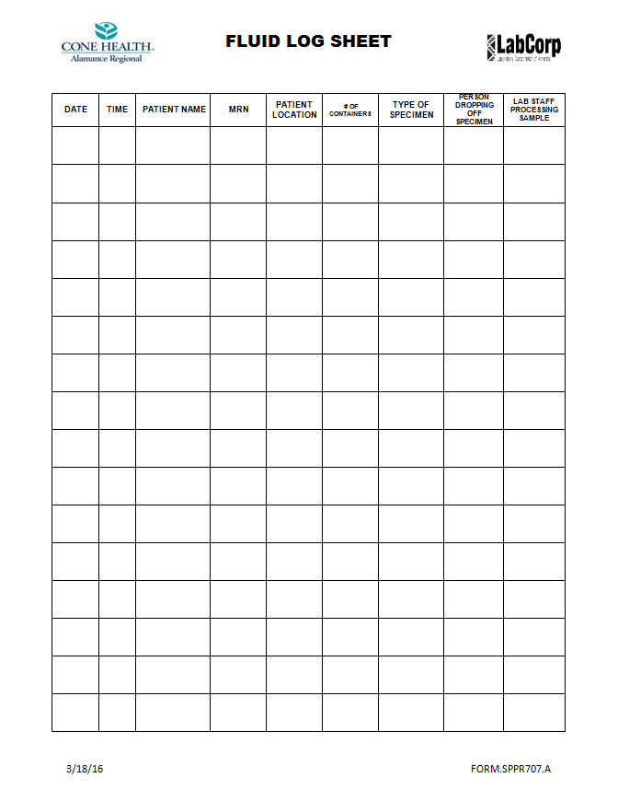

Supplemental Materials #2

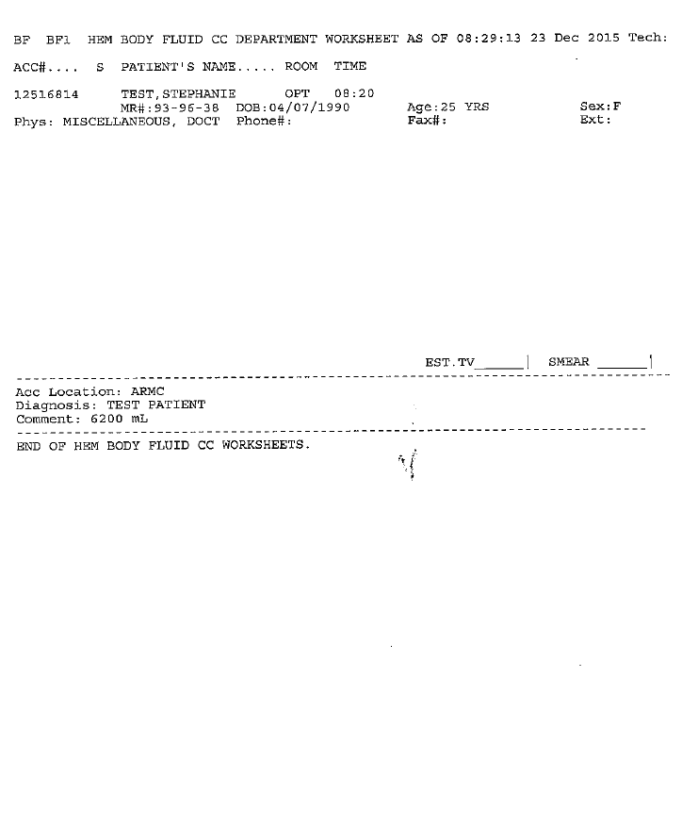

Supplemental Materials #3

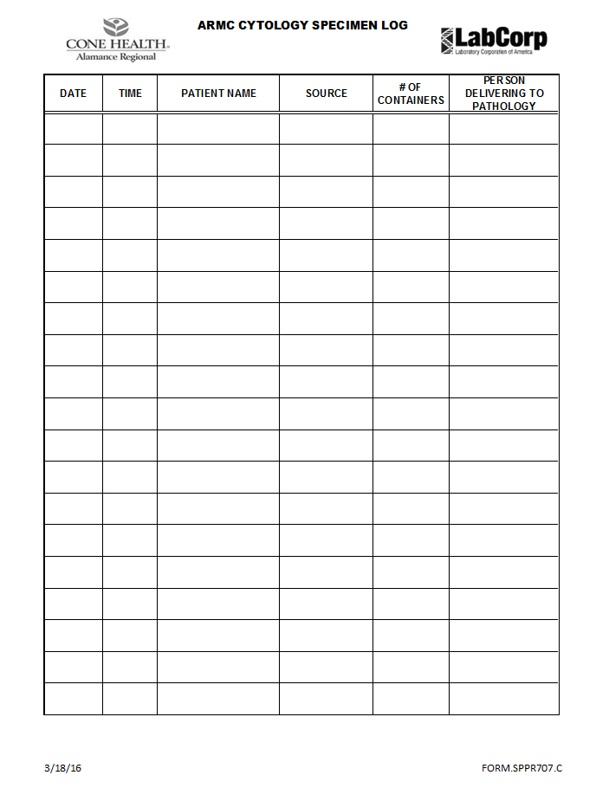

Supplemental Materials #4

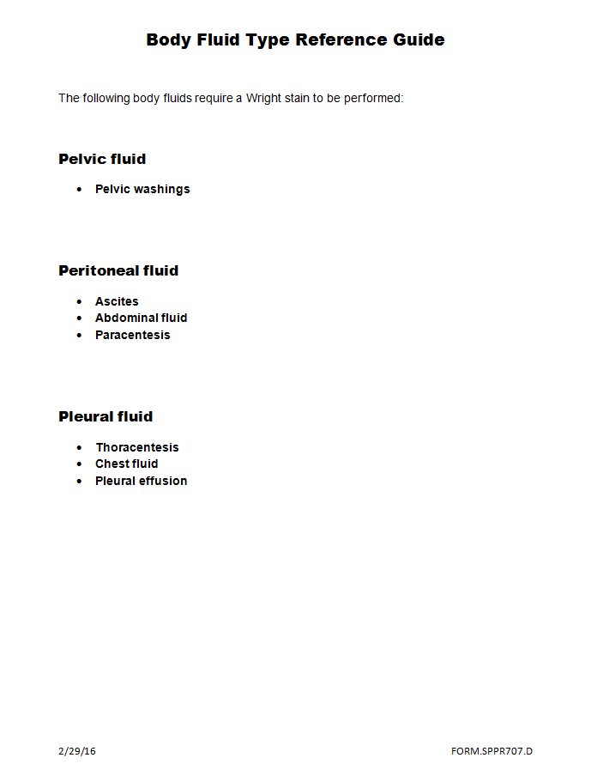

Supplemental Materials #5

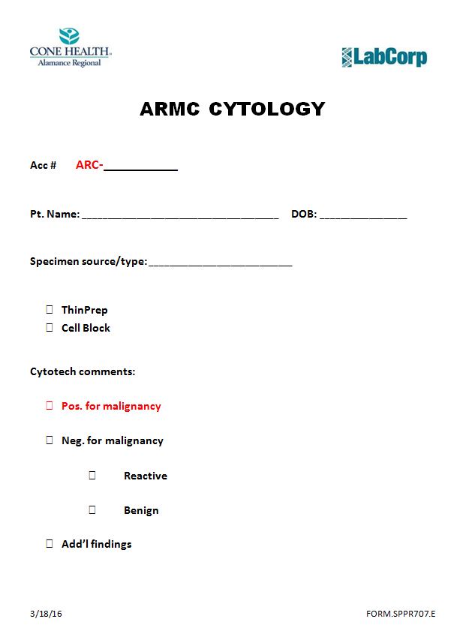

REFERENCES:

None

|  |  |  |  |
| --- | --- | --- | --- |
| Review Date | Signature | Mgmt. | Director |
|  |  |  |  |
|  |  |  |  |
|  |  |  |  |
|  |  |  |  |
|  |  |  |  |
|  |  |  |  |
|  |  |  |  |
|  |  |  |  |
|  |  |  |  |
|  |  |  |  |
|  |  |  |  |
|  |  |  |  |
|  |  |  |  |
|  |  |  |  |
|  |  |  |  |
|  |  |  |  |
|  |  |  |  |
|  |  |  |  |
|  |  |  |  |
|  |  |  |  |

SOP HISTORY PAGE

SOP Number: SPPR-707

SOP Title: Body Fluid Processing for Cytology

Written By: Amanda Coble, MS PA(ASCP), MHA

Manual in which Hard Copy of this SOP is located: Specimen Processing

Distribution: Pathology

Supersedes Procedure: None

SOP CHANGE CONTROL

|  |  |  |  |  |  |
| --- | --- | --- | --- | --- | --- |
|  | Approvals | |  | Action | In |
| Mgmt. | Date | Director | Date |  | Effect |
|  |  |  |  |  |  |
|  |  |  |  |  |  |
|  |  |  |  |  |  |
|  |  |  |  |  |  |
|  |  |  |  |  |  |
|  |  |  |  |  |  |
|  |  |  |  |  |  |
|  |  |  |  |  |  |
|  |  |  |  |  |  |
|  |  |  |  |  |  |
|  |  |  |  |  |  |
| Date archived: _______________________________ | | | | |  |
| Reason: ____________________________________ Initials:__________ | | | | |  |
|  |  |  |  |  |  |