TITLE: PROCESSING LCA REFERENCE SPECIMENS

PRINCIPLE / PURPOSE: To provide directions for processing/packaging samples for reference testing.

SCOPE: This procedure applies to all specimen processing for tests sent to Laboratory Corporation of America (LCA) for testing.

SPECIMEN: Cytology, Histology, Chromosome analysis on products of conception, routine reference clinical specimens, and stat reference clinical specimens
Handling Conditions: Refer to the specimen collection guide, or reference book as needed if not indicated in this procedure.

EQUIPMENT AND MATERIALS:
Materials: Properly labeled and collected specimens, LCA reference forms, Lab Information System labels, appropriate biohazard bags, patient demographic information, ARMC reference sheet

PROCEDURE:

PROCESSING CYTOLOGY SPECIMENS:

- Cytology specimens are labeled and packaged at the bedside (nursing area). Patient name and source should be written on all slides and specimen containers.
- A completed history and LabCorp Cytology or LabCorp Histology/Cytology form must accompany each specimen to the lab. (Supplemental Materials #1 or #2)
- The test requested must be checked or recorded on the LCA order form.
- Specimens are submitted to the clinical lab. Fluid specimens are recorded on the "Fluid Log Sheet" (Supplemental Materials #3) in the accessioning area of the clinical lab by the staff dropping off the specimen.
- Refer to SPPR-703_Shared_Specimens_for_Clinical_and_Anatomic_Pathology_Labs
if a clinical lab order is requested in addition to a LabCorp cytology request.
- Place order (or verify the existing order) in the LIS.
- Place the LIS label on the specimen.
- Enter the LIS accession number on the LCA request form for the patient ID.
- Print a “Patient Insurance/Demographics” if nursing has not sent one with the specimen. (Supplemental Materials #4)

From the main Order Entry Menu of the AS400 Order Communications Computer System
  - Select menu item “Print Patient/Ins Demographics” and <ENTER>
  - Type the patient’s eight digit account number
  - <ENTER>
  - Patient Demographic/Insurance sheet will print
- Package the specimen for send-out. Place specimens in biohazard specimen bags after verifying all specimens are labeled correctly.
- Maintain the back copy of the requisition with the reference lab order copies and place other request copies and the Insurance/Demographic sheet in the bag.
- Record the specimen on the ARMC/LCA Cytology Specimen Log with appropriate information. (Supplemental Materials #5)
- Place the specimen in the designated cytology bin in the histology area and entered on the ARMC Cytology Specimen log.

PROCESSING HISTOLOGY SPECIMENS:
Histology personnel at ARMC are responsible for ensuring correct forms and labeling.
For all histology specimens including (but not limited to) Routine specimens, Fresh specimens for intraoperative consult or frozen specimen, Chromosome Analysis on Products of Conception, Bone Marrow testing, Muscle Biopsy, and Kidney Biopsy refer to: PATH-200_Histology_Specimen_Collection

PROCESSING ALL OTHER ‘ROUTINE’ SPECIMENS
- Specimens are collected and processed according to the Reference Lab’s Directory of Services Guide. Careful attention is given to specimen type, and storage instructions. (Refer to the specimen collection procedures as needed.)
- Verified specimens are placed in the reference/send-out area until packaged for pick-up.
- Print a reference request order form from the LIS (refer to the LIS manual). (Supplemental Materials #6: ARMC LIS generated reference request example)
- Record the sample information on the top right corner of the form (i.e. 1 gel tube, 1 frozen plasma, etc.)
- Initial the left corner of the request form.
- Maintain the back copy of the request and package the other copy with the specimen.
- Place the specimen in the biohazard specimen bag with the request.
- Put the specimen (in the specimen bag) in the correct storage area as required by the Directory of Service (freezer, fridge, room temp).
- The LabCorp courier has scheduled pick-ups and transport the samples to the reference laboratory according to LCA policy and procedures.

PROCESSING STAT SPECIMENS
- Package/process the sample immediately (See step 1-7 above for Routine Specimens).
- Call / Notify Reference Lab of the STAT
- Going to LabCorp - Daytime / Monday-Friday
Call 436-4235 (ext.2) to contact customer services.
- Going to LabCorp - Evening / Weekend / Holiday
Call 584-5171. Data Entry / Results Transmissions / Customer Services will answer.
- Give them the patient name, our account number (LabCorp (LCA) # is 32319310-1), test requested, and any other information they may need.
- Arrange for specimen transfer. LabCorp usually will call for a courier. Verify this will take place before ending the call. If necessary, call the courier service LabCab (336-270-6890) to pick up the STAT.
- Document all the call and sample information on the Reference STAT/Critical Log. (Supplemental Materials #7)
  - Patient information (LIS label, or hand-write patient’s name, LIS accession number, and test name)
  - Time customer service was notified the STAT was coming
  - Name of personnel receiving STAT notification call
  - Time courier was called
  - Time specimen is picked up for transport to the reference lab
- Results will be called when testing is completed. Record the following information on the Reference STAT/Critical Log:
  - Time results were called to ARMC by the reference lab
  - Name of Reference Lab person calling the result to ARMC
  - Results – including reference ranges, critical/toxic levels
- Call the results and the necessary information (reference range and critical ranges, etc) to the appropriate ordering personnel. Record the following on the Reference STAT/Critical Log:
  - Person ARMC lab called the results to (that received the results, and ranges)
  - ARMC Lab person calling the results
- Document the following in the LIS under general comment for the test:
  - First and Last Name of person who took the report
  - Date and Time report called
  - Read-Back information
- The Reference STAT/Critical Log is filed with the Quality Improvement data monthly.

NOTE: When using the Reference STAT/Critical Log to document a telephone report that was not either a STAT and/or sent to LabCorp for testing, place the notation ‘NA’ in the areas of the form that do not apply.

RELATED PROCEDURES:
PATH-200_Histology_Specimen_Collection
SPPR-703_Shared_Specimens_for_Clinical_and_Anatomic_Pathology_Labs

SUPPLEMENTAL MATERIALS/ADDENDUM:

Supplemental Materials #1: LCA Cytology Form

Supplemental Materials #2: LCA Histology/Cytology Form

Supplemental Materials #3: ARMC Fluid Specimen Log

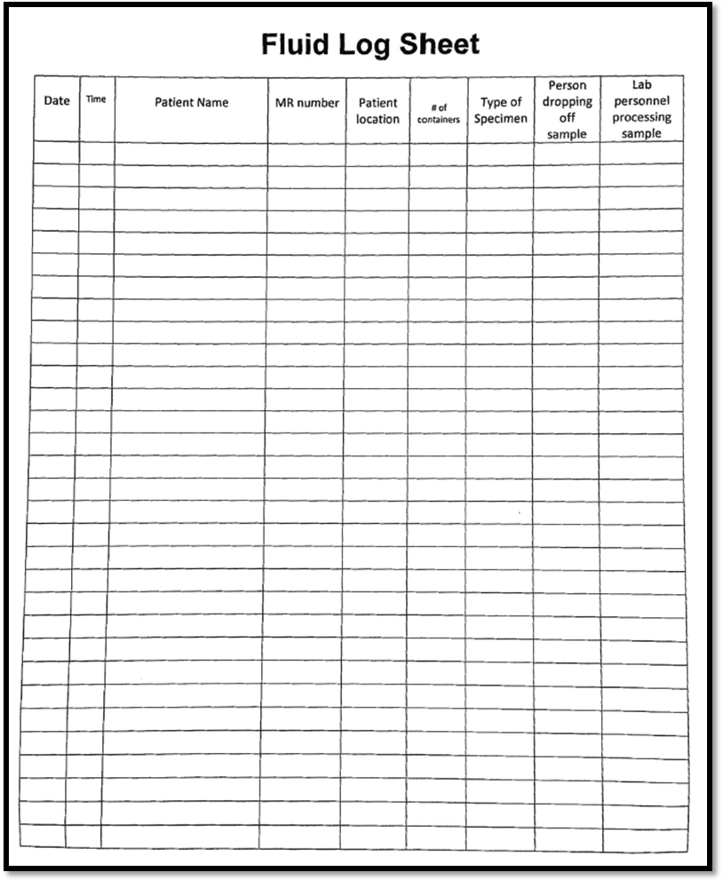

Supplemental Materials #4: Screen Shot Instructions to print Demographics

Supplemental Materials #5: ARMC/LCA Cytology Specimen Log

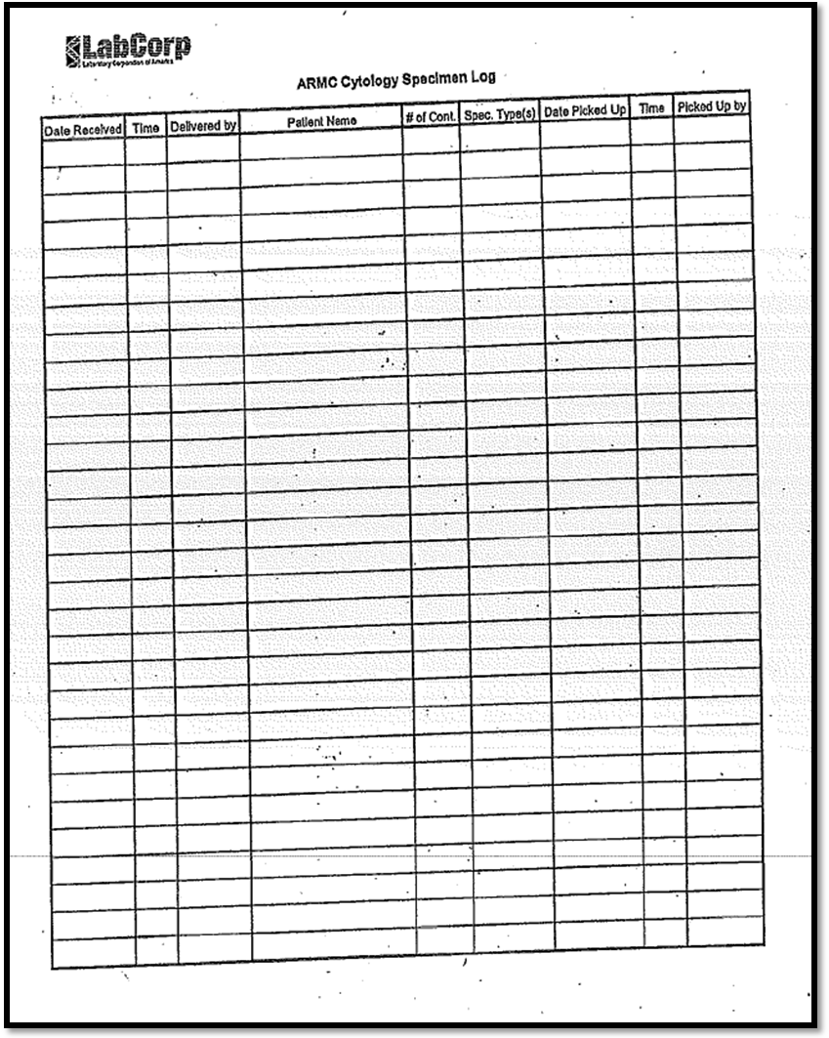

Supplemental Materials #6: ARMC LIS generated reference request example

Supplemental Materials #7: Reference Stat/Critical Log

Review Date | Signature | Mgmt. | Director

HISTORY PAGE

SOP Number: SPPR-709
SOP Title: Processing LCA Reference Specimens
Written By: Wendy Turner MT (ASCP)
Manual in which Hard Copy of this SOP is located: Specimen Processing and Clerical Manual
Distribution: no other locations
Supersedes Procedure:

SOP CHANGE CONTROL
 | Approvals |  |  | Action | In
Mgmt. | Date | Director | Date |  | Effect
√ | 3/16/16 |  |  | Modified location of specimen drop off location | 4/4/16
Jacee Farmer |  |  |  | and documentation to pathology lab.
Date archived: _______________________________
Reason: ____________________________________ Initials:__________

