The following are items missed from the educational CAP challenge VBF-A.

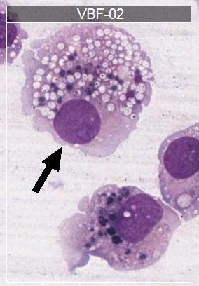

The cell identified in the picture is a monocyte/macrophage containing hemosiderin (siderophage). We incorrectly identified it as a monocyte/macrophage containing small, abundant lipid vacuoles. The dark blue stained “circles” inside the cell are hemosiderin. The technical explanation from CAP follows.

“The arrowed object is best considered a monocyte/macrophage or a siderophage, as correctly identified

by 81.8% of participants. Macrophages arise from bone marrow derived cells that migrate into tissues and

evolve morphologically. Monocyte/macrophage morphology in fluids is quite variable, ranging in

continuum from the typical blood monocyte of the peripheral blood to a vacuolated, activated stage with

themorphology of a typical macrophage. The cell arrowed in this case has morphologic features of a

macrophage. Macrophages are larger cells (15 to 80 μm) with abundant cytoplasm showing evidence of

active phagocytosis. This includes ingested material such as other blood cells or bacteria, hemosiderin,

fungi, and remnants of digested materials as well as cytoplasmic vacuoles postingestion. One or more

round to oval nuclei are present and ocasionally prominent nucleoli may be seen. The siderophage is a

macrophage containing the coarsely granular iron-protein complex known as hemosiderin. They are

granules that are dark blue with the Wright stain, arising from iron by-product from digested red cells.

These cells may also be seen in other conditions leading to hemorrhage in any body cavity. The Prussian

blue stain can confirm the identity of intracytoplasmic iron and stains hemosiderin a vivid lighter blue.

Hemosiderin pigment should be differentiated from melanin and anthracotic pigment.”

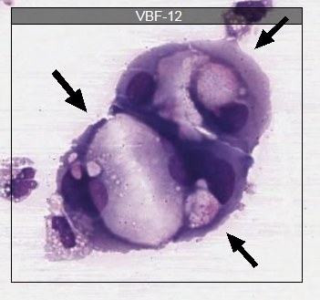

The cell(s) identified in this picture are malignant cells. We incorrectly identified this image as degenerating cells. We did recognize that something was abnormal about these cells, so we need to look at other clues to help. One of the biggest clues to help with identification is to compare the abnormal cells to the normal neutrophils sitting immediately to the left. Note how the malignant cells are clustered together, and how they are so much larger and more irregular than the neutrophils. The other important clue is in the background/diagnosis of the patient. “This ascites fluid cytospin slide is from an 81-year-old woman with ovarian cancer. Laboratory ascites fluid values: WBC = 1,753/μL (1.753 × 103/μL); and RBC = 319/μL (0.319 × 103/μL).” We must think when doing our job, and use all of the information given. Therefore, it is important to check a patient’s history for things like diagnoses or medications, especially when something abnormal is suspected. The technical explanation from CAP follows.

“The arrowed object is a malignant cell (non-hematopoietic) as correctly identified by 92.0% of

participants. Malignant cells are characterized by pleomorphism, high nuclear-to-cytoplasmic ratios,

irregular nuclei with abnormal chromatin, large nucleoli, and cellular and nuclear enlargement. The

cytoplasm is variable and may contain vacuoles. Malignant cells often form tight cell clusters and may

show nuclear molding. The malignant cells are a distinctly different population from the normal cells

present, with no transitional forms.”